20.05.10 ANOVA Analysis

JBK

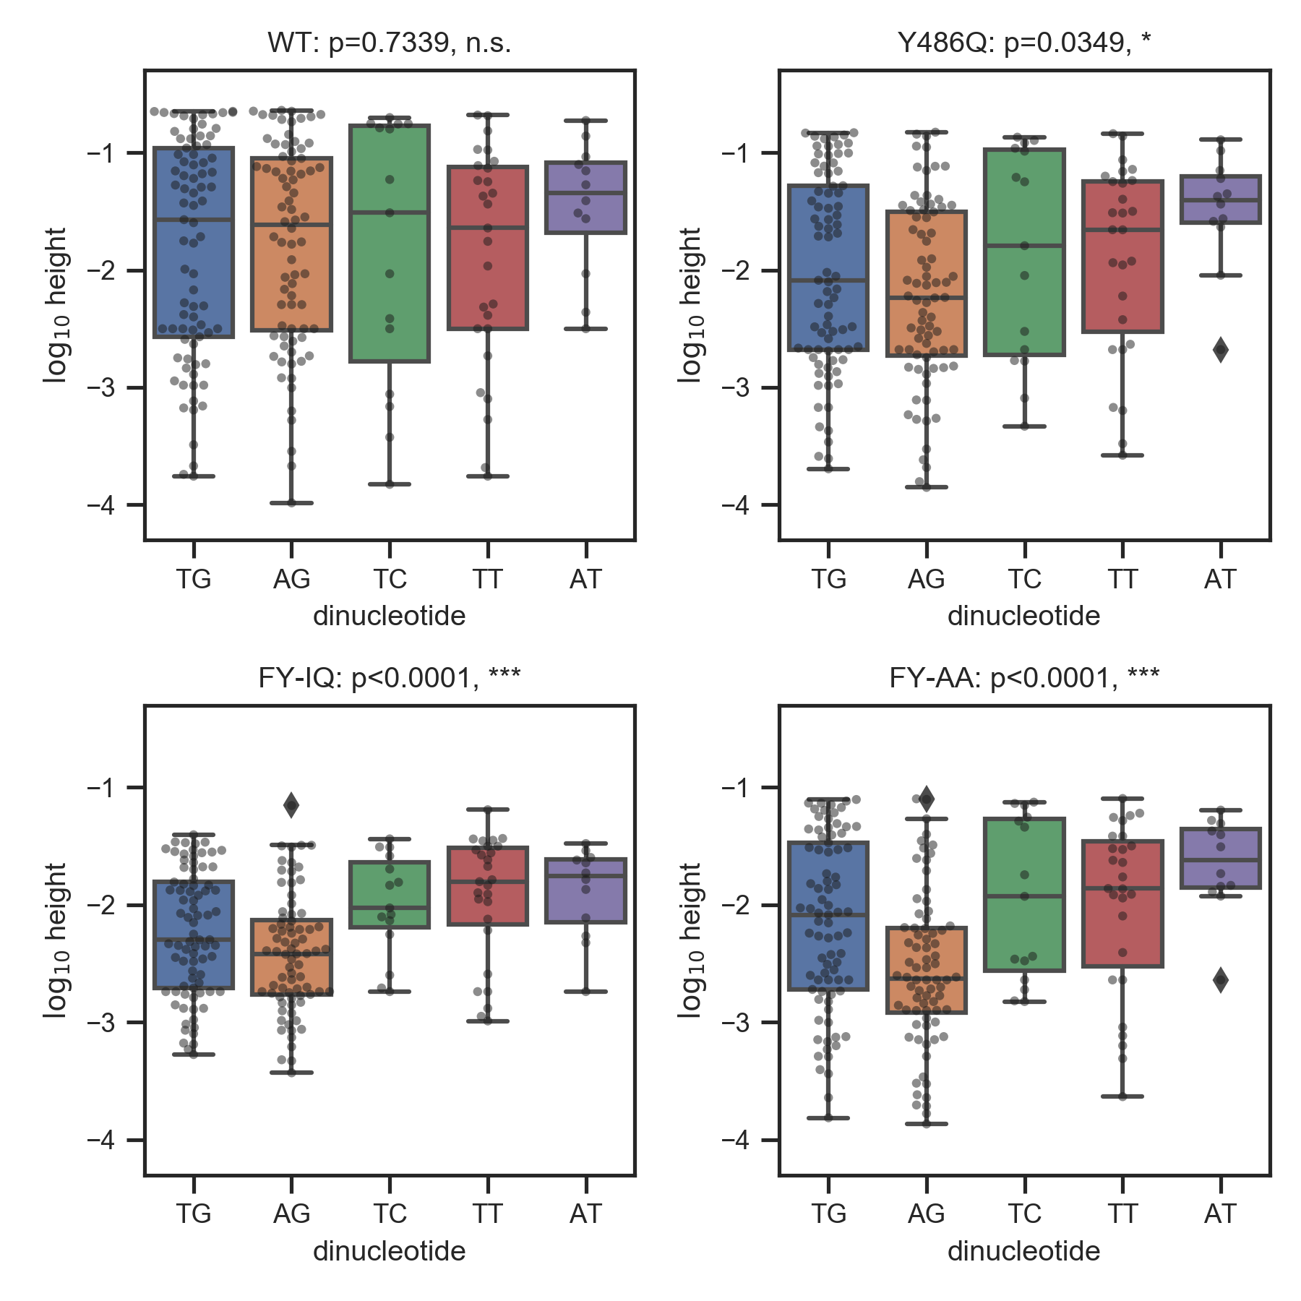

**Figure 1.** Dependence of EdU peak height on selected ACS dinucleotide in four different Orc4 mutant strains. Each dot represents an ACS annotated in ORI DB. P-values correspond to a one-way ANOVA test for the dependence of logEdU height on dinucleotide identity. Dinucleotides occurring in 3 or less annotated ACSs were removed prior to this analysis; a total of 211 ACSs were analyzed, while 9 were removed.



**Figure 2.** Correlations between log EdU heights and scores assigned by MPOS motifs across annotated ACSs. P-values assess the null hypothesis that log EdU heights and motif scores are not correlated. All P-values were Bonferoni corrected (i.e., by multiplying by the total number of tests). We find 16 significant correlations. Key: *p<0.05, **p<0.01, ***p<0.001.

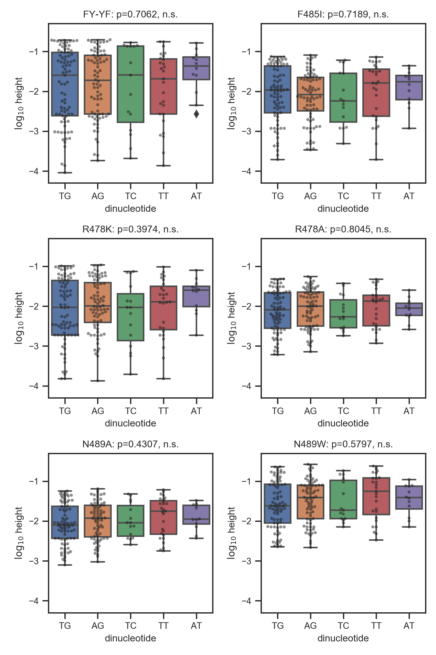

**Figure S1.** Same as Figure 1 but for all mutant strains.