**Identifying Whale Species Through Images of Flukes Using Several Learning Methods**

Spencer Smith, Joshua Black

**Display Objects:**

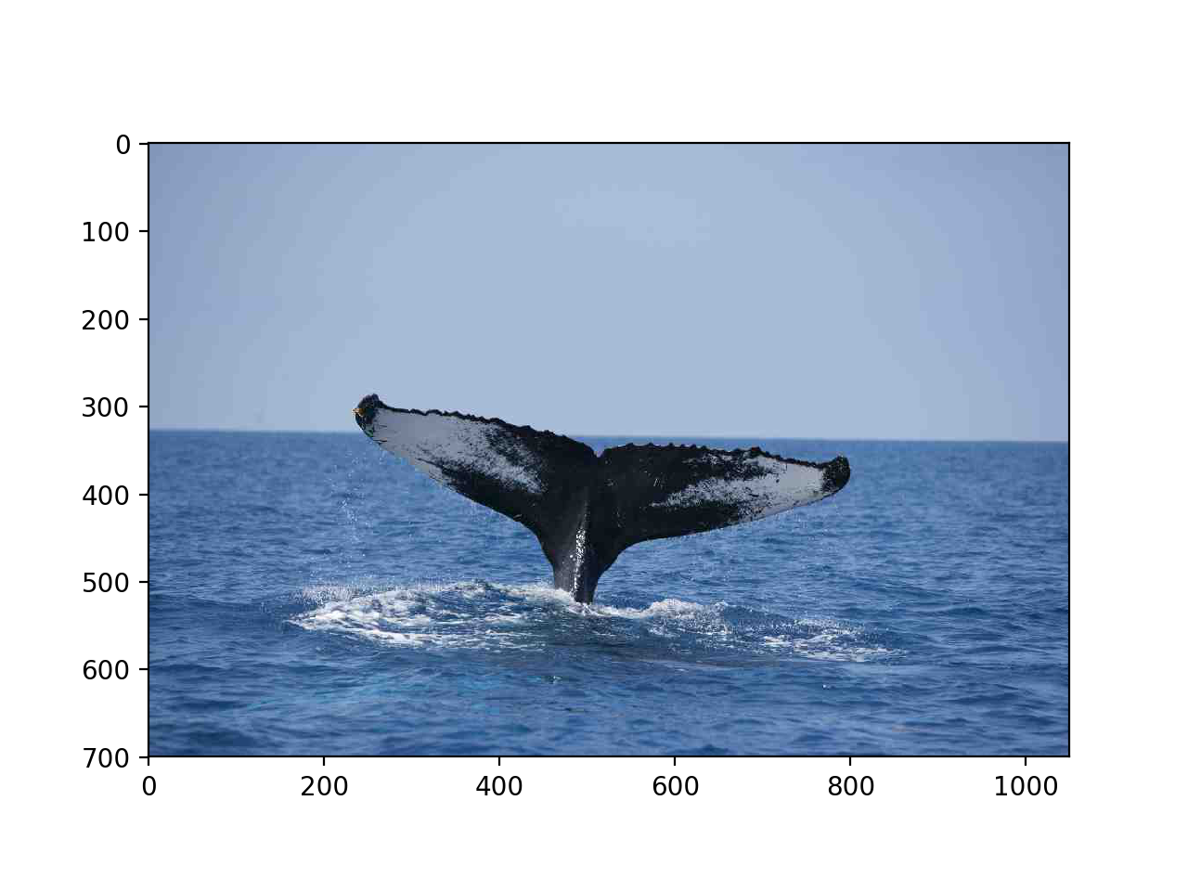

**Figure 1** Original fluke image that has not been augmented.

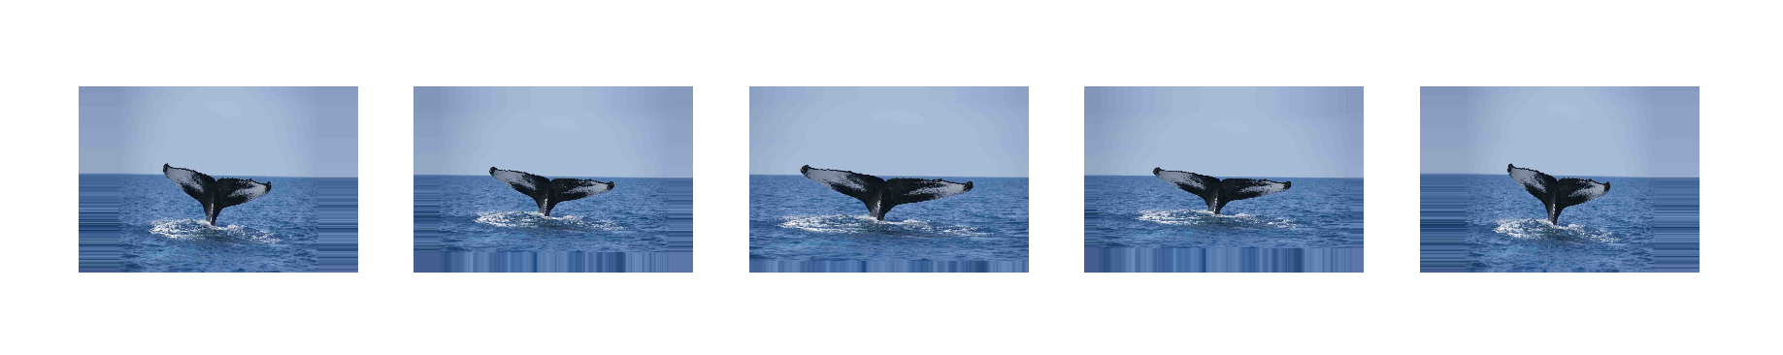

**Figure 2** Whale fluke images augmented with random zoom.

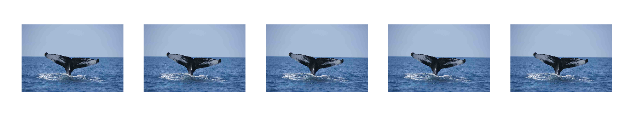

**Figure 3** Whale fluke images augmented with random sheering.

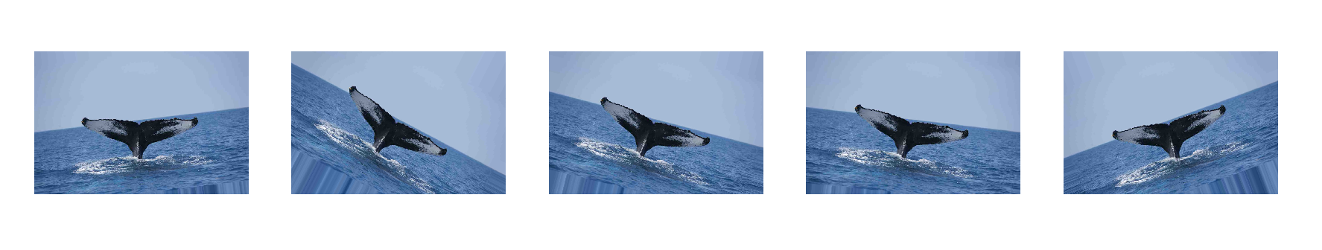

**Figure 4** Whale fluke images augmented with random rotation.

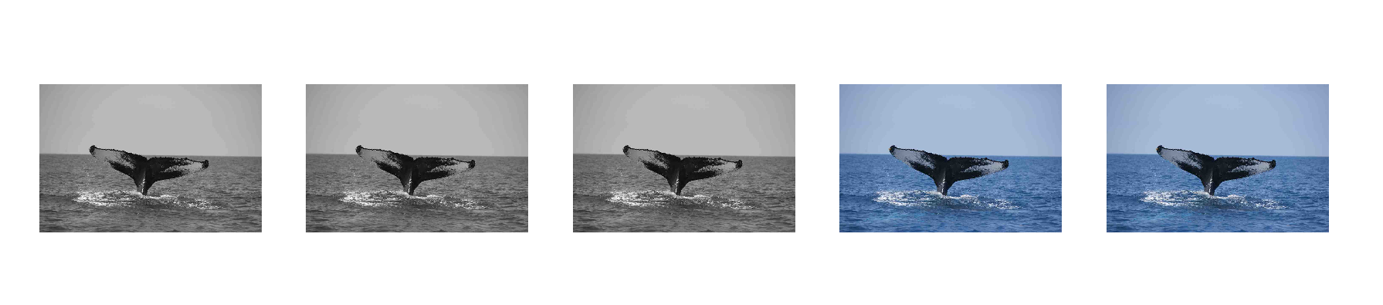

**Figure 5** Whale fluke images augmented with random greyscale.

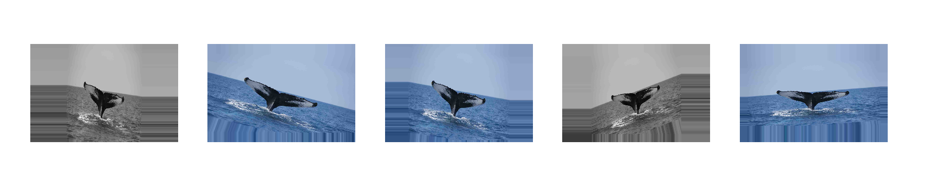

**Figure 6** Whale fluke images augmented with random combinations of previous techniques.

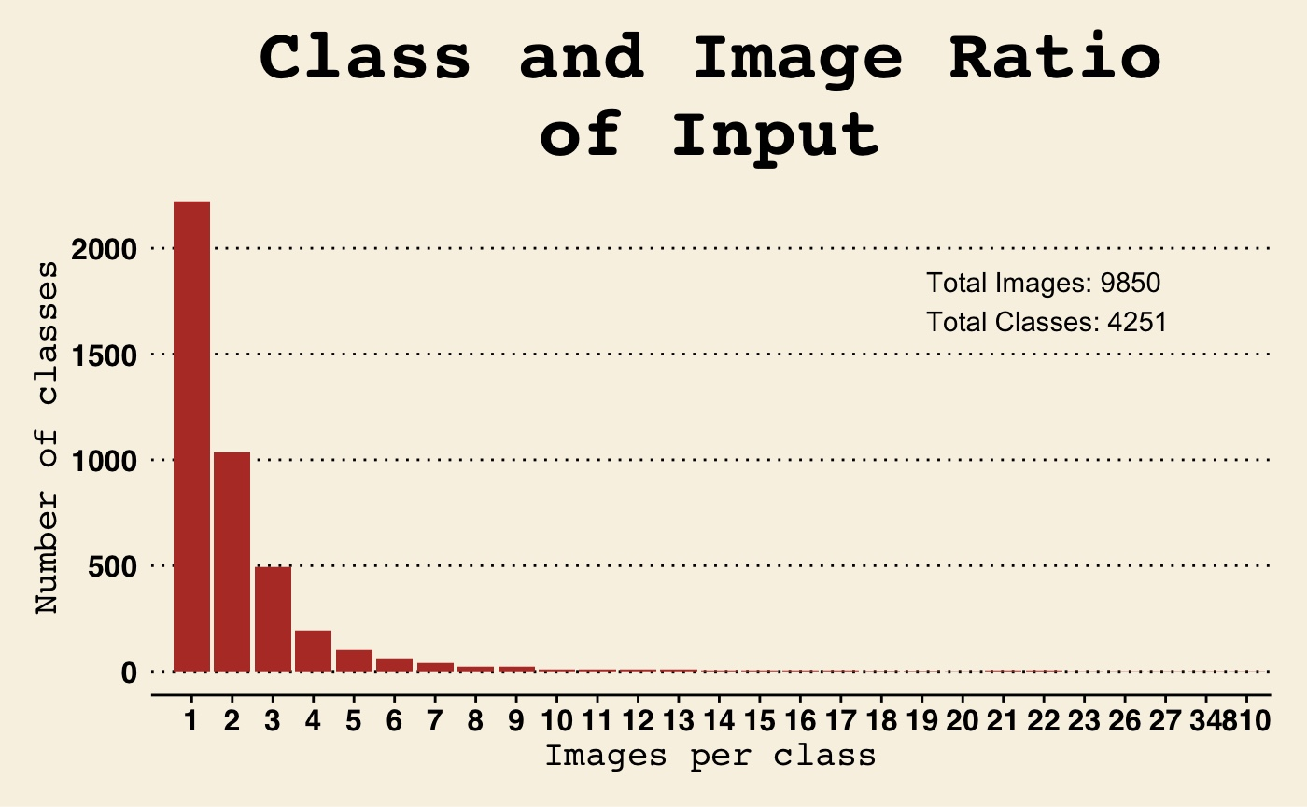

**Figure 6** Number of classes at each image level for the original input training image set. Depicts the lowest and most common group of classes with one image per class.

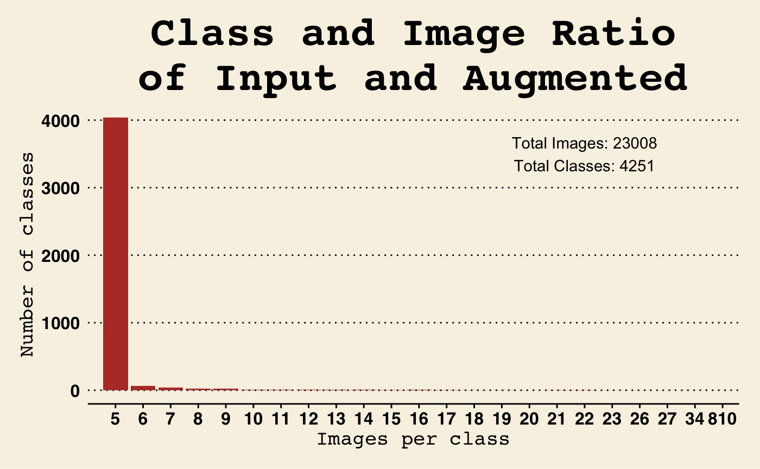

**Figure 7** Number of classes at each image level for the original input training image set combined with one augmented set. Depicts the new lowest and most common group with five images per class.

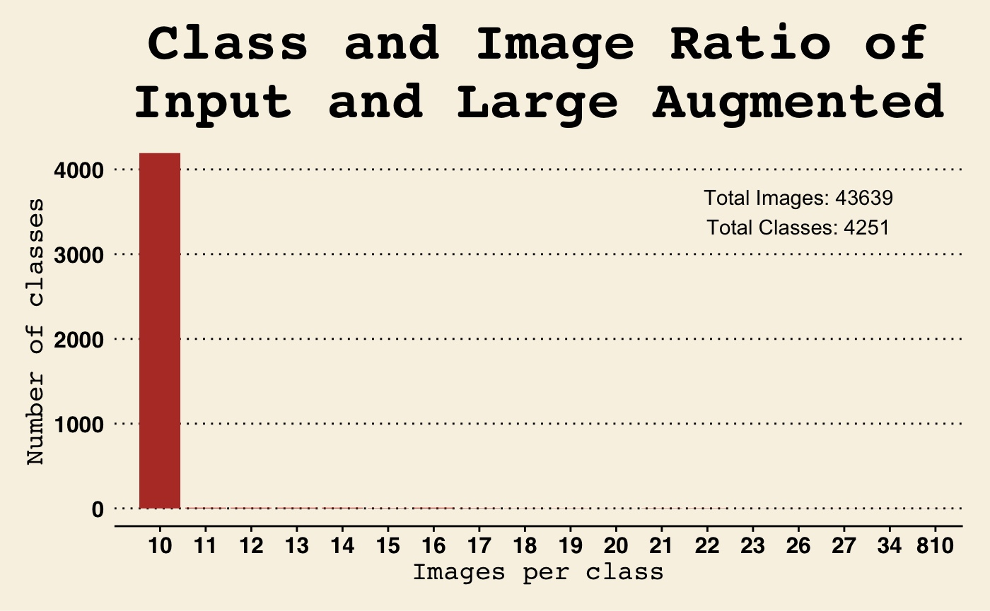

**Figure 8** Number of classes at each image level for the original input training image set combined with the largest augmented set. Depicts the new lowest and most common group with ten images per class.

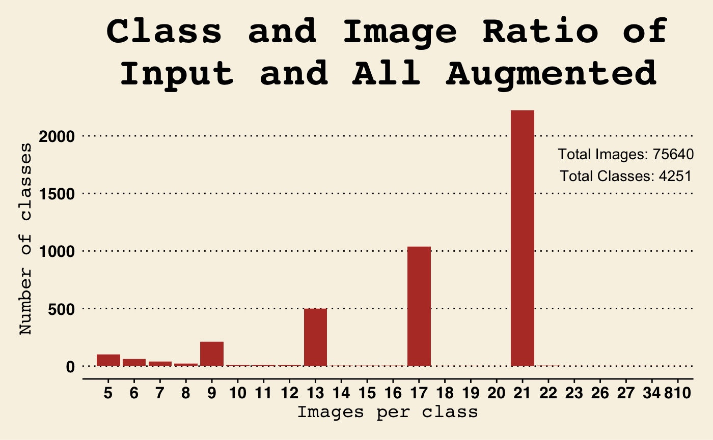

**Figure 9** Number of classes at each image level for the original input training image set combined with all augmented sets. Depicts the new lowest and most common group with five images per class. Also depicts the largest total image count of all training sets.

Description:

The greatest weakness of the predictive models we are creating is the lack of images of whales in the provided training set. In order to compensate, we developed several scripts that take a single image and augment it using several techniques to effectively generate several images that can be used to train a model. We found five random techniques to be most effective: zoom, sheering, rotation, greyscale, and a combination of the previous techniques. The original input training set contained 9850 images comprised of 4251 classes and our augmentation techniques produced many sets bringing the total number of images used to train our models to 75,640.

The large majority of classes have just one image included in the original input data that can be used in training the model. Our augmentation techniques were also aimed to increase the number of images representing each whale class. In the smallest augmentation set the minimum group has five images per class. We also created a set of training images that has at minimum ten images per class. As the examples for each class increase the model will be able to more accurately classify new whale images into these previously underrepresented classes.

|  |  |  |  |
| --- | --- | --- | --- |
| **Task** | **Overall time** | **Josh** | **Spencer** |
| Write script to create augmented images and labels | 10 hrs | 100% | 0 |
| Write script to prepare data for model | 5 hrs | 80% | 20% |
| Write script to create and train model | 6 hrs | 20% | 80% |
| Write script to create predictions | 4 hrs | 0 | 100% |
| Create image and class ratio charts | 4 hrs | 100% | 0 |
| Create example for all types of image augmentation | 2 hrs | 100% | 0 |
| Create flow chart | 2 hrs | 0 | 100% |
| Write Captions | 1 hr | 100 | 0 |
| Prepare environment on super computer | 1 hr | 50% | 50% |
| Write this sheet | 7 min | 80% | 20% |
| Prepare Milestone Report | 1 hr | 100% | 0 |