**1. [5 points] Trees.** Read the assigned chapter and notes for Week 5 located in the Learning Activities area in Blackboard. Then answer the following questions:

**. (a)**[3 points] Draw a binary tree that produces the inorder traversal for the nodes in the following order: 19, 24, 39, 77, 11, 76, 84, 71, 29, 34, 53, 36, 22.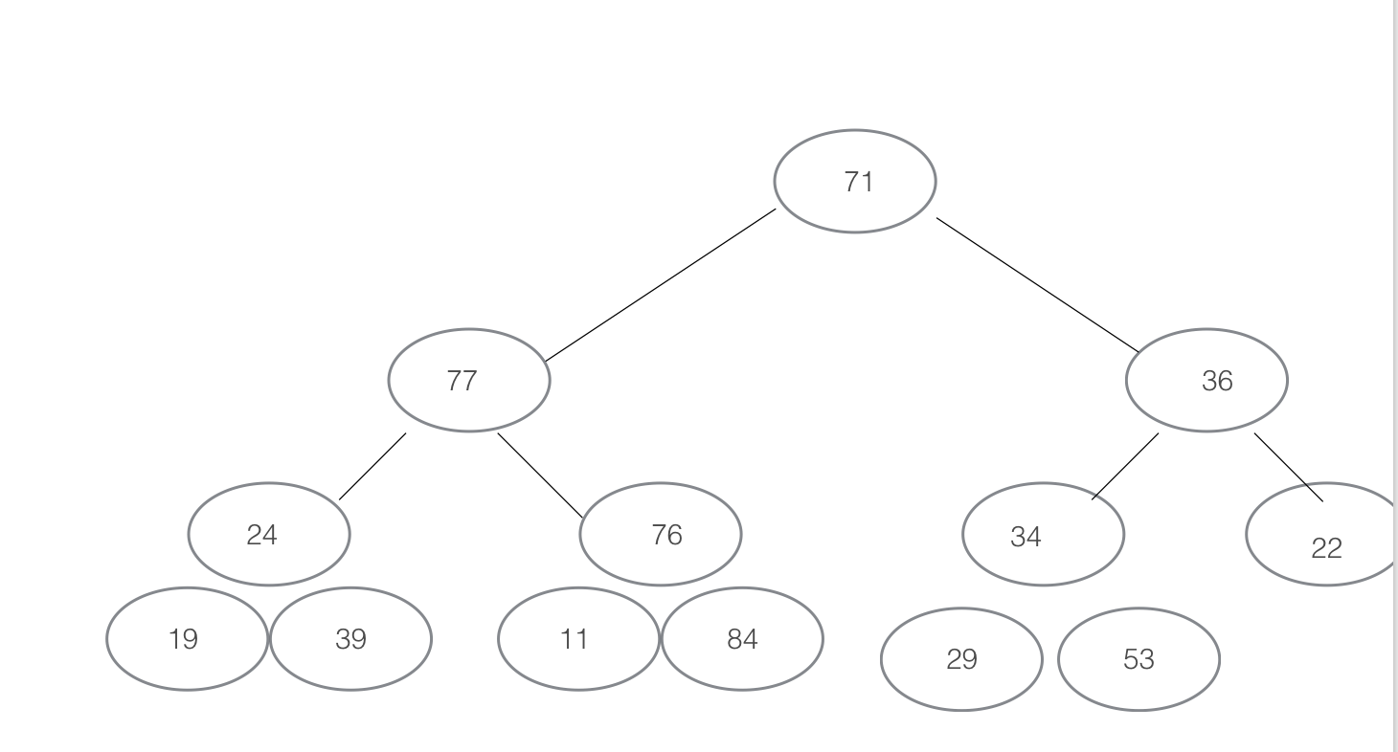

**. (b)**[2 points] Briefly explain the advantages of a binary tree in comparison to a linked list.

*A binary tree, if built properly, can reduce the amount of comparisons needed while searching for a number. On average cases, insert and delete also only take O(log n)n*

**2. [5 points] Hashing.** Read the assigned chapter and notes for Week 6 located in the Learning

Activities area in Blackboard. Then provide solutions to the following problems:

**. (a)**[2 points] Briefly explain the purpose of quadratic probing and provide an example of a mathematical function used to implement it. Also, briefly explain the problem associated with quadratic probing in terms of the number of items within the hash table.

*Quadratic probing is needed in order to resolve collisions. For example, the equation*

*is used to traverse through a hash table checking for an available space. As the hash table’s capacity decreases, the performance of its quadratic probing equation decreases also.*

**. (b)**[3 points] Perform an Internet search and briefly discuss in a few paragraphs a computer related algorithm based on hashing. Provide an example with a diagram or table to help illustrate how the algorithm works. List your sources at the end of your paragraphs using APA format.

**Other Notes:** Submit your solutions using the Problem Set 3 link provided in the Assignments area. As usual, please do not hesitate to ask questions in the *Ask the Instructor* forum or via e-mail.