GEOG 4/581: Test 1 (April 24) Name ___________________

I. Match each term (letters) with its definition (numbers). [3 points]
A. datum B. geographic coordinate system
C. geoid D. map projection
E. raster F. vector

____ 1. A model of the true shape of the earth.
____ 2. The position of a model of the earth relative to the center of the earth.
____ 3. A transformation which converts locations on a three-dimensional surface into locations on a two-dimensional flat surface or plane, providing a frame of reference in the new coordinate space.
____ 4. A data model that represents discrete objects as individual spatial representations with any number of related attributes.
____ 5. A data model that divides the covered extent with a regular grid, and stores a single attribute value in each grid cell.
____ 6. The use of angular measures from the Earth’s center to determine locations on a three-dimensional spherical surface.

II. Fill in the blanks. [6 points]

7. The lines of __________________ trace great circles around the Earth and pass through the north and south poles. Their values range from ________ to ________ .

8. The lines of __________________ trace non-intersecting circles that represent and angular measure from the Earth’s center of gravity between the north and south poles. Their values range from ________ to ________ .

9. Applying or tagging data object with a spatial location is known as ____________________ . Two examples of this type of tagging are ____________________________ and ___________________________ .

III. Attributes [8 points].

ObjectID* | rainfall | type | temp
0 | 45.2 | deciduous | 89.7
1 | 12.8 | coniferous | 53.4
2 | 20.0 | deciduous | 72.3
3 | 52.7 | deciduous | 101.5
4 | 19.3 | coniferous | 91.6
5 | 32.6 | coniferous | 75.1
6 | null | deciduous | 90.0
7 | 31.9 | coniferous | 100.2
8 | 5.7 | deciduous | 53.0
9 | 63.2 | deciduous | 97.3

11. Which rows in the table above satisfy the criteria specified in the following SQL query?
(‘‘rainfall’’ < 20 OR ‘‘temp’’ > 90) AND ‘‘type’’ = ‘deciduous’

List the object IDs: _____________________________________________________ [2 points]

12. For each field in the table, identify both the attribute type and the measurement scale of the values. [2 points]
ObjectID ________________________________ rainfall _____________________________
Type ___________________________________ temp _______________________________

13. Object ID = 6 has a `null` for its rainfall value. What does this mean? [2 points]

14. Shapefiles do not allow null-values. Suggest a possible stand-in value to indicate to the data user the same meaning as a null-value would. Consider the attribute data type and the possible values of the real-world property itself. [2 points]
IV. Match each projection type (letters) with property of minimized distortion. [3 points]
A. compromise B. conformal
C. equal area D. equidistant
E. gnomonic F. retroazimuthal

____ 13. Angles, or the general shape of objects.
____ 14. Direction from a fixed location.
____ 15. None: converts great circles to straight lines.
____ 16. Distance from a fixed point or line.
____ 17. No one property - attempts a chosen balance between distortions.
____ 18. Area.

V. Provide a brief response (2-3 complete sentences) to each of the prompts below. [10 points]

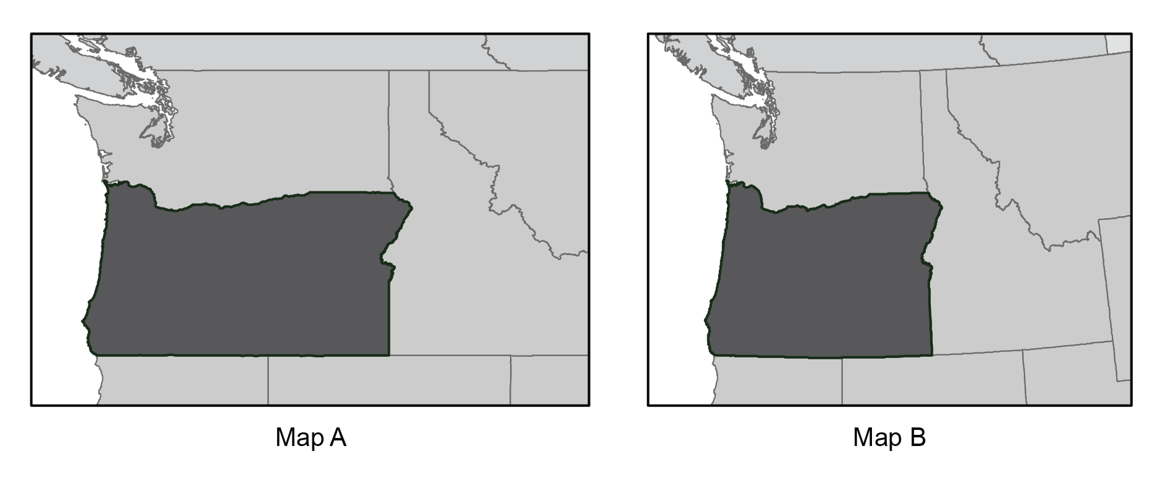
19. On the maps above, which has the more suitable projection for a map of the state of Oregon? Provide a brief justification for your choice. [2 points]

20. Give an argument for representing cities as vector points, and a counter-argument
against representing cities as vector points. [2 points]

21. Imagine that you have downloaded data for a single geographic area from two sources. When you plot the two data sets, things don’t quite line up. Give two potential reasons for the misalignment. [2 points]

23. Reflect on your own academic and/or mapping interests in the context of your upcoming final project: [4 points]
- What is a (potential) topic or phenomenon of interest?
- Where is there an instance of this topic or phenomenon?
- What data layers could provide context (e.g. political boundaries or physical landscape) or evidence of that topic or phenomenon (e.g., measured observable events, physical entities)?

