GEOG 4/581: Test 1 (April 24) Rubric

I. Match each term (letters) with its definition (numbers). [3 points]
A. datum B. geographic coordinate system
C. geoid D. map projection
E. raster F. vector

_C__ 1. A model of the true shape of the earth.
_A__ 2. The position of a model of the earth relative to the center of the earth.
_D__ 3. A transformation which converts locations on a three-dimensional surface into locations on a two-dimensional flat surface or plane, providing a frame of reference in the new coordinate space.
_F__ 4. A data model that represents discrete objects as individual spatial representations with any number of related attributes.
_E__ 5. A data model that divides the covered extent with a regular grid, and stores a single attribute value in each grid cell.
_B__ 6. The use of angular measures from the Earth’s center to determine locations on a three-dimensional spherical surface.

II. Fill in the blanks. [6 points]

7. The lines of ____longitude_____ trace great circles around the Earth and pass through the north and south poles. Their values range from ___0____ to __180___ . (-180 to 180 is also fair)

8. The lines of ____latitude______ trace non-intersecting circles that represent and angular measure from the Earth’s center of gravity between the north and south poles. Their values range from ___0____ to ___90___ . (-90 to 90 is also fair)

9. Applying or tagging data object with a spatial location is known as __georeferencing_____ . Two examples of this type of tagging are (check lecture 3 slide 7 for examples; if they came up with something else and it’s valid, that’s great) .

III. Attributes [8 points].

ObjectID* | rainfall | type | temp
0 | 45.2 | deciduous | 89.7
1 | 12.8 | coniferous | 53.4
2 | 20.0 | deciduous | 72.3
3 | 52.7 | deciduous | 101.5
4 | 19.3 | coniferous | 91.6
5 | 32.6 | coniferous | 75.1
6 | null | deciduous | 90.0
7 | 31.9 | coniferous | 100.2
8 | 5.7 | deciduous | 53.0
9 | 63.2 | deciduous | 97.3

11. Which rows in the table above satisfy the criteria specified in the following SQL query?
(‘‘rainfall’’ < 20 OR ‘‘temp’’ > 90) AND ‘‘type’’ = ‘deciduous’
List the object IDs: ____3, 8, 9 (2 & 6 only with <=/>=)_____________________ [2 points]

12. For each field in the table, identify both the attribute type (a) and the measurement scale (b) of the values. [2 points]
ObjectID ___a:numeric/integer; b:nominal_____ rainfall a: numeric/floating point; b: ratio
type ____a: text; b: nominal__________________ temp a: numeric/floating point; b: interval
Note: ‘attribute type’ seems to have thrown folks with how generic the term is; feel free to grade easy.
13. Object ID = 6 has a `null` for its rainfall value. What does this mean? [2 points]
(comment to the effect that there is no value recorded for that feature’s rainfall)
14. Shapefiles do not allow null-values. Suggest a possible stand-in value to indicate to the data user the same meaning as a null-value would. Consider the attribute data type and the possible values of the real-world property itself. [2 points]
(one of any values that match the data type and would be unusual or unlikely for the attribute)
IV. Match each projection type (letters) with property of minimized distortion. [3 points]
A. compromise B. conformal
C. equal area D. equidistant
E. gnomonic F. retroazimuthal

_B__ 13. Angles, or the general shape of objects.
_F__ 14. Direction from a fixed location.
_E__ 15. None: converts great circles to straight lines.
_D__ 16. Distance from a fixed point or line.
_A__ 17. No one property - attempts a chosen balance between distortions.
_C__ 18. Area.

V. Provide a brief response (2-3 complete sentences) to each of the prompts below. [10 points]

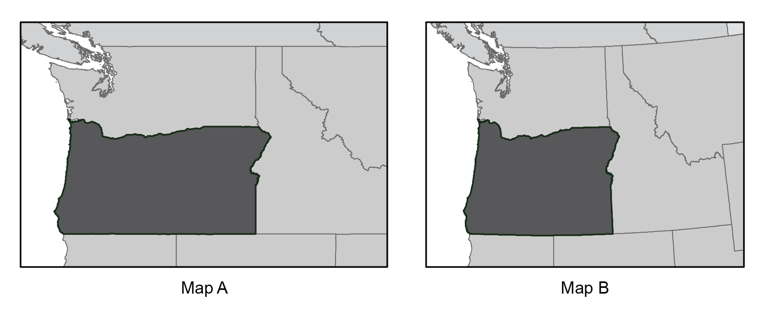
19. On the maps above, which has the more suitable projection for a map of the state of Oregon? Provide a brief justification for your choice. [2 points]

(comments to the effect of minimizing distortion in the area of Oregon, especially shape, distance, or area)

20. Give an argument for representing cities as vector points, and a counter-argument
against representing cities as vector points. [2 points]
(for points: something about scale needs, or a single fixed location for analysis)
(against points: arguments could include needing area from polygon; boundary needs for analysis or visualization, need raster representation for raster analysis; etc.)

21. Imagine that you have downloaded data for a single geographic area from two sources. When you plot the two data sets, things don’t quite line up. Give two potential reasons for the misalignment. [2 points]
Examples:different scales/quality for the datasets or their source material; different projected coordinate systems (transformation issues); etc.

23. Reflect on your own academic and/or mapping interests in the context of your upcoming final project: [4 points]
- What is a (potential) topic or phenomenon of interest?
- Where is there an instance of this topic or phenomenon?
- What data layers could provide context (e.g. political boundaries or physical landscape) or evidence of that topic or phenomenon (e.g., measured observable events, physical entities)?
I want students to get full points for engaging with this question thoughtfully, even if they were somewhat stumped. This was a stealth first attempt to get them to articulate possible project ideas, which will lead them into the worksheet they will bring to class Week 7. Feel free to give them encouraging or helpful comments here, though: I plan on returning these tests to them so they have their starting point.

