GEOG 4/581: Test 2 (May 24) Name ___________________

I. Matching. [4 points]
Label each figure (numbered) below with the spatial analysis function (lettered) that it represents from the following four options (a function may be represented more than once):
A. spatial selection/select by location B. buffer
C. contour D. definition query

1. ______ 2. ______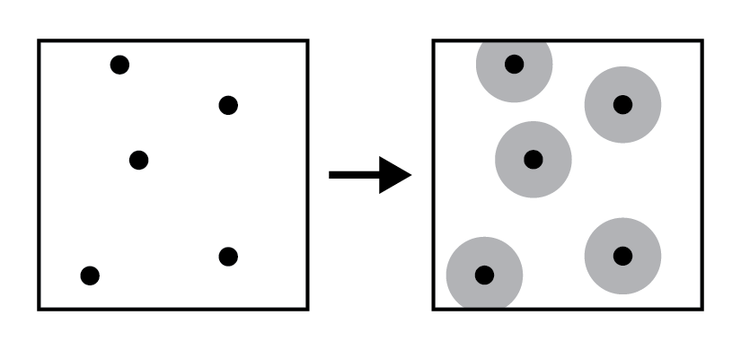 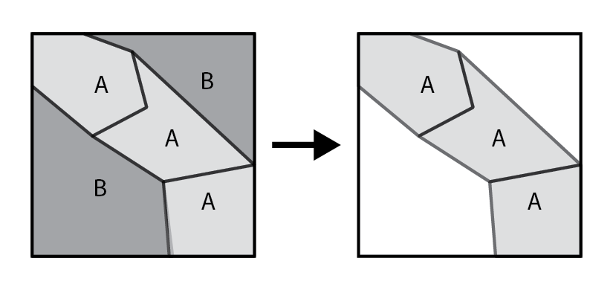
3. ______ 4. ______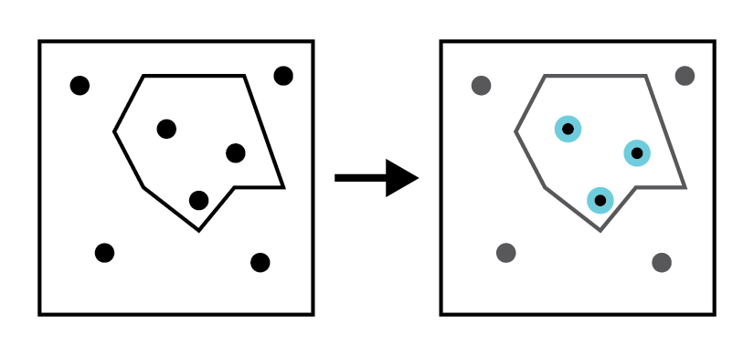 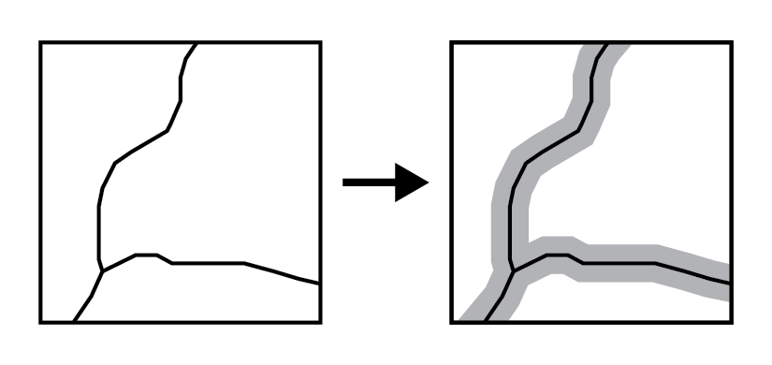
5. ______ 6. ______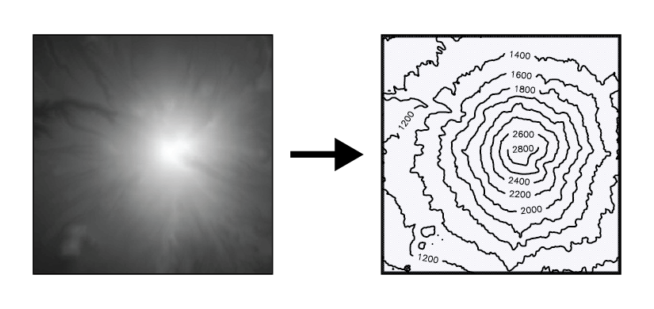 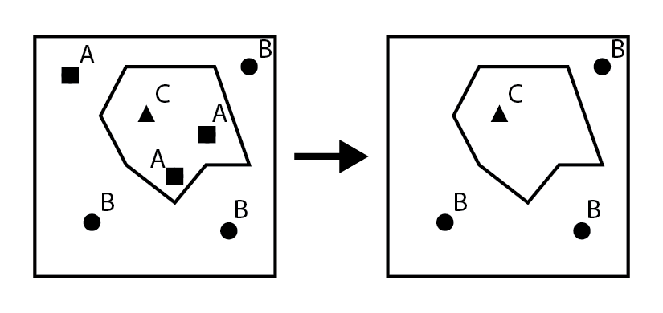
7. ______ 8. ______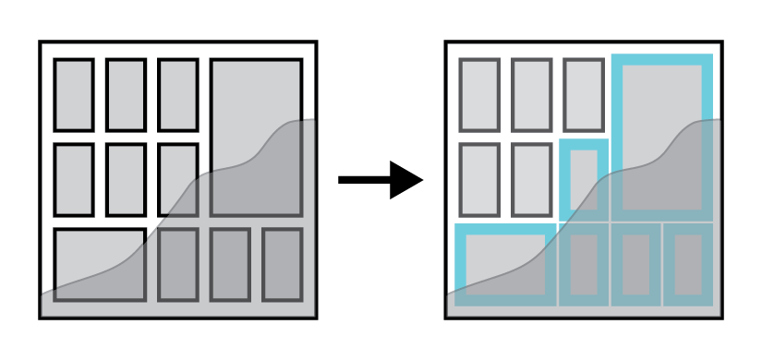 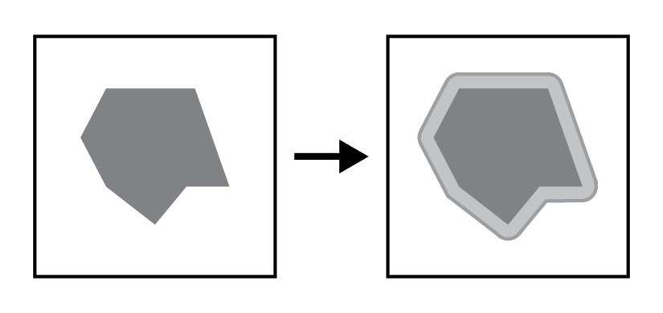

II. Match each term (letters) with its definition (numbers). [3 points]

A. isopleth B. dynamic
C. equal interval D. secondary data capture
E. graduated symbols F. natural breaks

____ 9. Map symbolization where the size of the symbol represents increase & decrease in the values of a quantitative attribute divided into a set number of groups or classes.
____ 10. A model type that loops through multiple iterations of the stages, with system parameters changing between iterations.
____ 11. Data collection where data captured for a different purpose is converted to a GIS data model, such as when digitizing vector features from a scanned map or aerial photo.
____ 12. Map symbolization where both the area polygons and the shading/color scheme of the area represent the data values.
____ 13. A classification method that divides the range of attribute values into equal-sized classes.
____ 14. A classification method that minimizes in-class variation while maximizing between-class variation, organizing classes around distinct clusters.

II. Fill in the blanks. [6 points]

15. Two visual variables for cartographic symbolization that suggest qualitative differences in attribute values are __________________ and __________________ . [2 points]

16. Two visual variable for cartographic symbolization that suggest quantitative differences are __________________ and __________________ . [2 points]

17. Connecting two attribute tables together using a common ‘key’ attribute value is called a __________________ . When this connection matches multiple features or rows to the same row via non-unique keys, this is called a __________________-to-one relationship. [2 points]

III. Map Design. [8 points]

18. Label each of the numbered elements in the example map layout below. [4 points]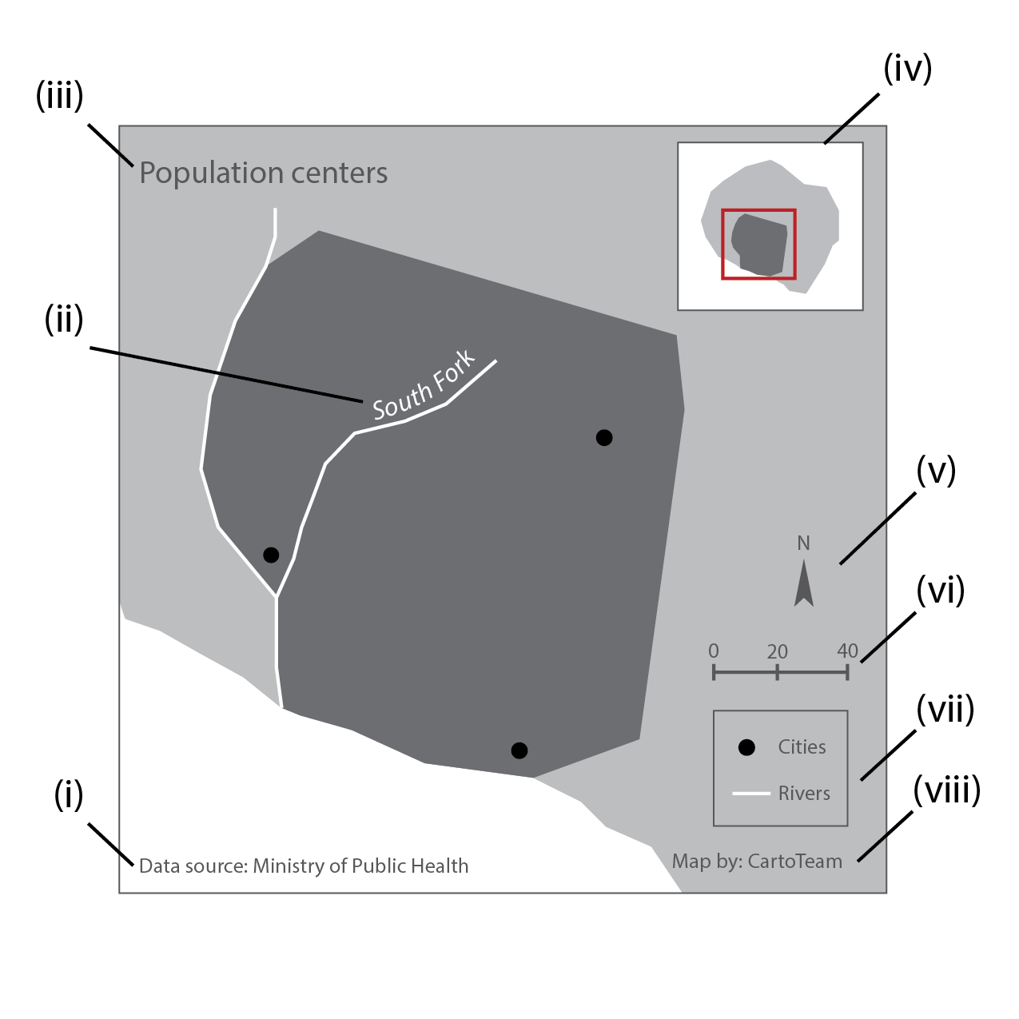
(i) _____________________________ (ii) _____________________________

(iii) _____________________________ (iv) _____________________________

(v) _____________________________ (vi) _____________________________

(vii) _____________________________ (viii) _____________________________

19. Based only on the cartographic design of the two maps below, circle the descriptors that best characterize the map. Select all that apply. [4 points]
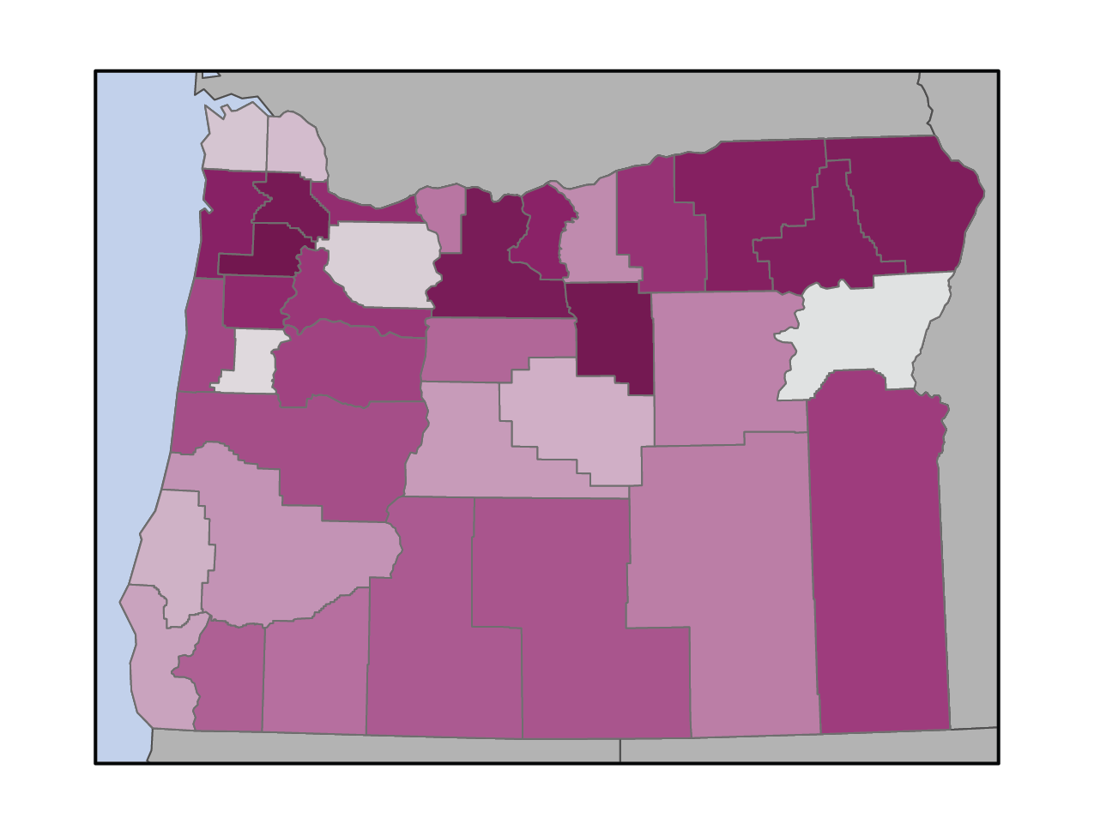

qualitative quantitative

single theme nominal

multivariate sequential

choropleth divergent

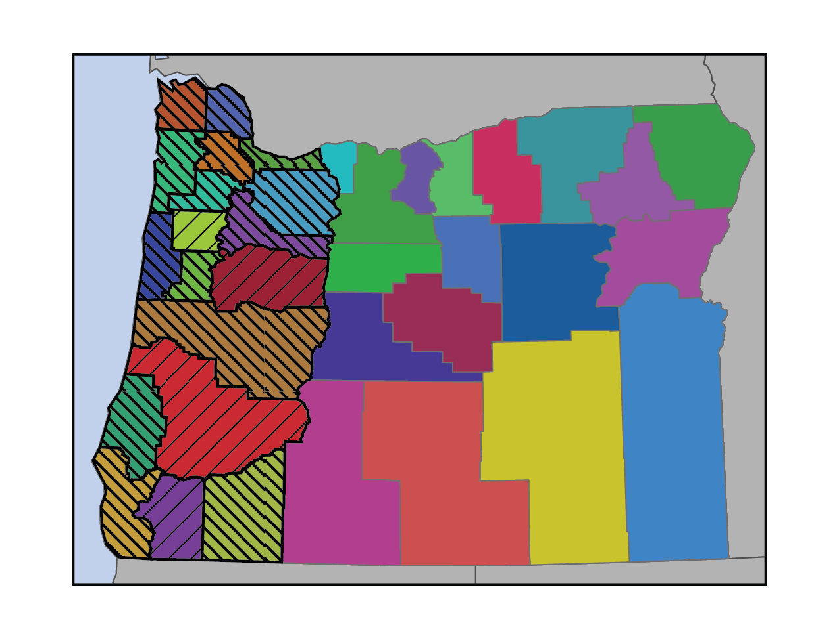

qualitative quantitative

single theme nominal

multivariate sequential

choropleth divergent

IV. Provide a brief response (1-3 complete sentences) to each of the questions below. [9 points]

20. Arthur Robinson conceived of seven controlling factors affecting map design: purpose, reality, available data, map scale, audience, conditions of use, and technical limits. Choose two factors and give a short explanation or example of how they affect map design. [4 points]

22. Give two examples of methods for primary data capture. [2 points]

23. Give two examples of possible places to find GIS data for your use (you can be specific or generic). In order to determine whether it fits your needs, what is one thing you can do to evaluate the dataset(s) you find? [3 points]

