GEOG 4/581: Test 2 (May 24) Rubric

I. Matching. [4 points]
Label each figure (numbered) below with the spatial analysis function (lettered) that it represents from the following four options (a function may be represented more than once):
A. spatial selection/select by location B. buffer
C. contour D. definition query

1. __B___ 2. __D___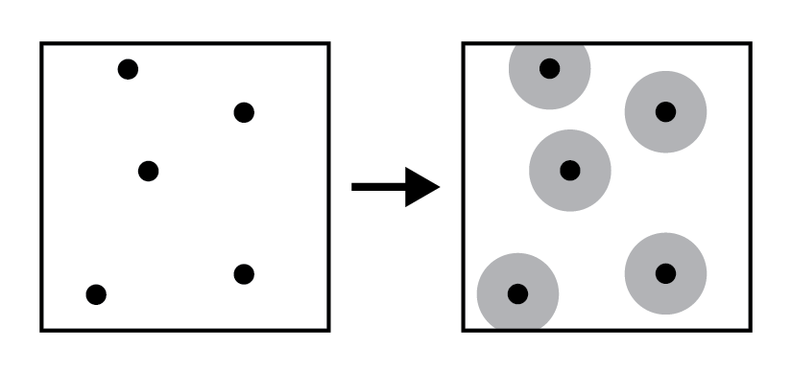 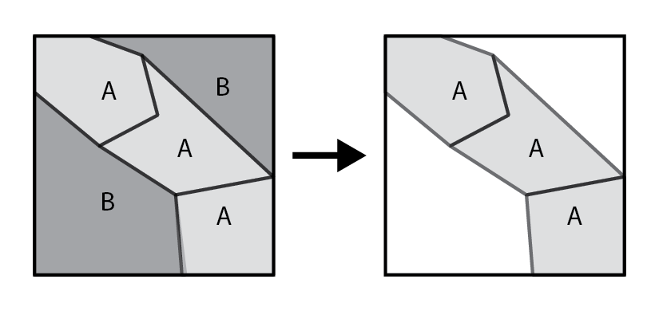
3. __A___ 4. __B___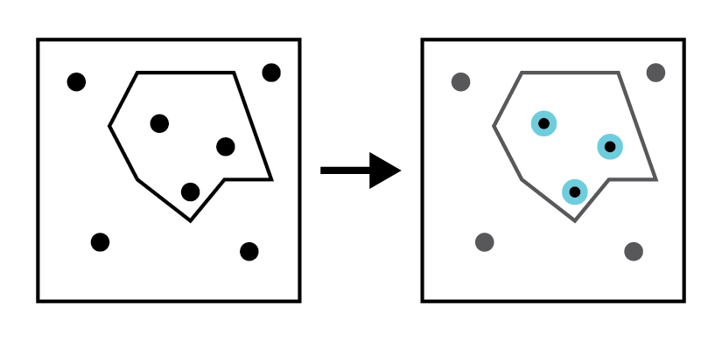 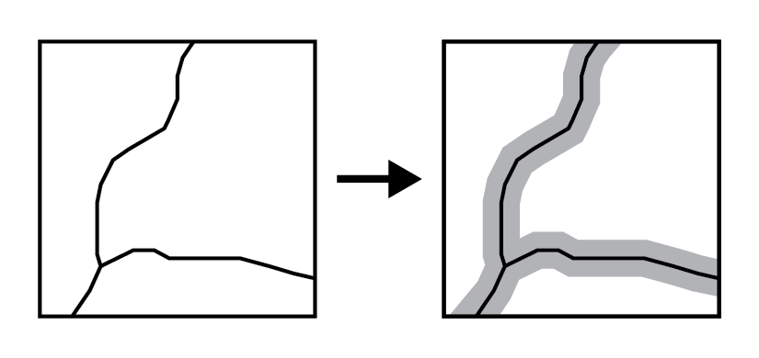
5. __C___ 6. __D___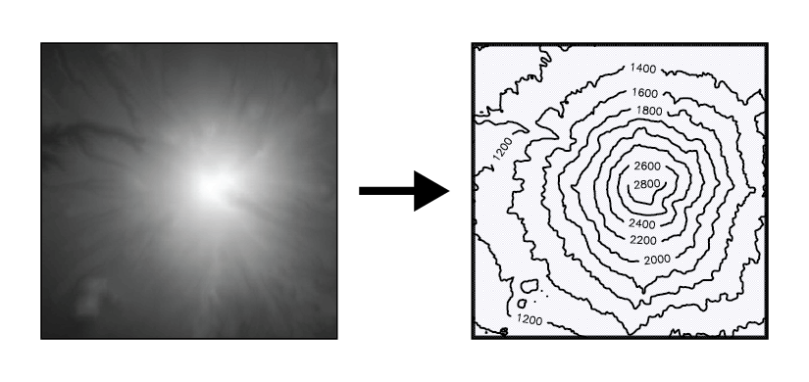 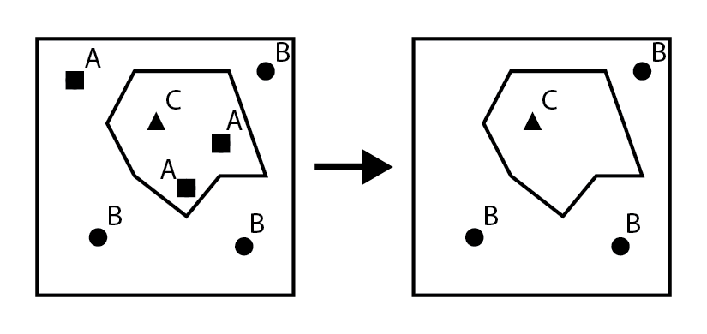
7. __A___ 8. __B___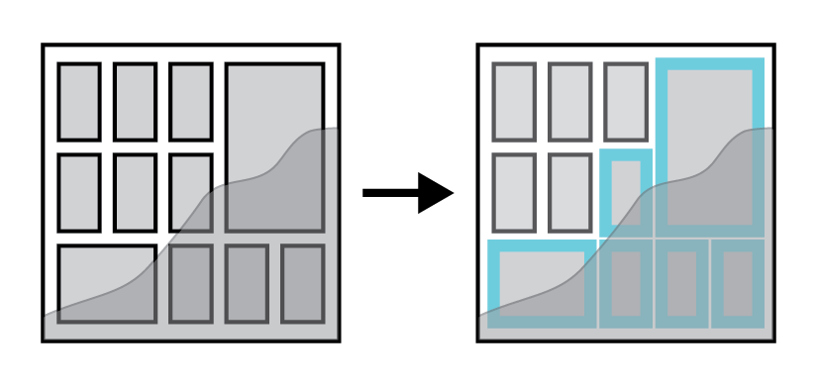 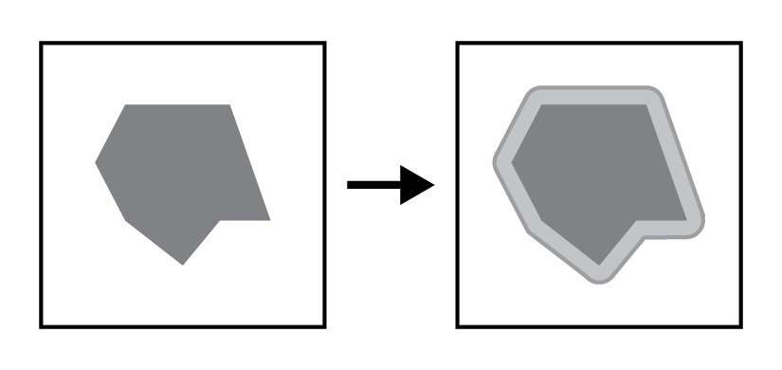

II. Match each term (letters) with its definition (numbers). [3 points]

A. isopleth B. dynamic
C. equal interval D. secondary data capture
E. graduated symbols F. natural breaks

_E__ 9. Map symbolization where the size of the symbol represents increase & decrease in the values of a quantitative attribute divided into a set number of groups or classes.
_B__ 10. A model type that loops through multiple iterations of the stages, with system parameters changing between iterations.
_D__ 11. Data collection where data captured for a different purpose is converted to a GIS data model, such as when digitizing vector features from a scanned map or aerial photo.
_A__ 12. Map symbolization where both the area polygons and the shading/color scheme of the area represent the data values.
_C__ 13. A classification method that divides the range of attribute values into equal-sized classes.
_F__ 14. A classification method that minimizes in-class variation while maximizing between-class variation, organizing classes around distinct clusters.

II. Fill in the blanks. [6 points]

15. Two visual variables for cartographic symbolization that suggest qualitative differences in attribute values are __________________ and __________________ . [2 points]
Any of: color/hue, orientation, shape, arrangement, texture/pattern
16. Two visual variable for cartographic symbolization that suggest quantitative differences are __________________ and __________________ . [2 points]
Any of: size/weight/stroke, color value/shade, color saturation/vividness/intensity/grayness, arrangement, texture/pattern
17. Connecting two attribute tables together using a common ‘key’ attribute value is called a ______join________ . When this connection matches multiple features or rows to the same row via non-unique keys, this is called a _______many_______-to-one relationship. [2 points]

III. Map Design. [8 points]

18. Label each of the numbered elements in the example map layout below. [4 points]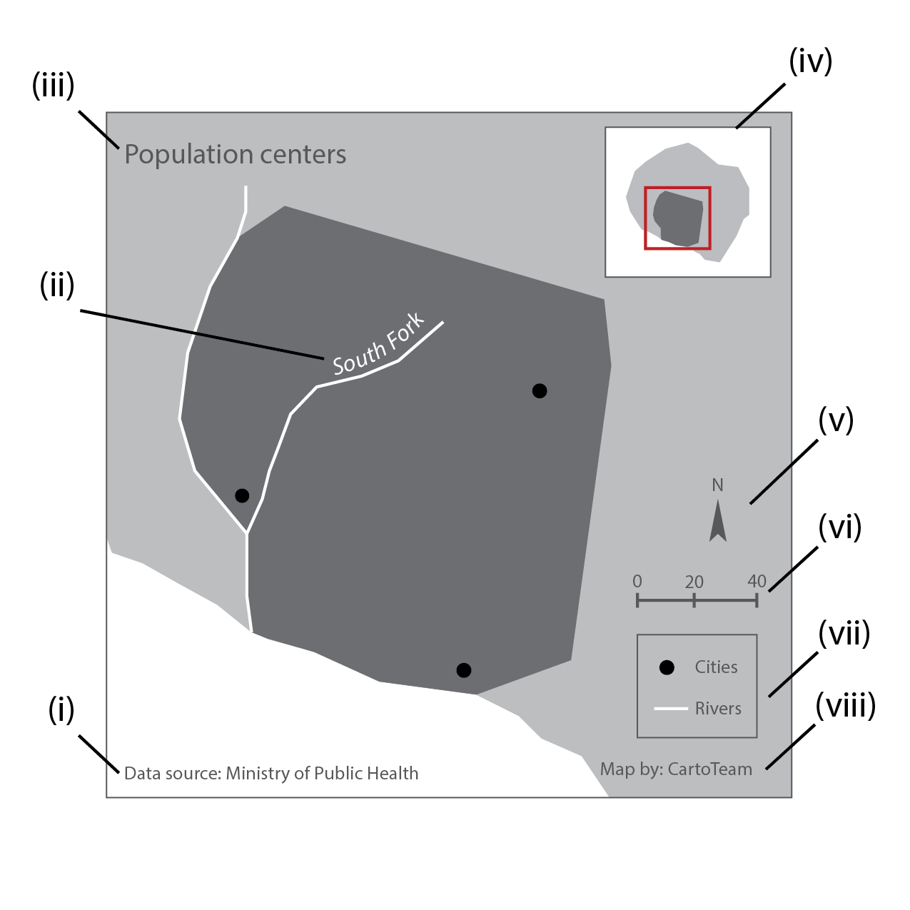
(i) __data source (map metadata OK) (ii) __map body (will accept label too)

(iii) __title (iv) __inset map or context map

(v) _north arrow or direction indicator (vi) __scale bar

(vii) __legend or key (viii) __author (map metadata OK)

19. Based only on the cartographic design of the two maps below, circle the descriptors that best characterize the map. Select all that apply. [4 points]
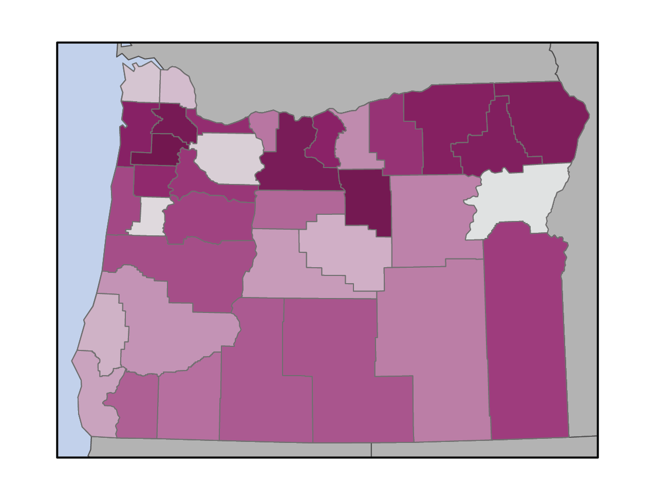

qualitative quantitative

single theme nominal

multivariate sequential

choropleth divergent

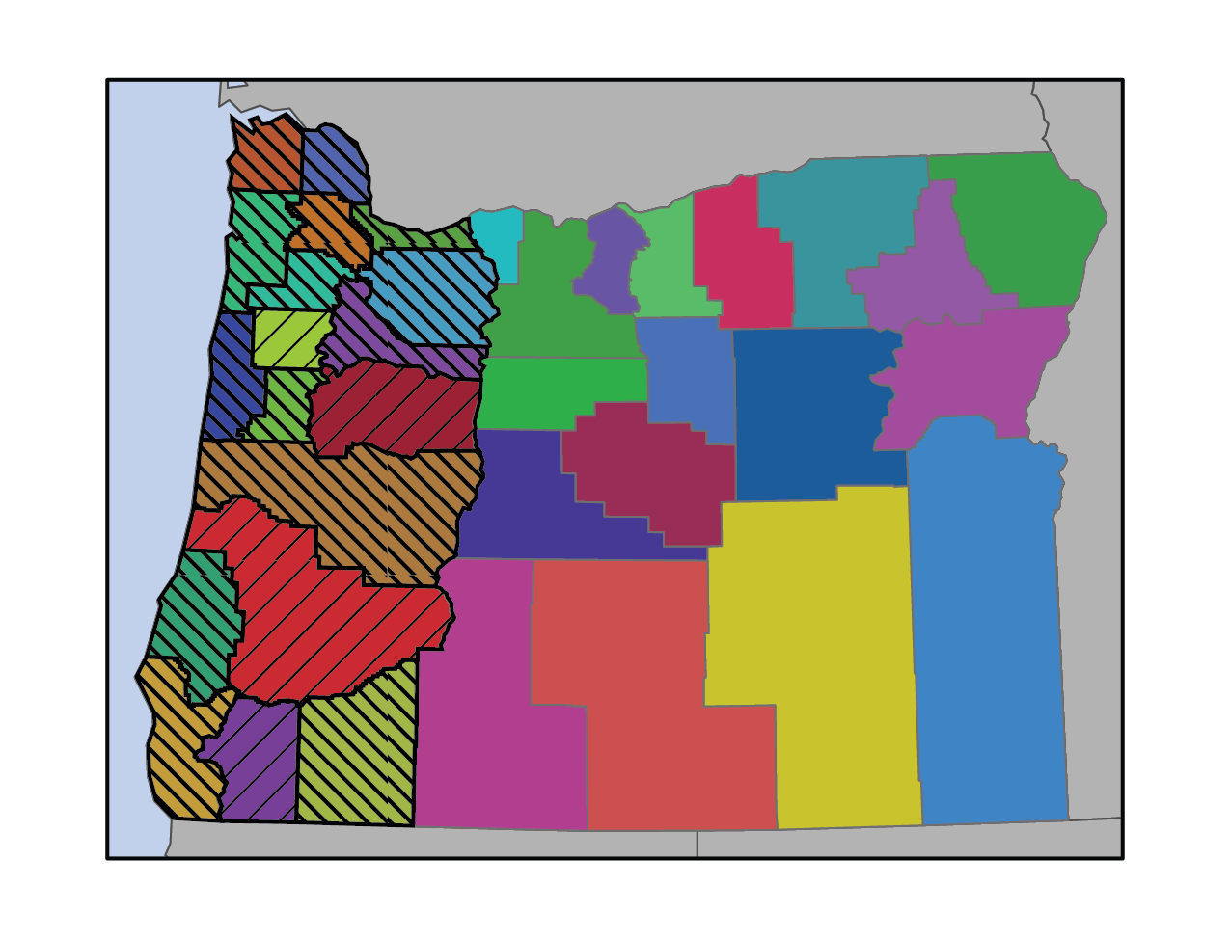

qualitative quantitative

single theme nominal

multivariate sequential

choropleth divergent

If they circle the red words, full points. If the circle the purple words, give them an extra half-point.

IV. Provide a brief response (1-3 complete sentences) to each of the questions below. [9 points]

20. Arthur Robinson conceived of seven controlling factors affecting map design: purpose, reality, available data, map scale, audience, conditions of use, and technical limits. Choose two factors and give a short explanation or example of how they affect map design. [4 points]

Any two of: purpose, reality, available data, map scale, audience, conditions of use, technical limits.
Use your discretion whether they sufficiently explain or show example; refer to Lecture 10 Slide 15.

22. Give two examples of methods for primary data capture. [2 points]

Use your discretion whether their examples are primary data capture methods. Refer to Lecture 12 Slides 4-8.

23. Give two examples of possible places to find GIS data for your use (you can be specific or generic). In order to determine whether it fits your needs, what is one thing you can do to evaluate the dataset(s) you find? [3 points]

Use your discretion whether their examples are clear and make sense.For generic examples, refer to Lecture 12 Slide 14.
Refer to Lecture 12 Slide 15 for evaluating data.

