This was just moving the cursor around using hjkl

Lesson 1.2: Exiting VIM

This was exiting vim using the :q! command which does not save any changes

This was deleting characters using the ‘x’ deletion command

Lesson 1.4: Text Editing – Insertion

Used ‘I’ to insert text, inserting is just typing into the file

Using ‘A’ to append which starts adding text at the end of the line

Editing a file, used :wq to save any changes made to the file

No change needed

Lesson 2.1: Deletion Commands

Using dw to delete an entire word

Used d$ to delete an entire line

Lesson 2.3: On operators and Motions

No changes made, showed how different operators affect the delete operator

Using numbers to alter how much an operator’s action takes place

Lesson 2.5: Using a count to delete More

Used d2w to delete two words at a time

using dd to delete whole lines

Lesson 2.7: The Undo Command

Used x to delete characters, then u to undo the last command, U to undo changes made to a whole line, and ctrl r to redo

No changes needed

Using p to insert deleted text

Lesson 3.2: the Replace Command

Using r to replace any character under the cursor

Used ce to change a word until the end of it

Using ‘c’ to change until the end of the line

Lesson 3: Summary

No change

Ctrl G gives location in file and its status, G moved me to the bottom of the file while gg moved me to the start, used 502g to move me back to where I was (I was at line 502)

Lesson 4.2: The Search Command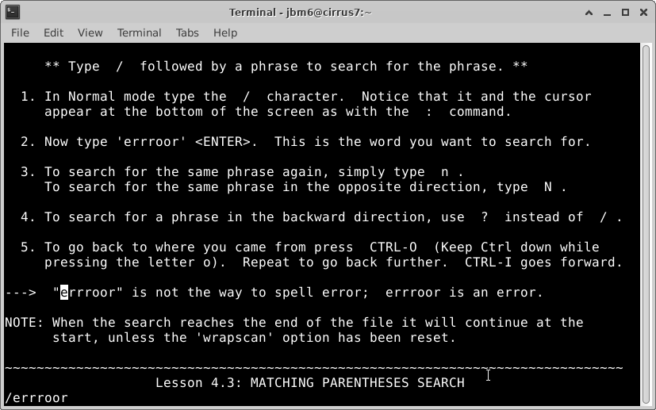

Used the /search to find words that match what I am searching

Used % to find any matching parenthesis

Lesson 4.4: The substitute Command

Used :s/thee/the/g to change all “thee” to “the”

Lesson 4: Summary

No change

Lesson 5.1: How to Execute an External Command

Used :! To run external commands

Creating a new file using :w TEST

Lesson 5.3: Selecting Text to Write

Saving part of a file in visual mode using v and then :w TEST

Copied lesson 5.3 and inserted it using :r TEST

Lesson 5: Summary

No changes   
Lesson 6.1: The Open Command

Using o and O to open a line above and below a targeted line

Lesson 6.2: the Append Command

Used ‘a’ to add text after the cursor

Lesson 6.3: Another Way to Replace

Used ‘R’ to replace multiple characters

Lesson 6.4: Copy and Paste Text

Used v and y to yank highlighted text, then used p to put the text where I wanted

Showed how to refine the search, can use :set ic to ignore capitalization

Lesson 6: Summary

No change

Lesson 7.1: Getting Help

Shows vim help using the :help command

Lesson 7.2: Create a Startup Script

This enabled extra features in vim such as syntax highlighting

Lesson 7.3 Completion

Used ctrl + d to show what commands are available based on what has already been typed, and finished it with tab

No change