
Obserra EU CRA Governance

Admin & Operator Guide
EU Cyber Resilience Act (Regulation (EU) 2024/2847) product governance
August 2026 · Confidential — prepared for internal use.

Contents
1. About Obserra EU CRA Governance
2. Installing the App (One-Click PWA)
3. On-Premise Installation (Docker)
4. Signing In
5. Going Live — Production Setup Checklist
6. Executive Overview
7. Cyber Crisis Commander
8. Agent Inventory
9. Tool Toxicity Map
10. Guardrails & Red Team
11. Shadow AI Discovery
12. Kill Switch & Runtime Enforcement
13. AI Incidents & Workflows
14. Defensibility & Evidence
15. Board Brief Scheduler
16. Settings, Branding & Deployment
17. Obserrian Advisor
18. Support

1. About Obserra EU CRA Governance
Obserra EU CRA Governance helps manufacturers, importers and distributors bring products with digital elements into conformity with the EU Cyber Resilience Act (Regulation (EU) 2024/2847). It gives compliance, security and executive teams a single live view of product classification, regulation-mapped readiness, SBOMs, Article 14 vulnerability reporting clocks, notified-body sign-off and CE Declaration of Conformity.
Every fact is computed LIVE from the underlying product records (No-Mock): proposed Class I / Class II / Critical classification, conformity pathway, assessment scores and market-readiness gates are all derived from real records. Every regulatory action is written to a tamper-evident, hash-chained Internal Regulatory Ledger so the compliance timeline is audit-defensible, and secure vendor / notified-body portals never expose that private ledger.

2. Installing the App (One-Click PWA)
Obserra installs like a native app straight from the browser — no app store required — and works across desktop, tablet and mobile.
Desktop (Chrome / Edge): click the Install icon in the address bar, or use the in-app 'Install' banner. Android (Chrome): tap the 'Install' banner or menu -> Add to Home screen. iPhone / iPad (Safari): tap Share -> Add to Home Screen.
Once installed, the app launches full-screen and can receive push notifications for AI security alerts, shadow-AI discoveries and guardrail breaches.

3. On-Premise Installation (Docker)
For fully self-hosted deployments, download the on-premise package from Settings -> Deployment & Documentation. An optional install.sh is included.
Prerequisites: Docker 24+ and Docker Compose v2, 2 vCPU / 4 GB RAM (8 GB recommended).
Steps: (1) place backend/ and frontend/ next to the deploy/ folder; (2) copy .env.example to .env and set JWT_SECRET, EMERGENT_LLM_KEY and PUBLIC_URL; (3) run docker compose -f deploy/docker-compose.yml --env-file deploy/.env up -d --build; (4) open http://<machine-ip>:8080. Full details are in the bundled INSTALL.md.

4. Signing In
Open the app and sign in with your work email and password. Passwords follow NIST 800-63B (>=12 chars with upper/lower/number/symbol). Roles determine what you see: admins get full enforcement controls, executives get the board view.
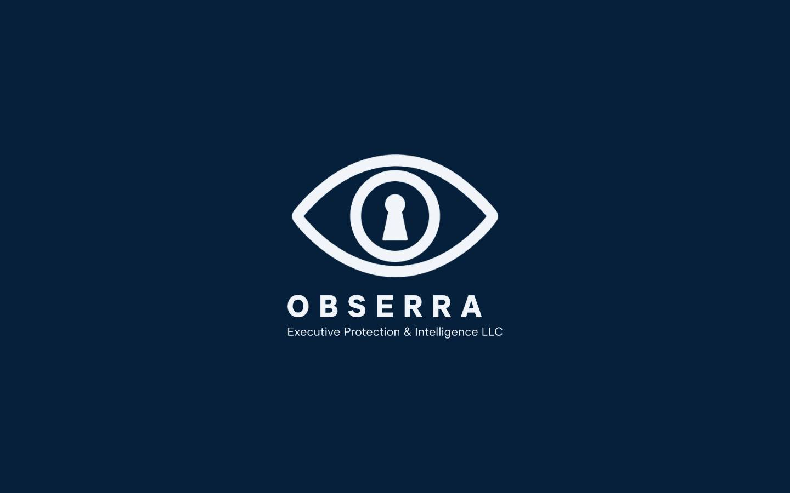
Figure: Signing In

5. Going Live — Production Setup Checklist
Follow these steps to take Obserra from first sign-in to a fully live, audit-defensible deployment. Progress is tracked automatically by the Go-Live Readiness checklist on the Connector Health page — every check runs against real state, so the score reflects your actual production readiness (No-Mock).
1) Connect your sources. Open Connector Health (Sources) and connect your identity, agent and security feeds, then use 'Re-probe all connectors' so every source reads healthy and fresh. Enterprise connectors that need customer OAuth credentials are shown honestly as 'credentials required' until you supply them.
2) Run the Go-Live Readiness checklist. It evaluates eight live checks: database connectivity, source-connector ingestion, data freshness, identity inventory, the correlation & risk engine, the AI advisor engine, the evidence integrity seal and the agent-runtime enforcement webhook. Each item shows Ready / Attention / Blocker with a live detail line, and the card auto-refreshes every 30 seconds.
3) Wire the agent-runtime enforcement webhook. Click 'Fix' on the runtime item (or go to Settings -> Agent runtime connector) and register your signed HTTPS endpoint. Once saved, Kill / Suspend / Resume actions are dispatched (HMAC-SHA256 signed) to your external agent runtime and the checklist reaches 100% — 'Production ready'.
4) Confirm readiness everywhere. A green 'Production ready' badge with a trend sparkline appears on the Executive Overview, and the readiness score is recorded automatically every day (no login required) so leadership can watch the trend climb toward 100%.
5) Export the proof. Download the signed Evidence Pack — every page-one cover carries a SHA-256 'Verified by Obserra' integrity seal — and share it with auditors or fold the score into the emailed board digest.
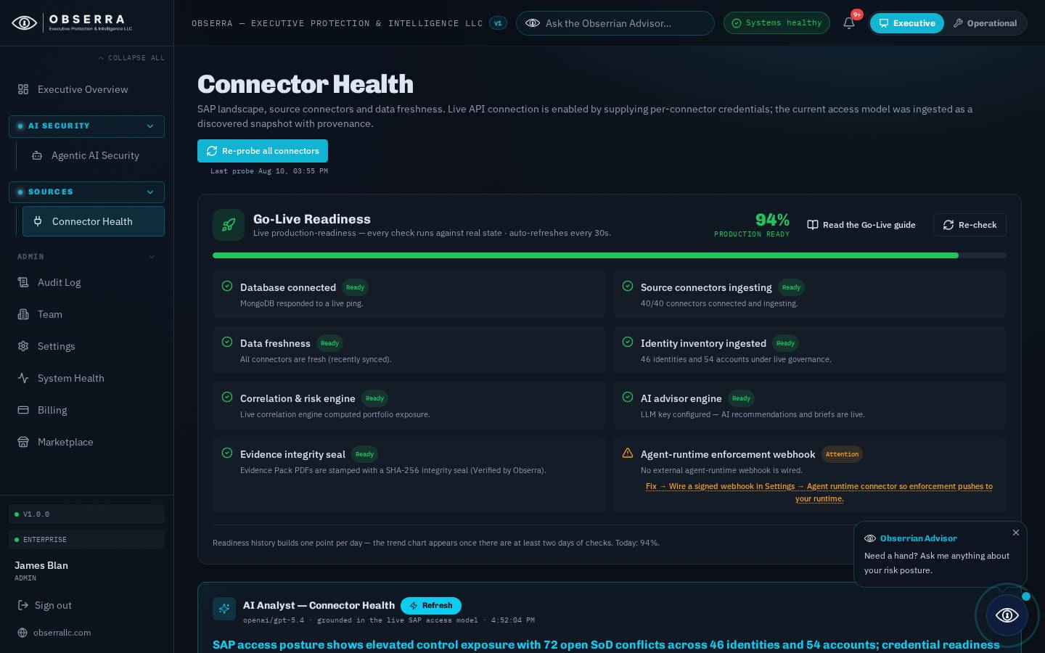
Figure: Going Live — Production Setup Checklist

6. Executive Overview
The landing dashboard is the complete rollup of the AI security estate: modelled agent risk, autonomous agents, toxic capability combinations, shadow-AI exposure, guardrail gaps and open AI incidents — all as one board-ready view. Every KPI and card opens a standardized deep-dive with an AI strategic brief and recommended actions, and admins can email the executive brief on demand or on a cadence from here.
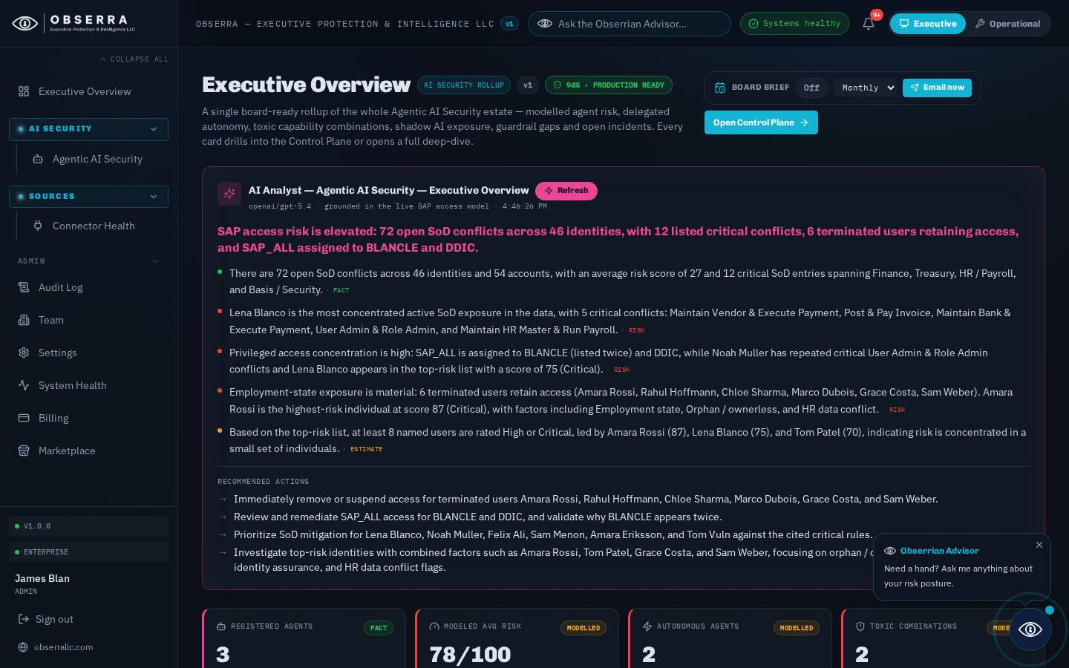
Figure: Executive Overview

7. Cyber Crisis Commander
The dedicated seven-tab workspace: Mission Control, Agent Inventory, Authority & Tools (with the Tool Toxicity Map), Guardrails & Red Team, Shadow AI, Incidents and Defensibility. Mission Control summarises the estate; every tile is clickable and drills into the relevant tab or agent.

8. Agent Inventory
Every registered AI agent with its owner, model, delegated tools and permissions, modelled risk score, authority tier, guardrail coverage and governance status. Search and filter by status or risk class; open any agent for full evidence and AI analysis.

9. Tool Toxicity Map
A visual Agent -> Tool -> Permission -> Resource graph that flags toxic capability combinations — for example an action-capable tool such as shell.exec paired with write permissions and no human-in-the-loop guardrail, or a data-exfiltration-capable tool with access to sensitive resources. The heatmap makes the most dangerous agents glanceable so reviewers can neutralise them first.

10. Guardrails & Red Team
Enterprise guardrail coverage (input/output filtering, tool allowlist, human approval) across every agent, plus the heuristic red-team baseline. Admins can toggle a guardrail on an agent's governance record and run the deterministic red-team probes; results are explicitly labelled as a heuristic baseline, not live adversarial runtime testing.

11. Shadow AI Discovery
A discovery feed that auto-populates the review queue with unsanctioned AI systems detected across the estate — common public GenAI SaaS as well as agents flagged shadow. Admins run discovery in one click and sanction each system to bring it under governance.

12. Kill Switch & Runtime Enforcement
From any agent's detail view, admins can Suspend (restrict), Kill (block) or Resume an agent. The runtime enforcement connector flips the agent's governance status, records the action to the Defensibility Ledger, posts a Slack/Teams alert, and — when an agent-runtime webhook is configured — dispatches the enforcement command to the external execution environment. The UI honestly reflects whether enforcement was applied in the control plane only or pushed to an external runtime.

13. AI Incidents & Workflows
AI security incident records (severity, mode, status) from the governance backend, alongside the related governance workflows. Each incident opens a deep-dive with an AI brief and recommended actions.

14. Defensibility & Evidence
The evidence layer: live data-source status, an explicit separation of FACT vs MODELLED vs HEURISTIC BASELINE vs AI RECOMMENDATION, the runtime-enforcement boundary statement and connector health. This is what makes the whole plane audit-defensible.

15. Board Brief Scheduler
A one-click control (admin) that emails the Cyber Crisis Commander Executive Brief — modelled agent risk, autonomous agents, toxic combinations, shadow AI and open incidents — via the managed email pipeline. Choose a weekly or monthly cadence, or send it immediately.

16. Settings, Branding & Deployment
Personal preferences (digest cadence, replay the guided tour) plus admin controls: alert recipients, custom branding (company name, logo, accent colour), a 'send me a test now' button, and the Deployment & Documentation downloads (on-premise package and these guides in PDF and Word).
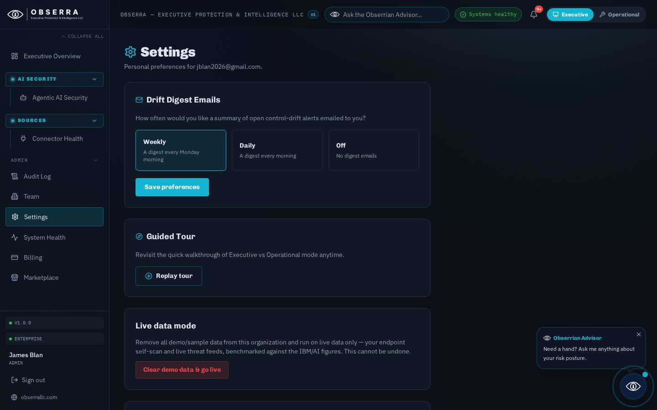
Figure: Settings, Branding & Deployment

17. Obserrian Advisor
The floating Obserrian Advisor (bottom-right, and via the top-bar ask box) answers AI security questions grounded on your LIVE agent telemetry — delegated tools, permissions, guardrail coverage, tool-governance violations and the red-team baseline. It can execute recommended actions and, for admins, reports its own usage and spend.

18. Support
For assistance contact your Obserra administrator. Risk scores and AI evaluations are decision-support estimates and do not constitute legal, financial, regulatory or security guarantees.

