Obserra EIOS — Install & User Guide
Executive Protection & Intelligence LLC
A continuous AI control plane for enterprise cyber risk, AI governance and board-ready executive intelligence. This guide covers installation (cloud, mobile and on-premise) and a full walkthrough of every dashboard.

1. About Obserra
Obserra presents one evidence-grounded platform at two altitudes: an Executive view (financial exposure, risk reduction, decisions required) and an Operational view (AI usage, patching, incidents and remediation). Every metric carries its source, freshness and confidence.
The platform is delivered as an installable Progressive Web App (PWA) and can also be self-hosted on-premise with Docker.

2. Installing the App (One-Click PWA)
Obserra installs like a native app straight from the browser — no app store required. It works across desktop, tablet and mobile.
Desktop (Chrome / Edge): open the site and click the Install icon in the address bar, or use the in-app 'Install Obserra' banner.
Android (Chrome): tap the 'Install Obserra' banner, or use menu -> Add to Home screen.
iPhone / iPad (Safari): tap Share -> Add to Home Screen.
Once installed, Obserra launches full-screen and can receive push notifications.

3. On-Premise Installation (Docker)
For fully self-hosted deployments, download the on-premise package from Settings -> Deployment & Documentation. No install script is required; an optional install.sh is included for convenience.
Prerequisites: Docker 24+ and Docker Compose v2, 2 vCPU / 4 GB RAM (8 GB recommended).
Steps: (1) place the backend/ and frontend/ source next to the deploy/ folder; (2) copy .env.example to .env and set JWT_SECRET, EMERGENT_LLM_KEY and PUBLIC_URL; (3) run: docker compose -f deploy/docker-compose.yml --env-file deploy/.env up -d --build; (4) open http://<machine-ip>:8080.
MongoDB data persists in a Docker volume across restarts. For production, terminate TLS with a reverse proxy in front of port 8080. Full details are in the bundled INSTALL.md.

4. Signing In
Open the app and sign in with your work email and password. Enterprise SSO, Apple and Google sign-in, and passwordless QR login are also available. Passwords follow NIST 800-63B (>=12 chars with upper/lower/number/symbol).

Figure: 4. Signing In

5. Executive Overview
The Executive view opens on strategic, board-ready intelligence: the Posture Trend, the Enterprise Health Index, Top Risks by Business Impact and Decisions Required. Use 'Generate Board Report' to produce a branded PDF at any time.
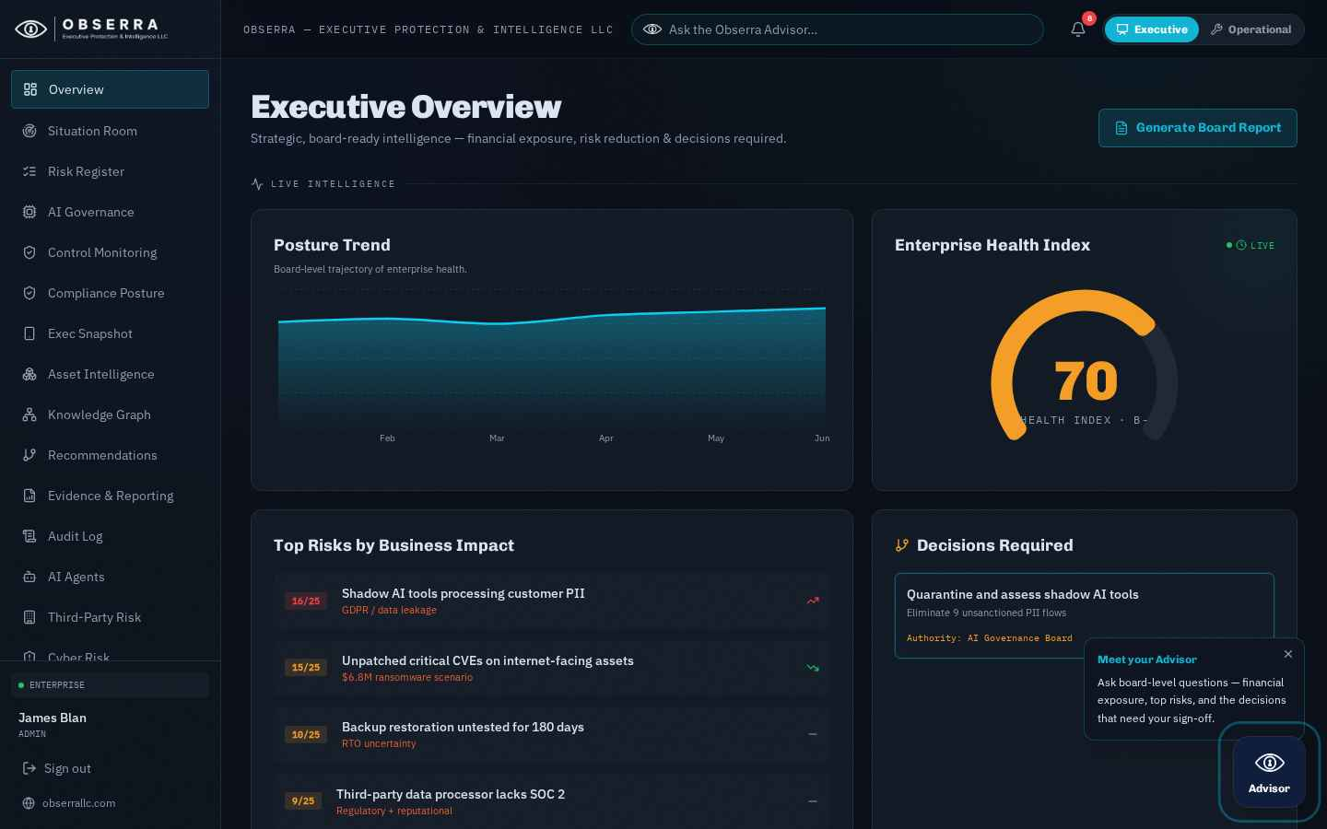
Figure: 5. Executive Overview

6. Operational Command
Toggle to Operational mode (top-right) for the working view: NIST control maturity, third-party vendor risk, phishing click-rate, patching coverage, the risk heatmap and remediation workflows.
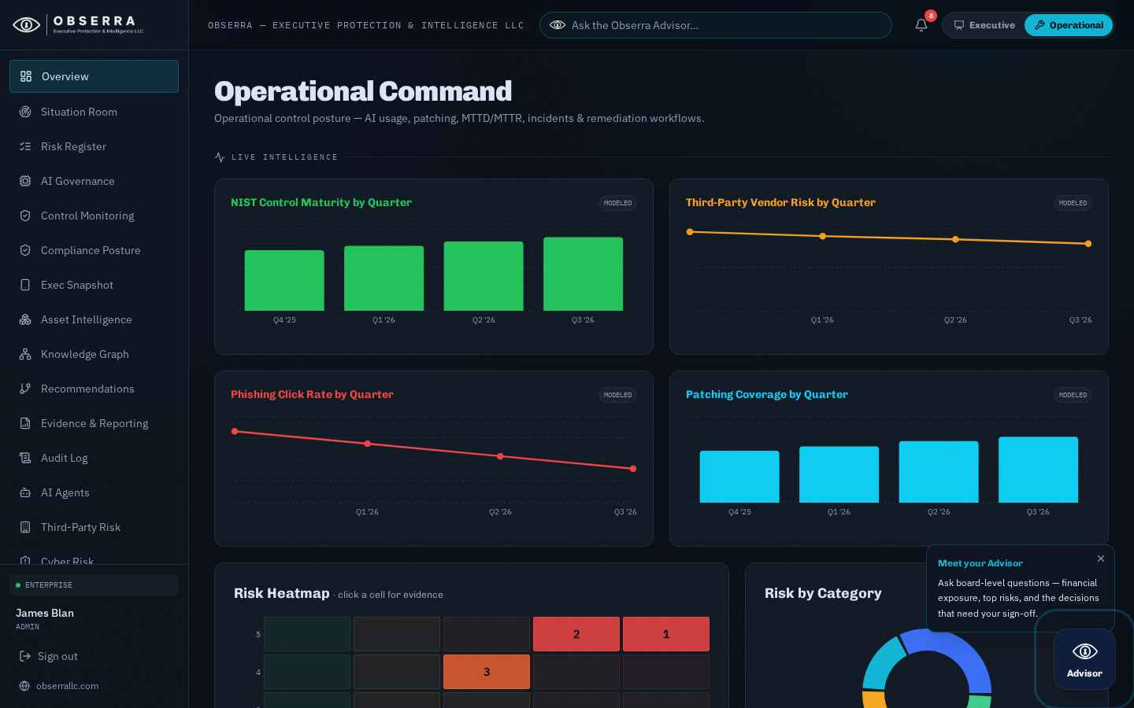
Figure: 6. Operational Command

7. Risk Register
The Risk Register lists every tracked risk with inherent vs residual scoring, financial exposure (FAIR-style annualized loss expectancy) and evidence links for board defensibility.
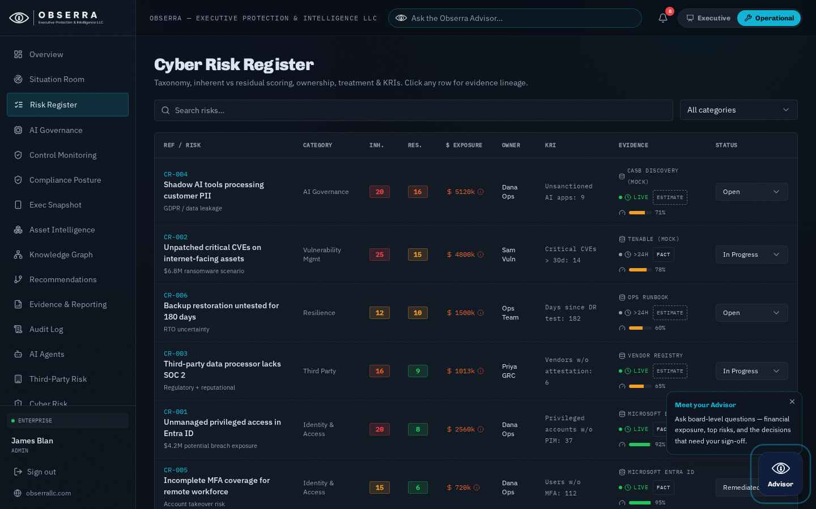
Figure: 7. Risk Register

8. AI Governance Suite
Inventory of AI systems with NIST AI RMF mapping, model cards (bias, safety, security, explainability), drift and hallucination indicators, shadow-AI discovery and incident management. Bring shadow tools under governance in one click.
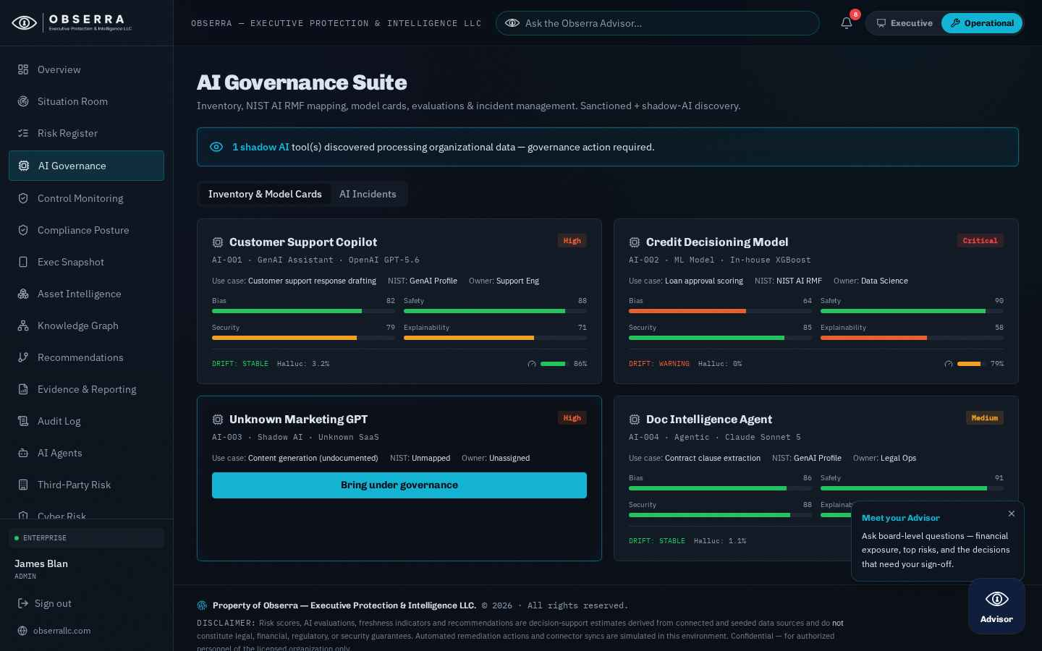
Figure: 8. AI Governance Suite

9. Control Monitoring
Continuously monitor control health and drift. Open alerts can be summarized to you on a daily or weekly digest cadence (configurable in Settings).
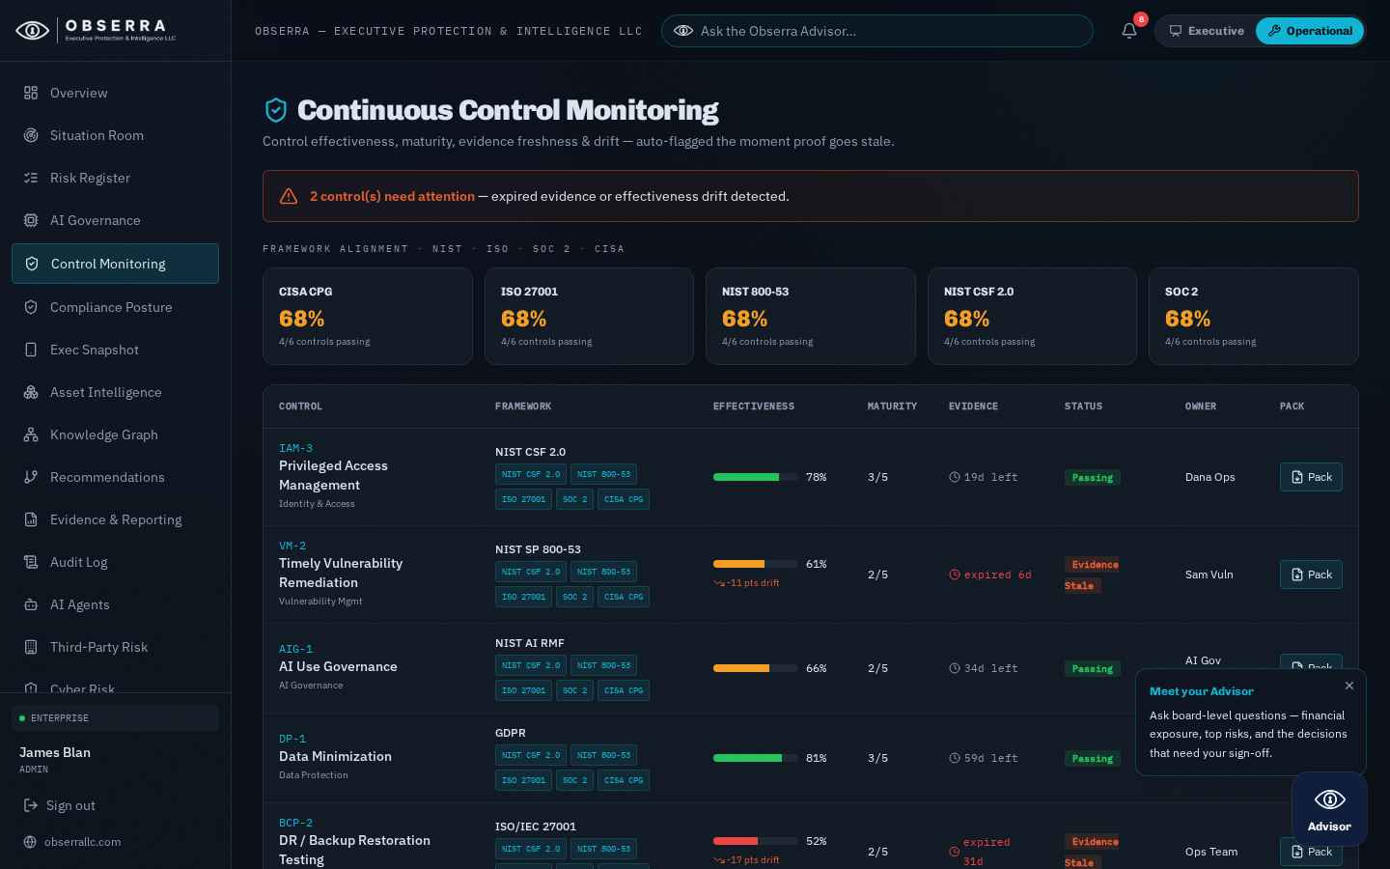
Figure: 9. Control Monitoring

10. Compliance Posture
Track compliance posture across frameworks with evidence freshness so every figure stays audit-ready.
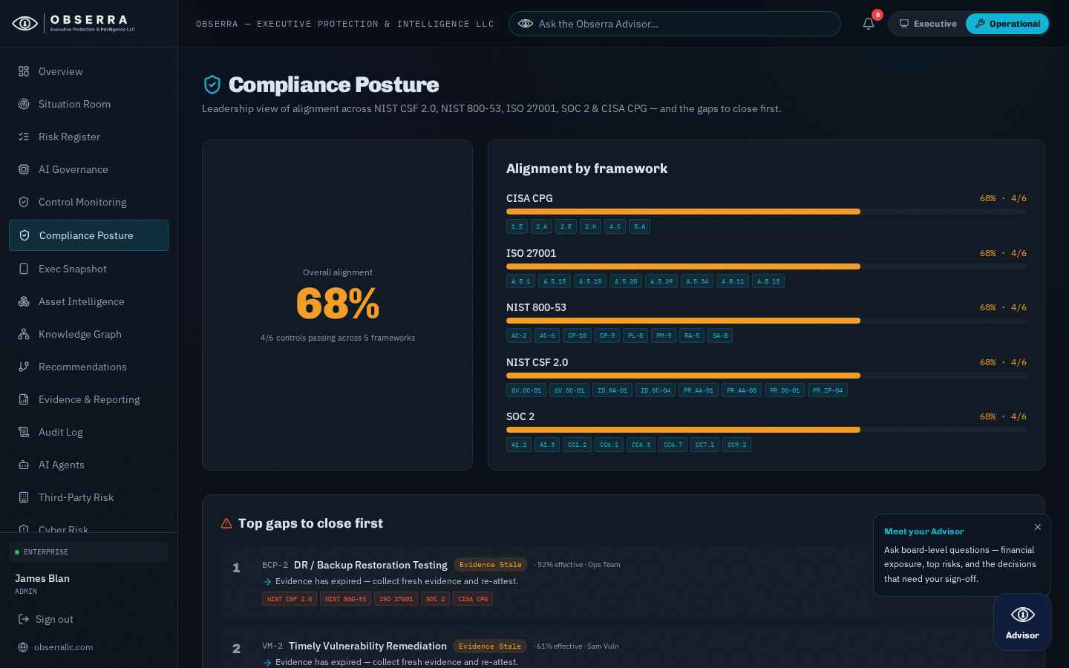
Figure: 10. Compliance Posture

11. Evidence & Reporting
Generate board-ready packets tied to evidence. 'New Board Report' synthesizes a report and shows a live branded cover preview. Export as a vertical PDF or a landscape Quarterly Deck, toggle a light/dark cover theme, email it, or share to Microsoft Teams. A monthly job also emails the branded PDF to chosen recipients automatically.
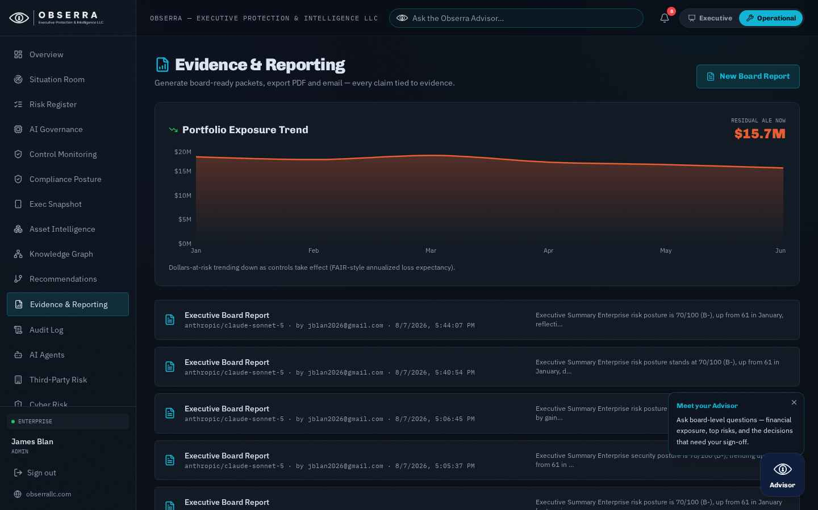
Figure: 11. Evidence & Reporting

12. Settings, Branding & Deployment
Personal preferences (digest cadence, replay the guided tour) plus admin controls: board-report recipients, custom report branding (company name, logo, accent colour) with a live cover preview, a 'Send me a test now' button, and the Deployment & Documentation downloads (on-premise package, this guide in PDF and Word).
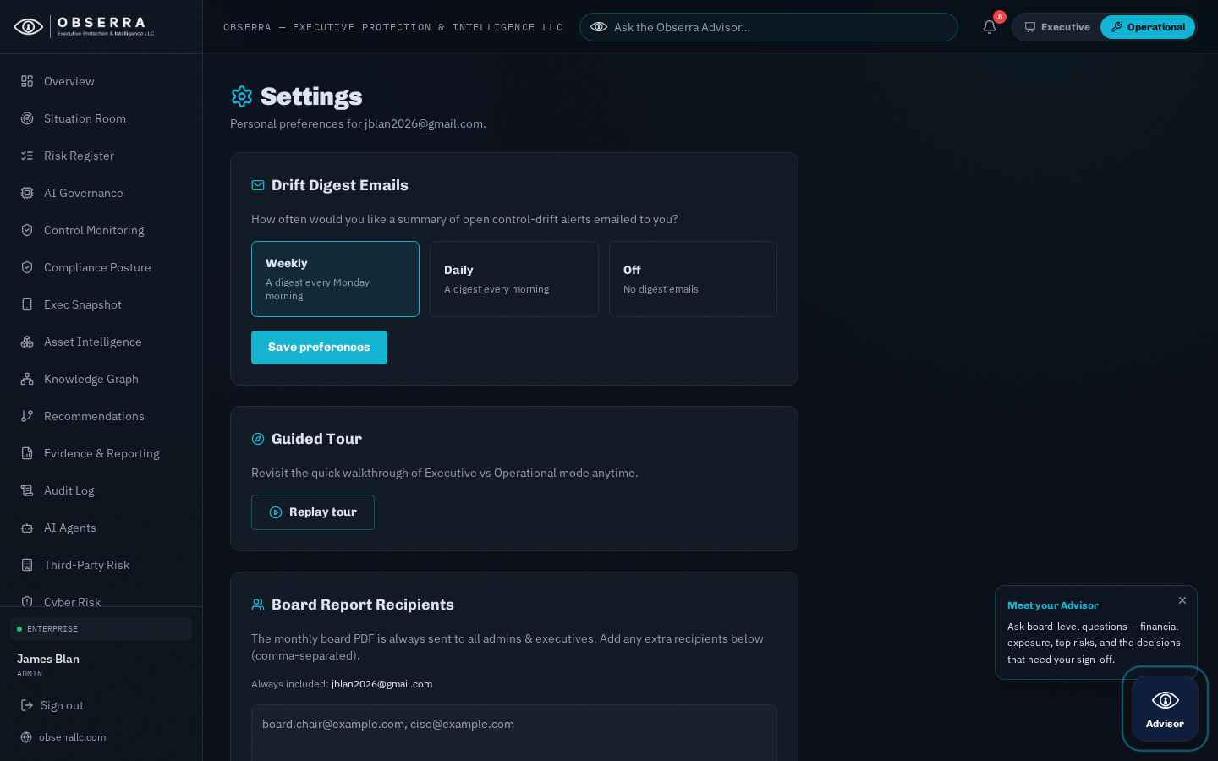
Figure: 12. Settings, Branding & Deployment

13. Obserra Advisor
The floating Advisor (bottom-right) answers board-level questions grounded on your live posture — financial exposure, top risks and the decisions that need sign-off. It can also execute recommended actions and, for admins, reports its own usage and spend.

14. Support
For assistance contact your Obserra administrator. Risk scores and AI evaluations are decision-support estimates and do not constitute legal, financial, regulatory or security guarantees.

