
Obserra SAP UAC

Admin & Operator Guide
Enterprise SAP User Access Control & Access Intelligence
August 2026 · Confidential — prepared for internal use.

Contents
1. About Obserra SAP UAC
2. Installing the App (One-Click PWA)
3. On-Premise Installation (Docker)
4. Signing In
5. Executive Overview
6. SAP Analytics
7. SoD Command Center
8. Risk Watchlist, Owner Leaderboard & Board Pack
9. Privileged Access (PAM)
10. Access Monitoring
11. Identities
12. Joiner / Mover / Leaver
13. HR Reconciliation
14. Role Intelligence
15. Access Requests
16. Certifications
17. Settings, Branding & Deployment
18. Obserra Advisor
19. Support

1. About Obserra SAP UAC
Obserra SAP UAC gives access, audit and GRC teams a single live view of who can do what across the SAP landscape — and the tooling to fix it. It reconciles HR against SAP accounts, detects Segregation-of-Duties (SoD) conflicts and privileged exposure in real time, and turns every finding into an actionable, auditable ServiceNow change.
Every number is computed LIVE from the underlying records on each request (No-Mock): the shipped dataset is a realistic, fully sourced snapshot, and real SAP / ServiceNow connectors slot in later without changing the API contract. Every metric carries its source and freshness so findings are audit-defensible.

2. Installing the App (One-Click PWA)
Obserra SAP UAC installs like a native app straight from the browser — no app store required — and works across desktop, tablet and mobile.
Desktop (Chrome / Edge): click the Install icon in the address bar, or use the in-app 'Install' banner. Android (Chrome): tap the 'Install' banner or menu -> Add to Home screen. iPhone / iPad (Safari): tap Share -> Add to Home Screen.
Once installed, the app launches full-screen and can receive push notifications for access alerts and SoD threshold breaches.

3. On-Premise Installation (Docker)
For fully self-hosted deployments, download the on-premise package from Settings -> Deployment & Documentation. An optional install.sh is included.
Prerequisites: Docker 24+ and Docker Compose v2, 2 vCPU / 4 GB RAM (8 GB recommended).
Steps: (1) place backend/ and frontend/ next to the deploy/ folder; (2) copy .env.example to .env and set JWT_SECRET, EMERGENT_LLM_KEY and PUBLIC_URL; (3) run docker compose -f deploy/docker-compose.yml --env-file deploy/.env up -d --build; (4) open http://<machine-ip>:8080. Full details are in the bundled INSTALL.md.

4. Signing In
Open the app and sign in with your work email and password. Passwords follow NIST 800-63B (>=12 chars with upper/lower/number/symbol). Roles determine what you see: admins get full governance controls, executives get the board view.

Figure: Signing In

5. Executive Overview
The landing dashboard opens on board-ready SAP access posture: the auto-running AI Analyst headline, key KPIs (identities, accounts, open SoD, average risk, license usage), top exposures and the decisions that need attention. Switch altitude between Executive and Operational from the toggle in the top bar.
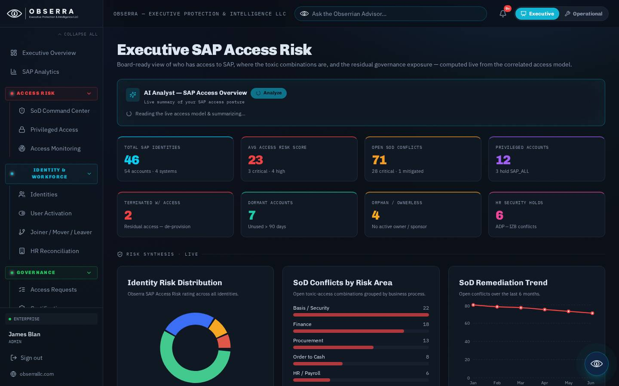
Figure: Executive Overview

6. SAP Analytics
A deep analytics workspace over the whole SAP estate: identities, accounts, SoD by business area, license utilisation and risk distribution, with drill-downs on every chart. Export any view as a branded PDF or CSV for auditors and steering committees.
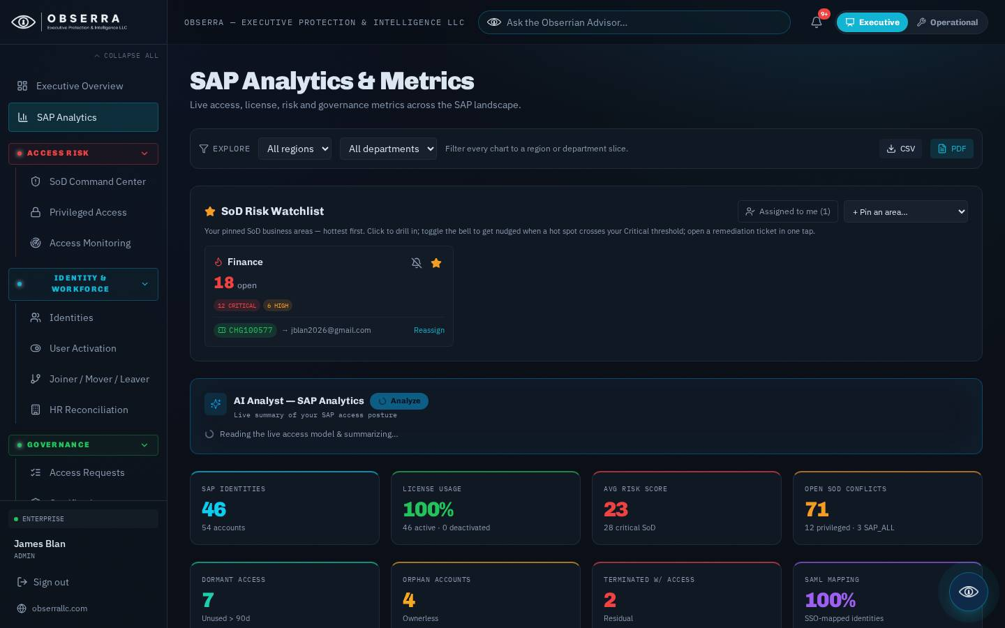
Figure: SAP Analytics

7. SoD Command Center
The heart of the platform. An AI insight card summarises the live SoD picture, followed by severity KPIs, the Access Governance Scorecard (with an 8-week trend and 'why the score moved'), the SoD -> ServiceNow Auto-Remediation rule engine, the Governance Digest schedule (email + Slack/Teams + voice briefing + evidence pack), a pre-assignment risk simulator, the SoD rule library and the full detected-conflicts table with severity, area and status filters. Every row opens a detail view with an AI risk rating and concrete 'how to fix' steps.
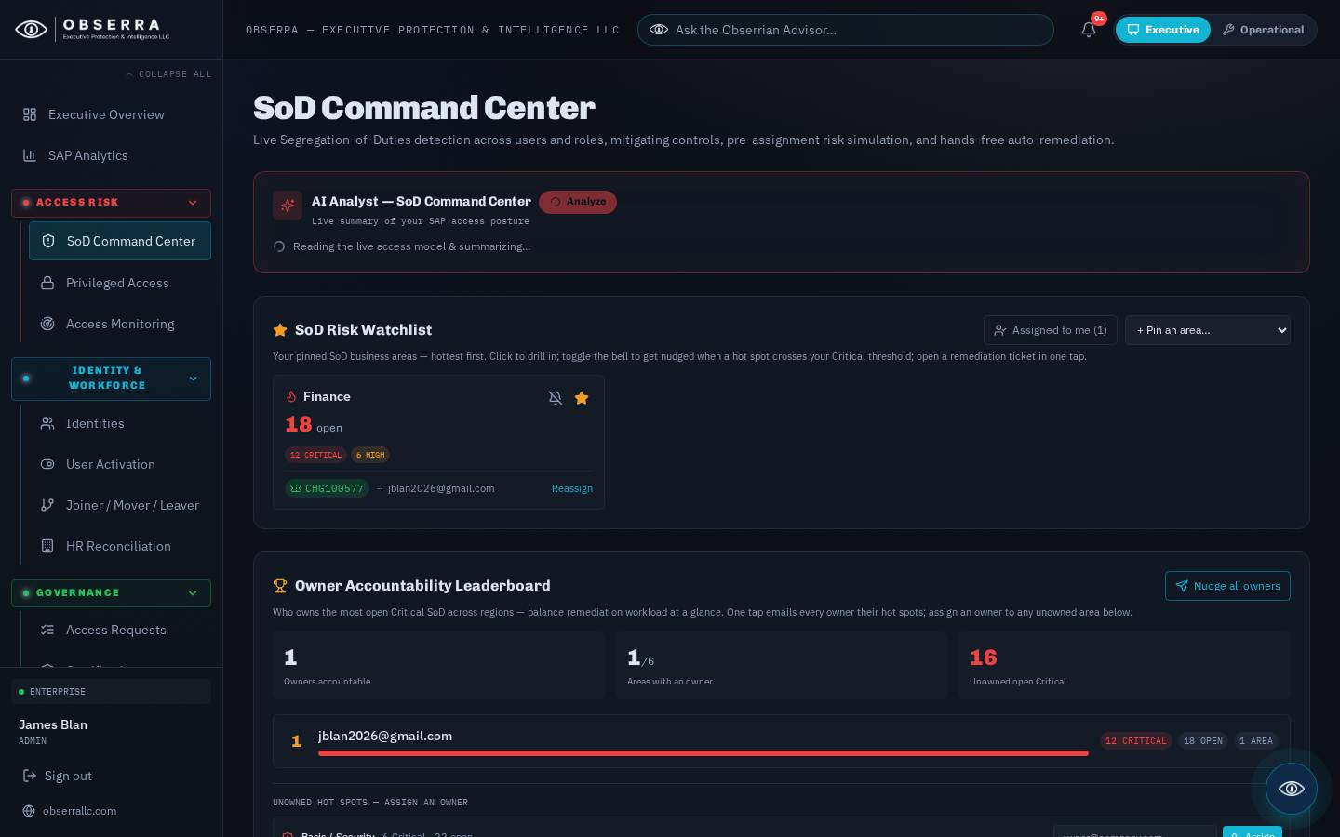
Figure: SoD Command Center

8. Risk Watchlist, Owner Leaderboard & Board Pack
Pin the SoD business areas you own to the Risk Watchlist so their hot spots surface every login; flip the 'Assigned to me' lens, set a bell alert threshold, and open a one-tap ServiceNow remediation ticket. Click any ticket badge to view its full ServiceNow change timeline, which auto-refreshes while open.
The Owner Accountability Leaderboard ranks who carries the most open Critical SoD across regions, flags unowned hot spots, lets admins assign an owner in place, and can 'nudge all owners' — emailing each owner their assigned hot spots on demand.
The Board Pack card previews this month's executive access-governance pack with the analytics PDF attached; admins can send it immediately or schedule the monthly auto-send day and recipients inline.
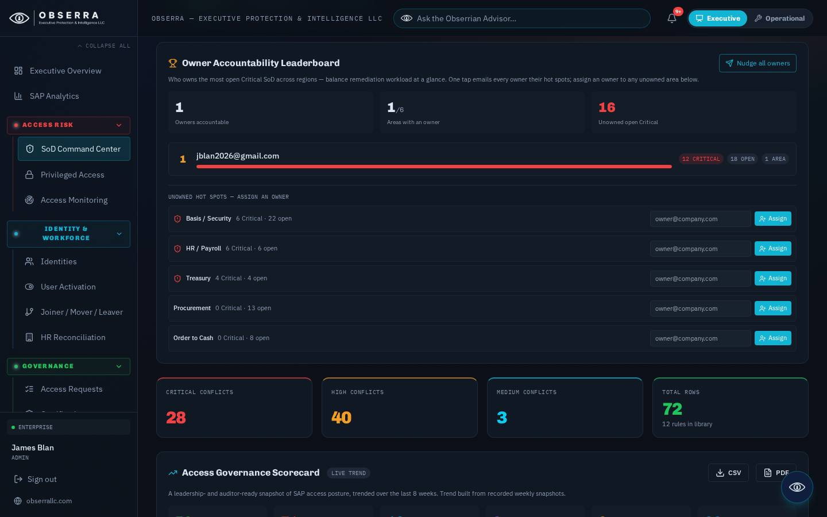
Figure: Risk Watchlist, Owner Leaderboard & Board Pack

9. Privileged Access (PAM)
Track SAP privileged and emergency (firefighter) access: who holds elevated roles, how long, and whether usage is justified. Revoke privileged access, lock accounts or trigger recertification in one click, each stamped to the audit trail and a ServiceNow change.
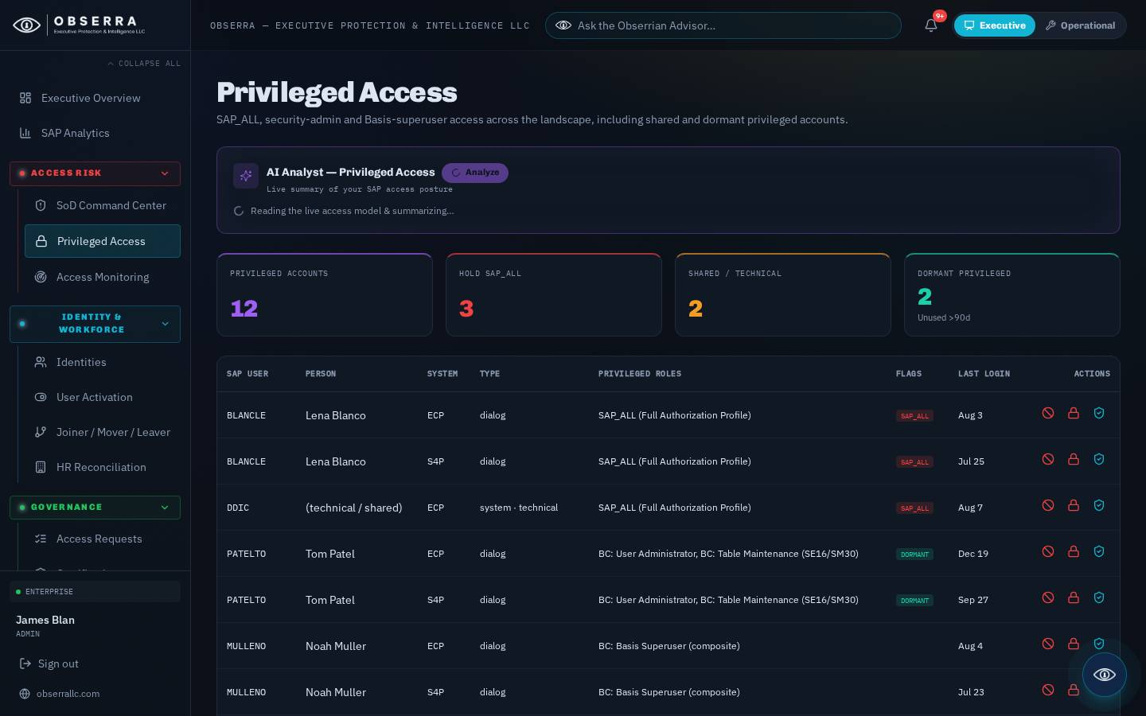
Figure: Privileged Access (PAM)

10. Access Monitoring
Continuous monitoring of access signals — anomalous logons, dormant-but-entitled accounts, terminated identities with residual access and connector health — so drift is caught the moment it appears.
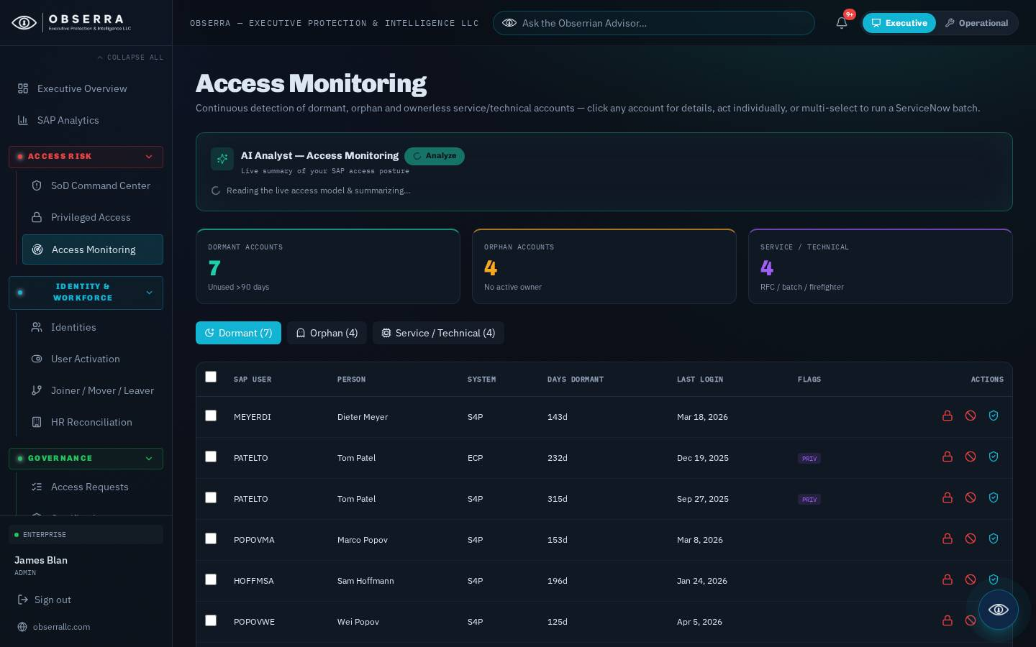
Figure: Access Monitoring

11. Identities
The canonical identity register reconciled from HR: each person with their SAP accounts, roles, risk score and lifecycle state. Open any identity for the full access footprint, an AI risk rating and lifecycle actions (activate, suspend, resume, deactivate).
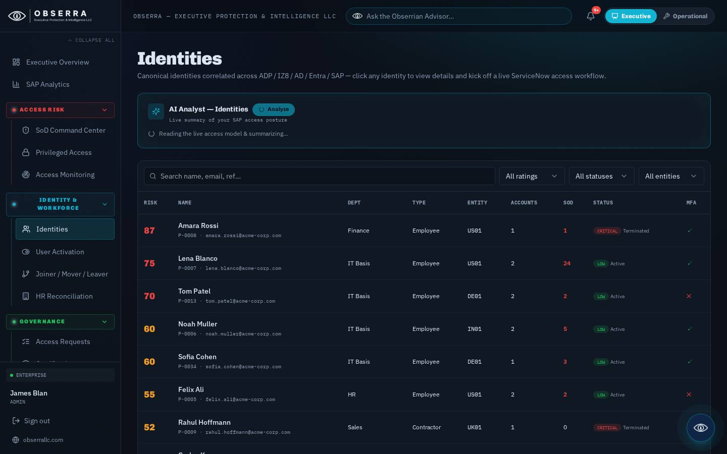
Figure: Identities

12. Joiner / Mover / Leaver
Automate the identity lifecycle. Joiners are provisioned to role templates, movers are re-evaluated for SoD as they change departments, and leavers are deprovisioned with residual-access checks — every step orchestrated through ServiceNow.
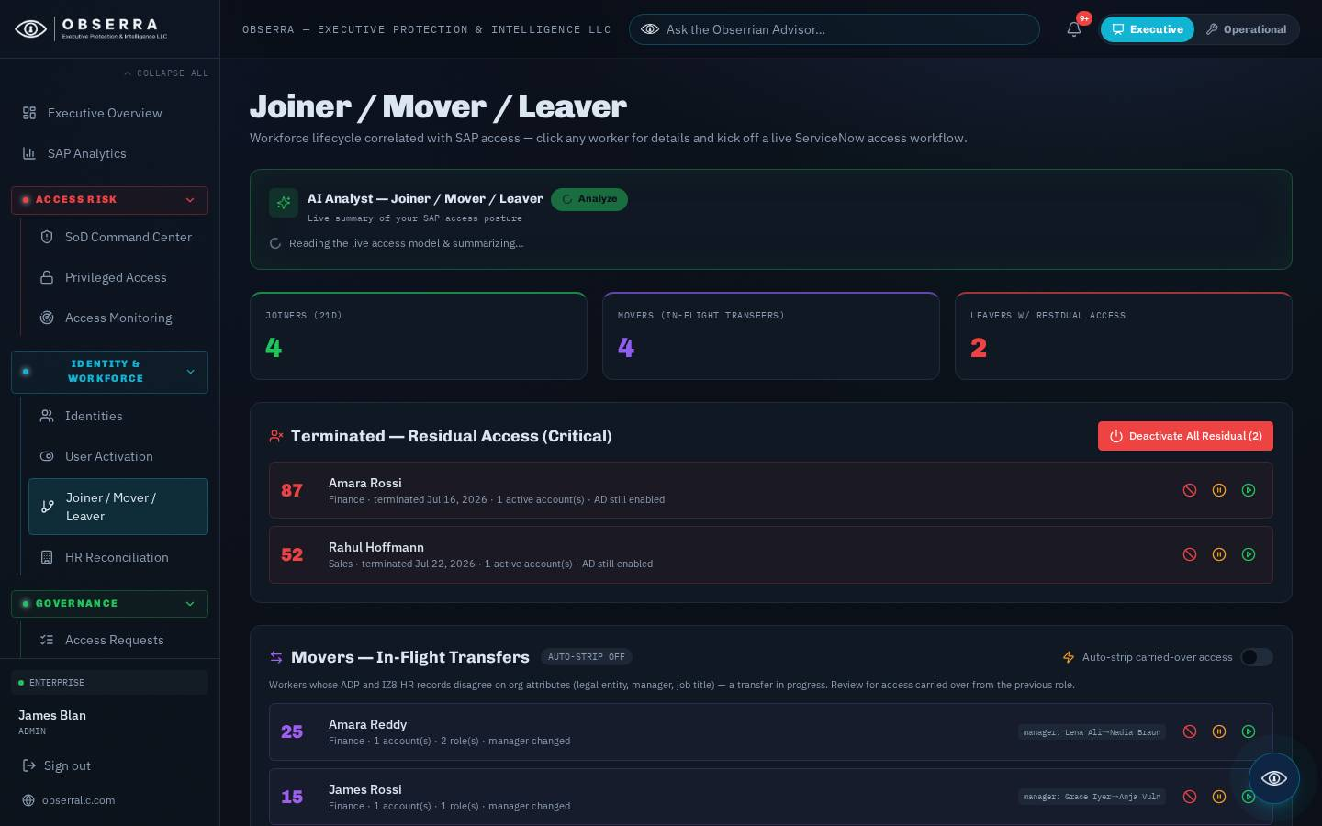
Figure: Joiner / Mover / Leaver

13. HR Reconciliation
Reconcile SAP accounts against the HR source of truth to surface orphaned accounts, missing owners and identity mismatches, with one-tap remediation for each exception.
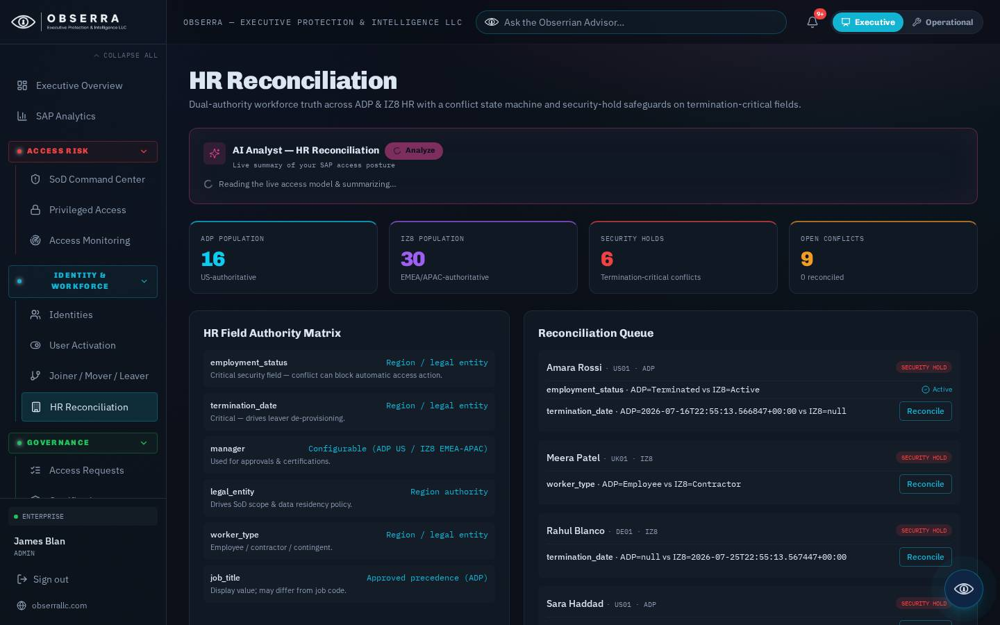
Figure: HR Reconciliation

14. Role Intelligence
Analyse the role model: composite vs single roles, over-provisioning, redundant assignments and role-level SoD risk — with recommendations to right-size access before it becomes an audit finding.
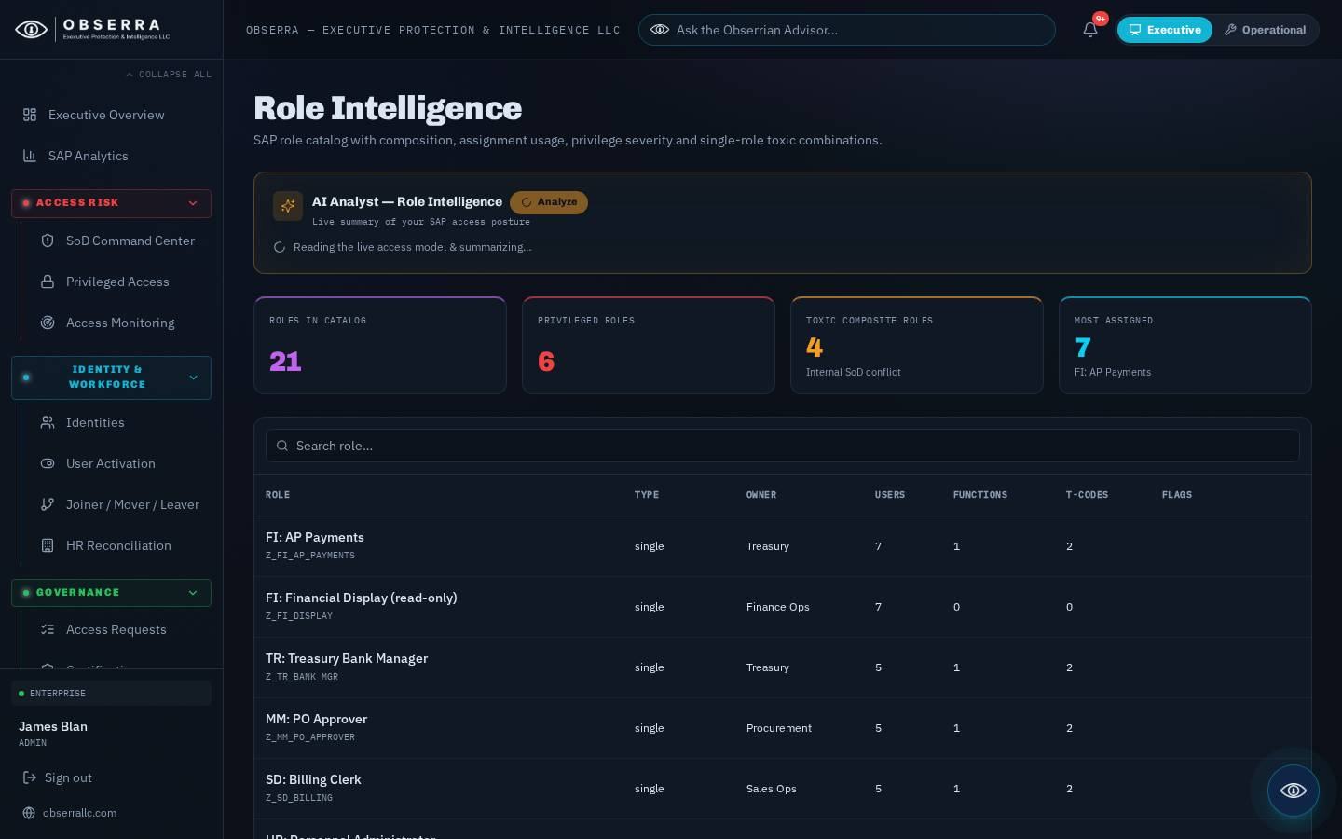
Figure: Role Intelligence

15. Access Requests
A self-service access request and approval workflow with automatic pre-assignment SoD simulation, so risky combinations are flagged before they are ever granted.
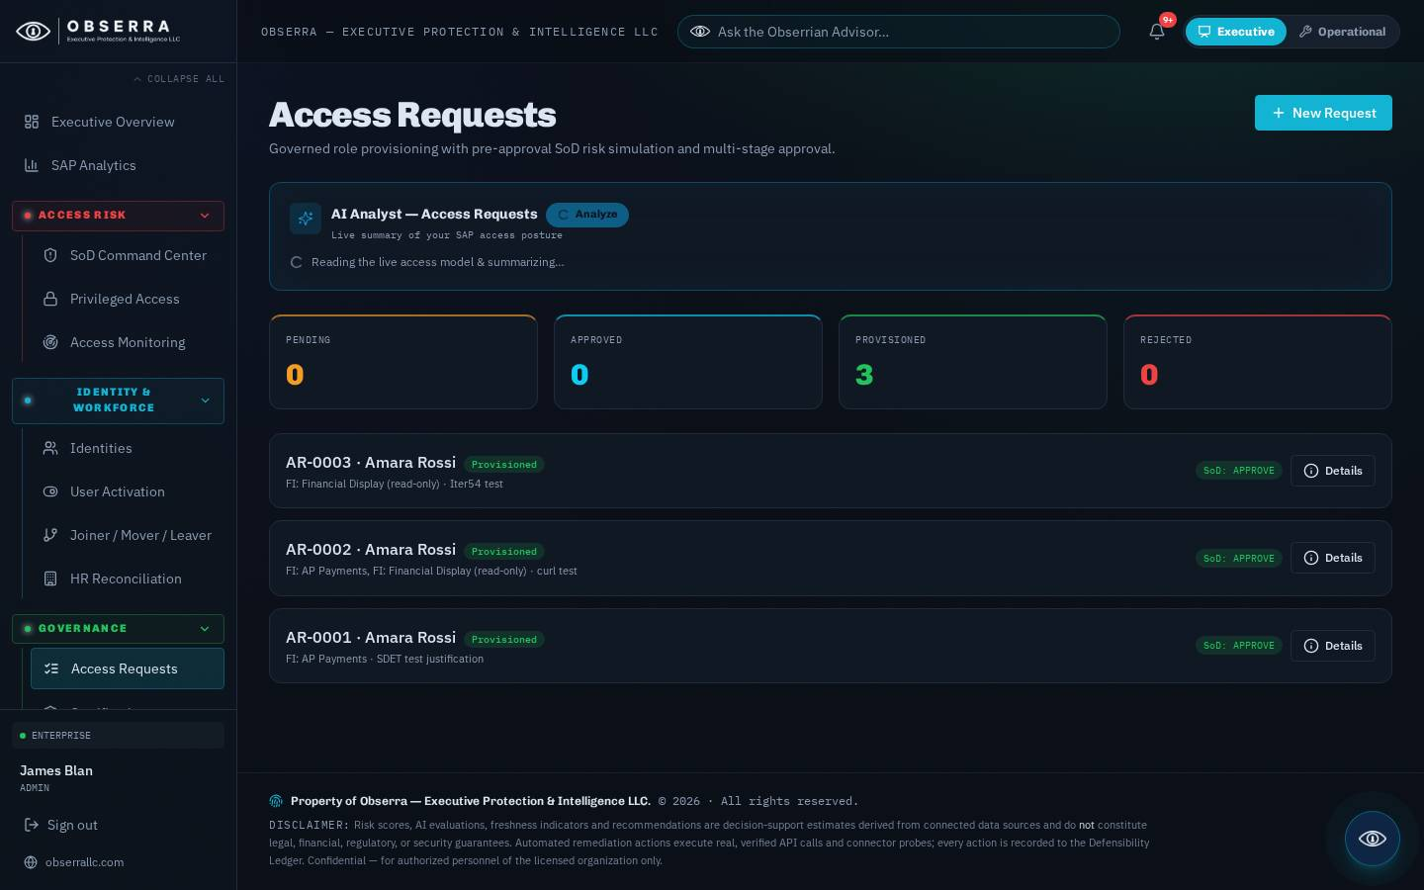
Figure: Access Requests

16. Certifications
Run periodic access certification (attestation) campaigns: reviewers confirm or revoke entitlements, with progress tracking and an auditable record of every decision.
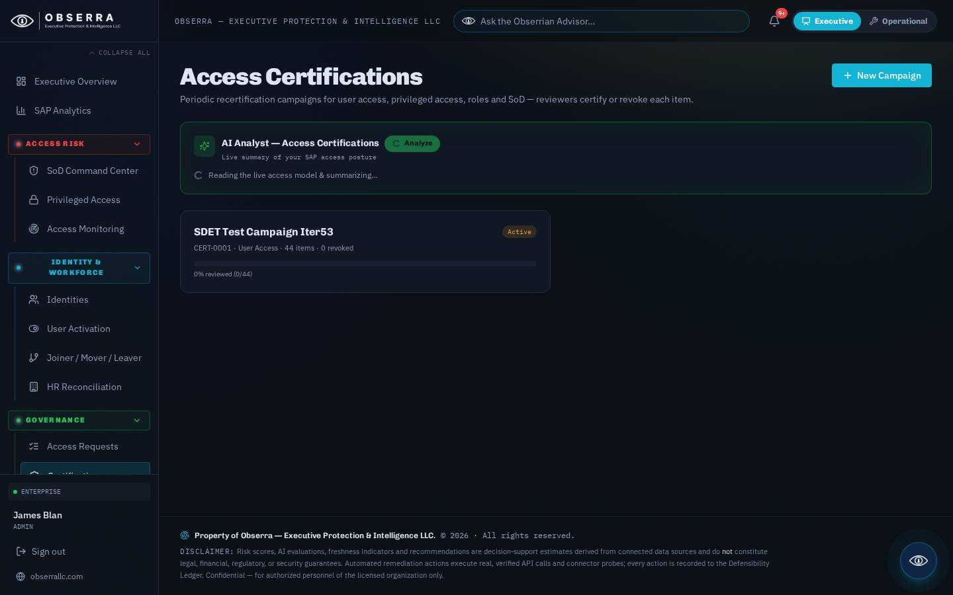
Figure: Certifications

17. Settings, Branding & Deployment
Personal preferences (digest cadence, replay the guided tour) plus admin controls: governance-digest and board-pack recipients, custom branding (company name, logo, accent colour), a 'send me a test now' button, and the Deployment & Documentation downloads (on-premise package and these guides in PDF and Word).
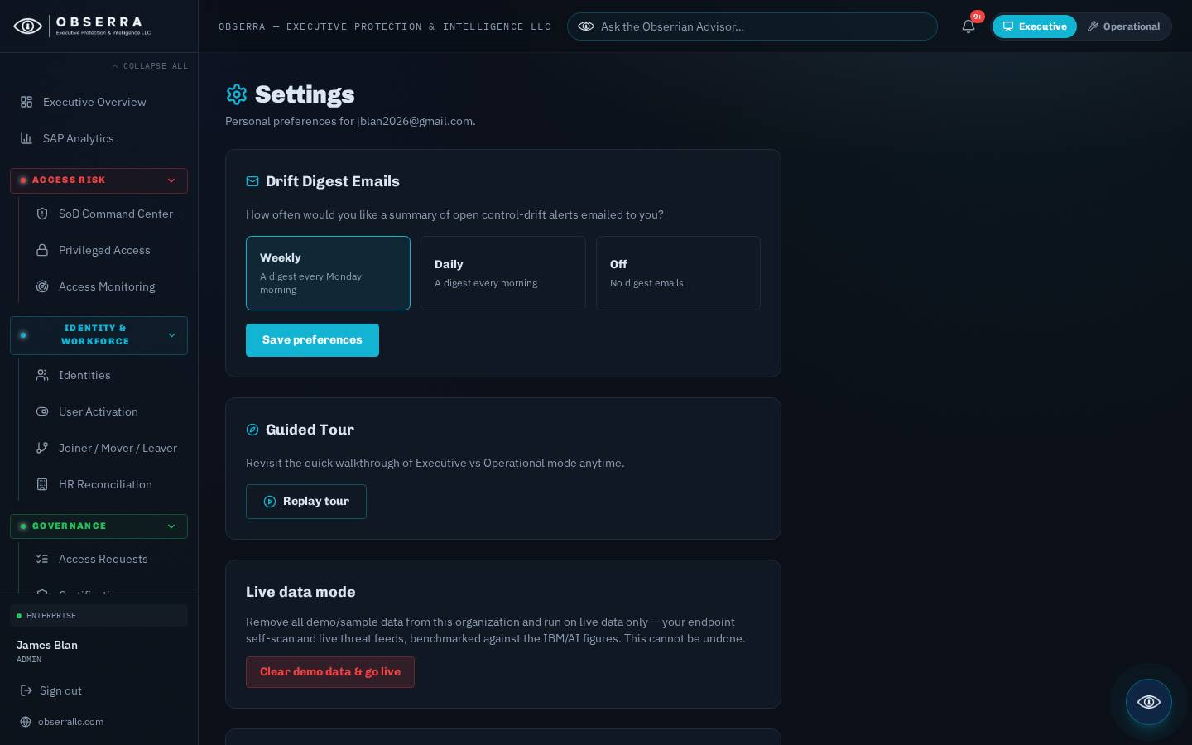
Figure: Settings, Branding & Deployment

18. Obserra Advisor
The floating Advisor (top bar) answers access-governance questions grounded on your live SAP posture — open SoD, privileged exposure and the remediations that need sign-off. It can execute recommended actions and, for admins, reports its own usage and spend.

19. Support
For assistance contact your Obserra administrator. Risk scores and AI evaluations are decision-support estimates and do not constitute legal, financial, regulatory or security guarantees.

