
Obserra Control Intelligence

Executive Guide
Control Intelligence — continuous control effectiveness, evidence assurance & framework coverage
August 2026 · Confidential — prepared for internal use.

Contents
1. About Obserra Control Intelligence
2. Installing the App (One-Click PWA)
3. Signing In
4. Going Live — Production Setup Checklist
5. Executive Overview
6. Control Intelligence
7. Tool Toxicity Map
8. Defensibility & Evidence
9. Obserrian Advisor
10. Support

1. About Obserra Control Intelligence
Obserra Control Intelligence lets you discover, understand, govern, constrain and respond to the AI agents and models operating across your enterprise — before delegated machine authority becomes enterprise risk. It gives security, GRC and executive teams a single live view of which agents exist, what tools and permissions they hold, how much autonomy they have, and where their capabilities combine into dangerous — 'toxic' — patterns.
Every number is computed LIVE from the underlying agent records on each request (No-Mock): delegated authority tiers, modelled agent risk scores, guardrail coverage and the heuristic red-team baseline are all derived from real telemetry. Governance actions (sanction, restrict, suspend, kill) are written to the Defensibility Ledger so every decision is audit-defensible, and the runtime enforcement connector can push those decisions to an external agent runtime.

2. Installing the App (One-Click PWA)
Obserra installs like a native app straight from the browser — no app store required — and works across desktop, tablet and mobile.
Desktop (Chrome / Edge): click the Install icon in the address bar, or use the in-app 'Install' banner. Android (Chrome): tap the 'Install' banner or menu -> Add to Home screen. iPhone / iPad (Safari): tap Share -> Add to Home Screen.
Once installed, the app launches full-screen and can receive push notifications for AI security alerts, shadow-AI discoveries and guardrail breaches.

3. Signing In
Open the app and sign in with your work email and password. Passwords follow NIST 800-63B (>=12 chars with upper/lower/number/symbol). Roles determine what you see: admins get full enforcement controls, executives get the board view.
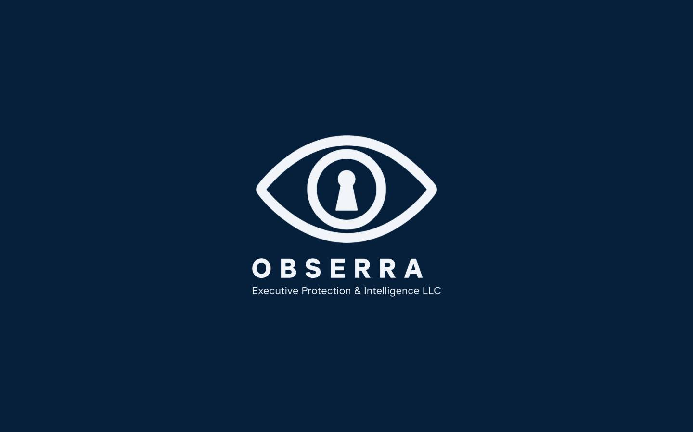
Figure: Signing In

4. Going Live — Production Setup Checklist
Follow these steps to take Obserra from first sign-in to a fully live, audit-defensible deployment. Progress is tracked automatically by the Go-Live Readiness checklist on the Connector Health page — every check runs against real state, so the score reflects your actual production readiness (No-Mock).
1) Connect your sources. Open Connector Health (Sources) and connect your identity, agent and security feeds, then use 'Re-probe all connectors' so every source reads healthy and fresh. Enterprise connectors that need customer OAuth credentials are shown honestly as 'credentials required' until you supply them.
2) Run the Go-Live Readiness checklist. It evaluates eight live checks: database connectivity, source-connector ingestion, data freshness, identity inventory, the correlation & risk engine, the AI advisor engine, the evidence integrity seal and the agent-runtime enforcement webhook. Each item shows Ready / Attention / Blocker with a live detail line, and the card auto-refreshes every 30 seconds.
3) Wire the agent-runtime enforcement webhook. Click 'Fix' on the runtime item (or go to Settings -> Agent runtime connector) and register your signed HTTPS endpoint. Once saved, Kill / Suspend / Resume actions are dispatched (HMAC-SHA256 signed) to your external agent runtime and the checklist reaches 100% — 'Production ready'.
4) Confirm readiness everywhere. A green 'Production ready' badge with a trend sparkline appears on the Executive Overview, and the readiness score is recorded automatically every day (no login required) so leadership can watch the trend climb toward 100%.
5) Export the proof. Download the signed Evidence Pack — every page-one cover carries a SHA-256 'Verified by Obserra' integrity seal — and share it with auditors or fold the score into the emailed board digest.
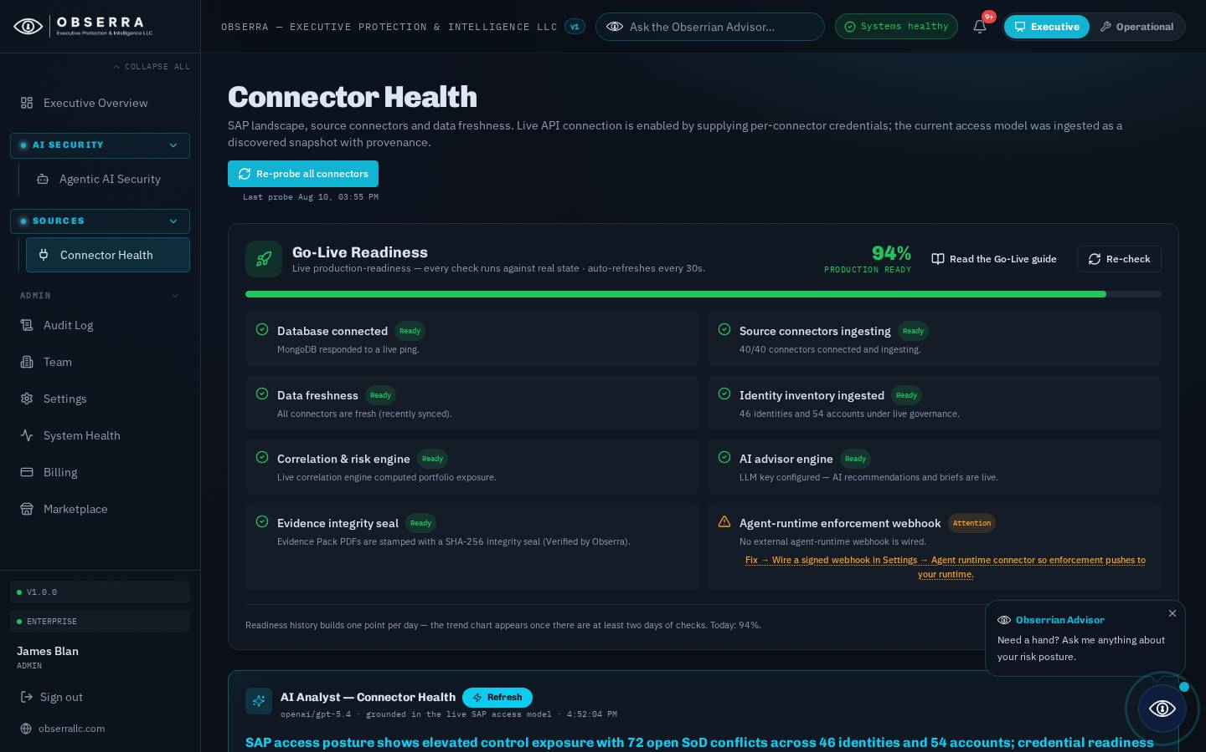
Figure: Going Live — Production Setup Checklist

5. Executive Overview
The landing dashboard is the complete rollup of the AI security estate: modelled agent risk, autonomous agents, toxic capability combinations, shadow-AI exposure, guardrail gaps and open AI incidents — all as one board-ready view. Every KPI and card opens a standardized deep-dive with an AI strategic brief and recommended actions, and admins can email the executive brief on demand or on a cadence from here.
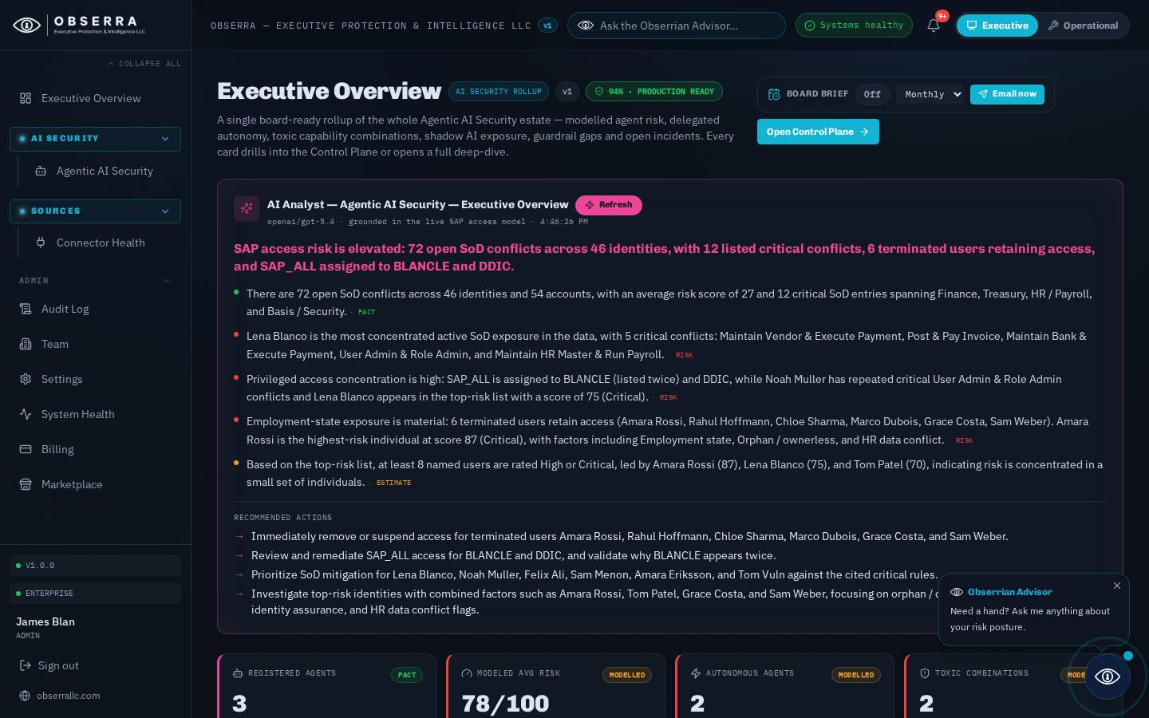
Figure: Executive Overview

6. Control Intelligence
The dedicated seven-tab workspace: Mission Control, Agent Inventory, Authority & Tools (with the Tool Toxicity Map), Guardrails & Red Team, Shadow AI, Incidents and Defensibility. Mission Control summarises the estate; every tile is clickable and drills into the relevant tab or agent.

7. Tool Toxicity Map
A visual Agent -> Tool -> Permission -> Resource graph that flags toxic capability combinations — for example an action-capable tool such as shell.exec paired with write permissions and no human-in-the-loop guardrail, or a data-exfiltration-capable tool with access to sensitive resources. The heatmap makes the most dangerous agents glanceable so reviewers can neutralise them first.

8. Defensibility & Evidence
The evidence layer: live data-source status, an explicit separation of FACT vs MODELLED vs HEURISTIC BASELINE vs AI RECOMMENDATION, the runtime-enforcement boundary statement and connector health. This is what makes the whole plane audit-defensible.

9. Obserrian Advisor
The floating Obserrian Advisor (bottom-right, and via the top-bar ask box) answers AI security questions grounded on your LIVE agent telemetry — delegated tools, permissions, guardrail coverage, tool-governance violations and the red-team baseline. It can execute recommended actions and, for admins, reports its own usage and spend.

10. Support
For assistance contact your Obserra administrator. Risk scores and AI evaluations are decision-support estimates and do not constitute legal, financial, regulatory or security guarantees.

