Merlin
Technical Appendix
Physical AI for the buildings of the world
Adaptiv Systems · June 2026
Investor / due-diligence package · Confidential
merlin.adaptiv.systems · mobile.adaptiv.systems

1. Executive Summary
Merlin is Adaptiv Systems' operating layer for physical spaces — a multi-tenant SaaS platform where specialized AI agents continuously observe building signals (sensors, devices, schedules, contracts) and work alongside facility managers and contractors as an AI co-worker. The product combines a React single-page application, Vercel serverless APIs, and a Supabase Postgres backend with row-level security (RLS) for enterprise-grade tenant isolation.
Baseline (June 2026): ~200K lines of code · 259 forward-only migrations · 1,709 commits · 10 CI jobs · 21 Vitest suites · 3 Playwright E2E journeys · Node 22 runtime.

2. System Stack
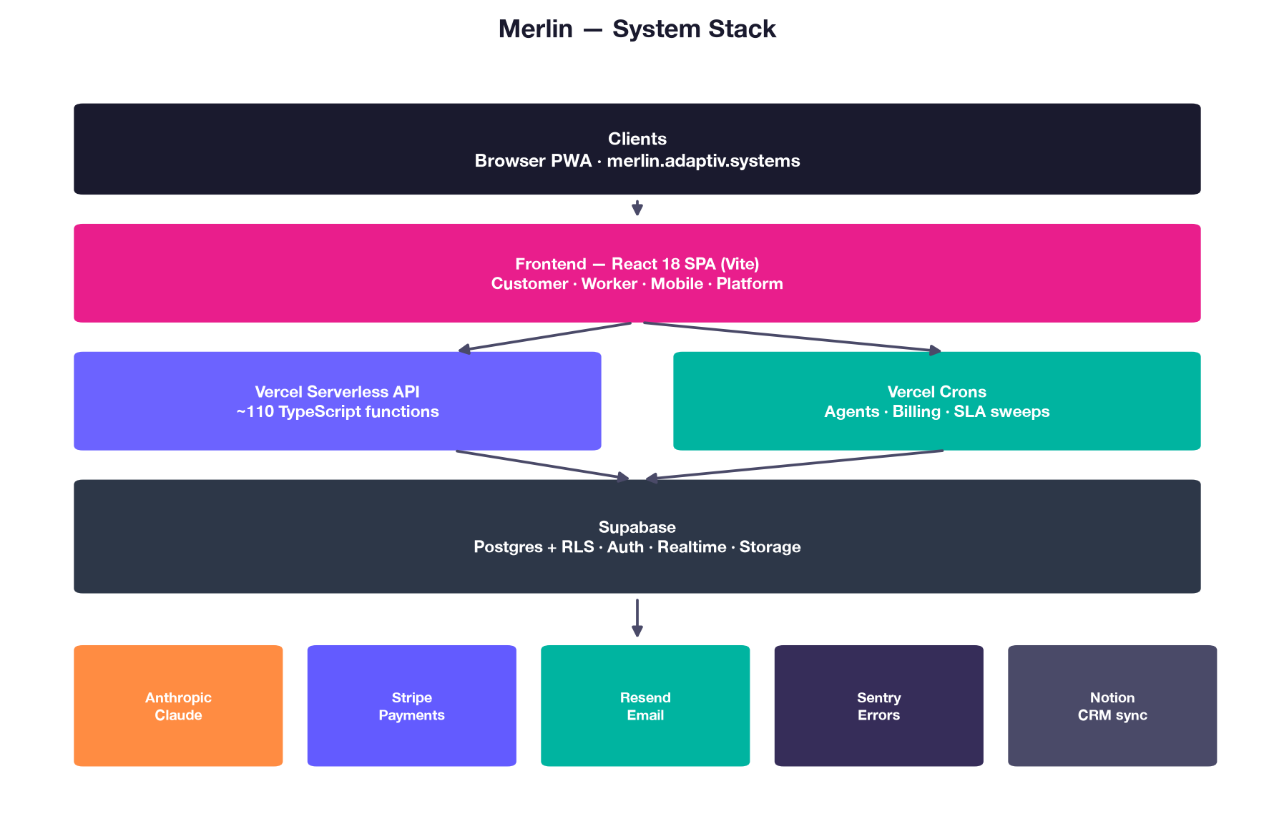

The frontend is a React 18 SPA built with Vite and deployed on Vercel. Heavy routes (Platform, Operations, Insights, Admin) are lazy-loaded to keep the cold-load bundle lean. Business logic that must stay secret (LLM API keys, Stripe, admin operations) runs in ~110 TypeScript serverless functions. Supabase provides Postgres with RLS, authentication, realtime subscriptions, and object storage.
Layer | Technology
Frontend | React 18 · Vite · four app surfaces · i18n EN/FR/DE
Backend | Vercel Serverless Functions — 113 TypeScript files
Database | Supabase Postgres + RLS (259 migrations)
AI | Anthropic Claude (streaming via /api/chat)
Payments | Stripe LIVE — subscriptions, agent add-ons
Email | Resend + Supabase Auth SMTP (SPF/DKIM/DMARC)
Monitoring | Sentry — all API/cron handlers wrapped
Runtime | Node 22.x pinned in CI and production

3. Building Operations Model
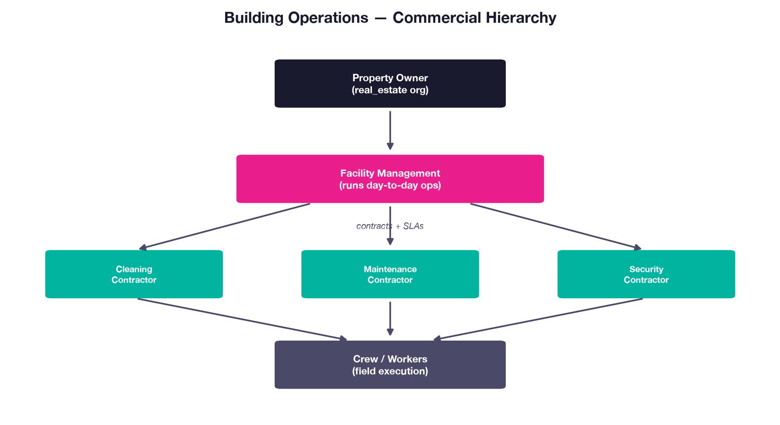

Unlike a naive "one org = one building" model, Merlin models the commercial fabric of real estate operations. Organizations have a kind: real_estate (owners/FMs), contractor (service firms), or adaptiv (platform admin). Locations carry explicit owner_org_id and manager_org_id columns so ownership and management can diverge.
- Real estate orgs — FM orgs hold buildings, configure agents, hire contractors, review compliance.
- Contractor orgs — hold contracts with FM clients; see only their contracted scope via RLS.
- Dual contractor paths — can operate self-serve (own buildings) or manager-invited (inside FM tree).

4. Core Data Model
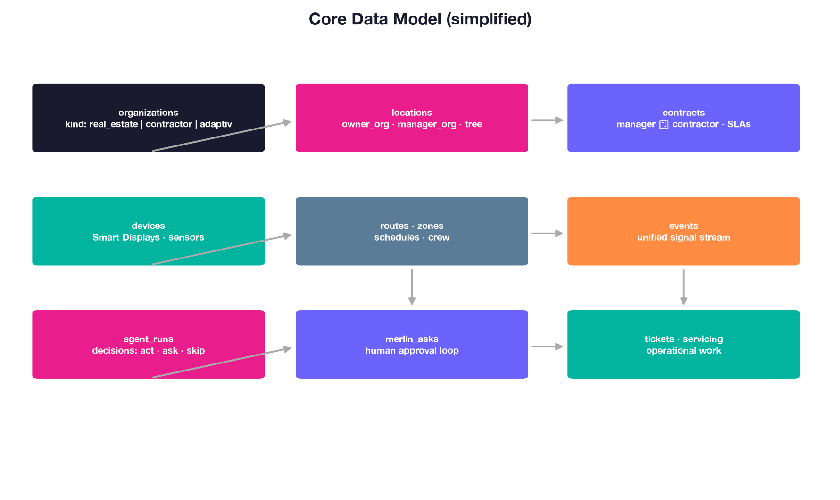

The schema centers on organizations, a hierarchical location tree (campus → building → floor → room → zone), contracts linking manager and contractor parties, operational artifacts (routes, schedules, devices), and the events/agent_runs pipeline that powers AI decision-making. Tickets and servicing boards track human work; merlin_asks implements the human-in-the-loop approval gate before agents act autonomously.

5. Multi-Tenancy & Security
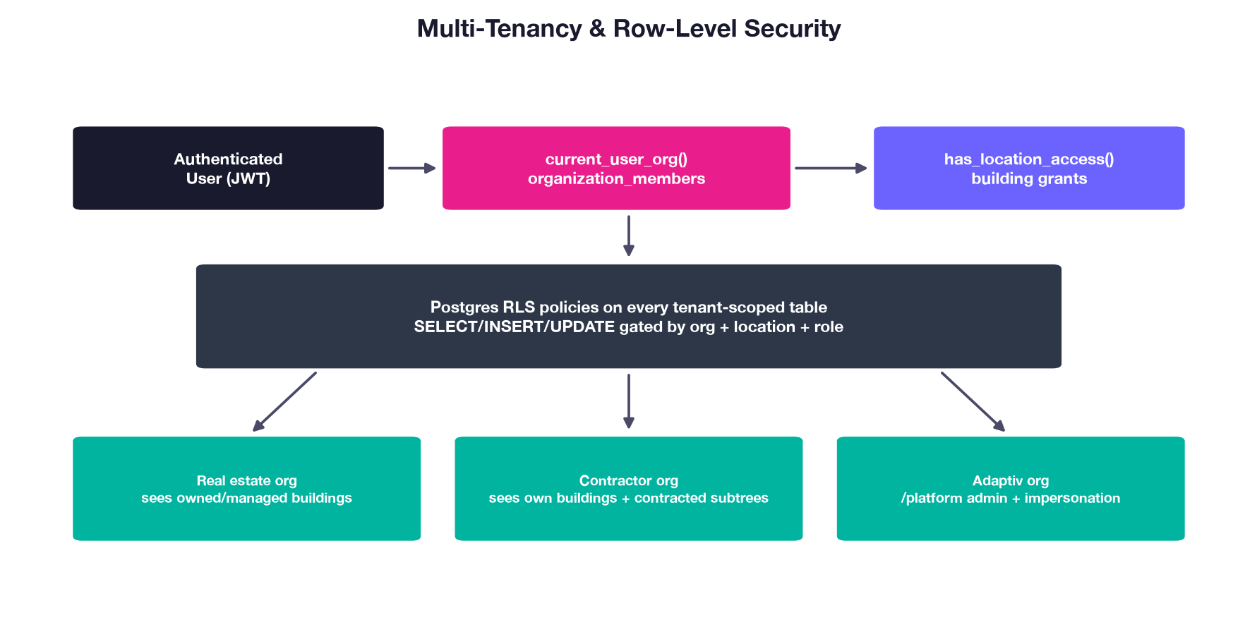

Every tenant-scoped table has Row-Level Security enabled. Helper functions (current_user_org, has_location_access, is_platform_admin, is_contractor_on_location) centralize access logic so policies stay consistent across 259 migrations. June 2026 hardening (migrations 257–259) revoked over-broad PUBLIC execute on RPCs. Contractors reading FM-owned locations use subtree-aware prefix matching on contract_locations. Platform admins operate via a separate /platform shell with impersonation audit logging.

6. Events Pipeline
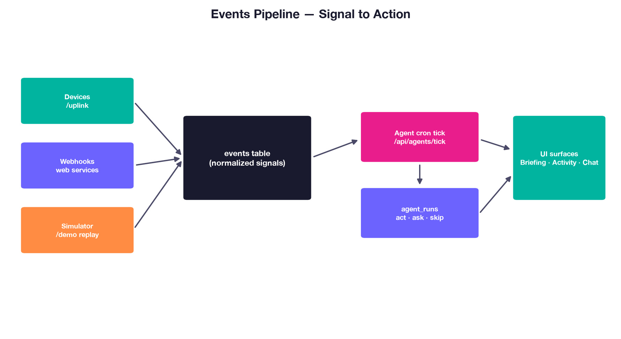

All signals — from physical devices, external webhooks, or the demo simulator — normalize into a single events table. Agent cron jobs (every minute via Vercel crons) read pending events per building, invoke specialized agents (cleaning, HVAC, security, cold chain, etc.), and write decisions to agent_runs. Decisions of type 'ask' surface as Merlin asks requiring human approval; 'act' triggers side-effect tables and tickets.
Demo orgs use replay mode: agent activity is captured once and replayed without calling Anthropic, eliminating LLM cost during sales demos.

7. Application Shells
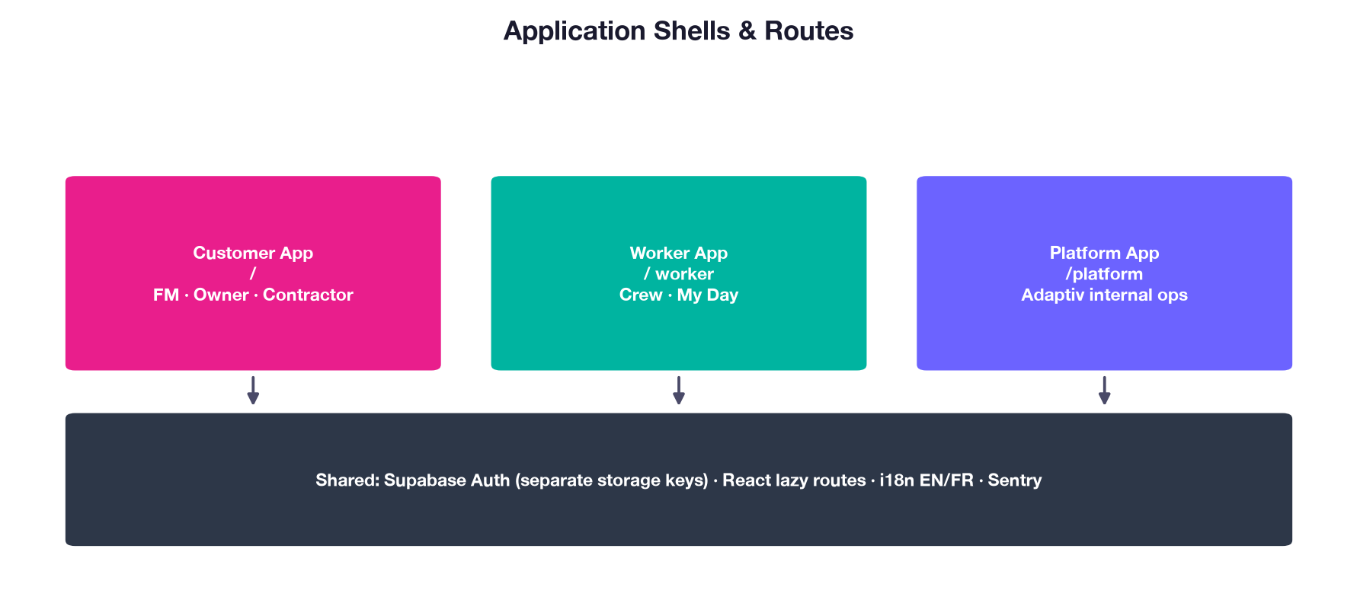

Four lazy-loaded application shells share infrastructure with separate Supabase auth storage keys. Customer app (FM, owners, contractors), worker app (desktop crew), Merlin Field mobile PWA (mobile.adaptiv.systems), and platform app (/platform — Adaptiv internal ops: tenants, Stripe, devices, support, marketing CMS).

8. Customer Experience — Five Pillars
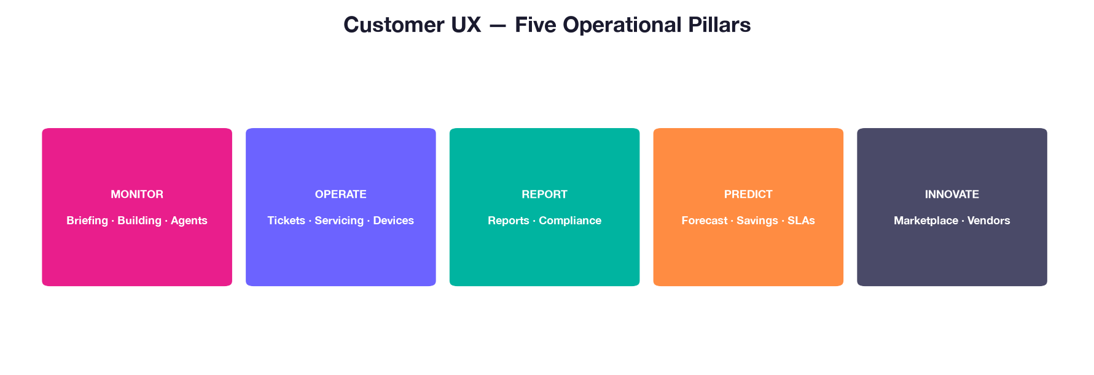

The customer navigation organizes building operations into five pillars. MONITOR surfaces what is happening (briefing, building view, agents). OPERATE is where work gets done (tickets, servicing boards, schedules, devices, 3D hypervisor). REPORT covers compliance and formal outputs. PREDICT provides forecasting, savings, wellbeing, and SLA analytics. INNOVATE connects to Adaptiv's partner marketplace and vendor ecosystem.

9. Engineering Process & CI
Production deploys from main on Vercel after CI passes. PR template codifies test plan, risk level, and rollback notes. Husky pre-commit runs Prettier + ESLint on staged files.
CI job | Purpose
build | Production bundle; fails on Rollup circular-chunk warnings
typecheck (api) | tsc --noEmit — 113/113 API TypeScript files
typecheck (frontend) | @ts-check opt-in modules (27 today)
lint-i18n / lint-rls / lint-js | Translation keys, org scope, hooks = error
test | Vitest — leak suite, money-path guards, smoke, units
e2e | Playwright — 3 hermetic journeys (stub Supabase)
lint-deadcode / audit | Knip + npm audit (informational)

Monolith decomposition (June 2026): MobileApp 2,136→786 lines · Admin 5,088→190 · Dashboard 2,839→384 (complete). Chat split in progress (~1,565 lines).

10. Test Strategy
Critical paths are guarded in CI: cross-tenant RLS leak tests (prod read-only as Lisa@SparkleCo), money-path RPC guards, page render smoke (~33 routes), route-map drift, mobile worker RPC guard, and api/_lib unit tests (autonomy gate, Stripe config, push dispatch).
Playwright E2E (hermetic, no prod secrets):
- mobile-happy-path — worker marks task done, raises ticket with photo
- login — password sign-in to signed-in surface
- ask — worker Ask Merlin tab receives reply in thread
Open: desktop approve-flow and contractor login E2E. Handler-level HTTP integration tests (Stripe webhook signature) remain manual.

11. Security & Governance Policies
Lightweight policies ship in docs/deliverables/policies/ for enterprise questionnaires:
- Information Security Policy
- Access Control Policy (MFA, named prod admins)
- Incident Response Policy (Sentry → triage → rollback → postmortem)
- Change Management Policy (PR + CI + main deploy)
- Data Retention & Tenant Deletion Policy
Subprocessors: Supabase, Vercel, Stripe, Resend, Anthropic, Sentry — DPA/SOC 2 register at docs/deliverables/subprocessors/. Not SOC 2 certified; inherit from vendors when required.

12. Scalability (~100 Tenants)
Completed hardening:
- Pagination past PostgREST 1K cap
- Per-tenant write rate limiting (migration 066)
- Composite indexes on hot paths (migration 064)
- RPC least-privilege (migrations 257–259)
Open before scale milestone:
- Realtime subscription org-scoping
- RLS performance audit (pg_stat_statements)
- Executed backup PITR drill (procedure documented)
- Load test on sandbox restore
- tenant_seed_starter provisioning RPC

13. Known Gaps (June 2026)
Gap | Severity
2 more Playwright E2E journeys | Medium
Sentry → Slack metric alerts | Medium
Backup drill dated record | Medium
Chat.jsx split completion | Low
GDPR export + hard delete | Medium if EU GTM
Knip blocking in CI | Low

14. 90-Day Engineering Priorities
- Finish Chat.jsx split · desktop + contractor E2E
- Sentry alerts · backup drill documentation
- Knip ratchet · App.jsx decomposition
- Load test · @ts-check net expansion (target 50+ modules)

15. Production Tenancy
Eight organizations run in production today:
- Meridian — flagship multi-building tenant (HQ tower + warehouse + healthcare clinic)
- First Empire Bank — 581-branch ecosystem
- International Monetary Fund — internal-only institutional demo
- SparkleCo, ShineRight, NorthStar, GuardWatch — contractor orgs on Meridian
- Adaptiv — platform admin org
Merlin passes Series-A technical due diligence on schema, multi-tenancy, and CI. Remaining investment is governance packaging, two E2E journeys, and ops proof — not an architectural rewrite.

Merlin Technical Appendix · docs/deliverables/ · Regenerate: python3 scripts/generate-merlin-architecture-doc.py

