# Installation

Extract the contents of the Deployment folder onto fdc1s-sp23wfet1. Open the SharePoint Management Shell as Administrator and change the directory to the deployment folder path. Run the DeploymentScript.ps1 with the appropriate environment flag for TEST.

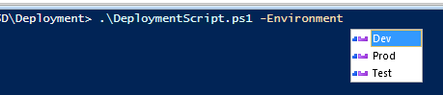

*Select the appropriate Environment when deploying.*

This will install all of the WSPs within the WSPs folder and activate all of the features that were deployed and create a SQL backup of the ASD Content DB.

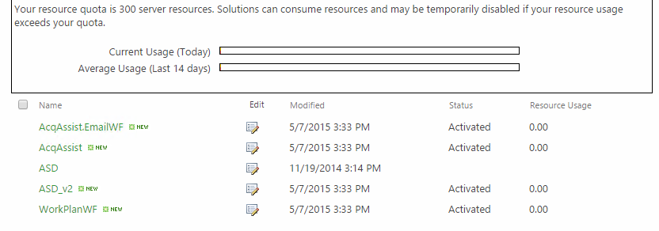

This will also add the new Work Plan site columns to the legacy forms and add a new field to the ASD Base content type and enforce unique values on the Title column for the Acquisition Assistance list.

# Rollback

Open SharePoint Management Shell as administrator, change the directory to the POSH folder within the deployment path. Run the Restore-ASD.ps1 with the appropriate environment flag for TEST.

Give the svc.spfarm.test service account DB Owner on the SPTEST_Content_ASD database by logging into the fdc1s-sp23sqlt1 server. ***This account may already have these permssions.***

Go to [Site Features](https://test.sp.ferc.gov/asd/_layouts/15/ManageFeatures.aspx) and disable the ASD feature, then re-enable the ASD feature.

The restore is finished and ASD will be back in a state prior to deployment.