# Set up People picker

<https://github.com/OfficeDev/PnP/tree/master/Components/Core.PeoplePicker>

Changes:

1. Not use app.js, but copy the code to the page because each page need different people picker, and the page already have the document.ready() method. Refactor the code to have multiple people picker in 1 page.
2. Control in aspx must have “ClientID = ‘Static’” because the ID from the page is generated with the masterpage name, so the javascript cannot find the ID during parsing and query the people picker

<div class="col-md-3">

<div class="ms-core-form-line">

<div id="divCsomAdministrators" class="cam-peoplepicker-userlookup ms-fullWidth">

<span id="spanCsomAdministrators"></span>

<asp:TextBox ID="inputCsomAdministrators" ClientIDMode="Static" runat="server" CssClass="cam-peoplepicker-edit" Width="70"></asp:TextBox>

</div>

<div id="divCsomAdministratorsSearch" class="cam-peoplepicker-usersearch"></div>

<asp:HiddenField ID="hdnCsomAdministrators" ClientIDMode="Static" runat="server" />

</div>

</div>

1. Modify the css in peoplepicker.css to have the border in cam-peoplepicker-usersearch

# Source control

Project use git as default source control. All changes is committed locally first.

When a changes is ready to push to TFS, go to Team🡪 Connect to team foundation server, select PIW and click on Connect, click on Source Control Explorer

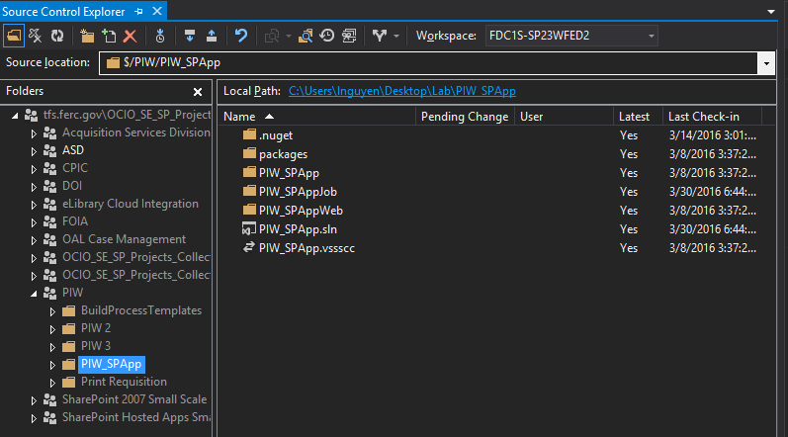

The project is mapped to the local location in server. Right click on PIW_SPApp and select “Check in all pending changes”. All changes made my visual studio will be checked in to FERC TFS.