Front End Design Exercise

Summary
Attached is a zip file with a .psd showing search results for purchasing tickets to event and attractions. In order for the end user to make a selection they have to hit the “View Pricing” button. This causes:
- A section to expand, exposing a form that the end user must fill out to provide details of they wish to purchase.
- The View Pricing button also changes to show arrows pointing downward.
- When you click the view Pricing Button again the page should contract to how it was before.

Before Clicking View Details | After Clicking View Details
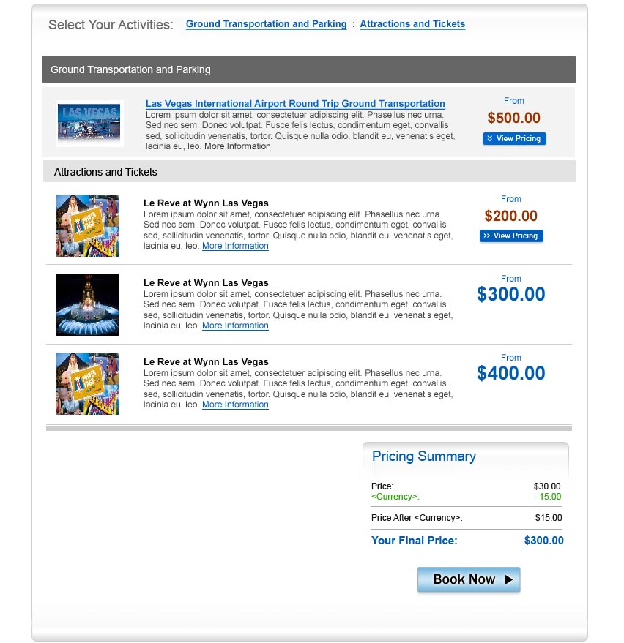 | 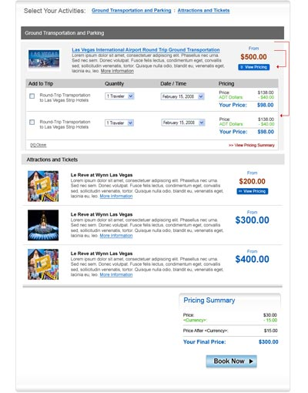

Task
If choose to undertake this test exercise you should build out the attached .psd using HTML/CSS plus create the expanding/contracting ability using JQuery. Make sure it is cross browser compatible. Please email the end result to me, or post on a web location.

Note
Please be advised, that we have already built these pages and their functionality and currently in the process of implementing. This is therefore only a test of skillset.

Thanks in advance for your effort!

