CareAgent
Diagram Documentation
Workflow Diagram · UML Class Diagram · Use Case Diagram
A detailed technical explanation of all three system diagrams for the CareAgent
AI-Driven Clinical Decision Support Prototype

1. Introduction
This document provides a comprehensive technical explanation of the three system diagrams produced for the CareAgent project: a multi-agent AI clinical decision support prototype developed as a final year project for the BSc Artificial Intelligence programme at Northumbria University. The three diagrams are the Workflow Diagram, the UML Class Diagram, and the Use Case Diagram. Together they provide a complete picture of how CareAgent is structured, how data and control flow through the system, and how different user roles and external systems interact with it.
Each diagram is explained from first principles, covering its purpose, the notation conventions used, a walk-through of every component it contains, and how it relates to the actual Python implementation of the system. The explanations are written for a reader who understands software engineering concepts but may be encountering CareAgent's architecture for the first time.
CareAgent is a working multi-agent AI prototype. Its five agents — Orchestrator, Patient Intake, Diagnostic Reasoning, Treatment Planner, and Clinician Liaison — collaborate to synthesise patient data, generate differential diagnoses using XGBoost and SHAP, match findings to clinical guidelines, and deliver explainable recommendations to clinicians.

2. Workflow Diagram

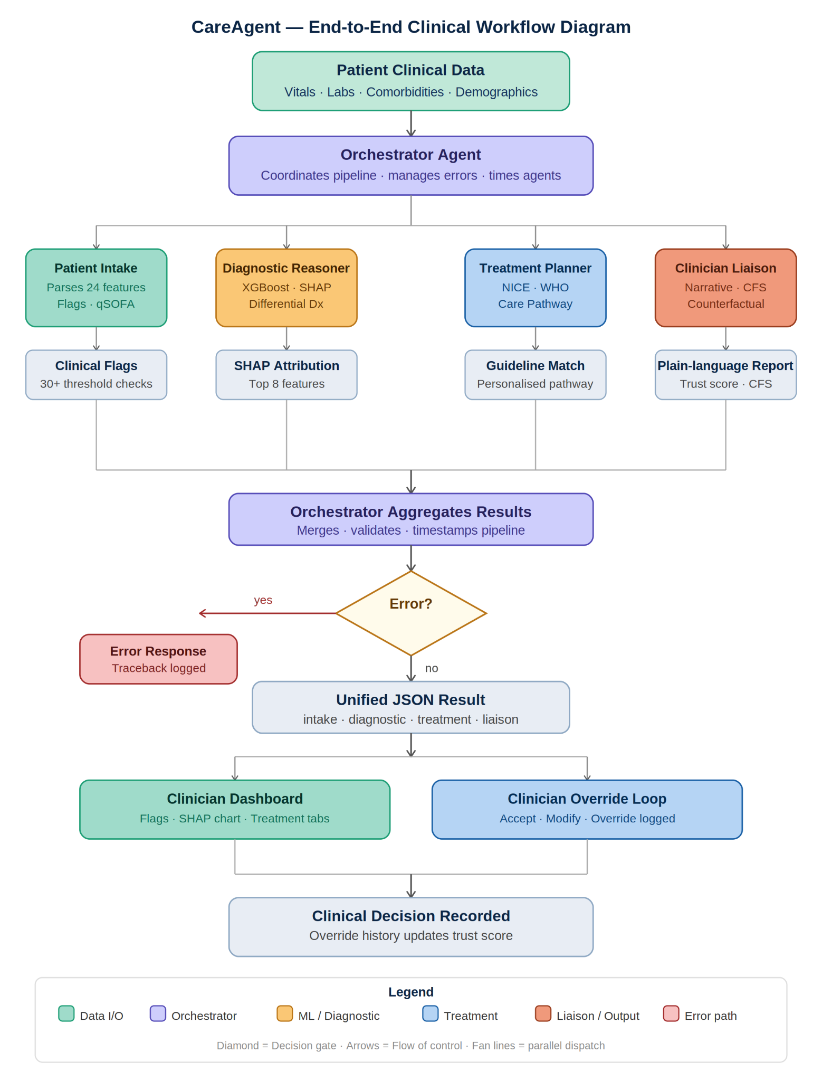

2.1 Purpose and Overview
The workflow diagram is a flowchart that maps the complete end-to-end operational pipeline of CareAgent, from the moment a clinician submits patient data to the point at which a clinical decision is recorded and the system's trust score is updated. It is a process-oriented diagram: it shows what happens, in what order, and under what conditions, rather than showing how the software is structured internally.
The diagram uses standard flowchart notation: rectangular nodes for processes and actions, a diamond for a decision gate (the error check), and directional arrows to show the sequence of control. Colour coding is applied consistently: teal nodes represent data input and output, purple nodes represent Orchestrator activity, amber nodes represent the diagnostic and ML layer, blue nodes represent the treatment pathway, coral nodes represent the clinician liaison and communication layer, and red indicates the error handling path.

2.2 Stage-by-Stage Walkthrough
Stage 1: Patient Clinical Data (Input)
The workflow begins with a teal-coloured input node labelled 'Patient clinical data', subtitled 'Vitals · Labs · Comorbidities · Demographics'. This node represents the raw data provided by the clinician or loaded from a demo patient record. In the implementation, this data is a Python dictionary containing 24 clinical features including heart rate, systolic blood pressure, respiratory rate, SpO2, temperature, white blood cell count, lactate, creatinine, troponin, C-reactive protein, sodium, potassium, glucose, haemoglobin, platelet count, ALT, bilirubin, age, sex, and five binary comorbidity flags (diabetes, hypertension, chronic kidney disease, coronary artery disease, and recent infection). This raw dictionary is passed directly to the Orchestrator Agent as the starting point of the pipeline.
Stage 2: Orchestrator Agent (Dispatch)
The data flows into the first purple Orchestrator Agent node, labelled 'Coordinates pipeline · manages errors · times agents'. This is the central coordinating class of the system, implemented as OrchestratorAgent in agents/orchestrator.py. The Orchestrator's role at this stage is to receive the raw patient record, record the pipeline start time, initialise the result dictionary, and then dispatch the data to the four specialist agents in sequence. It does not perform any clinical reasoning itself; it is purely a coordinator. This separation of concerns is a key architectural decision: the Orchestrator knows which agents exist and in what order to call them, but it has no knowledge of clinical features, model predictions, or treatment guidelines.
Stage 3: The Four Specialist Agents (Parallel Sub-Pipeline)
Below the Orchestrator, the diagram shows four agents arranged side by side, connected to the Orchestrator by a horizontal distribution line with vertical drops. This layout reflects the logical decomposition of the clinical task into four specialist concerns. In the Python implementation these agents are called sequentially (not truly in parallel), but the diagram presents them as a conceptual tier to emphasise their equal status as peer sub-systems. Each agent receives its inputs from the previous agent's output rather than from raw patient data, forming a sequential chain:
- Patient Intake Agent (teal): Receives the raw patient dictionary. Parses all 24 features, applies 30+ evidence-based threshold checks to generate clinical flags (such as Hypotension, Elevated Lactate, Tachycardia, and Leukocytosis), computes the qSOFA (quick Sequential Organ Failure Assessment) score as a sepsis screening tool, identifies comorbidities, and returns a structured IntakeSummary dictionary. This is implemented in agents/intake_agent.py.
- Diagnostic Reasoning Agent (amber): Receives the IntakeSummary. Constructs a 24-element feature vector from the raw patient data, loads the pre-trained XGBoost classifier, obtains class probability estimates for all ten supported diagnoses, and applies a Contextual Clinical Score (CCS) multiplier based on the acuity of each diagnosis. It then invokes the SHAP TreeExplainer to compute feature attribution values for the top predicted diagnosis, identifying up to eight key contributing features split into supporting (positive SHAP) and against (negative SHAP) factors. This is implemented in agents/diagnostic_agent.py.
- Treatment Planner Agent (blue): Receives the top differential diagnosis name from the DiagnosticResult. Looks up the corresponding entry in its internal NICE/WHO/Surviving Sepsis Campaign guideline knowledge base (stored in agents/treatment_agent.py), which contains 10 complete evidence-based protocols covering immediate actions, required investigations, pharmacological treatments, monitoring parameters, and recommended disposition. It also applies patient-specific personalisation notes based on comorbidities detected by the Intake Agent.
- Clinician Liaison Agent (coral): Receives the IntakeSummary, DiagnosticResult, and TreatmentPlan. Synthesises these into a plain-language clinical narrative, generates a counterfactual explanation (describing what would change if the primary SHAP driver had been within normal range), applies a trust calibration score, and optionally calls the Claude API to enrich the narrative if an API key is present. This is implemented in agents/liaison_agent.py.
Stage 4: Agent Sub-Step Nodes
Below each agent, the diagram shows a grey sub-step node representing the primary output of that agent: 'Clinical flags' (30+ threshold checks), 'SHAP attribution' (top 8 features), 'Guideline match' (personalised pathway), and 'Plain-language report' (trust score and Contextual Clinical Score). These sub-step nodes are included in the diagram to make the outputs tangible and to emphasise that each agent produces a concrete, structured artefact rather than simply modifying shared state.
Stage 5: Convergence and Orchestrator Aggregation
The four vertical lines from the sub-step nodes converge at a horizontal merge line, which then feeds into the second purple Orchestrator node labelled 'Orchestrator aggregates results'. This stage represents the Orchestrator collecting the output dictionaries from all four agents, merging them into a single unified result object, adding timing metadata (the pipeline_ms field recording total elapsed time), and preparing the JSON response. In the implementation, this is the return statement of the OrchestratorAgent.run() method.
Stage 6: Error Decision Gate
The aggregated result passes through a diamond-shaped decision gate labelled 'Error?'. If any agent raised an exception during execution — for example, if the model files were not found, if the patient data was malformed, or if a guideline lookup failed — the Orchestrator catches the exception and stores it in the result's 'error' field along with a full traceback. The 'yes' branch leads to a red error response node. The 'no' branch, taken in the normal execution path, continues downward to the unified JSON result. This error gate is implemented using a try/except block in OrchestratorAgent.run().
Stage 7: Unified JSON Result
The grey node labelled 'Unified JSON result' represents the structured Python dictionary returned by the Orchestrator, containing four top-level keys: intake (the IntakeSummary), diagnostic (the DiagnosticResult including differentials, SHAP values, and confidence), treatment (the TreatmentPlan with full guideline content), and liaison (the LiaisonReport with narrative, counterfactual, and trust score). This dictionary is serialised to JSON by Flask and returned to the client as the HTTP response body from the /api/analyse endpoint.
Stage 8: Dashboard Outputs and Clinician Override Loop
The result fans out into two teal/blue branches. The left branch represents the clinician dashboard — the Flask web interface that renders the clinical flags, vital signs grid, differential diagnosis bars, SHAP waterfall chart, and tabbed treatment pathway. The right branch represents the clinician override loop: the clinician can accept the recommendation, modify the proposed treatment (for example, substituting an antibiotic due to a known allergy), or reject the recommendation entirely. All override decisions are logged, and the override history is used to update the clinician-specific trust calibration weight for future pipeline runs.
Stage 9: Clinical Decision Recorded
The two branches reconverge at the terminal grey node labelled 'Clinical decision recorded · Override history updates trust score'. This represents the persistent outcome of a single pipeline run: the clinician's decision (whether it matched the AI recommendation or not) is stored, and the Clinician Liaison Agent's trust score for this clinician is recalibrated accordingly. In the current prototype this is a simple in-memory update; a production system would persist this to a database.

2.3 Key Design Decisions Reflected in the Workflow
Several important architectural decisions are visible in the workflow diagram. The separation of the Orchestrator from the four specialist agents reflects the principle of single responsibility: each component does exactly one thing. The sequential rather than parallel agent execution reflects the data dependencies between agents (the Diagnostic Agent needs the Intake output; the Treatment Agent needs the top diagnosis; the Liaison Agent needs all three). The error gate reflects the defensive programming approach taken in the Orchestrator, ensuring that partial failures are contained and reported rather than propagated as Python exceptions to the Flask caller. The override loop reflects the human-in-the-loop design principle mandated by the NHS AI Ethics Framework and the EU AI Act, ensuring that the clinician retains full accountability.

3. UML Class Diagram

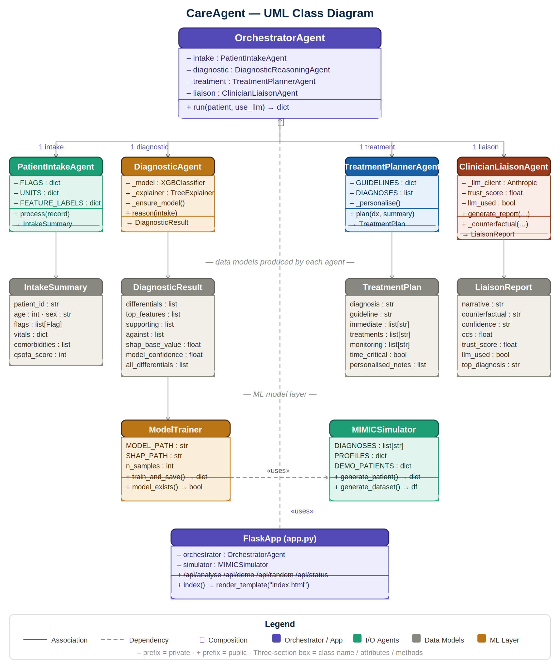

3.1 Purpose and Overview
The UML (Unified Modelling Language) class diagram documents the static structure of the CareAgent software system. Unlike the workflow diagram, which shows process and sequence, the class diagram shows what classes exist, what attributes and methods each class has, and how the classes relate to one another through association, composition, and dependency relationships. It is the primary reference for understanding the codebase's organisation and is intended for use by developers who need to extend or maintain the system.
The diagram uses standard UML class notation: each class is represented as a three-section rectangle containing the class name at the top, attributes (prefixed with '–' for private) in the middle section, and methods (prefixed with '+' for public) in the bottom section. Relationships are shown as lines with specific arrowhead types: a filled diamond (◆) at the source indicates composition (the source owns the target), a dashed arrow indicates a dependency or 'uses' relationship, and a solid arrow indicates a directed association.

3.2 Class-by-Class Description
OrchestratorAgent
OrchestratorAgent is the top-level coordinating class, shown in purple to reflect its orchestration role. It holds four private attributes — intake, diagnostic, treatment, and liaison — each typed as the corresponding specialist agent class. These four attributes are initialised in the constructor and represent composition relationships: the OrchestratorAgent owns and is responsible for the lifecycle of each sub-agent. The single public method is run(patient, use_llm) which accepts a raw patient dictionary and a boolean flag controlling LLM usage, and returns a unified result dictionary. In the diagram, composition relationships are represented by a filled diamond at the Orchestrator end of each connecting line and a directional arrow pointing to each sub-agent, with multiplicity labels (1 intake, 1 diagnostic, 1 treatment, 1 liaison) indicating that exactly one instance of each sub-agent is held.
PatientIntakeAgent
PatientIntakeAgent is shown in teal, reflecting its role as the data input and parsing layer. Its two class-level attributes are FLAGS (a dictionary mapping flag names to threshold-checking lambda functions) and UNITS (a dictionary mapping feature names to display units and decimal precision). The single public method is process(record) which accepts a raw patient dictionary and returns an IntakeSummary. In the implementation, this method evaluates all 30+ flag conditions, computes the qSOFA score, formats vitals for display, and identifies comorbidities. The class has no instance state (all data is derived from the input record), making it effectively a stateless transformer.
DiagnosticReasoningAgent
DiagnosticReasoningAgent is shown in amber, reflecting its role as the machine learning and explainability layer. It has two private instance attributes: _model (an XGBoost XGBClassifier instance) and _explainer (a SHAP TreeExplainer instance). These are loaded lazily via the private _ensure_model() method, which checks whether the serialised model files exist and trains them from scratch if not. The public reason(intake) method accepts an IntakeSummary dictionary and returns a DiagnosticResult dictionary containing the ranked differential diagnosis, SHAP feature contributions, and confidence metrics. The lazy loading pattern is necessary because model training takes approximately 30 seconds and should not block application startup.
TreatmentPlannerAgent
TreatmentPlannerAgent is shown in blue, reflecting its role in treatment pathway planning. Its two class-level attributes are GUIDELINES (a large dictionary mapping diagnosis names to structured guideline entries) and DIAGNOSES (a list of the ten supported diagnosis strings). The public plan(dx, summary) method accepts a diagnosis name and the patient summary, looks up the corresponding guideline entry, applies personalisation based on the patient's comorbidities and flags, and returns a TreatmentPlan dictionary. The personalisation logic is handled by a private module-level function _personalise(), which adds contextual notes for conditions such as CKD (dose adjustment), advanced age (frailty assessment), and unexplained source of infection.
ClinicianLiaisonAgent
ClinicianLiaisonAgent is shown in coral, reflecting its role as the communication and explanation layer. Its three private instance attributes are _llm_client (an Anthropic API client, initialised only if an API key is present), trust_score (a float representing the calibrated confidence for the current clinician), and llm_used (a boolean flag recording whether the LLM was used in the current run). The public generate_report() method accepts the three upstream outputs and produces a LiaisonReport. It first attempts to call the Claude API for a richer narrative; if this fails or no key is available, it falls back to a high-quality template-based narrative. The private _counterfactual() method generates the counterfactual explanation by identifying the highest-SHAP feature and describing what the diagnosis would have been had that feature been within normal range.
Data Model Classes
The four grey data model classes — IntakeSummary, DiagnosticResult, TreatmentPlan, and LiaisonReport — are shown below their corresponding agent classes, connected by directed association arrows. These classes represent the structured output dictionaries produced by each agent. In the Python implementation they are plain dictionaries rather than typed classes, but they are documented here as classes to make their schemas explicit and to aid developers who might refactor the system to use dataclasses or Pydantic models.
IntakeSummary contains patient_id, age, sex, flags (a list of flag entries with priority markers), vitals (a formatted dictionary keyed by feature name), comorbidities, qsofa_score, flag_count, and raw (the original input record for downstream use). DiagnosticResult contains differentials (a ranked list of diagnosis entries with probability, CCS, and acuity multiplier), top_features, supporting, against, shap_base_value, and model_confidence. TreatmentPlan contains diagnosis, guideline, source, time_critical, bundle_window, and the five content lists: immediate, investigations, treatments, monitoring, and personalised_notes. LiaisonReport contains narrative, counterfactual, confidence, ccs, trust_score, llm_used, top_diagnosis, and shap_summary.
ModelTrainer
ModelTrainer is shown in amber in the ML layer below the agent tier. It is responsible for generating the synthetic MIMIC-III training data, training the XGBoost classifier, building the SHAP TreeExplainer, saving both to disk as pickle files, and writing a per-class classification report. Its class-level attributes are MODEL_PATH and SHAP_PATH (paths to the serialised artefacts) and n_samples (the training set size, defaulting to 3,000). Its two public methods are train_and_save() (which executes the full training pipeline and returns a metrics dictionary) and model_exists() (a convenience predicate used by DiagnosticReasoningAgent to decide whether training is needed). ModelTrainer has a dependency relationship with MIMICSimulator, shown as a dashed arrow labelled 'uses', because it calls generate_dataset() to produce its training data.
MIMICSimulator
MIMICSimulator is shown in teal in the ML layer. It is the data generation module that produces clinically realistic synthetic patient records mirroring the value distributions of the MIMIC-III ICU dataset. Its class-level attributes are DIAGNOSES (a list of ten diagnosis strings), PROFILES (a dictionary of per-diagnosis statistical parameter tuples defining the mean, standard deviation, and clipping bounds for each of the 24 clinical features), and DEMO_PATIENTS (a dictionary of three pre-defined patient scenarios: sepsis_classic, ami_stemi, and dka_young). Its two public methods are generate_patient() (which samples a single patient record for a given or randomly selected diagnosis) and generate_dataset() (which generates a balanced dataset of n records across all ten diagnosis classes). The module is used both by ModelTrainer during training and by FlaskApp to serve random and demo patient data via the REST API.
FlaskApp
FlaskApp is shown in purple at the bottom of the diagram, reflecting its role as the application entry point and API layer. It holds two private dependencies: an OrchestratorAgent instance (used to process patient data) and a MIMICSimulator reference (used to serve demo and random patients). Its public interface consists of five Flask route handlers: /api/analyse (POST, runs the full pipeline), /api/demo/<name> (GET, returns a named demo patient), /api/random (GET, returns a randomly generated patient), /api/diagnoses (GET, returns the list of supported diagnoses), and /api/status (GET, returns system readiness including model availability and LLM enablement). The FlaskApp's dependency on OrchestratorAgent is shown as a long dashed arrow labelled 'uses' running from the bottom of the diagram back to the Orchestrator at the top, emphasising that the entire agent hierarchy is instantiated and owned by the application layer.

3.3 Relationship Summary

From | To | Relationship | Meaning
OrchestratorAgent | PatientIntakeAgent | Composition (◆) | Orchestrator owns and creates the Intake agent
OrchestratorAgent | DiagnosticReasoningAgent | Composition (◆) | Orchestrator owns and creates the Diagnostic agent
OrchestratorAgent | TreatmentPlannerAgent | Composition (◆) | Orchestrator owns and creates the Treatment agent
OrchestratorAgent | ClinicianLiaisonAgent | Composition (◆) | Orchestrator owns and creates the Liaison agent
DiagnosticAgent | ModelTrainer | Association | Diagnostic agent loads model produced by Trainer
ModelTrainer | MIMICSimulator | Dependency («uses») | Trainer calls generate_dataset() to get training data
FlaskApp | OrchestratorAgent | Dependency («uses») | App instantiates and calls the Orchestrator per request

4. Use Case Diagram

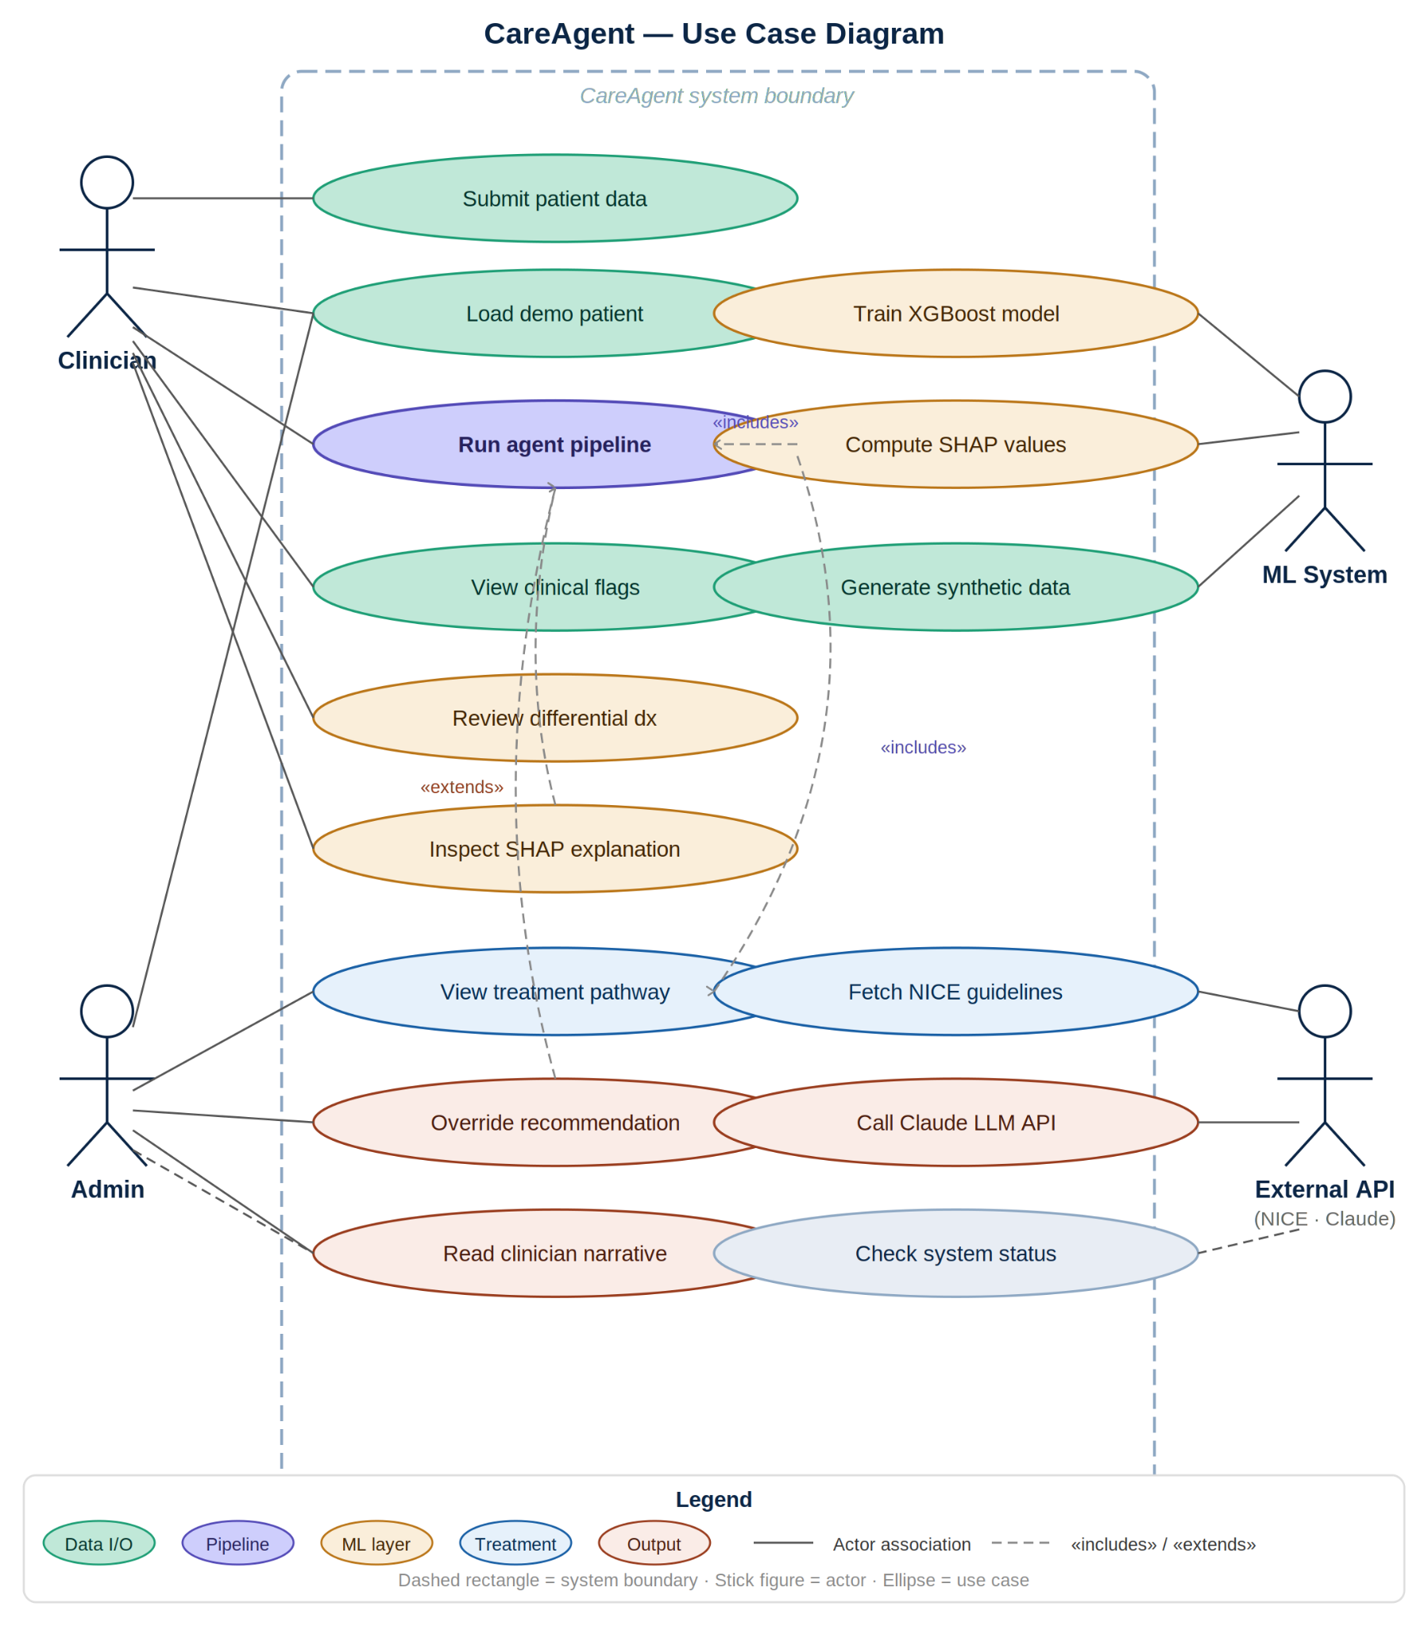

4.1 Purpose and Overview
The use case diagram is a behavioural UML diagram that documents who interacts with CareAgent and what goals they can achieve through those interactions. Unlike the workflow diagram (which shows how data flows) and the class diagram (which shows how the code is structured), the use case diagram is written from the perspective of external actors: it captures requirements rather than implementation. It is the appropriate starting point for understanding the system from a user's or stakeholder's point of view.
The diagram follows standard UML use case notation. The system boundary is drawn as a dashed rectangle labelled 'CareAgent system', containing all use cases that the system supports. Actors are represented as stick figures outside the boundary, connected to their associated use cases by solid association lines. Use cases are represented as ellipses containing short verb-phrase labels. Stereotyped relationships («includes» and «extends») are shown as dashed arrows between use cases inside the boundary.

4.2 Actors
Clinician
The Clinician actor represents any registered healthcare professional who uses the CareAgent dashboard to obtain decision support for a patient. This includes Foundation Year doctors, Core Medical Trainees, Registrars, and Consultants. The Clinician is the primary actor of the system: the majority of use cases are initiated by or in response to a Clinician action. The Clinician interacts with the system through the Flask web dashboard at http://localhost:5000, submitting patient data and receiving the pipeline output.
Admin
The Admin actor represents a technical administrator responsible for system maintenance. The Admin's interactions with CareAgent are primarily operational rather than clinical: training the machine learning model, checking system status and model readiness, and monitoring the system for errors. In the current prototype, Admin actions are performed via command-line tools (python models/trainer.py) rather than through the web interface, though a production deployment would typically expose these through a protected admin panel.
ML System
The ML System actor is a non-human actor representing the machine learning infrastructure. It participates in use cases that involve automated computation rather than user-initiated requests: training the XGBoost model, computing SHAP values, and generating synthetic patient data from the MIMIC-III simulator. In UML terms this is a system actor — a software system that interacts with CareAgent either as a dependency (the trained model files) or as an internal computational service (the SHAP explainer invoked during each pipeline run).
External API
The External API actor represents two third-party services that CareAgent communicates with: the NICE clinical guideline knowledge base (currently implemented as a local JSON store in the prototype, but designed to be replaced by live API calls in production) and the Anthropic Claude API used by the Clinician Liaison Agent to generate enriched plain-language narratives when an API key is configured. This actor is non-human and non-interactive: CareAgent calls these services programmatically during pipeline execution.

4.3 Use Case Descriptions
Submit Patient Data (Clinician)
The primary initiating use case. The Clinician enters or pastes patient clinical data into the dashboard form — 24 numerical and binary fields covering vitals, laboratory results, and comorbidities — or loads a pre-defined demo patient using the demo patient loader. This use case populates the patient data dictionary that will be submitted to the pipeline. It corresponds to the HTTP POST body sent to /api/analyse.
Load Demo Patient (Clinician)
A supporting use case that allows the Clinician to populate the form automatically from one of three pre-defined clinical scenarios: a 67-year-old male with classic sepsis features (elevated lactate, hypotension, fever, leukocytosis), a 58-year-old male with STEMI-pattern acute myocardial infarction (high troponin, chest pain, CAD history), or a 24-year-old female with diabetic ketoacidosis (extreme hyperglycaemia, hyperkalaemia, Kussmaul breathing pattern). These cases are served by the /api/demo/<name> endpoint and are implemented as static dictionaries in data/mimic_simulator.py.
Run Agent Pipeline (Clinician)
The central use case that triggers the full CareAgent multi-agent pipeline. Initiated when the Clinician clicks 'Run CareAgent Pipeline' on the dashboard. This use case «includes» 'Compute SHAP values' (because SHAP attribution is always computed as part of the diagnostic reasoning step) and logically «includes» 'Fetch NICE guidelines' (because guideline matching is always performed as part of the treatment planning step). The pipeline typically completes in under two seconds for a single patient record and returns the unified JSON result to the dashboard for rendering.
View Clinical Flags (Clinician)
After the pipeline runs, the Clinician can view the set of clinical flags raised by the Patient Intake Agent. These are displayed as colour-coded badges in the dashboard: high-priority flags (such as Severe Hypoxia, Severe Lactataemia, and Hypotension) are shown in red, while routine flags (such as Tachycardia, Fever, and Elevated CRP) are shown in green. The qSOFA score is displayed prominently alongside the flags as a validated sepsis screening metric. This use case is purely presentational and does not trigger any further computation.
Review Differential Diagnosis (Clinician)
The Clinician reviews the ranked list of up to five differential diagnoses produced by the Diagnostic Reasoning Agent. Each diagnosis entry displays its name, the base model probability, the Contextual Clinical Score (CCS), and the acuity multiplier applied. A horizontal progress bar visualises the CCS for each diagnosis, allowing the Clinician to quickly assess the relative confidence of each candidate. The top diagnosis is highlighted with a star and a distinct background colour.
Inspect SHAP Explanation (Clinician)
The Clinician inspects the SHAP waterfall chart showing the contribution of each clinical feature to the top diagnosis prediction. Features with positive SHAP values (supporting the diagnosis) are shown as right-extending green bars; features with negative SHAP values (arguing against the diagnosis) are shown as left-extending red bars. The magnitude of each bar is proportional to the feature's absolute SHAP contribution. This use case «extends» 'Run Agent Pipeline' in the sense that it is only accessible after the pipeline has produced a result, but it does not trigger any additional computation.
View Treatment Pathway (Clinician)
The Clinician views the evidence-based treatment pathway proposed by the Treatment Planner Agent. The pathway is presented in four tabs: Immediate (time-critical actions to be taken within the bundle window), Investigations (diagnostic tests to order), Treatments (pharmacological and procedural interventions), and Monitoring (ongoing parameters to track). The guideline source (e.g., NICE NG51 for sepsis) is displayed as a hyperlink, and any personalised notes generated from the patient's comorbidities are shown in an amber callout box at the bottom.
Override Recommendation (Clinician)
The Clinician may disagree with or wish to modify the AI recommendation. This use case captures the act of recording a clinical override: the Clinician accepts the diagnosis but changes the proposed antibiotic, or rejects the top diagnosis in favour of an alternative, or modifies the disposition recommendation. In the prototype, overrides are logged to the pipeline result; in a production system they would be persisted to a patient record and used to update the clinician-specific trust calibration weight. This use case «extends» 'Run Agent Pipeline' because it presupposes that a pipeline result exists.
Read Clinician Narrative (Clinician)
The Clinician reads the plain-language clinical summary produced by the Liaison Agent. This summary synthesises the patient demographics, clinical flag count, qSOFA score, comorbidities, top diagnosis with confidence level, key SHAP drivers, relevant guideline reference, and recommended disposition into a coherent narrative paragraph. If the Claude API is enabled, the narrative is generated by the LLM; otherwise it is produced by the high-quality template in agents/liaison_agent.py. The counterfactual explanation is displayed below the narrative in a blue callout box, providing the 'what-if' reasoning.
Train XGBoost Model (Admin / ML System)
The Admin initiates model training by running python models/trainer.py from the command line. This use case involves the ML System generating 3,000 synthetic patient records via MIMICSimulator, training an XGBoost multi-class classifier with 350 estimators, evaluating it on a 20% hold-out test set (achieving 93% accuracy in the current configuration), building a SHAP TreeExplainer on 200 background samples, and saving both artefacts to disk as pickle files. The per-class classification report is also written to models/eval_report.txt. This use case must be completed before 'Run Agent Pipeline' can function, as the DiagnosticReasoningAgent depends on the saved model files.
Compute SHAP Values (ML System)
Invoked automatically as part of every 'Run Agent Pipeline' execution. The ML System calls shap.TreeExplainer.shap_values() on the patient's 24-element feature vector, producing a SHAP value matrix of shape (n_samples, n_features, n_classes). The row corresponding to the top predicted class is extracted to identify per-feature attributions. This use case is included within 'Run Agent Pipeline' and cannot be invoked independently.
Generate Synthetic Data (ML System)
Invoked by 'Train XGBoost Model' and also by the /api/random Flask endpoint when the Clinician requests a random patient. The ML System uses the MIMICSimulator's per-diagnosis statistical profiles (mean, standard deviation, and value clipping bounds for each of the 24 features across all 10 diagnoses) to sample a clinically realistic patient record using NumPy's random number generator. Binary comorbidity flags are sampled using Bernoulli distributions with diagnosis-specific prevalence rates derived from published clinical literature.
Fetch NICE Guidelines (External API)
Invoked automatically as part of every 'Run Agent Pipeline' execution. The Treatment Planner Agent looks up the top diagnosis in its local GUIDELINES dictionary. In the prototype this is a static in-memory lookup; in the production architecture this would be replaced by a live HTTP request to a NICE API or FHIR-formatted clinical knowledge server. The External API actor is listed as a participant to make this dependency explicit and to signal that a production deployment would require managing API credentials, rate limits, and caching.
Call Claude LLM API (External API)
Invoked by the Clinician Liaison Agent when an ANTHROPIC_API_KEY environment variable is present. The agent constructs a structured prompt containing the patient summary, top diagnosis, CCS, key SHAP drivers, guideline reference, and disposition, and sends it to the claude-sonnet model via the Anthropic Python SDK. The response is used as the narrative in the LiaisonReport. If the API call fails (for example, due to rate limiting or network error), the agent falls back to the template-based narrative without raising an exception. This graceful degradation is reflected in the LiaisonReport's llm_used boolean flag.
Check System Status (Admin / External)
Available to both the Admin and (in the diagram's dashed-line convention) to external monitoring tools. The /api/status endpoint returns a JSON object containing three fields: status (always 'ok' if the Flask application is running), model_ready (a boolean indicating whether careagent_model.pkl and shap_explainer.pkl exist on disk), and llm_enabled (a boolean indicating whether ANTHROPIC_API_KEY is set). This use case allows operators to verify that the system is ready to serve pipeline requests before exposing the dashboard to users.

4.4 Stereotype Relationships
The use case diagram uses two UML stereotyped relationships between use cases:
- «includes»: A dashed arrow from the base use case to the included use case, indicating that the base use case always invokes the included use case as a mandatory sub-step. In CareAgent, 'Run Agent Pipeline' «includes» both 'Compute SHAP Values' and 'Fetch NICE Guidelines', because these steps are non-optional parts of every pipeline execution.
- «extends»: A dashed arrow from the extension use case to the base use case, indicating that the extension adds optional or conditional behaviour to the base. In CareAgent, 'Override Recommendation' «extends» 'Run Agent Pipeline' (a recommendation must exist before it can be overridden), and 'Inspect SHAP Explanation' «extends» 'Run Agent Pipeline' (the SHAP chart is only rendered after a pipeline result is available).

5. Cross-Diagram Analysis

5.1 How the Three Diagrams Complement Each Other
The three diagrams are designed to answer three different questions about the same system. The workflow diagram answers 'What happens when a patient record is processed?' by showing the sequence of events, decision points, and data transformations. The class diagram answers 'How is the system built?' by showing the classes, their attributes and methods, and the relationships between them. The use case diagram answers 'Who uses the system and for what purpose?' by showing the actors and their goals.
Together they provide complete coverage of the system from three perspectives that correspond to the three levels of system description in software engineering: the dynamic/behavioural level (workflow), the static/structural level (class), and the functional/requirements level (use case). A developer using these diagrams in combination can understand both what the system does and how it does it, which is exactly the information needed to extend, maintain, or evaluate the prototype.

5.2 Traceability Between Diagrams
The five agents in the workflow diagram correspond directly to the five agent classes in the class diagram (OrchestratorAgent, PatientIntakeAgent, DiagnosticReasoningAgent, TreatmentPlannerAgent, and ClinicianLiaisonAgent). The four sub-step output nodes in the workflow diagram correspond to the four data model classes in the class diagram (IntakeSummary, DiagnosticResult, TreatmentPlan, LiaisonReport). The 'Run Agent Pipeline' use case in the use case diagram corresponds to the OrchestratorAgent.run() method in the class diagram and to the entire central pipeline sequence in the workflow diagram. The 'Inspect SHAP Explanation' use case in the use case diagram corresponds to the SHAP attribution sub-step in the workflow diagram and to the DiagnosticReasoningAgent._explainer attribute and reason() method in the class diagram.

5.3 Alignment with Ethical and Regulatory Requirements
The use case diagram makes the human-in-the-loop design principle explicit through the 'Override Recommendation' use case, which is an extension (not an inclusion) — meaning that the system is designed to produce a recommendation that a clinician may or may not accept, rather than an automated action that is taken without human approval. This directly reflects the requirements of the EU AI Act (Article 6, High-Risk AI systems) and the NHS AI Ethics Framework, both of which require that clinicians retain full accountability for all clinical decisions. The 'Check System Status' use case reflects the post-market monitoring requirement of the EU AI Act. The 'Train XGBoost Model' use case, involving the Admin and ML System actors, reflects the quality management system requirement for documented, auditable model development processes.

6. Notation Reference

Symbol | Diagram | Meaning
Rectangle (rounded) | Workflow / Class | Process step (workflow) or Class (UML)
Diamond | Workflow | Decision gate (conditional branch)
Directed arrow (→) | All | Flow of control, data, or association direction
Dashed arrow (→) | Class / Use Case | Dependency («uses») or stereotype («includes» / «extends»)
Filled diamond (◆) | Class | Composition: source owns and is responsible for target
Ellipse | Use Case | A use case (a system goal from an actor's perspective)
Stick figure | Use Case | Actor (human or system that interacts with CareAgent)
Dashed rectangle | Use Case | System boundary: separates CareAgent from external actors
– attribute | Class | Private attribute (access restricted to the owning class)
+ method() | Class | Public method (accessible by any caller)

7. Conclusion
The three diagrams collectively provide a complete and multi-layered documentation of the CareAgent system. The workflow diagram captures the temporal, sequential character of the agent pipeline and makes visible the key design decisions: the Orchestrator's coordinating role, the data dependencies between agents, the error handling gate, and the clinician override loop that ensures human accountability. The UML class diagram exposes the internal structure of each class, the composition hierarchy that the Orchestrator enforces, and the data flow between agents via typed output dictionaries. The use case diagram frames the entire system from the perspective of its users and stakeholders, making explicit the human-in-the-loop principle, the role of external services, and the regulatory requirements embedded in the design.
Together these diagrams fulfil the documentation requirements of the Design Science Research (DSR) framework adopted for this project (Hevner et al., 2004), which demands that designed artefacts be rigorously described at both the structural and behavioural levels. They also align with the transparency and auditability requirements of the EU AI Act (2024) for High-Risk AI systems, providing the technical documentation that a conformity assessment would require. Readers wishing to extend CareAgent — for example, by adding a new specialist agent, integrating a live NHS FHIR API, or implementing a federated learning training loop — will find that these three diagrams together contain the information necessary to understand the current system and reason about where changes should be made.

References
EU AI Act (2024) Regulation (EU) 2024/1689 of the European Parliament and of the Council on Artificial Intelligence. Official Journal of the European Union.
Hevner, A.R. et al. (2004) ‘Design science in information systems research’, MIS Quarterly, 28(1), pp. 75–105.
Lundberg, S.M. and Lee, S.I. (2017) ‘A unified approach to interpreting model predictions’, Advances in Neural Information Processing Systems, 30.
NHS England (2023) NHS AI Ethics Framework. Available at: https://www.england.nhs.uk/digitaltechnology/a-i/ (Accessed: 28 April 2026).
Rumbaugh, J., Jacobson, I. and Booch, G. (2004) The Unified Modeling Language Reference Manual. 2nd edn. Boston: Addison-Wesley.
Wooldridge, M. (2009) An Introduction to MultiAgent Systems. 2nd edn. Chichester: John Wiley & Sons.

