The Cheesecake Factory is a US based restaurant company that has numerous locations across 41 states. It is founded in 1978 by Overton who opened the first Cheesecake Factory restaurant in Beverly Hills, California. Cheesecake Factory is known for its enormous portion of food and an assortment of cheesecake.

The team members are Josephine Boenawan and Theresia Susanto.

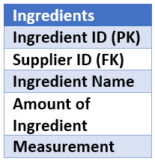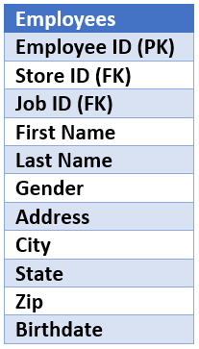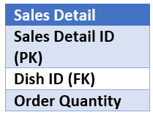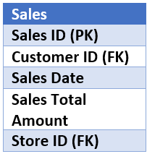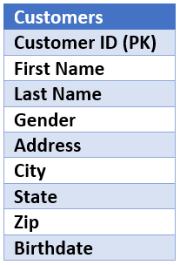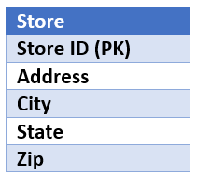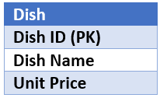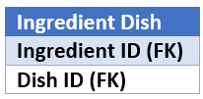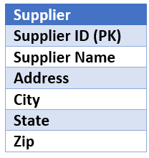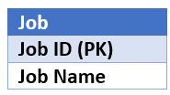

1

1

1

1

1

1

1

1

1

M

M

M

M

M

M

M

M

M