**A LOOK AT HOSPITALS AND THEIR TREATMENTS OF HEART FAILURE in 2011**

The maps below show the average Medicare hospital charges for heart failure in 2011. On a state by state basis, New Jersey charges the most to patients, followed by California and Nevada. The cheapest state to have heart failure in is Maryland followed by North Dakota and West Virginia.

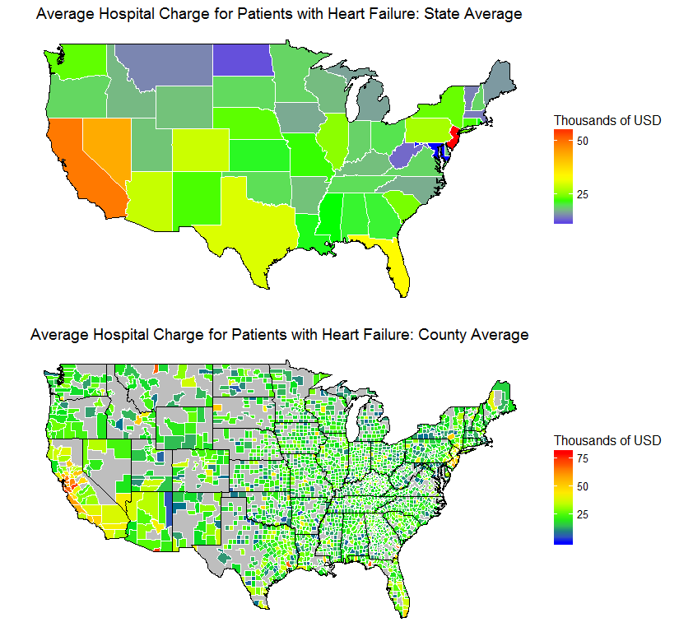

The next graph below shows the breakdown by county (counties with unavailable data are gray). California has the most counties with high charges, but also has a few counties with cheaper charges. New Jersey, has fewer highly expensive counties, but most counties charge more than average. The counties on the coast tend to charge more than counties in the center of the country.



The tables below show the counties that charge the most (left) and the lease (right). Seven out of the ten most expensive counties are in California.



The graph below shows how many heart attack patients were discharged by state, with a red line to highlight the average number of patients. Florida discharges the most patients with heart failure and Wyoming discharges the fewest (Note: data is not available for total number of people with heart failure). Not all of the most expensive states have the most patients: Arizona discharges a below average number of patients. And not all of the cheapest states have the least number of patients: Alabama, Louisiana, and Tennessee discharged an above average number of patients.

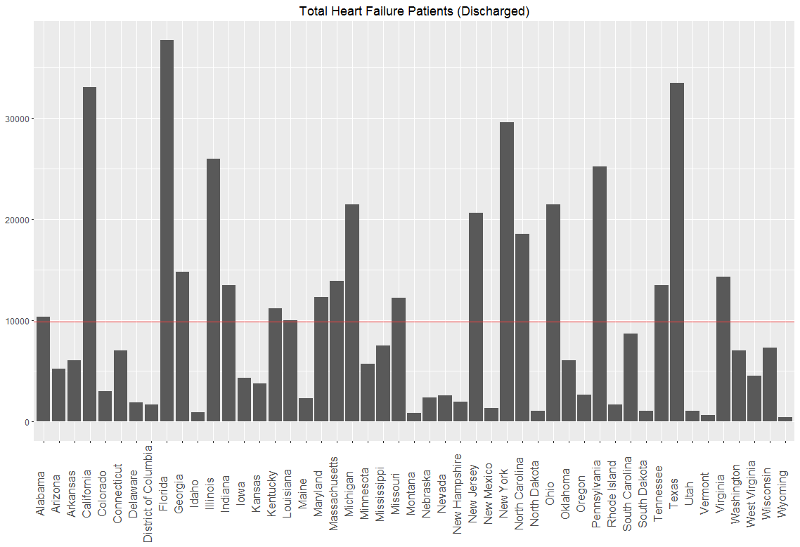

The previous data was from 2011 and perhaps costs have changed. The next graph shows the growth in costs from 2011 to 2014 by region in the US (the red line shows the averages for the region). Not a single state saw a drop in costs and the West saw the greatest growth in costs while the Midwest saw the smallest growth in costs.

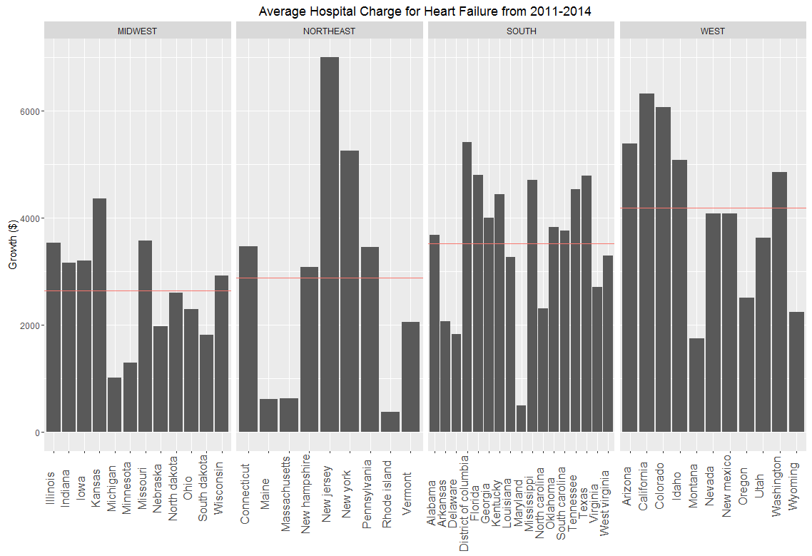

AN EXTRA VERSION OF THE DOUBLE GRAPH

