DOMAIN SHIFT IN ARTIFICIAL NEURAL NETWORKS: A SURVEY OF DOMAIN ADAPTATION TECHNIQUES
A PROJECT REPORT
Submitted by
Jai (RA2411026010131)
Aggam Singh Arora (RA2411026010139)
Areeb Akhtar (RA2411026010154)
Ujwal M (RA2411026010157)
Under the Guidance of
Dr. KOTHAI G
(Assistant Professor, Department of Computational Intelligence)
in partial fulfillment of the requirements for the degree of
BACHELOR OF TECHNOLOGY
in
COMPUTER SCIENCE AND ENGINEERING
with specialization in (ARTIFICIAL INTELLIGENCE & MACHINE LEARNING)

DEPARTMENT OF COMPUTATIONAL INTELLIGENCE
COLLEGE OF ENGINEERING AND TECHNOLOGY
SRM INSTITUTE OF SCIENCE AND TECHNOLOGY
KATTANKULATHUR - 603 203
NOVEMBER 2026
SRM INSTITUTE OF SCIENCE AND TECHNOLOGY
KATTANKULATHUR - 603 203
BONAFIDE CERTIFICATE
Certified that 21CSE326T - Artificial Neural Networks - Project report titled “Domain Shift in Artificial Neural Networks: A Survey of Domain Adaptation Techniques” is the bonafide work of “Jai (RA2411026010131), Aggam Singh Arora (RA2411026010139), Areeb Akhtar (RA2411026010154), Ujwal M (RA2411026010157)” who carried out the project work under my supervision. Certified further, that to the best of my knowledge the work reported herein does not form any other project report or dissertation on the basis of which a degree or award was conferred on an earlier occasion on this or any other candidate.

SIGNATURE  Dr. KOTHAI G  Faculty In-Charge  Assistant Professor,  Department of Computational Intelligence | SIGNATURE  Dr. ANNIE UTHRA R  Professor & Head,  Department of Computational Intelligence
ACKNOWLEDGEMENTS
We express our humble gratitude to Dr. C. Muthamizhchelvan, Vice-Chancellor, SRM Institute of Science and Technology, for the facilities extended for the project work and for his continued support.
We extend our sincere thanks to Dr. Leenus Jesu Martin M, Dean-CET, SRM Institute of Science and Technology, for his invaluable support.
We wish to thank Dr. Revathi Venkataraman, Professor and Chairperson, School of Computing, SRM Institute of Science and Technology, for her support throughout the project work.
We extend our sincere thanks to Dr. M. Pushpalatha, Professor and Associate Chairperson - CS, School of Computing, and Dr. Lakshmi, Professor and Associate Chairperson - AI, School of Computing, SRM Institute of Science and Technology, for their invaluable support.
We are grateful to our Head of the Department, Dr. Annie Uthra R, Professor and Head, Department of Computational Intelligence, SRM Institute of Science and Technology, for her suggestions and encouragement at all stages of the project work.
We thank our Project Coordinators, Panel Head and Panel Members, Department of Computational Intelligence, SRM Institute of Science and Technology, for their inputs during the project reviews and for their support.
We thank our Faculty Advisor, Dr. Abhijah Roseline S, Department of Computational Intelligence, SRM Institute of Science and Technology, for guiding us through the course.
We are deeply grateful to our guide, Dr. Kothai G, Department of Computational Intelligence, SRM Institute of Science and Technology, for giving us the opportunity to pursue this project under their mentorship. They gave us the freedom and support to explore research topics of our interest, and their enthusiasm for solving problems has been a constant source of inspiration.
We thank all the staff members of the Department of Computational Intelligence, School of Computing, SRM Institute of Science and Technology, for their help during the project. Finally, we thank our parents, family members and friends for their constant love, support and encouragement.
TABLE OF CONTENTS
ABSTRACT 1
CHAPTER 1 INTRODUCTION 2
1.1 Background of the Problem 2
1.2 Motivation 2
1.3 Problem Statement 3
1.4 Research Objectives 3
1.5 Scope of the Study 4
1.6 Significance and Expected Contributions 4
CHAPTER 2 LITERATURE SURVEY 6
2.1 Overview of the Research Area 6
2.2 Existing Models and Frameworks 7
2.3 Research Gaps Identified 11
2.4 Research Objectives 11
CHAPTER 3 SPRINT PLANNING AND EXECUTION METHODOLOGY 12
3.1 Sprint I: Problem Setup and Baseline 12
3.2 Sprint II: Adaptation Methods 15
CHAPTER 4 LIST OF FIGURES 19
CHAPTER 5 LIST OF TABLES 20
CHAPTER 6 ABBREVIATIONS 21
List of Abbreviations 21
CHAPTER 7 RESULTS AND DISCUSSIONS 23
7.1 Project Outcomes (Performance Evaluation, Comparisons, Testing Results) 23
7.2 Domain Shift 25
7.3 AdaBN 25
7.4 DANN 26
7.5 What the t-SNE Plot Shows 26
7.6 What Worked and Why 27
7.7 Limitations 27
CHAPTER 8 CONCLUSION AND FUTURE ENHANCEMENT 28
Future Enhancement 28
CHAPTER 9 REFERENCES 30
1. Foundation Papers 30
2. Domain Adaptation Methods 31
3. Real-World Domain Shift Studies 32
4. Tools and Frameworks 33
CHAPTER 10 APPENDIX 34
1. Data loading and preprocessing (MNIST and MNIST-M) 34
2. Shared CNN backbone and supervised training (source-only and target-only) 34
3. AdaBN 35
4. DANN: gradient reversal layer and training loop 35
SCREENSHOTS AND VISUALIZATIONS 37

ABSTRACT
Neural networks are trained on samples from one data distribution and then used on another. When the two differ, accuracy can fall sharply even though the task is unchanged. This is called domain shift. A study of pneumonia-detection networks on chest X-rays found lower accuracy at outside hospitals in 3 of 5 comparisons, and the same networks could identify the source hospital of an X-ray with more than 99.9% accuracy on two of the sites. This report surveys methods that reduce the effect of domain shift: fine-tuning, discrepancy-based methods (DAN, Deep CORAL), adversarial methods (DANN, ADDA), adaptive batch normalization (AdaBN), pixel-level translation and augmentation, domain generalization, and test-time adaptation (TENT). The methods are compared on whether they need target labels, whether they need target data during training, compute cost, implementation effort and typical failure modes.
A small worked example supports the survey. A convolutional network is trained on MNIST (source) and tested on MNIST-M (target), a version of MNIST with coloured natural-image backgrounds. Training uses 10,000 images per domain, 30 epochs, the SGD recipe of Ganin et al. and 3 random seeds, and results are reported as mean accuracy over the seeds. The source-only model reaches 98.8% on MNIST but only 19.6% on MNIST-M. A model trained on labeled MNIST-M reaches 94.2%, which is the ceiling. AdaBN, which needs no training, raises MNIST-M accuracy to 47.6% (37.6% of the gap closed) and leaves MNIST accuracy unchanged. DANN, trained with labeled MNIST and unlabeled MNIST-M, reaches 39.5% (26.7% of the gap closed), less than AdaBN in every seed. A t-SNE view of the learned features shows that the two domains remain separate after DANN. The digits are a toy benchmark, and the report discusses why real shifts such as those in medical imaging are harder.

CHAPTER 1
INTRODUCTION

1.1 Background of the Problem
An artificial neural network learns a mapping from inputs to outputs using a finite set of training examples. Standard machine learning theory assumes that the training examples and the examples seen after deployment are drawn independently from the same distribution (the i.i.d. assumption). Under this assumption, accuracy on a held-out test set estimates accuracy in use.
In practice the assumption often fails. A model is trained on data from one hospital, one camera, one season or one city, and is then applied somewhere else. The training distribution is called the source domain and the deployment distribution is called the target domain. The difference between them is called domain shift or dataset shift [Quiñonero-Candela et al., 2009]. Domain shift is not a rare corner case: it appears whenever the conditions of data collection change, and a network that scores highly on its own test set can perform poorly on the target domain.
Domain adaptation is the area of machine learning that studies how to reduce this loss of accuracy. It is a special case of transfer learning [Pan and Yang, 2010] in which the task stays the same and only the input distribution (or its relation to the labels) changes.

1.2 Motivation
The clearest evidence of the problem comes from medicine. Zech et al. (2018) trained convolutional neural networks (CNNs) to detect pneumonia on chest X-rays from three sources: the NIH Clinical Center, Mount Sinai Hospital and Indiana University Network for Patient Care. In 3 of 5 natural comparisons, performance on X-rays from outside hospitals was significantly lower than on held-out X-rays from the hospitals used for training. The authors also found that the CNNs could identify the hospital system that produced an X-ray with very high accuracy: 99.95% for the NIH images and 99.98% for the Mount Sinai images. Scanner settings, image processing and markers differ between hospitals, so a network can use these cues. The network learned patterns specific to where its training data came from, and not only the signs of disease. A model that looks accurate in internal validation can therefore be less reliable in a new hospital.
The same effect appears in driving. A perception model trained on images taken in clear daytime weather is usually less accurate in rain, fog or at night, because the pixel statistics of the scene change while the objects to be recognised stay the same. Work on foggy scene understanding is one example of research motivated by this gap [Sakaridis et al., 2018].
These real cases are difficult to reproduce and measure. This project therefore uses a controlled version of the same problem. A network trained on clean handwritten digits (MNIST) is tested on digits drawn over natural-image backgrounds in random colours (MNIST-M). The label set is identical, the digit shapes are the same, and only the appearance changes. The drop in accuracy can be measured exactly, and the methods in the survey can be compared under identical conditions.

1.3 Problem Statement
A neural network trained on a labeled source domain performs well on source data but loses accuracy on a target domain whose input distribution differs. Collecting and labeling new data for every new deployment condition is expensive and, in medicine, often impractical. There is a need to understand:
• why neural networks are sensitive to domain shift;
• which families of domain adaptation methods exist and what each requires in terms of labels, data and compute;
• how much of the lost accuracy simple and adversarial methods recover under a fair, controlled comparison.

1.4 Research Objectives
The main objectives of this project are:
1. To define domain shift (covariate, label and concept shift) and explain why the i.i.d. assumption breaks.
2. To explain why neural networks are vulnerable to domain shift, using generalization, overfitting and inductive bias.
3. To survey the main domain adaptation methods and compare them on target-label need, target-data need, compute cost, implementation complexity and failure modes.
4. To demonstrate domain shift with a small CNN trained on MNIST and tested on MNIST-M.
5. To implement and compare AdaBN and DANN against source-only and target-only baselines using the same backbone, and to report the share of the accuracy gap each one closes.
The project is aligned with two United Nations Sustainable Development Goals. SDG 3: Good Health and Well-being: diagnostic models are increasingly trained at one hospital and used at others, and the Zech et al. study shows that unnoticed domain shift can make them unreliable. Methods that detect and reduce domain shift support safer deployment of AI in health care. SDG 9: Industry, Innovation and Infrastructure: industrial and transport systems, such as visual inspection and driver assistance, operate under changing conditions, and robust adaptation methods help build dependable intelligent infrastructure.

1.5 Scope of the Study
This study is a literature survey with a small supporting experiment. The scope includes:
• A survey of domain adaptation methods for image classification: fine-tuning, discrepancy-based, adversarial, normalization-based, pixel-level, domain generalization and test-time adaptation.
• An experiment on one digit pair: MNIST as the source and MNIST-M as the target.
• Four experimental settings with one shared CNN backbone: source-only, AdaBN, DANN and target-only.
• A subsample of 10,000 training images per domain, 30 training epochs and 3 random seeds, so that every run finishes in minutes on a CPU.
The study does not implement the other surveyed methods (DAN, Deep CORAL, ADDA, CyCADA, TENT), does not use medical images, and does not tune hyperparameters for the best possible accuracy.

1.6 Significance and Expected Contributions
The report gives a single, readable account of how domain shift arises in neural networks and how it is handled. The expected contributions are:
• A structured taxonomy and a comparison table of domain adaptation methods that can be used to choose a method for a given situation.
• A reproducible demonstration of domain shift on MNIST and MNIST-M, with all numbers produced by the project notebook.
• A like-for-like comparison of a training-free method (AdaBN) and an adversarial method (DANN) on the same backbone, with the share of the accuracy gap closed.
• A discussion of the limits of the experiment and of open challenges for real-world domain shift.

CHAPTER 2
LITERATURE SURVEY

2.1 Overview of the Research Area

2.1.1 Source and target domains
A domain consists of an input space and a probability distribution over it. In domain adaptation there is a source domain with labeled data, where the model is trained, and a target domain, where the model will be used. Both share the same task and label set. In unsupervised domain adaptation (UDA) the target data are available without labels. In supervised domain adaptation a few labeled target samples are available. Wang and Deng (2018) give a survey of deep methods for these settings in visual recognition.

2.1.2 Types of shift
Let X be the input and Y the label. Three kinds of shift are usually distinguished.
• Covariate shift: the input distribution P(X) changes but the rule linking inputs to labels, P(Y|X), stays the same [Shimodaira, 2000]. MNIST to MNIST-M is of this kind: the digit still determines the label, but the images look different. Chest X-rays from two scanners are another example.
• Label shift (prior shift): the label distribution P(Y) changes while P(X|Y) stays the same. A pneumonia classifier trained at a hospital where 10% of patients have pneumonia and used at a hospital where 40% do is an example.
• Concept shift: the relation P(Y|X) itself changes. The same input should now receive a different label, for example when a diagnostic criterion is revised or when the meaning of a word changes over time.
Real shifts usually combine these. Most methods in this survey target covariate shift, because it is the case that can be addressed without target labels.

2.1.3 Why the i.i.d. assumption breaks
Generalization guarantees assume that test examples come from the same distribution as training examples. When deployment data come from a different distribution, the held-out validation accuracy measured on source data no longer estimates target accuracy. The network is not malfunctioning: it is being asked a question outside the distribution it was trained on.

2.1.4 Why neural networks are vulnerable
The vulnerability can be tied to three topics from the course syllabus.
• Generalization and overfitting (Unit 3, Session 23). A network that fits its training data well can still fail on new data. Domain shift is a specific form of this: the network generalizes to unseen samples from the same distribution, but not to samples from a different one. Any feature that helps on the training set, including a spurious one such as the background, scanner type or hospital marker, will be used.
• Hypothesis space and inductive bias (Unit 3, Session 22). A CNN is flexible enough to represent many functions that agree on the source data and disagree on the target data. Training on source data alone gives no reason to prefer the function that ignores the background. Its inductive bias (locality, weight sharing) does not encode which image properties are irrelevant to the label.
• Data selection and preprocessing (Unit 5, Session 37). The training set determines what the model can learn. Data collected under narrow conditions, and normalization computed on those data, bake the source conditions into the model. Batch normalization statistics are an example: they are estimated on source data and fixed at test time, which is what AdaBN later changes.
Ben-David et al. (2010) give a bound that expresses this formally. For a hypothesis h, the target error is bounded by the source error plus a term that measures how different the two domains look to the hypothesis class, plus a term for the error of the best single hypothesis on both domains:
ε_T(h) ≤ ε_S(h) + ½ d_HΔH(D_S, D_T) + λ
In words, target error is small only if (a) the model is accurate on the source, (b) the two domains are hard to tell apart with the available hypotheses, and (c) some hypothesis does well on both domains. Training on the source only controls the first term. The methods in this survey try to shrink the second term, either by making features of the two domains look alike (discrepancy-based, adversarial, normalization-based methods) or by making the inputs look alike (pixel-level methods).

2.2 Existing Models and Frameworks
Domain adaptation methods can be grouped by how they reduce the difference between domains. Figure 1 shows the taxonomy used in this report.
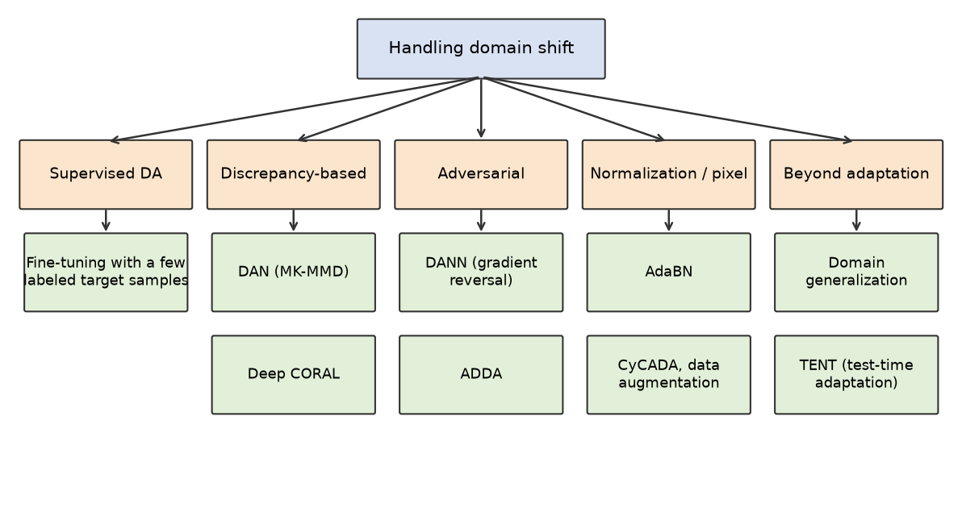
Figure 1: Taxonomy of domain shift handling methods

2.2.1 Fine-tuning with a few labeled target samples (supervised DA)
The simplest approach continues training a source-trained network on a small labeled target set, usually with a lower learning rate. It needs no new algorithm and works well when a few labels are available. Its limits are overfitting to the small target set and forgetting of source knowledge. Labeling target data is the cost that the other methods try to avoid.

2.2.2 Discrepancy-based methods
These methods add a loss that measures the distance between source and target feature distributions and minimize it together with the classification loss.
• DAN (Deep Adaptation Network) [Long et al., 2015] adds a multi-kernel maximum mean discrepancy (MK-MMD) penalty on the activations of the task-specific layers of a CNN. MMD is the distance between the mean embeddings of two distributions in a kernel feature space.
• Deep CORAL [Sun and Saenko, 2016] aligns the second-order statistics, the feature covariance matrices, of source and target. The loss is the squared Frobenius distance between the two covariance matrices, and it is differentiable and cheap to add to a network.

2.2.3 Adversarial methods
These methods train a domain classifier to tell source features from target features, while the feature extractor is trained to make this impossible.
• DANN (Domain-Adversarial Neural Network) [Ganin and Lempitsky, 2015; Ganin et al., 2016] attaches a domain classifier to the feature extractor through a gradient reversal layer (GRL). The GRL is the identity in the forward pass and multiplies the gradient by a negative constant in the backward pass. The domain classifier therefore learns to separate the domains, while the feature extractor receives the reversed gradient and learns features that confuse it. The label classifier is trained on labeled source data only. The method is motivated by the domain-divergence term in the Ben-David bound.
• ADDA (Adversarial Discriminative Domain Adaptation) [Tzeng et al., 2017] first trains a source encoder and classifier with labels. It then learns a separate target encoder, with untied weights, against a domain discriminator using a GAN-style loss, and applies the source classifier to the target encoder output.

2.2.4 Normalization-based methods
AdaBN (Adaptive Batch Normalization) [Li et al., 2016] is based on the observation that label-related knowledge lives mainly in the network weights, while domain-related knowledge lives largely in the statistics of the batch normalization layers. AdaBN replaces the source mean and variance in every BN layer with the mean and variance computed on target data. No weights are changed, no labels are used and no gradient step is taken, so the cost is a single forward pass over target data. It only helps networks that contain BN layers.

2.2.5 Pixel-level and data-level methods
Instead of aligning features, these methods change the images. CyCADA [Hoffman et al., 2018] translates source images into the style of the target domain with cycle-consistent image-to-image translation, adds a semantic consistency loss so that content is preserved, and combines this with feature-level adaptation. The translated, labeled images are used to train the task model. Data augmentation (random colour changes, blur, noise, crops) enlarges the range of appearances seen in training and makes the model less dependent on any single one. It needs no target data but only helps against variations that the augmentation anticipates.

2.2.6 Beyond adaptation: domain generalization and test-time adaptation
• Domain generalization (DG) assumes that no target data are available at training time. The model is trained on several source domains and is expected to work on unseen domains [Zhou et al., 2023]. A large benchmark study found that plain empirical risk minimization, when tuned carefully, is competitive with specialised DG methods [Gulrajani and Lopez-Paz, 2021].
• TENT (test-time entropy minimization) [Wang et al., 2021] adapts the model while it is being tested. For each batch of unlabeled test data it uses test-batch BN statistics and updates only the BN scale and shift parameters to reduce the entropy of the predictions. It needs neither source data nor labels at test time.

2.2.7 Comparison of methods
Table 1 compares the methods on the properties that matter for choosing one in practice. Entries describe general tendencies reported in the literature and are qualitative.
Table 1: Comparison of domain shift methods
Method | Needs target labels? | Needs target data at training? | Compute cost | Implementation complexity | Typical failure modes
Fine-tuning (supervised DA) | Yes, a few | Yes (labeled) | Low | Low | Overfits the small target set; forgets source knowledge
DAN / MK-MMD | No | Yes (unlabeled) | Medium (kernel terms grow with batch size) | Medium | Sensitive to kernel choice; aligns overall distributions, not classes
Deep CORAL | No | Yes (unlabeled) | Low to medium | Low | Matches only second-order statistics; weak under large non-linear shift
DANN | No | Yes (unlabeled) | Medium (extra domain head, joint training) | Medium | Unstable adversarial training; sensitive to the lambda schedule and learning rate; can mix classes
ADDA | No | Yes (unlabeled) | Medium to high (two stages, second encoder) | High | Unstable GAN-style training; depends on a good source encoder
AdaBN | No | Yes (unlabeled, statistics only) | Very low (one forward pass) | Very low | Fixes only shift that BN statistics can capture; needs BN layers and enough target samples
Pixel-level (CyCADA) | No | Yes (unlabeled images) | High (GAN training) | High | Translation artifacts or content changes; GAN training is hard to stabilise
Data augmentation | No | No | Low | Low | Covers only the shifts that were anticipated
Domain generalization | No | No (needs several source domains) | Low to high | Medium | No guarantee on truly new domains; needs diverse sources
TENT (test-time) | No | At test time only (unlabeled) | Low (one update per test batch) | Low | Error accumulation and collapse with small batches or long streams; label shift

2.3 Research Gaps Identified
1. Toy benchmarks. Many methods are evaluated on digits and office-object benchmarks. Gains on these do not always carry over to medical images or driving scenes, where the shift is subtler and the cost of error is higher.
2. No target labels for model selection. In unsupervised adaptation there are no target labels to choose hyperparameters or to decide when to stop, yet many papers select settings using target accuracy.
3. Unstable adversarial training. Adversarial methods can oscillate or fail to converge, and results can vary across random seeds.
4. Label and concept shift. Most feature-alignment methods assume covariate shift only. Under label shift, forcing the feature distributions to match can hurt accuracy [Zhao et al., 2019].
5. Few like-for-like comparisons. Papers often use different backbones and training budgets, which makes it hard to say how much of an improvement comes from the adaptation method itself.
6. Reporting of simple baselines. Cheap methods such as AdaBN are not always included as baselines even though they can recover a large part of the loss.

2.4 Research Objectives
1. Quantify the effect of domain shift on a small CNN using MNIST as the source and MNIST-M as the target.
2. Use one shared backbone and the same training budget for all methods so that comparisons are fair.
3. Evaluate a training-free adaptation method (AdaBN) and an adversarial method (DANN) without target labels.
4. Measure each method by the share of the source-only to target-only accuracy gap that it closes.
5. Inspect the learned features with t-SNE to see how the two domains are arranged before and after adversarial adaptation.
6. State the limitations of the experiment and the open challenges for real-world domain shift.

CHAPTER 3
SPRINT PLANNING AND EXECUTION METHODOLOGY
The practical work was organised in two sprints. Sprint I sets up the problem and the baselines. Sprint II adds the adaptation methods and compares them. All code is in one notebook (domain_shift.ipynb) with a small helper module (da.py), and every number in this report is read from the file results.json that the notebook writes.

3.1 Sprint I: Problem Setup and Baseline

3.1.1 Objectives with User Stories of Sprint I
1. Load MNIST (source) and MNIST-M (target) and bring both to the same input format.
2. Define one CNN backbone that is used unchanged by every method.
3. Train a source-only model and measure its accuracy on both domains to demonstrate domain shift.
4. Train a target-only model on labeled MNIST-M to obtain an upper bound.
User stories:
• As a reader, I want to see sample images from both domains so that I understand what changes between them.
• As a researcher, I want one shared model definition so that differences in results come from the method and not from the architecture.
• As a researcher, I want a source-only baseline and a target-only ceiling so that I can express every method as a share of the gap between them.

3.1.2 Functional Document
1. Data loading. MNIST is loaded with torchvision. MNIST-M is loaded from the Hugging Face dataset “Mike0307/MNIST-M” (parquet files, PNG images).
2. Preprocessing. MNIST images are resized from 28x28 to 32x32 and copied to three channels. MNIST-M images are already 32x32 RGB. Pixel values of both domains are scaled to the range [-1, 1].
3. Subsampling. 10,000 training images are drawn at random from each domain with a fixed seed. Full test sets are used: 10,000 MNIST and 9,001 MNIST-M images.
4. Training. Supervised training with cross-entropy loss, using SGD with momentum 0.9 and a learning rate annealed from 0.01 as in Ganin et al. Source-only uses labeled MNIST. Target-only uses labeled MNIST-M.
5. Evaluation. Accuracy on the MNIST test set and on the MNIST-M test set for every model.
Table 2: Experimental setup
Item | Setting
Source domain | MNIST (torchvision), 60,000 train / 10,000 test images
Target domain | MNIST-M (Hugging Face: Mike0307/MNIST-M), 59,001 train / 9,001 test images
Input format | 3 x 32 x 32, values in [-1, 1]
Training images used | 10,000 per domain (random subsample)
Test images used | 10,000 MNIST, 9,001 MNIST-M (full test sets)
Backbone | 3 x (Conv 3x3, BatchNorm, ReLU, MaxPool) with 32, 64, 128 channels; Linear 2048 to 128; ReLU
Label classifier | Linear 128 to 10
Optimizer | SGD momentum 0.9, lr 0.01 / (1 + 10p)^0.75, batch size 128
Epochs | 30 for every method
Random seeds | 0, 1, 2 (results are mean and standard deviation over seeds)
Hardware | CPU only

3.1.3 Architecture Document
Every method uses the same network, shown in Figure 2. Three convolution blocks (convolution, batch normalization, ReLU, 2x2 max pooling) reduce the 32x32 input to a 4x4 map with 128 channels. A linear layer maps the flattened 2048 values to a 128-dimensional feature vector, and a linear classifier maps the feature to ten digit classes. Batch normalization layers are included on purpose, because AdaBN works by changing their statistics. The network is small so that every run finishes in minutes on a CPU.
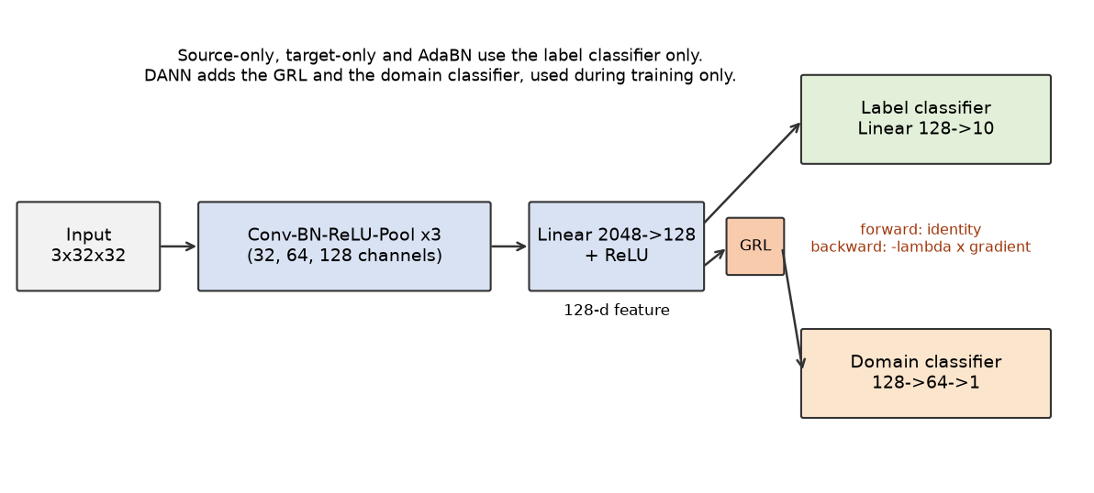
Figure 2: Shared CNN backbone and the additional DANN components
The two domains are shown in Figure 3. MNIST digits are white strokes on a black background. In MNIST-M the same digit shapes are blended with random patches from natural photographs, so the strokes take on the colours and textures of the background.
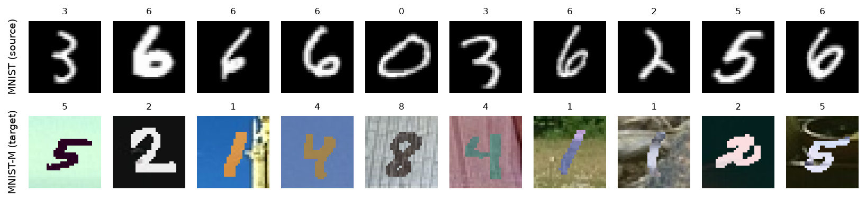
Figure 3: Sample images from MNIST (source) and MNIST-M (target)

3.1.4 Outcome of Objectives / Result Analysis of Sprint I
Table 3: Sprint I results: source-only and target-only models (mean ± standard deviation over 3 seeds)
Method | MNIST accuracy (%) | MNIST-M accuracy (%)
Source-only (trained on MNIST) | 98.75 ± 0.07 | 19.62 ± 2.56
Target-only (trained on MNIST-M) | 94.01 ± 2.02 | 94.18 ± 0.10

The source-only model reaches 98.8% on MNIST but only 19.6% on MNIST-M, a drop of 79.1 percentage points on a task with the same ten labels. Random guessing would give about 10%, so the model is only slightly better than chance on the target domain. This is the domain shift demonstration. The target-only model reaches 94.2% on MNIST-M, which shows that the backbone is able to solve the target task when it has labeled target data. This value is the ceiling used to compute the share of the gap closed by each method. The target-only model reaches 94.0% on clean MNIST, lower than the source-only model on its own domain, which shows that the shift also hurts in the opposite direction, though less.

3.1.5 Sprint Retrospective
• The source-only baseline and target-only ceiling gave a clear scale: a method that gets close to 94.2% on MNIST-M has closed the gap, and one that stays near 19.6% has not.
• Using one backbone and one training budget for all methods keeps the comparison fair. The cost is that the backbone is not tuned for any single method.
• Training on a 10,000-image subsample keeps each run to about 101 seconds on a CPU, but the absolute accuracies would differ with the full training sets.
• The MNIST-M test split in the Hugging Face copy has 9,001 images, not the 9,000 often quoted. The report uses the data as distributed.

3.2 Sprint II: Adaptation Methods

3.2.1 Objectives with User Stories of Sprint II
1. Implement AdaBN on the source-only model using unlabeled MNIST-M data.
2. Implement DANN with a gradient reversal layer, a domain classifier and the lambda schedule of Ganin et al.
3. Compare AdaBN and DANN with the baselines using the share of the gap closed.
4. Inspect the learned features with t-SNE for the source-only model and for DANN.
User stories:
• As a practitioner, I want to know how much a free, training-free fix such as AdaBN recovers.
• As a researcher, I want to see whether adversarial training with unlabeled target data improves on that.
• As a reader, I want a picture that shows how the two domains are arranged in feature space.

3.2.2 Functional Document
AdaBN.
1. Take the trained source-only model.
2. Reset the running mean and variance of every batch normalization layer.
3. Pass the unlabeled MNIST-M training images through the network in training mode, without gradient steps, so that each layer accumulates the average mean and variance of the target data.
4. Switch to evaluation mode and test. No weight changes and no target labels are used.
DANN.
1. Each step takes a batch of labeled MNIST images and a batch of unlabeled MNIST-M images.
2. Both batches pass through the feature extractor.
3. The label classifier is trained with cross-entropy loss on the source features only.
4. The domain classifier receives source and target features through the gradient reversal layer and is trained with binary cross-entropy to predict the domain (source 0, target 1).
5. The reversal layer sends the negated, scaled gradient to the feature extractor, so the feature extractor is pushed to make the two domains indistinguishable while still supporting the label classifier.
The reversal strength follows the schedule of Ganin et al.: λ = 2 / (1 + exp(-10p)) - 1, where p goes from 0 to 1 over training. It starts near 0, so the classifier first learns digits, and rises towards 1, so domain confusion is enforced progressively.
t-SNE. Features (the 128-dimensional output of the feature extractor) of 1,000 MNIST test images and 1,000 MNIST-M test images are embedded in two dimensions with t-SNE (perplexity 30, fixed random state) for the seed-0 source-only and DANN models.

3.2.3 Architecture Document
AdaBN does not change the architecture. DANN adds two parts to the shared backbone (Figure 2): a gradient reversal layer (GRL) and a domain classifier made of two linear layers (128 to 64 to 1) with a ReLU. The GRL is an identity function in the forward pass and multiplies the gradient by -λ in the backward pass. The total training loss is the sum of the label loss on source data and the domain loss on source and target data. All methods, DANN included, are trained with the recipe of Ganin et al.: SGD with momentum 0.9 and a learning rate 0.01 / (1 + 10p)^0.75, where p is the fraction of training steps completed. Source and target images of a step are passed through the network as one concatenated batch, so batch normalization statistics during DANN training are computed over both domains.

3.2.4 Outcome of Objectives / Result Analysis of Sprint II
Table 4: Sprint II results: adaptation methods (mean ± standard deviation over 3 seeds)
Method | MNIST accuracy (%) | MNIST-M accuracy (%) | Gap closed (%)
AdaBN | 98.75 ± 0.07 | 47.63 ± 2.77 | 37.6 ± 1.6
DANN | 98.69 ± 0.05 | 39.47 ± 5.47 | 26.7 ± 5.7

AdaBN raises MNIST-M accuracy from 19.6% to 47.6% and closes 37.6% of the gap, without any training. MNIST accuracy is the same as for the source-only model (98.8%), because MNIST images are scored with the source statistics. DANN reaches 39.5% on MNIST-M and closes 26.7% of the gap, while keeping 98.7% on MNIST. DANN results vary more between seeds than AdaBN results (standard deviation of 5.5 against 2.8 points on MNIST-M). In this experiment AdaBN closed more of the gap than DANN, in every seed.
Figure 4 shows the t-SNE embedding of the features. For the source-only model, MNIST features form ten compact clusters, one per digit, while MNIST-M features form one large, diffuse region that touches only a few of those clusters. For DANN, the ten MNIST clusters remain and the MNIST-M points form elongated bands that stay apart from them. The two domains are not merged in this run.
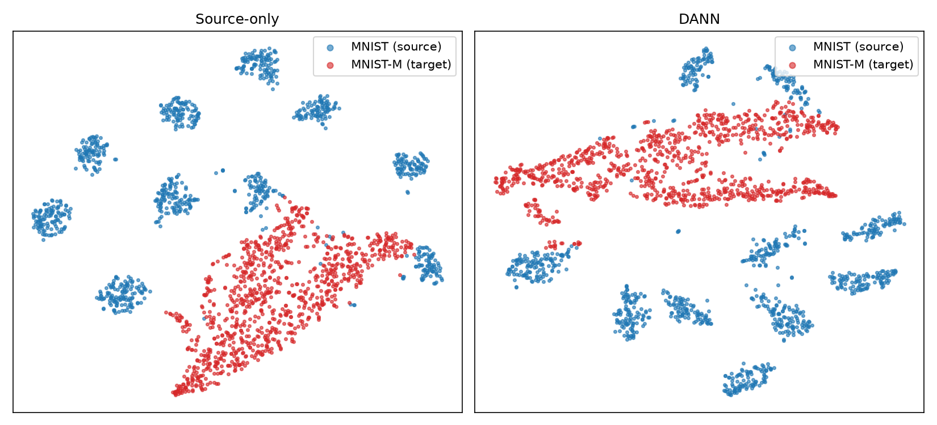
Figure 4: t-SNE of 128-dimensional features: source-only model (left) and DANN (right)

3.2.5 Sprint Retrospective
• AdaBN was the cheapest method by a large margin: 1.1 seconds per run, against 203 seconds for DANN training.
• The domain loss of DANN reached 0.6926 in the last epoch of seed 0 (see the training log in the screenshots), close to ln 2 = 0.693, the value of a domain classifier that cannot separate the domains in training batches. Yet target accuracy improved only moderately and the t-SNE view still shows separate domains, so fooling the domain classifier was not sufficient for aligning the classes.
• The gap closed by DANN was 34.4%, 25.0%, 20.7% for seeds 0, 1 and 2, and AdaBN closed more in every seed.
• Next steps would be to train longer on the full datasets, tune the domain classifier, and treat source and target batches separately in batch normalization. These were not done, because the aim was a fair comparison with one recipe and one backbone on a CPU.

CHAPTER 4
LIST OF FIGURES

1. Taxonomy of domain shift handling methods
Groups the surveyed methods into supervised adaptation, discrepancy-based, adversarial, normalization and pixel-level, and methods that go beyond adaptation.

2. Shared CNN backbone and the additional DANN components
Shows the shared feature extractor and label classifier, and the gradient reversal layer and domain classifier that are added for DANN only.

3. Sample images from MNIST (source) and MNIST-M (target)
Shows ten training images from each domain with their labels. The digit shapes are the same; MNIST-M adds coloured natural-image backgrounds.

4. t-SNE of 128-dimensional features: source-only model (left) and DANN (right)
Shows 1,000 MNIST (blue) and 1,000 MNIST-M (red) test images embedded in 2-D for the seed-0 source-only and DANN models.

5. Accuracy of each method on MNIST and MNIST-M (error bars: standard deviation over 3 seeds)
Bar chart of the results summary table, with MNIST and MNIST-M accuracy for each method.

CHAPTER 5
LIST OF TABLES

1. Comparison of domain shift methods
Compares the surveyed methods on target-label need, target-data need during training, compute cost, implementation complexity and typical failure modes.

2. Experimental setup
Lists datasets, image format, training subsample, backbone, optimizer, epochs, batch size and seeds used in all experiments.

3. Sprint I results: source-only and target-only models (mean ± standard deviation over 3 seeds)
Reports test accuracy on MNIST and MNIST-M for the source-only baseline and the target-only upper bound.

4. Sprint II results: adaptation methods (mean ± standard deviation over 3 seeds)
Reports MNIST and MNIST-M accuracy and the share of the source-only to target-only gap closed for AdaBN and DANN.

5. Results summary (mean ± standard deviation over 3 seeds)
Gives MNIST accuracy, MNIST-M accuracy and the share of the gap closed for source-only, AdaBN, DANN and target-only.

6. MNIST-M accuracy (%) for each seed
Lists the MNIST-M test accuracy of every method for each random seed, to show the run-to-run variation.

7. MNIST accuracy (%) for each seed
Lists the MNIST test accuracy of every method for each random seed.

8. Gap closed (%) for each seed
Lists the share of the source-only to target-only gap on MNIST-M that AdaBN and DANN closed for each random seed.

9. Average training time per run on CPU
Gives the average time in seconds needed to train or adapt each method for one seed.

CHAPTER 6
ABBREVIATIONS
This chapter lists the abbreviations used in the report so that readers from different backgrounds can follow the terms in the survey, the method descriptions and the experiments.

List of Abbreviations
1. AdaBN: Adaptive Batch Normalization, a method that replaces source batch normalization statistics with target statistics.
2. ADDA: Adversarial Discriminative Domain Adaptation, an adversarial method with a separate target encoder.
3. ANN: Artificial Neural Network, a model made of layers of connected units that learns from examples.
4. BCE: Binary Cross-Entropy, the loss used by the domain classifier.
5. BN: Batch Normalization, a layer that normalizes activations using batch mean and variance.
6. CNN: Convolutional Neural Network, a network built from convolution layers, used for image data.
7. CORAL: Correlation Alignment, a method that aligns feature covariances of two domains.
8. CPU: Central Processing Unit, the hardware on which all experiments were run.
9. CyCADA: Cycle-Consistent Adversarial Domain Adaptation, a pixel-level and feature-level adaptation method.
10. DA: Domain Adaptation, the task of adapting a model trained on a source domain to a different target domain.
11. DAN: Deep Adaptation Network, a discrepancy-based method using multi-kernel MMD.
12. DANN: Domain-Adversarial Neural Network, an adversarial method that uses a gradient reversal layer.
13. DG: Domain Generalization, training a model to work on unseen domains without target data.
14. GAN: Generative Adversarial Network, a model trained with a generator and a discriminator.
15. GRL: Gradient Reversal Layer, an identity layer in the forward pass that negates the gradient in the backward pass.
16. i.i.d.: Independent and identically distributed, the standard assumption about training and test samples.
17. MK-MMD: Multi-Kernel Maximum Mean Discrepancy, a distance between distributions using several kernels.
18. MMD: Maximum Mean Discrepancy, a distance between the mean embeddings of two distributions.
19. MNIST: Modified National Institute of Standards and Technology handwritten digit dataset, the source domain.
20. MNIST-M: MNIST digits blended with natural-image backgrounds, the target domain.
21. ReLU: Rectified Linear Unit, the activation function max(0, x).
22. SDG: Sustainable Development Goal, as defined by the United Nations.
23. SGD: Stochastic Gradient Descent, used with momentum for all training runs.
24. TENT: Test-time entropy minimization, a test-time adaptation method.
25. t-SNE: t-distributed Stochastic Neighbor Embedding, a method for 2-D visualization of high-dimensional features.
26. UDA: Unsupervised Domain Adaptation, adaptation using unlabeled target data.
27. USPS: United States Postal Service handwritten digit dataset, a common second digit domain; not used in this project.

CHAPTER 7
RESULTS AND DISCUSSIONS

7.1 Project Outcomes (Performance Evaluation, Comparisons, Testing Results)
All four settings use the same CNN backbone, the same training recipe and 30 epochs, and were run with 3 random seeds. Accuracy is measured on the full MNIST test set (10,000 images) and the full MNIST-M test set (9,001 images). The share of the gap closed is (method - source-only) / (target-only - source-only), computed on MNIST-M accuracy for each seed and then averaged.
Methodology notes. First, the inputs were audited before training: both domains reach the model as 3 x 32 x 32 float tensors in [-1, 1] with the same normalization (mean 0.5, standard deviation 0.5 per channel), the three channels of MNIST are identical copies of the grayscale image, and labels are integer class indices. The audit found nothing to change. Second, AdaBN is evaluated with two sets of batch normalization statistics: MNIST test images are scored with the original source statistics and MNIST-M test images with the statistics re-estimated on unlabeled MNIST-M training images. The weights are identical in both cases, so the MNIST accuracy of AdaBN equals that of the source-only model by construction. Third, every method is trained with the recipe of Ganin et al.: SGD with momentum 0.9 and a learning rate annealed as 0.01 / (1 + 10p)^0.75, where p runs from 0 to 1 over training. DANN uses the reversal coefficient λ = 2 / (1 + exp(-10p)) - 1. The recipe and the number of epochs were fixed before the reported run and applied identically to all methods. A first run with the Adam optimizer is not reported.
Table 5: Results summary (mean ± standard deviation over 3 seeds)
Method | MNIST accuracy (%) | MNIST-M accuracy (%) | Gap closed (%)
Source-only | 98.75 ± 0.07 | 19.62 ± 2.56 | 0.0 ± 0.0
AdaBN | 98.75 ± 0.07 | 47.63 ± 2.77 | 37.6 ± 1.6
DANN | 98.69 ± 0.05 | 39.47 ± 5.47 | 26.7 ± 5.7
Target-only | 94.01 ± 2.02 | 94.18 ± 0.10 | 100.0 ± 0.0

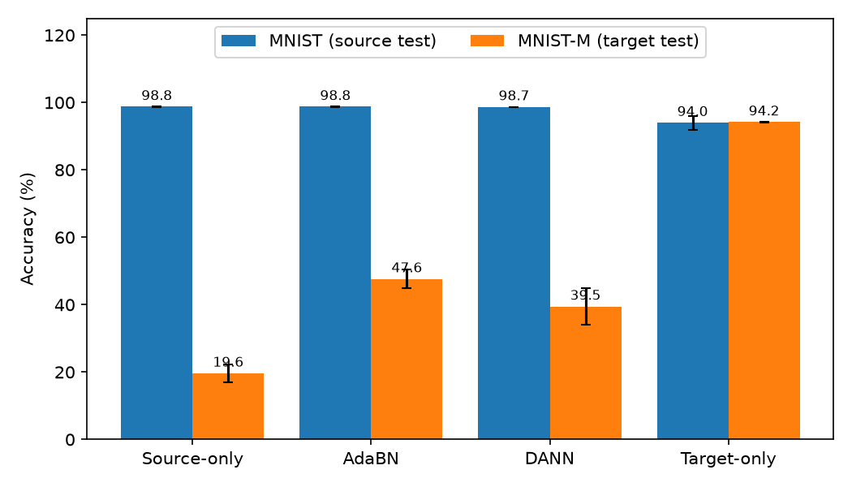
Figure 5: Accuracy of each method on MNIST and MNIST-M (error bars: standard deviation over 3 seeds)
Table 6: MNIST-M accuracy (%) for each seed
Method | Seed 0 | Seed 1 | Seed 2
Source-only | 20.28 | 22.39 | 16.21
AdaBN | 48.29 | 50.64 | 43.96
DANN | 45.71 | 40.31 | 32.40
Target-only | 94.17 | 94.06 | 94.31

Table 7: MNIST accuracy (%) for each seed
Method | Seed 0 | Seed 1 | Seed 2
Source-only | 98.83 | 98.75 | 98.67
AdaBN | 98.83 | 98.75 | 98.67
DANN | 98.76 | 98.66 | 98.65
Target-only | 95.39 | 95.48 | 91.15

Table 8: Gap closed (%) for each seed
Method | Seed 0 | Seed 1 | Seed 2
AdaBN | 37.9 | 39.4 | 35.5
DANN | 34.4 | 25.0 | 20.7

Table 9: Average training time per run on CPU
Method | Time per run (s)
Source-only | 101.4
AdaBN | 1.1
DANN | 203.5
Target-only | 112.9

7.2 Domain Shift
The source-only model is almost perfect on MNIST (98.8%) and far lower on MNIST-M (19.6%), where chance is 10%. High accuracy on the source test set therefore says nothing about accuracy on the target domain, which is the same point made by the hospital X-ray study: internal validation did not predict performance at other sites. The network likely relies on cues that are present in clean MNIST and changed in MNIST-M, such as the contrast between a bright stroke and a black background. This explanation is consistent with the results but was not tested separately.
For reference, Ganin and Lempitsky (2015) report 57.5% source-only accuracy and 98.9% target-only accuracy on MNIST to MNIST-M, with their own MNIST-M generation, network and training set sizes. The source-only accuracy here is lower, and the target-only accuracy is a few points lower. The differences may come from the smaller network, the 10,000-image subsample or the copy of MNIST-M used, but this was not isolated by an experiment, and the absolute numbers in this report should not be compared directly with published ones.

7.3 AdaBN
AdaBN closed 37.6 ± 1.6% of the gap (47.63 ± 2.77% on MNIST-M) with about 1.1 seconds of computation, and it improved on the source-only model for every seed (48.3, 50.6, 44.0% against 20.3, 22.4, 16.2%). A likely reason is that the first layers of a CNN see the pixel statistics directly. MNIST-M images have different channel means and variances from MNIST images, so the source-estimated BN statistics push the activations of target images to the wrong range. Replacing them with target statistics puts the activations back into a range the weights were trained for. No label or weight update is needed, which suggests that part of the shift here is a change of overall intensity and contrast statistics that BN can absorb. This explanation was not tested separately. The remaining gap shows that statistics alone are not enough: the textured backgrounds of MNIST-M are not just a change of mean and variance.
AdaBN needs unlabeled target data at adaptation time and a way to know which domain an input comes from, because the model holds one set of statistics per domain. Its MNIST accuracy is unchanged only because MNIST images are still scored with the source statistics.

7.4 DANN
DANN reached 39.47 ± 5.47% on MNIST-M and closed 26.7 ± 5.7% of the gap, while keeping MNIST accuracy at 98.69 ± 0.05%. It improved on source-only in every seed (45.7, 40.3, 32.4%), but it closed less of the gap than AdaBN on average and in every seed (AdaBN: 48.3, 50.6, 44.0%). DANN took 203 seconds per run against 1.1 seconds for AdaBN. Its improvement is therefore modest, and it varies between seeds more than that of AdaBN.
DANN needs no target labels because the only signal it takes from the target data is the domain label, which is known by construction (every image in the target batch is a target image). The classification loss uses source labels only. The target data influence the feature extractor through the reversed gradient of the domain loss.
The training log (Screenshot 2) shows that the domain loss reached 0.693 in the last epoch of seed 0, which is the value ln 2 = 0.693 expected when the domain classifier performs at chance on training batches. The adversarial game therefore ended in a state where the domain classifier could not separate the domains, yet target accuracy was only 39.5% and the t-SNE view (Figure 4) still shows the two domains apart. Fooling a domain classifier does not guarantee that the feature distributions are aligned class by class, and marginal feature alignment is known to have this limit [Zhao et al., 2019]. Other factors may also contribute: the network is small, the training set is a 10,000-image subsample, the domain classifier was not tuned, and the source and target images of a step share one batch normalization batch. None of these was isolated by an experiment. Ganin and Lempitsky (2015) report 81.5% for DANN on MNIST to MNIST-M with a different setup, and the accuracy here is lower.

7.5 What the t-SNE Plot Shows
In Figure 4, the source-only model produces ten tight MNIST clusters, and the MNIST-M features form one large, diffuse region that touches only a few of those clusters. This matches the low target accuracy: target images are mostly not mapped near the class clusters. After DANN, the ten MNIST clusters remain, and the MNIST-M points form elongated bands that stay apart from all of them. The plot therefore does not show the domains merging, which is consistent with the modest accuracy gain for seed 0 (MNIST-M accuracy 45.7% for DANN against 20.3% for source-only).
t-SNE is a qualitative tool. The plot is from one seed and 2,000 points, t-SNE distances are not meaningful beyond local neighbourhoods, and the absence of overlap in two dimensions does not by itself prove that the domains are separable in the full 128-dimensional space. The plot supports the accuracy numbers but does not replace them.

7.6 What Worked and Why
• AdaBN gave the best improvement per unit of effort (37.6% of the gap closed in about 1.1 seconds, without training), likely because part of the shift is visible in layer statistics. It was better than DANN in every seed.
• DANN improved on source-only (39.5% against 19.6%) and kept source accuracy, using no target labels, but it closed only 26.7% of the gap and was less effective than AdaBN in this setup.
• Target labels remain the most reliable fix: the target-only model reached 94.2%. Domain adaptation methods are useful when such labels cannot be obtained.

7.7 Limitations
• Digits are a toy benchmark. The shift from MNIST to MNIST-M is large but synthetic. Real shifts, for example between hospitals, are subtler, mix covariate and label shift, and cannot be checked as easily.
• Only 3 seeds, a 10,000-image subsample per domain and a small CNN were used. Rankings of methods may change with a different backbone, budget or tuning.
• DANN used the recipe of Ganin et al. but on a smaller network and dataset, and its domain classifier and batch handling were not tuned. The comparison shows how the methods behave under identical conditions, not their best achievable accuracy, and it is not a reproduction of the published DANN numbers.
• The recipe and the number of epochs were fixed in advance and applied to all methods. A real unsupervised setting has no target labels for model selection.
• Only AdaBN and DANN were implemented. The other surveyed methods are discussed from the literature only.

CHAPTER 8
CONCLUSION AND FUTURE ENHANCEMENT
This report surveyed domain shift in neural networks and the main methods used to reduce it, and supported the survey with a controlled experiment. The hospital X-ray study of Zech et al. shows that the problem is real: networks that were accurate at the hospitals they were trained on were less accurate elsewhere, and could identify the hospital from the image. The MNIST to MNIST-M experiment reproduces the same effect in a form that can be measured.
The main findings are:
• A CNN trained on MNIST scored 98.8% on MNIST and 19.6% on MNIST-M, while a CNN trained on labeled MNIST-M scored 94.2% on MNIST-M. High source accuracy did not predict target accuracy.
• AdaBN, which only replaces batch normalization statistics, closed 37.6% of the gap in about one second without training, and left source accuracy unchanged when MNIST was scored with source statistics.
• DANN closed 26.7% of the gap on average, kept source accuracy, and was less effective than AdaBN in every seed. Its domain classifier ended at chance level, but the t-SNE view still shows the two domains apart.
• Methods differ in what they require. AdaBN and TENT need little compute, DANN and ADDA need adversarial training, CyCADA needs image translation, and fine-tuning needs target labels.
The study met its objectives: it defined the types of shift, linked the vulnerability of networks to generalization, inductive bias and data selection, compared the method families, and measured two of them under identical conditions. It also has limits. The benchmark is a toy one, the training budget is small, DANN was only moderately effective in this setup, and the other surveyed methods were not run.

Future Enhancement
• Train DANN longer on the full datasets and tune the domain classifier and batch handling, then report how much of the gap to published results is due to the setup.
• Add the other surveyed methods on the same backbone (Deep CORAL, DAN, TENT) for a wider like-for-like comparison.
• Add USPS as a second target domain, and a harder benchmark with natural images.
• Test on a real medical-imaging shift, for example chest X-rays from two hospitals, where label shift and concept shift also occur.
• Study model selection without target labels, which is the unresolved practical problem of unsupervised domain adaptation.
• Detect shift before accuracy is lost, for example by monitoring feature statistics at deployment.

CHAPTER 9
REFERENCES

1. Foundation Papers
Theory, surveys and background
• Ben-David, S., Blitzer, J., Crammer, K., Kulesza, A., Pereira, F., & Vaughan, J. W. (2010). A theory of learning from different domains. Machine Learning, 79(1-2), 151-175. doi:10.1007/s10994-009-5152-4.
Key: Gives the bound on target error in terms of source error and domain divergence.
• Quiñonero-Candela, J., Sugiyama, M., Schwaighofer, A., & Lawrence, N. D. (Eds.). (2009). Dataset Shift in Machine Learning. MIT Press.
Key: Standard reference on dataset shift and its types.
• Shimodaira, H. (2000). Improving predictive inference under covariate shift by weighting the log-likelihood function. Journal of Statistical Planning and Inference, 90(2), 227-244.
Key: Early formal treatment of covariate shift.
• Pan, S. J., & Yang, Q. (2010). A survey on transfer learning. IEEE Transactions on Knowledge and Data Engineering, 22(10), 1345-1359.
Key: Places domain adaptation within transfer learning.
• Wang, M., & Deng, W. (2018). Deep visual domain adaptation: A survey. Neurocomputing, 312, 135-153. doi:10.1016/j.neucom.2018.05.083.
Key: Survey of deep domain adaptation methods for visual recognition.
• Zhou, K., Liu, Z., Qiao, Y., Xiang, T., & Loy, C. C. (2023). Domain generalization: A survey. IEEE Transactions on Pattern Analysis and Machine Intelligence, 45(4), 4396-4415. doi:10.1109/TPAMI.2022.3195549.
Key: Survey of domain generalization methods.
• LeCun, Y., Bottou, L., Bengio, Y., & Haffner, P. (1998). Gradient-based learning applied to document recognition. Proceedings of the IEEE, 86(11), 2278-2324.
Key: Source of the MNIST dataset.
• Ioffe, S., & Szegedy, C. (2015). Batch normalization: Accelerating deep network training by reducing internal covariate shift. Proceedings of the 32nd International Conference on Machine Learning (ICML), PMLR 37, 448-456.
Key: Defines the batch normalization layer that AdaBN modifies.

2. Domain Adaptation Methods
Methods covered in the taxonomy
• Long, M., Cao, Y., Wang, J., & Jordan, M. I. (2015). Learning transferable features with deep adaptation networks. Proceedings of the 32nd International Conference on Machine Learning (ICML), PMLR 37, 97-105.
Key: DAN: multi-kernel MMD on task-specific layers.
• Sun, B., & Saenko, K. (2016). Deep CORAL: Correlation alignment for deep domain adaptation. In Computer Vision - ECCV 2016 Workshops, LNCS 9915, 443-450.
Key: Aligns feature covariances of source and target.
• Ganin, Y., & Lempitsky, V. (2015). Unsupervised domain adaptation by backpropagation. Proceedings of the 32nd International Conference on Machine Learning (ICML), PMLR 37, 1180-1189.
Key: Introduces the gradient reversal layer and the MNIST-M dataset; reports 57.5% source-only and 81.5% DANN accuracy on MNIST to MNIST-M.
• Ganin, Y., Ustinova, E., Ajakan, H., Germain, P., Larochelle, H., Laviolette, F., Marchand, M., & Lempitsky, V. (2016). Domain-adversarial training of neural networks. Journal of Machine Learning Research, 17(59), 1-35.
Key: Full DANN paper with the lambda schedule and theory.
• Tzeng, E., Hoffman, J., Saenko, K., & Darrell, T. (2017). Adversarial discriminative domain adaptation. Proceedings of the IEEE Conference on Computer Vision and Pattern Recognition (CVPR), 7167-7176.
Key: ADDA: untied target encoder trained against a discriminator.
• Li, Y., Wang, N., Shi, J., Liu, J., & Hou, X. (2016). Revisiting batch normalization for practical domain adaptation. arXiv:1603.04779.
Key: AdaBN: replaces BN statistics with target statistics.
• Hoffman, J., Tzeng, E., Park, T., Zhu, J.-Y., Isola, P., Saenko, K., Efros, A., & Darrell, T. (2018). CyCADA: Cycle-consistent adversarial domain adaptation. Proceedings of the 35th International Conference on Machine Learning (ICML), PMLR 80, 1989-1998.
Key: Pixel-level and feature-level adaptation.
• Wang, D., Shelhamer, E., Liu, S., Olshausen, B., & Darrell, T. (2021). Tent: Fully test-time adaptation by entropy minimization. International Conference on Learning Representations (ICLR).
Key: TENT: test-time adaptation.
• Gulrajani, I., & Lopez-Paz, D. (2021). In search of lost domain generalization. International Conference on Learning Representations (ICLR).
Key: Benchmark study of domain generalization methods.
• Zhao, H., Tachet des Combes, R., Zhang, K., & Gordon, G. (2019). On learning invariant representations for domain adaptation. Proceedings of the 36th International Conference on Machine Learning (ICML), PMLR 97, 7523-7532.
Key: Shows the limits of feature-distribution alignment under label shift.

3. Real-World Domain Shift Studies
Evidence of domain shift outside benchmarks
• Zech, J. R., Badgeley, M. A., Liu, M., Costa, A. B., Titano, J. J., & Oermann, E. K. (2018). Variable generalization performance of a deep learning model to detect pneumonia in chest radiographs: A cross-sectional study. PLOS Medicine, 15(11), e1002683. doi:10.1371/journal.pmed.1002683.
Key: Pneumonia CNNs were less accurate at outside hospitals in 3 of 5 comparisons and could identify the hospital system.
• Sakaridis, C., Dai, D., & Van Gool, L. (2018). Semantic foggy scene understanding with synthetic data. International Journal of Computer Vision, 126(9), 973-992. doi:10.1007/s11263-018-1072-8.
Key: Scene understanding in fog, with synthetic fog added to clear-weather images.

4. Tools and Frameworks
Software and datasets used in the experiment
• Paszke, A., et al. (2019). PyTorch: An imperative style, high-performance deep learning library. Advances in Neural Information Processing Systems 32 (NeurIPS).
Key: Framework used for the models and training.
• Pedregosa, F., et al. (2011). Scikit-learn: Machine learning in Python. Journal of Machine Learning Research, 12, 2825-2830.
Key: Provides the t-SNE implementation.
• van der Maaten, L., & Hinton, G. (2008). Visualizing data using t-SNE. Journal of Machine Learning Research, 9, 2579-2605.
Key: The t-SNE method.
• Lhoest, Q., et al. (2021). Datasets: A community library for natural language processing. Proceedings of the 2021 Conference on Empirical Methods in Natural Language Processing: System Demonstrations, 175-184.
Key: Hugging Face datasets library used to load MNIST-M.
• Hunter, J. D. (2007). Matplotlib: A 2D graphics environment. Computing in Science & Engineering, 9(3), 90-95.
Key: Plotting library.
• Harris, C. R., et al. (2020). Array programming with NumPy. Nature, 585, 357-362.
Key: Numerical library.
• Mike0307. MNIST-M [Dataset]. Hugging Face Hub, https://huggingface.co/datasets/Mike0307/MNIST-M.
Key: Copy of MNIST-M used as the target domain.
In-text citations of the form [Author, Year] refer to this list.

CHAPTER 10
APPENDIX
The listings below are copied from da.py, the helper module used by the notebook domain_shift.ipynb. Long lines are wrapped for printing.

1. Data loading and preprocessing (MNIST and MNIST-M)
Code snippet:
def load_data(n_train=N_TRAIN, seed=0):
# MNIST: grayscale 28x28 -> 3-channel 32x32 so one model handles both domains
rs = np.random.RandomState(seed)
mn = {}
for split in ("train", "test"):
ds = datasets.MNIST("data", train=(split == "train"), download=True)
x = F.interpolate(ds.data[:, None].float(), size=32, mode="bilinear",
align_corners=False)
x = x.expand(-1, 3, -1, -1).numpy().transpose(0, 2, 3, 1).clip(0,
255).astype(np.uint8)
mn[split] = (x, ds.targets.numpy())
# MNIST-M: parquet from the Hugging Face hub, already 32x32 RGB
hf = load_dataset("Mike0307/MNIST-M")
mm = {}
for split in ("train", "test"):
x = np.stack([np.array(im.convert("RGB")) for im in hf[split]["image"]])
mm[split] = (x, np.array(hf[split]["label"]))
out = {}
for name, d in (("mnist", mn), ("mnistm", mm)):
for split in ("train", "test"):
x, y = d[split]
if split == "train":
idx = rs.permutation(len(x))[:n_train]
x, y = x[idx], y[idx]
out[f"{name}_{split}"] = (_norm(x), torch.from_numpy(y).long())
return out

2. Shared CNN backbone and supervised training (source-only and target-only)
Code snippet:
class Net(nn.Module):
# Shared backbone for every method: 3 conv blocks (BN is what AdaBN adapts) ->
# 128-d feature -> linear classifier
def __init__(self):
super().__init__()
def block(i, o):
return nn.Sequential(nn.Conv2d(i, o, 3, padding=1), nn.BatchNorm2d(o),
nn.ReLU(), nn.MaxPool2d(2))
self.feat = nn.Sequential(block(3, 32), block(32, 64), block(64, 128),
nn.Flatten(), nn.Linear(128 * 16, 128), nn.ReLU())
self.clf = nn.Linear(128, 10)

def forward(self, x):
return self.clf(self.feat(x))

def make_opt(params):
# Training recipe of Ganin et al.: SGD with momentum 0.9; the learning rate is
# annealed per step by set_lr
return torch.optim.SGD(params, lr=0.01, momentum=0.9)

def set_lr(opt, p):
# p goes from 0 to 1 over training: lr = 0.01 / (1 + 10p)^0.75
for g in opt.param_groups:
g["lr"] = 0.01 / (1 + 10 * p) ** 0.75

def train_supervised(x, y, epochs, seed, log, tag):
set_seed(seed)
m = Net()
opt = make_opt(m.parameters())
steps = epochs * ((len(x) + 127) // 128)
k = 0
for ep in range(epochs):
m.train()
tot = 0
for xb, yb in batches(x, y):
set_lr(opt, k / steps)
k += 1
loss = F.cross_entropy(m(xb), yb)
opt.zero_grad()
loss.backward()
opt.step()
tot += loss.item() * len(xb)
log(f"[{tag}] seed {seed} epoch {ep + 1}/{epochs} loss {tot /
len(x):.4f}")
return m

3. AdaBN
Code snippet:
@torch.no_grad()
def adabn(model, x_target):
# Replace BN running statistics with target-domain statistics; no weights
# change, no labels used
import copy
m = copy.deepcopy(model)
for mod in m.modules():
if isinstance(mod, nn.BatchNorm2d):
mod.reset_running_stats()
mod.momentum = None # cumulative average over all target batches
m.train()
for xb, _ in batches(x_target, torch.zeros(len(x_target)), 128, False):
m(xb)
return m.eval()

4. DANN: gradient reversal layer and training loop
Code snippet:
class GRL(torch.autograd.Function):
# Identity in the forward pass; multiplies the gradient by -lambda in the
# backward pass
@staticmethod
def forward(ctx, x, lam):
ctx.lam = lam
return x.view_as(x)

@staticmethod
def backward(ctx, g):
return -ctx.lam * g, None

def train_dann(xs, ys, xt, epochs, seed, log, tag="dann"):
set_seed(seed)
m = Net()
dom = nn.Sequential(nn.Linear(128, 64), nn.ReLU(), nn.Linear(64, 1))
opt = make_opt(list(m.parameters()) + list(dom.parameters()))
steps = epochs * ((len(xs) + 127) // 128)
k = 0
for ep in range(epochs):
m.train()
tl = td = 0
# source batches carry labels; target batches are unlabeled and only feed
# the domain loss
for (xb, yb), (tb, _) in zip(batches(xs, ys), batches(xt,
torch.zeros(len(xt)))):
p = k / steps
set_lr(opt, p)
lam = 2 / (1 + np.exp(-10 * p)) - 1 # schedule from Ganin et al.
k += 1
n = min(len(xb), len(tb))
xb, yb, tb = xb[:n], yb[:n], tb[:n]
f = m.feat(torch.cat([xb, tb]))
lc = F.cross_entropy(m.clf(f[:n]), yb)
d = dom(GRL.apply(f, lam)).squeeze(1)
dl = torch.cat([torch.zeros(n), torch.ones(n)])
ld = F.binary_cross_entropy_with_logits(d, dl)
opt.zero_grad()
(lc + ld).backward()
opt.step()
tl += lc.item()
td += ld.item()
nb = steps // epochs
log(f"[{tag}] seed {seed} epoch {ep + 1}/{epochs} label_loss {tl / nb:.4f}
domain_loss {td / nb:.4f} lambda {lam:.3f}")
return m

SCREENSHOTS AND VISUALIZATIONS
Training logs are rendered from the text printed by the notebook. Plots are the images saved by the notebook.
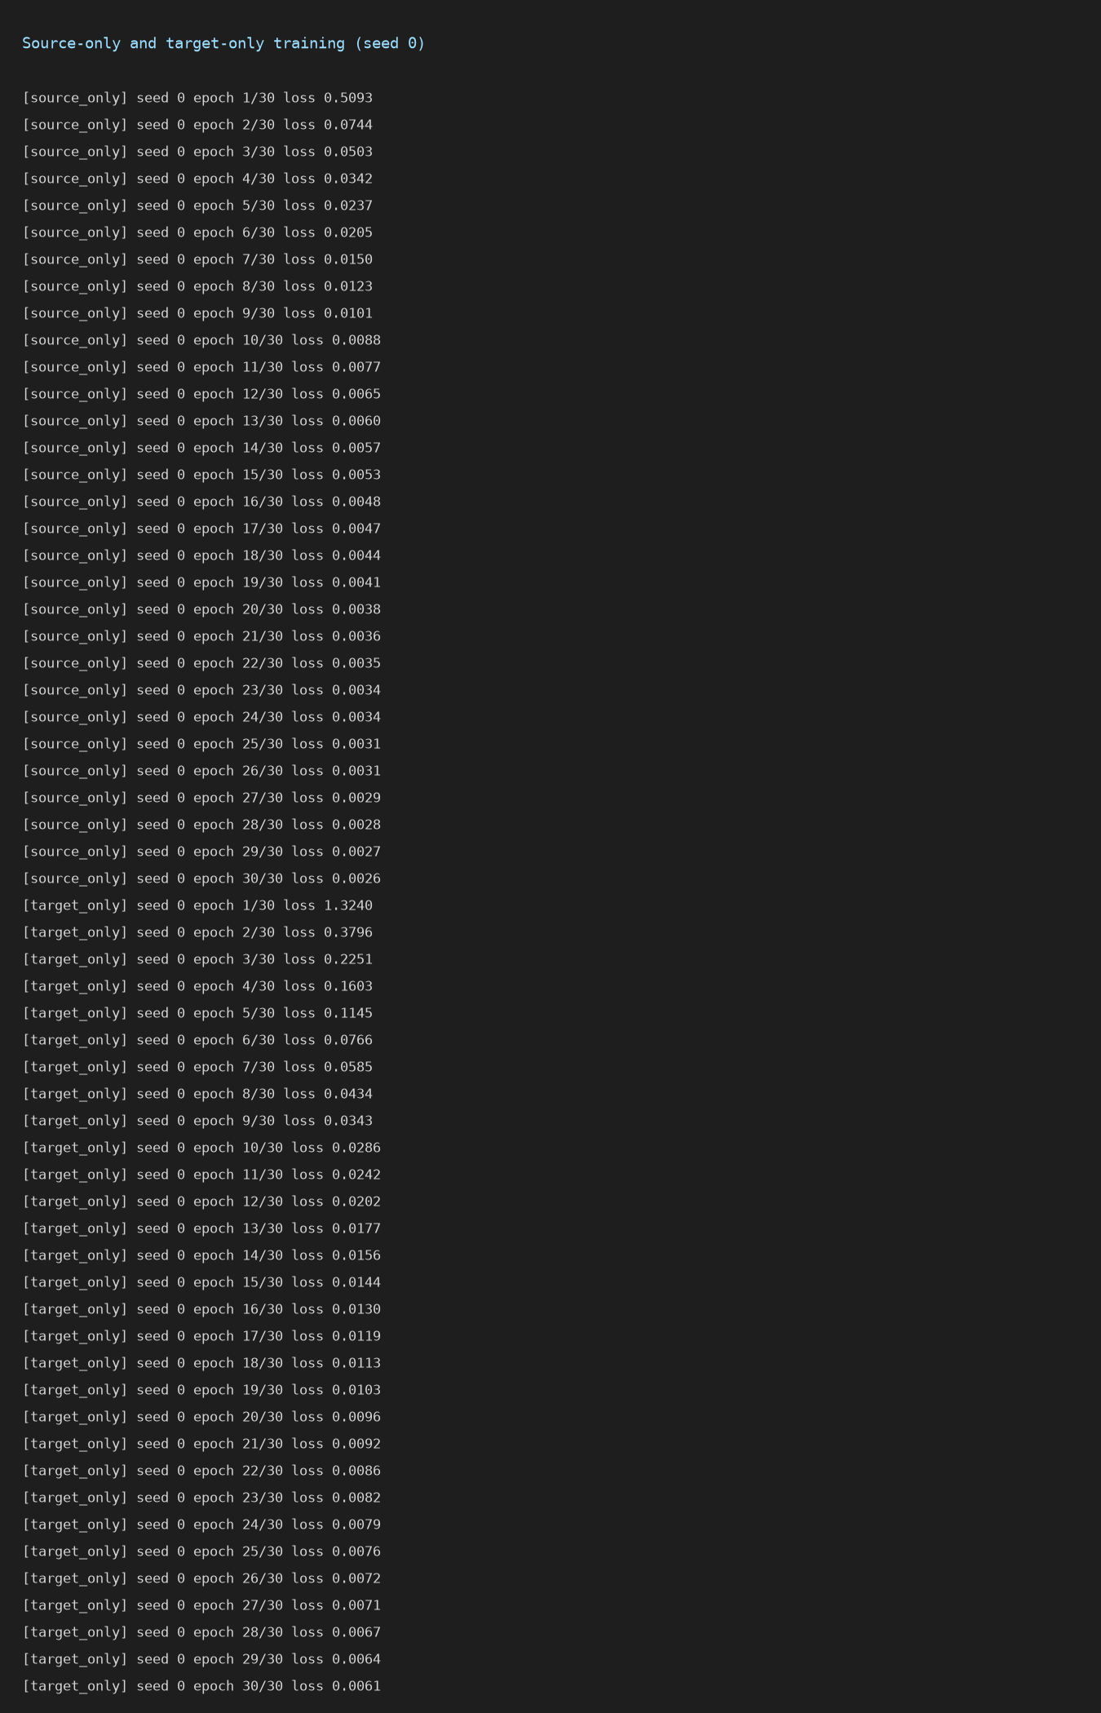
Screenshot 1: Training log of the source-only and target-only models (seed 0)
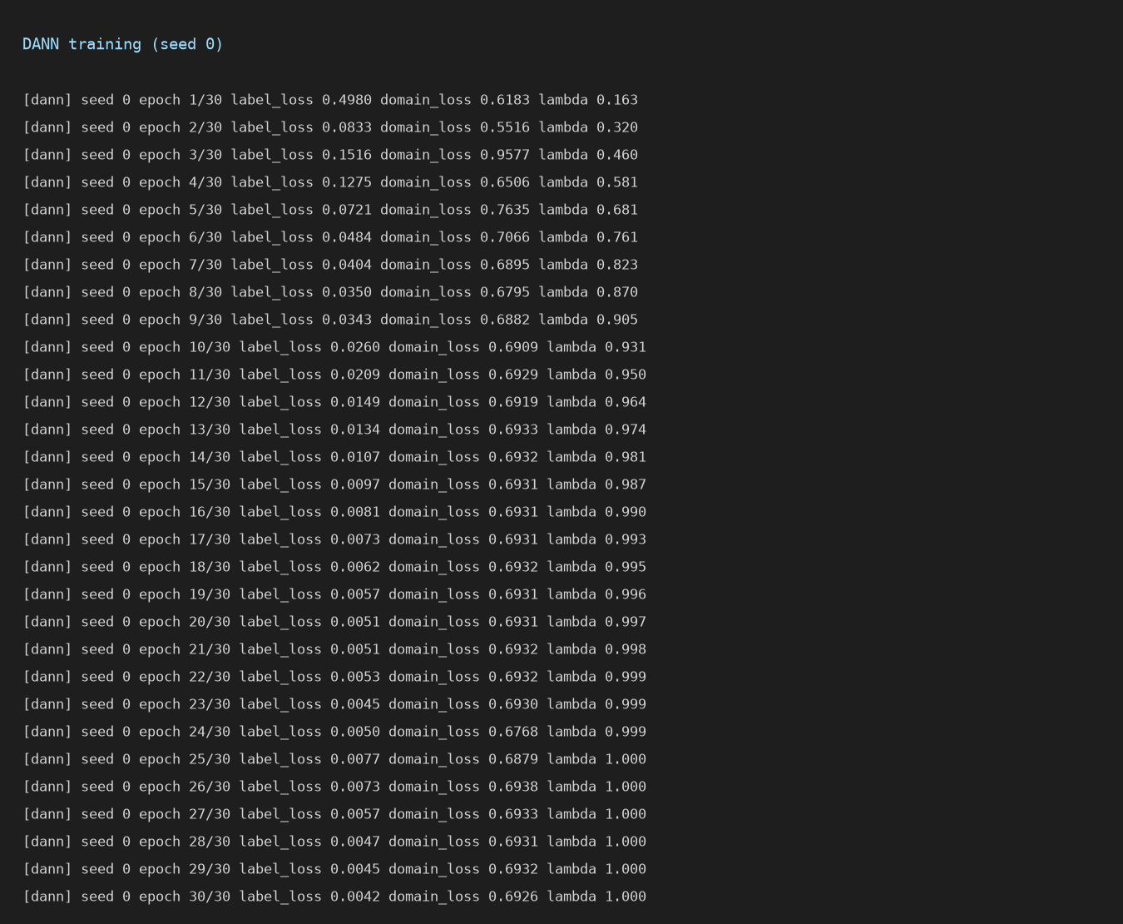
Screenshot 2: Training log of DANN (seed 0): label loss, domain loss and lambda per epoch
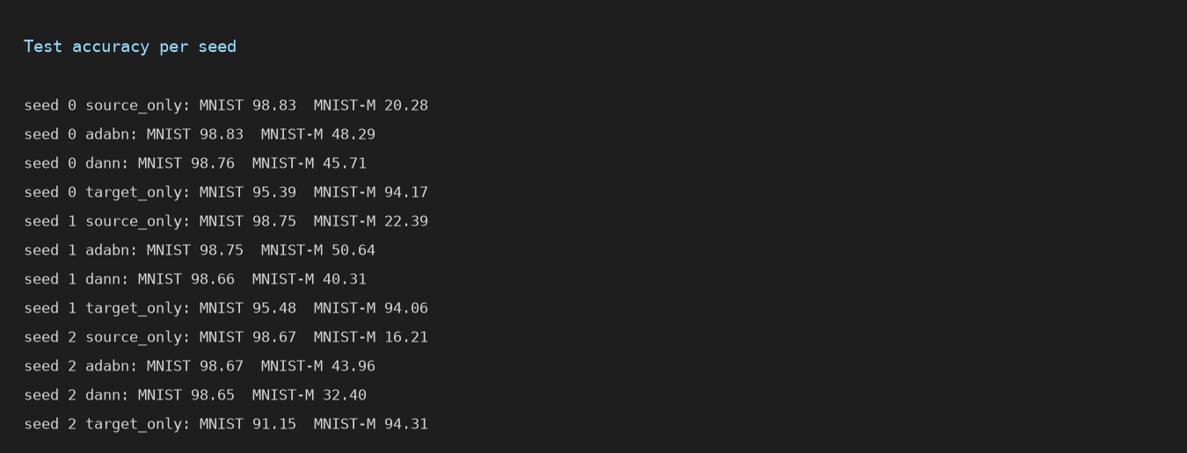
Screenshot 3: Test accuracy of every method for each seed, as printed by the notebook
Screenshot 4: Sample images from MNIST and MNIST-M (Figure 3)
Screenshot 5: Results bar chart (Figure 5)
Screenshot 6: t-SNE of source-only and DANN features (Figure 4)

