Part 1

Case Study Analysis

Business Opportunity

In AAVAIL company there is an existing tiered-subscription-based-service, however experimenting using a la carte approach. AAVAIL decided to switch to newly proposed a la carte approach.

Now the question is how to predict Monthly revenue?

Accurately predicting monthly revenue for the following month is the business opportunity.

Hypothesis

Question: Will the new marker model help in increased revenue?

Step 1:

Null Hypothesis: H0- There is no increase in the revenue because of new model.

Alternate hypothesis: H1- is there a increase/decreased in the revenue of new model.

Step 2:

Considering threshold value for this case as Binomial test (α)=0.05

Step 3:

Collect Data from 2 different revenue datasets.

Step 4:

Perform a t-test and evaluate P value.

Step 5:

If P>0.05 reject the null hypo in favour of alternate hypothesis.

Data Needed to perform scientific analysis for the business opportunity.

Highly recommended to have least granular data

* transactional level
* Invoice
* Day wise

Below is an example data required to perform revenue analysis:

* Time
* InvoiceID
* Amount
* Country

Target variable - Amount

Feature Variable - Time, Invoice, Country

EDA Points

Below are the key observations made while performing exploratory data analysis:

1. United Kingdom constitutes around 92% of the total revenue

Netherlands being the lowest @0.32%

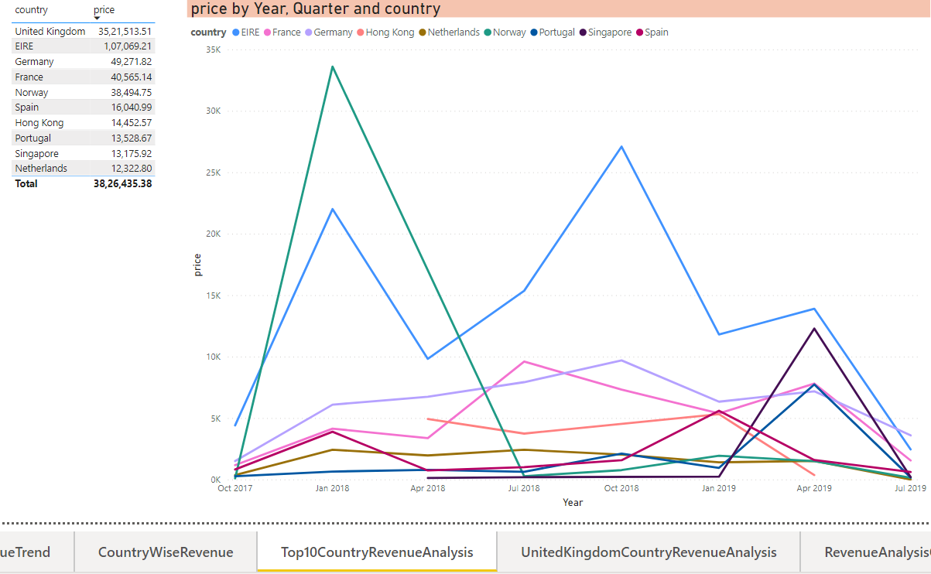

1. Revenue period of countries except United Kingdom is very asymmetric

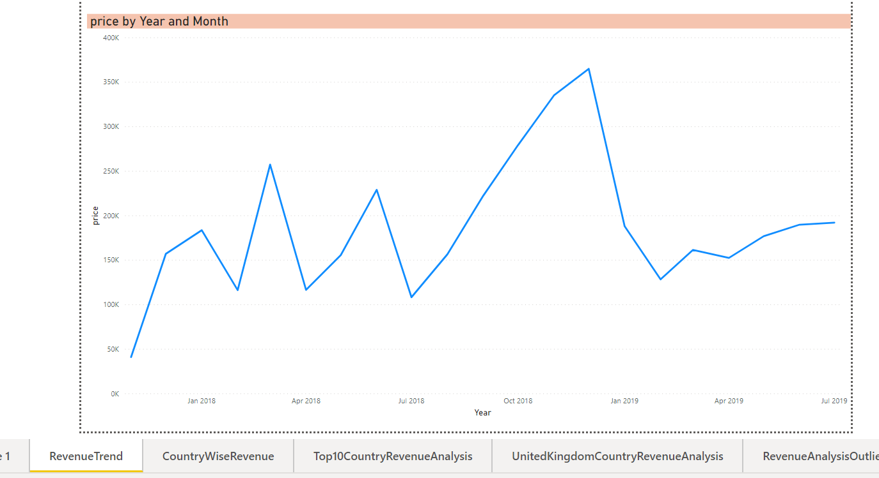

1. Price has mainly 3 outliers for United Kingdom

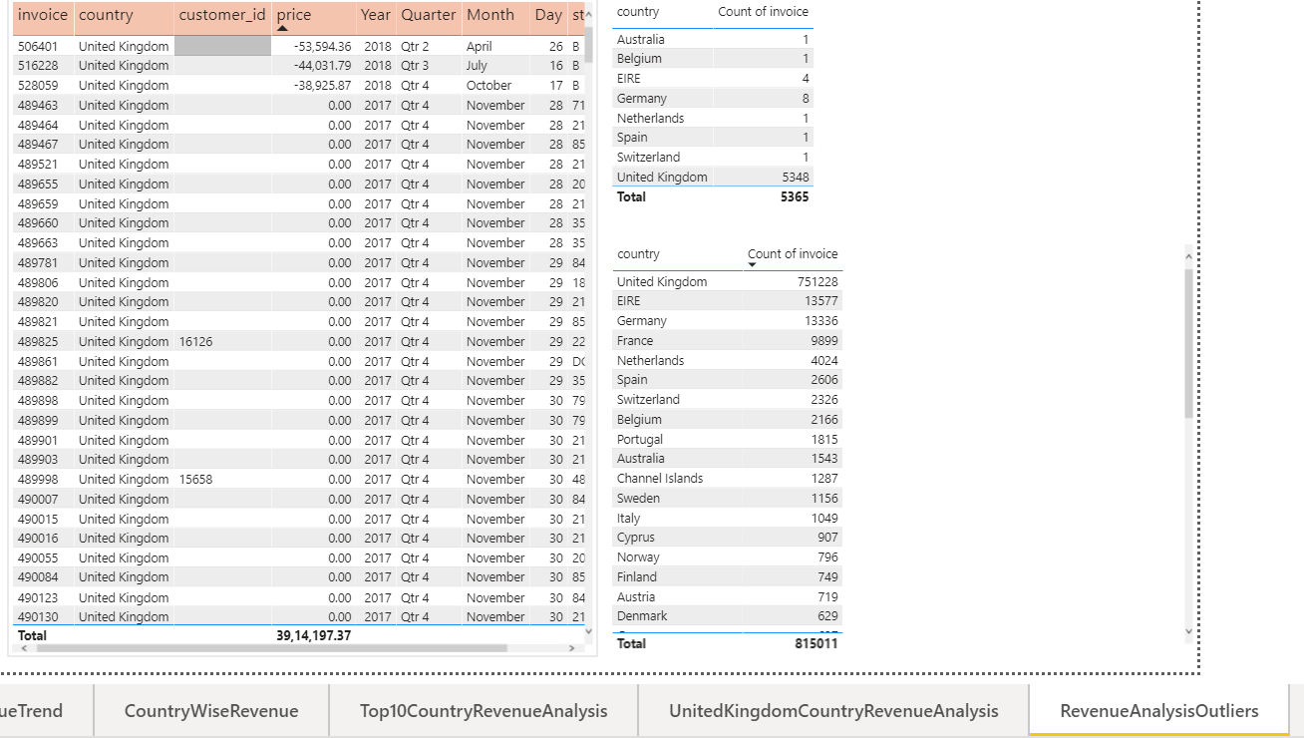

1. Majority of invoice with zero values are in United Kingdom constitutes for 0.8%

