Part 2

**Model development & approaches**

A time-series forecast approach can be employed utilising statsmodels time-series-package, however as the data is limited to 2years, model might not be able to identify underlying patters in the data.

However, observations are still made by decomposing the time series data which are below:

Time-series decomposition into individual elements to identify seasonality, trend and others.

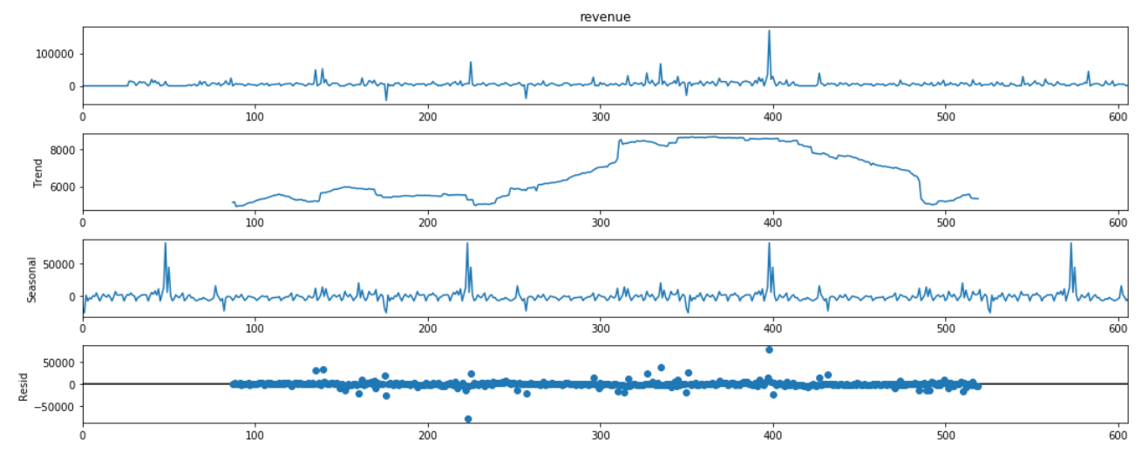

* Seasonality is present in the time series with frequency 180.
* Trend is seen in the above chart as slightly upwards

As it’s known that to employ any modelling techniques like AR, ARIMA, SARIMAX on the time series data, time series should be stationary.

However, as per the above analysis time series is not stationary and to make it as stationary different modelling techniques like lag and others are employed.

So, assuming the time-series might not identify patterns with limited data, a supervised learning approach is usedto predict the next 30days revenue as a single value.