CS 3520: Algorithms

Homework 3

**Due Date: Wednesday, March 13, 2019 at beginning of class**

***Please write legibly. Show your steps to receive partial credit.***

1. (40 points) Topologically sort the nodes in the following digraph using
   1. The DFS-based algorithm. List the stack operations and the result of the sorting.

f6,3

g5, 4 h8,6

d4,5 e7,7

b2, 1 c3,8

a1,2

* 1. Source removing algorithm. List the node removed at each step.

c, e, h, d, g, f, a, b

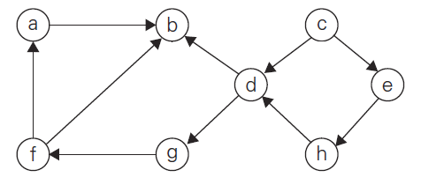

1. (30 points)
2. Use the Russian peasant algorithm to compute $95×12$. List your steps to receive credit.

95 x 12 - 12

94 x 12

47 x 24 - 24

46 x 24

23 x 48 - 48

22 x 48

11 x 96 - 96

10 x 96

5 x 192 - 192

4 x 192

2 x 384

1 x 768 - 768

1140

1. What is the time efficiency of the algorithm applied to .

O (log2n)

1. Can you think of a way to improve the computation in part a?

Switch the numbers. 12 x 95 is much quicker.

1. (30 points) Use the Quick Select algorithm with Lomuto’s Partitioning as d escribed on pages 159-160 of the book to find the median of the list of numbers 4, 18, 5, 17, 23, 2, 9. List the pivot and the partitions after each step.

**4**, 18, 5, 17, 23, 2, 9

**4**, 2, 5, 17, 23, 18, 9 2 < 4

2, 4, **5**, 17, 23, 18, 9

2, 4, **5**, 17, 23, 18, 9

**17**, 23, 18, 9

**17**, 9, 18, 23

2, 4, 5, 9, **17**, 18, 23 3 < 4

9