Blog entry from a .docm (Word) document
This blog post was written in Word and saved as a .docm (macro-enabled) Word document. The document gets automatically converted into HTML by the WEIRD build process.

Supported
The .docm conversion supports pretty much anything thrown at it. OK, not necessarily anything. WEIRD hasn’t been tested exhaustively yet. But it supports a lot.

Normal things like headings work
Paragraphs come through just fine, even with foonotes.
- Unordered
- Lists
- Work
Bold, italics, underlining, and strikethrough, and ^{sup} and _{sub} effects are fine.
- Ordered
- Lists
- Work
- Too.
Images work with or without ALT text. For instance, here’s an image from my lunch some time ago. It’s got ALT text. If you use WEIRD maybe I can afford better food.
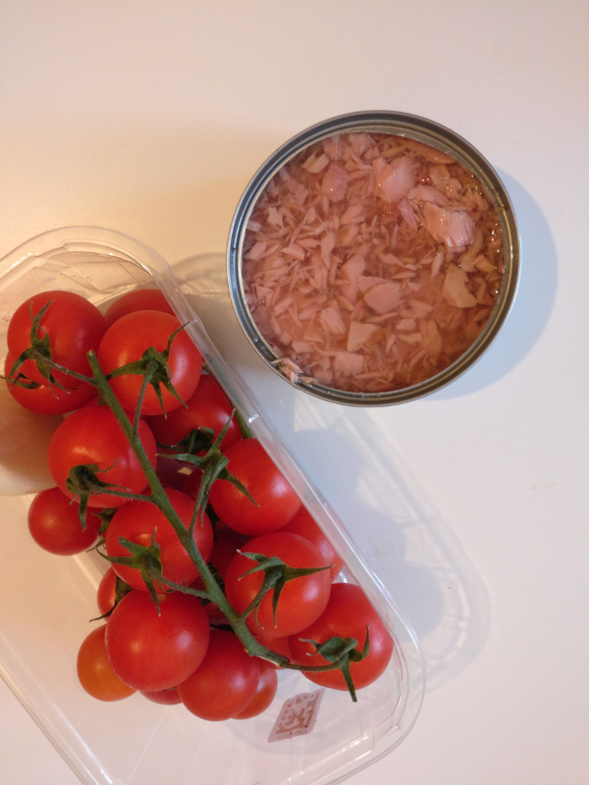

More complex stuff
The .docm conversion process takes significantly longer than the .docx conversion. However, it can handle more complex stuff like. Below some examples.
1 | 2 | A nice link back to WEIRD
4 | 5  6

Limitations
The conversion process for .docm files takes significantly longer than the one for .docx files. Stick to .docx files to the maximum extent possible. Use .docm in situations needing tables and other complex things.

This is a footnote.

