What is WEIRD?
(This is how our homepage would look if we had opted to use a Word document for it).
WEIRD is a multi-modal web framework.  It converts documents (HTML, markdown, Word documents, and more coming) into websites through a series of Python-meets-JS shenanigans. There’s also some VBA code hidden somewhere.  Yeah, we get it. WEIRD is weird.  But it can easily produce surprisingly good and fairly sustainable websites from little more than just a few documents. Even Word documents!  Download and try WEIRD from its dedicated GitHub repo. | 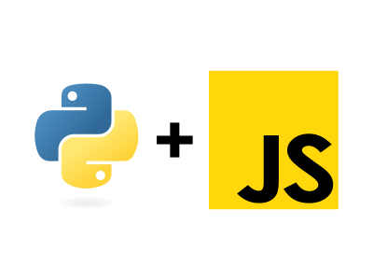
> If we were better at marketing, we'd say something like 'blogging reinvented'.

Key features

Multi-modal  Pages and blogs can be created in HTML, markdown, and Word. It is also possible to combine formats.  Potential benefits:  - Small-to-medium websites in no time.  - Easier to integrate dumps form data analytics.  - Rapid publishing of long-format documents. | A solid foundation  Customisation is possible but not necessary. Without additional customisation, WEIRD produces a site like this one.  Potential benefits:  - Small-to-medium websites in no time, even from Word documents.  - Painless way to launch project websites.  - A way for Python developers to easily create full websites.
Expandable  WEIRD can be expanded and customised using CSS/JS, jQuery (pre-installed), Bootstrap (pre-installed), and other libraries (upon import).  Potential benefits:  - An interpretable framework.  - Multiple design approaches possible.  - Imagination is the limit. | Fast!  Depending on how you approach it, WEIRD websites can be incredibly fast and fairly sustainable.  Potential benefits:  - Improved user experience.  - Outstanding performance metrics.  - Excellent sustainability scores.


Small to medium websites  WEIRD generates static websites. These are excellent for project, documentation, marketing, and landing pages, as well as some portfolios and SME websites. | Flexible yet painless blogs  WEIRD’s multi-modal nature means you can personalise key sections using markdown, HTML, CSS, and JS, yet blog easily on a regular basis by simply uploading blogs as Word documents. | Sustainable websites  WEIRD can produce websites that emit less carbon emissions than the average. WEIRD is therefore optimal for anyone interested in the environment and/or demonstrating a commitment to sustainability.

License
WEIRD is a product by polyzentrik.com, released under an Apache 2.0 open source license.
We kindly ask you to leave the branding in the footer intact or make a small voluntary payment via our payments gateway if you wish to remove it.

