Janay Hernandez

Samara Brown

Jose Tiznado

Josh Boltz

Archery 3D GDD Final Draft - Group 3

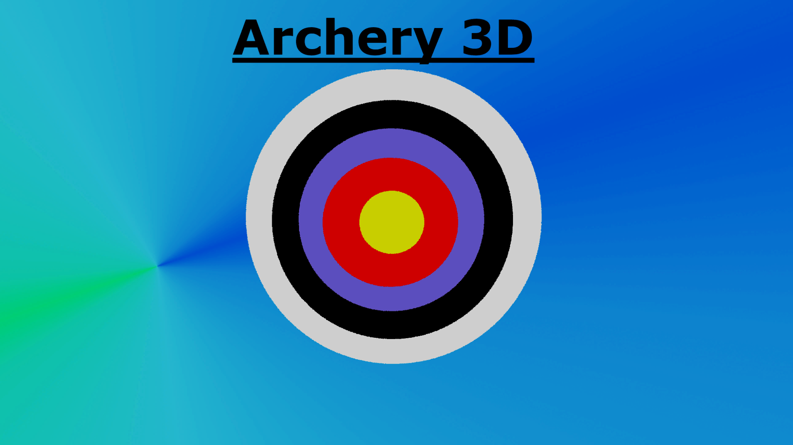

***‘You miss 100% of the shots you don’t take’***

Table of Contents and Team Member Listing

| Table of Contents  [1 Game Overview](https://n-xovwktmtjsnaxyc2mwes2xu7pohqedmdm6zjw5q-2lu-script.googleusercontent.com/userCodeAppPanel)  [2 High Concept](https://n-xovwktmtjsnaxyc2mwes2xu7pohqedmdm6zjw5q-2lu-script.googleusercontent.com/userCodeAppPanel) / Genre  [3 Unique Selling Points](https://n-xovwktmtjsnaxyc2mwes2xu7pohqedmdm6zjw5q-2lu-script.googleusercontent.com/userCodeAppPanel)  [4 Platform Minimum Requirements](https://n-xovwktmtjsnaxyc2mwes2xu7pohqedmdm6zjw5q-2lu-script.googleusercontent.com/userCodeAppPanel)  [5 Competitors / Similar Titles](https://n-xovwktmtjsnaxyc2mwes2xu7pohqedmdm6zjw5q-2lu-script.googleusercontent.com/userCodeAppPanel)  [6 Synopsis](https://n-xovwktmtjsnaxyc2mwes2xu7pohqedmdm6zjw5q-2lu-script.googleusercontent.com/userCodeAppPanel)  [7 Game Objectives](https://n-xovwktmtjsnaxyc2mwes2xu7pohqedmdm6zjw5q-2lu-script.googleusercontent.com/userCodeAppPanel)  [8 Game Rules](https://n-xovwktmtjsnaxyc2mwes2xu7pohqedmdm6zjw5q-2lu-script.googleusercontent.com/userCodeAppPanel)  [9 Game Structure](https://n-xovwktmtjsnaxyc2mwes2xu7pohqedmdm6zjw5q-2lu-script.googleusercontent.com/userCodeAppPanel)  [10 Game Play](https://n-xovwktmtjsnaxyc2mwes2xu7pohqedmdm6zjw5q-2lu-script.googleusercontent.com/userCodeAppPanel)  [10.1 Game Controls](https://n-xovwktmtjsnaxyc2mwes2xu7pohqedmdm6zjw5q-2lu-script.googleusercontent.com/userCodeAppPanel)  [10.2 Game Camera](https://n-xovwktmtjsnaxyc2mwes2xu7pohqedmdm6zjw5q-2lu-script.googleusercontent.com/userCodeAppPanel)  [10.2.1 HUD](https://n-xovwktmtjsnaxyc2mwes2xu7pohqedmdm6zjw5q-2lu-script.googleusercontent.com/userCodeAppPanel)  [10.2.2 Maps](https://n-xovwktmtjsnaxyc2mwes2xu7pohqedmdm6zjw5q-2lu-script.googleusercontent.com/userCodeAppPanel)  [11 Players](https://n-xovwktmtjsnaxyc2mwes2xu7pohqedmdm6zjw5q-2lu-script.googleusercontent.com/userCodeAppPanel)  [11.1 Characters](https://n-xovwktmtjsnaxyc2mwes2xu7pohqedmdm6zjw5q-2lu-script.googleusercontent.com/userCodeAppPanel)  [11.2 Metrics](https://n-xovwktmtjsnaxyc2mwes2xu7pohqedmdm6zjw5q-2lu-script.googleusercontent.com/userCodeAppPanel)  [11.3 States](https://n-xovwktmtjsnaxyc2mwes2xu7pohqedmdm6zjw5q-2lu-script.googleusercontent.com/userCodeAppPanel)  [11.4 Weapons](https://n-xovwktmtjsnaxyc2mwes2xu7pohqedmdm6zjw5q-2lu-script.googleusercontent.com/userCodeAppPanel)  [12 Player Line-up](https://n-xovwktmtjsnaxyc2mwes2xu7pohqedmdm6zjw5q-2lu-script.googleusercontent.com/userCodeAppPanel)  [13 NPC](https://n-xovwktmtjsnaxyc2mwes2xu7pohqedmdm6zjw5q-2lu-script.googleusercontent.com/userCodeAppPanel)  [13.1 Enemies](https://n-xovwktmtjsnaxyc2mwes2xu7pohqedmdm6zjw5q-2lu-script.googleusercontent.com/userCodeAppPanel)  [13.1.1 Enemy States](https://n-xovwktmtjsnaxyc2mwes2xu7pohqedmdm6zjw5q-2lu-script.googleusercontent.com/userCodeAppPanel)  [13.1.2 Enemy Spawn Points](https://n-xovwktmtjsnaxyc2mwes2xu7pohqedmdm6zjw5q-2lu-script.googleusercontent.com/userCodeAppPanel)  [14 Art](https://n-xovwktmtjsnaxyc2mwes2xu7pohqedmdm6zjw5q-2lu-script.googleusercontent.com/userCodeAppPanel)  [14.1 Setting](https://n-xovwktmtjsnaxyc2mwes2xu7pohqedmdm6zjw5q-2lu-script.googleusercontent.com/userCodeAppPanel)  [14.2 Level Design](https://n-xovwktmtjsnaxyc2mwes2xu7pohqedmdm6zjw5q-2lu-script.googleusercontent.com/userCodeAppPanel)  [14.3 Audio](https://n-xovwktmtjsnaxyc2mwes2xu7pohqedmdm6zjw5q-2lu-script.googleusercontent.com/userCodeAppPanel)  [15 Procedurally Generated Content](https://n-xovwktmtjsnaxyc2mwes2xu7pohqedmdm6zjw5q-2lu-script.googleusercontent.com/userCodeAppPanel)  [15.1 Environment](https://n-xovwktmtjsnaxyc2mwes2xu7pohqedmdm6zjw5q-2lu-script.googleusercontent.com/userCodeAppPanel)  [15.2 Audio](https://n-xovwktmtjsnaxyc2mwes2xu7pohqedmdm6zjw5q-2lu-script.googleusercontent.com/userCodeAppPanel)  [15.3 Minimum Viable Product (MPV)](https://n-xovwktmtjsnaxyc2mwes2xu7pohqedmdm6zjw5q-2lu-script.googleusercontent.com/userCodeAppPanel)  [16 Wish List](https://n-xovwktmtjsnaxyc2mwes2xu7pohqedmdm6zjw5q-2lu-script.googleusercontent.com/userCodeAppPanel)  17 Bibliography   |  | | --- | | Game Development Team Members    PRODUCER  Janay Hernandez  Samara Brown  Jose Tiznado  Josh Boltz    PRODUCTION MANAGER  Janay Hernandez  Samara Brown  Jose Tiznado  Josh Boltz    PRODUCTION COORDINATOR  Janay Hernandez  Samara Brown  Jose Tiznado  Josh Boltz  GAME DESIGNERS  Janay Hernandez  Samara Brown  Jose Tiznado  Josh Boltz  SYSTEMS/IT COORDINATOR  Janay Hernandez  Samara Brown  Jose Tiznado  Josh Boltz  PROGRAMMERS  Janay Hernandez  Samara Brown  Jose Tiznado  Josh Boltz  TECHNICAL ARTISTS  Janay Hernandez  Samara Brown  Jose Tiznado  Josh Boltz  AUDIO ENGINEERS  Janay Hernandez  Samara Brown  UX TESTERS  Janay Hernandez  Samara Brown  Jose Tiznado  Josh Boltz |
| --- | --- | --- |

|  |
| --- |

# 1 Game Overview

Title: Archery 3D

Platform: PC Standalone

Genre: First Person Shooter

Rating: (10+) ESRB

Target: Casual gamer (aging from 12 - 30)

Release date: December, 2021

Publisher: Archery 3D Studios

Description: Archery 3D is a first-person shooter game where the player has to hit all the targets within the given time frame for the specified level. The player has to move around carefully to avoid jumping in the water, while also aiming and shooting strategically to try and hit all the targets before the timer runs out. The player has the choice of 3 difficulties, where each difficulty corresponds to an amount of time they have to hit all the targets. If the player wins, their best time is recorded and they have to try to beat that best time next time. The targets always spawn in random spots so you can’t memorize the layout!

# 2 High Concept / Genre

Archery 3D is a first person shooter genre of game that sets the player in an outdoors setting where he/she is practicing to become a professional archer. Moving targets and time are the challenges you must overcome. Grab your bow and arrow and shoot! Move around quickly to get all the targets before time runs out. Watch out, or else you may end up jumping into the water!

# 3 Unique Selling Points

* Beautiful scenery
* Calm and relaxing atmosphere
* A fun target shooting game with the ability to move around the map

# 4 Platform Minimum Requirements

Since this is not a super demanding computational game, it can be played on old hardware to new hardware. All that is required is a PC that can play basic Unity games.

# 5 Competitors / Similar Titles

This game took some inspiration from the game Archery Master 3D, but is significantly different.

# 6 Synopsis

Since you were young, you dreamed of becoming a professional archer to compete in the Olympics. Now is your time to prepare. This is your chance, give it your best shot! Try to get a better and better time in hitting all of the targets and make your friends jealous. If you’re not able to hit all the targets within the time limit or you decide to try jumping overboard into the water though, you’ll be met with a game over screen. Try to challenge yourself by hitting the target that moves around the map!

# 7 Game Objectives

The objective of this game is to shoot 10 targets with your bow and arrow. You must be able to do this within the time limit. The time limit is based on the user’s chosen difficulty level. Easy is 3 minutes, medium is 2 minutes and hard is 1 minute. If you can’t finish in time or jump into the water, it’s game over.

# 8 Game Rules

The game level is an outdoor setting where the player is tasked with shooting moving targets. The player can move around and adjust their aim to shoot. The player needs to stay within the boundary to keep playing. The player can also walk, run, or jump to get around. The player needs to shoot 10 targets within a certain time limit to win, and they’ll see what their best time is on the game screen.

# 9 Game Structure

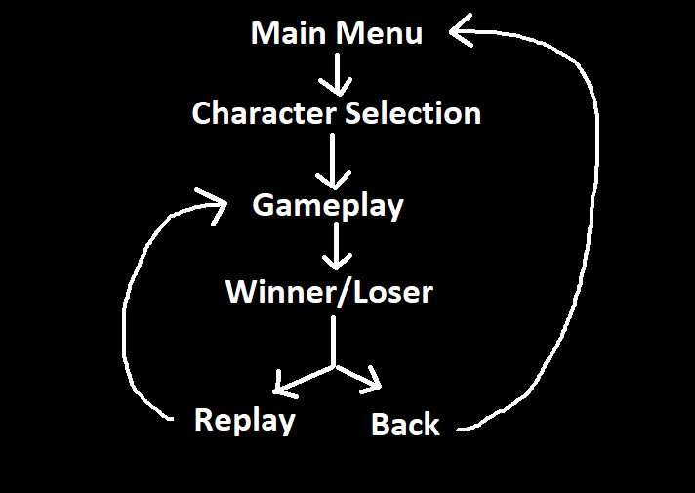

# 10 Game Play

## 10.1 Game Controls

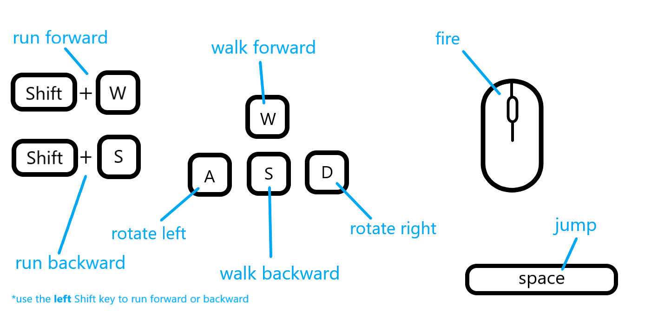

## 10.2 Game Camera

The camera is attached to the player. That is, the game is played from a first-person point of view. So, the camera turns and moves with the player. The player’s bow and arrow is visible.

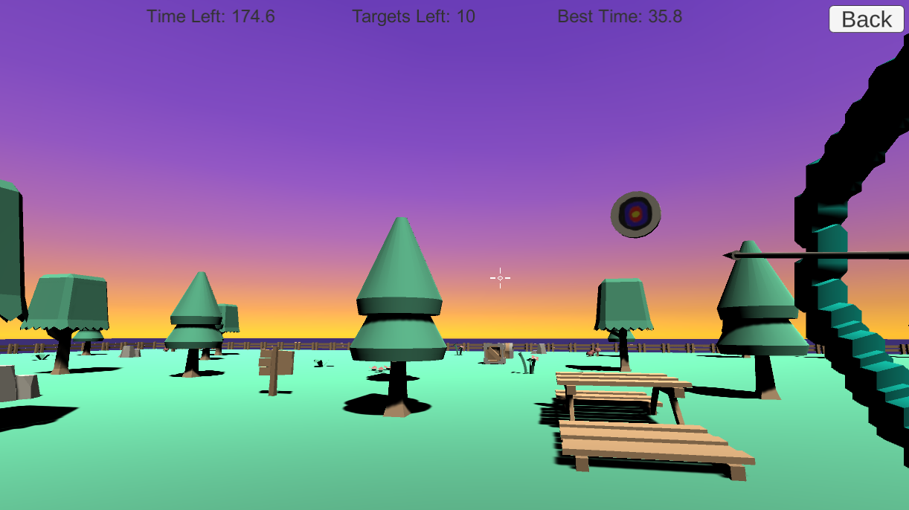

### 10.2.1 HUD

The HUD, tells us how much time (in seconds) we have left, the number of targets we have left to hit, as well as the best time achieved so far.



### 10.2.2 Maps

We have our main map which the player can move around in to shoot all the targets that are instantiated at random locations at run time

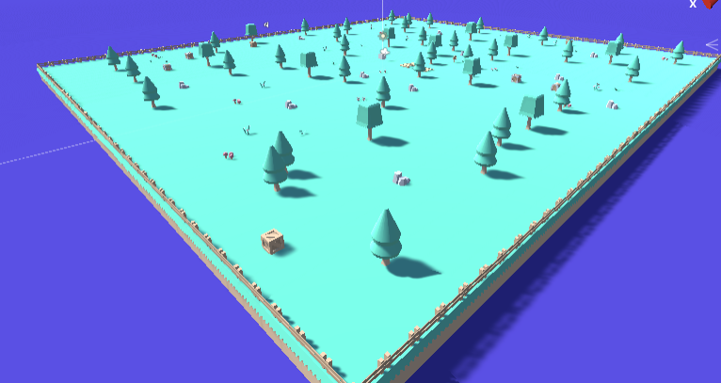

# 11 Players

## 11.1 Characters

You can choose from one of 7 different “players” (ie. bow colors), as well as name yourself anything you want.

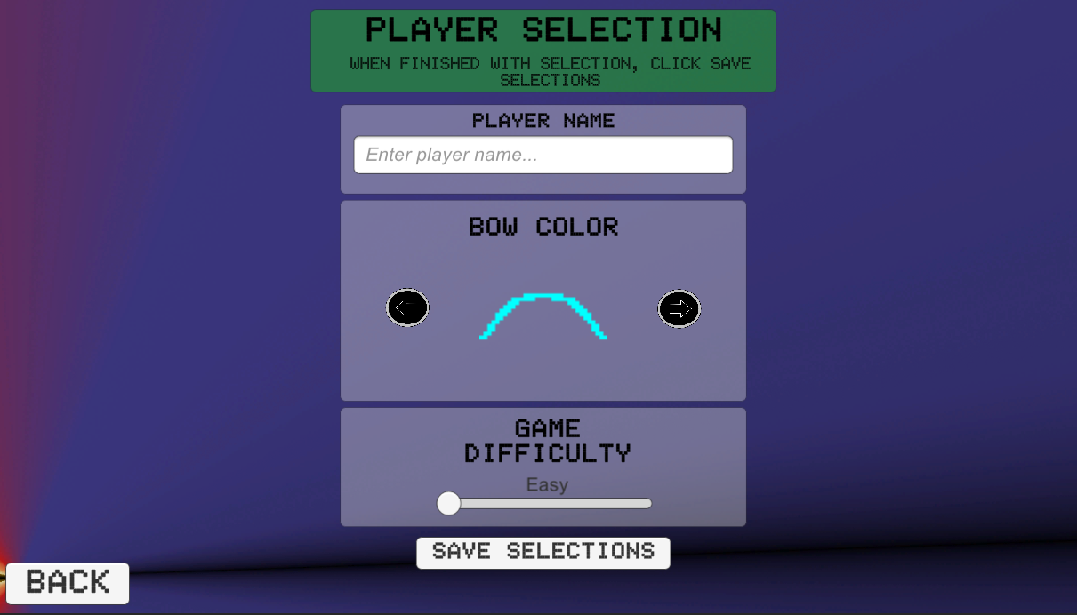

## 11.2 Metrics

* **Target Health:** 1
* **Arrow Damage:** 1
* **Jump Height:** 3
* **Walking Speed:** 1
* **Running Speed:** 3

## 11.3 States

**Idle:** The player can stand still and shoot targets

**Moving:** The player can move around the map using the wasd keys

## 11.4 Weapons

The player has a bow and arrow and they can click the mouse button to shoot arrows. The arrows destroy every target they come into contact with. You point the bow and arrow at targets by pointing your mouse in the direction of the target using the crosshair and pressing the mouse button.

# 12 Player Line-up

Choose from 7 different player choices

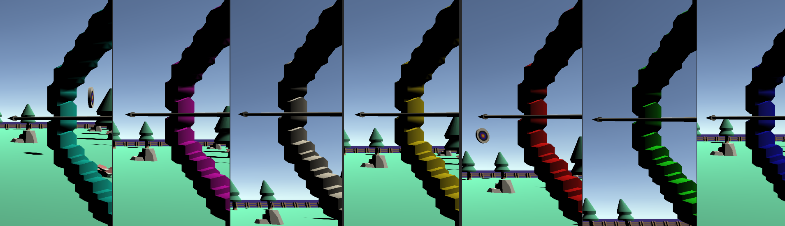

# 13 NPC

## 13.1 Enemies

The targets spawn randomly across the map and are programmed/animated to rotate and move to make hitting them harder. All targets just need to be hit once by your arrow for them to be destroyed.

Target:

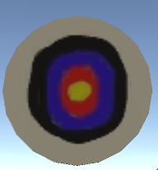

### 13.1.1 Enemy States

**Rotating:** The target rotates around the Z-axis using an animation

**Moving:** The target moves around the edge of the map using an animation

### 13.1.2 Enemy Spawn Points

Targets are spawned randomly around the map during each play through.

# 14 Art

## 14.1 Setting

The game takes place in a lush forest surrounded by water with targets for you to hit everywhere you look. The game is meant to be very serene and calming as you take in the nice atmosphere and shoot some targets.

## 14.2 Level Design

The level consists of this setting described above where you look for and shoot targets with your bow and arrow and try to shoot all of them before the time runs out.

## 14.3 Audio

In-Game Background Sound:

* OriginalBirdsSound.mp3
* Plays continuously in the background while you play to create a very relaxing environment

In-Game Movement Sound:

* OriginalStepsSound.mp3
* Plays whenever the player moves in game to simulate the sound of walking in the outdoors

In-Game Target Hit Sound:

* OriginalTargetHitSound.mp3
* Plays whenever the player hits a target with his arrow

Button Clicking Sound:

* ButtonClick.mp3
* Plays whenever the player selects their character in the Player Selection scene and when they click the Play Game button

# 15 Procedurally Generated Content

## 15.1 Environment

The environment is procedurally populated with targets at runtime. The targets are placed in random positions and will rotate or move around the map. When you shoot a target, explosions are generated from the target to indicate to the user that they hit the target. The target is then destroyed in the process.

## 15.2 Audio

A serene background audio is generated upon playing the game where you hear the calming noise of birds chirping in the background. Upon moving the player, you will also hear footsteps being generated as well as when you hit a target, an explosion sound is generated as well.

## 15.3 Minimum Viable Product (MPV)

* 7 different bow colors to choose from
* 3 difficulty levels to choose from
* 1 level to play on
* Built for the PC platform

# 16 Wish List

* More levels to play on
* Ability to choose a different weapon; e.g. axe, slingshot
* Requirement to hit a certain amount of different targets; e.g. smaller normal targets, balloons, bottles

# 17 Bibliography

Animations

* GameOverTextChanging.anim Janay Hernandez
* WinnerTextChanging.anim Janay Hernandez
* TargetMoving.anim Josh Boltz
* TargetRoundabout.anim Josh Boltz

Arts:

* Back_Button.png Jose Tiznado
* PlaneBackground.png Josh Boltz
* TemporaryBackground2.png Josh Boltz
* SplashScreen.png Josh Boltz
* crosshairs.png Visdye Interactives*
* Skybox Samara Brown

Models

* Bow.dae Josh Boltz
* Target.fbx Josh Boltz
* Arrow.fbx Josh Boltz
* block.dae https://kenney.nl/
* bridge.dae https://kenney.nl/
* chest.dae https://kenney.nl/
* crate.dae https://kenney.nl/
* crateStrong.dae https://kenney.nl/
* fence.dae https://kenney.nl/
* fenceBroken.dae https://kenney.nl/
* fenceCorner.dae https://kenney.nl/
* flag.dae https://kenney.nl/
* flowers.dae https://kenney.nl/
* flowersLow.dae https://kenney.nl/
* hedge.dae https://kenney.nl/
* ladder.dae https://kenney.nl/
* mushrooms.dae https://kenney.nl/
* plant.dae https://kenney.nl/
* platform.dae https://kenney.nl/
* rocks.dae https://kenney.nl/
* sign.dae https://kenney.nl/
* tree.dae https://kenney.nl/
* treePine.dae https://kenney.nl/

Prefabs:

* aim.prefab Samara Brown
* explosion.prefab Jose Tiznado
* Target.prefab Josh Boltz & Janay Hernandez & Jose Tiznado
* Bow.prefab Josh Boltz
* Arrow.prefab Josh Boltz

Scenes:

* CreditsScene All four of us
* InstructionsScene All four of us
* MainMenuScene All four of us
* PlayerSelectionScene All four of us
* PlayGameScene All four of us

Scripts:

* PlayerMovement.cs Jose Tiznado & Josh Boltz & Janay Hernandez
* GameManager.cs Josh Boltz & Jose Tiznado
* PlayerData.cs Josh Boltz
* CountdownTimer.cs Josh Boltz
* PlayerScore.cs Josh Boltz
* Arrow.cs Josh Boltz & Samara Brown
* AudioManager.cs Samara Brown
* TargetSpawner.cs Josh Boltz
* Target.cs Josh Boltz & Janay Hernandez & Jose Tiznado

Sounds:

* OriginalBirdsSound.mp3 Janay Hernandez⁺
* OriginalStepsSound.mp3 Janay Hernandez⁺
* OriginalTargetHitSound.mp3 Janay Hernandez⁺
* ButtonClick.mp3 Samara Brown**

Sprites

* Bow2D.png Josh Boltz
* Arrow2D.png Samara Brown

* Link to Visdye Interactive: <https://assetstore.unity.com/publishers/25148>

⁺ Recorded audio using built-in voice recorder in Android phone, Edited audio using AudioMass audio editor (link: <https://audiomass.co/>)

** Button click sounds from: https://www.fesliyanstudios.com/royalty-free-sound-effects-download/video-game-menu-153