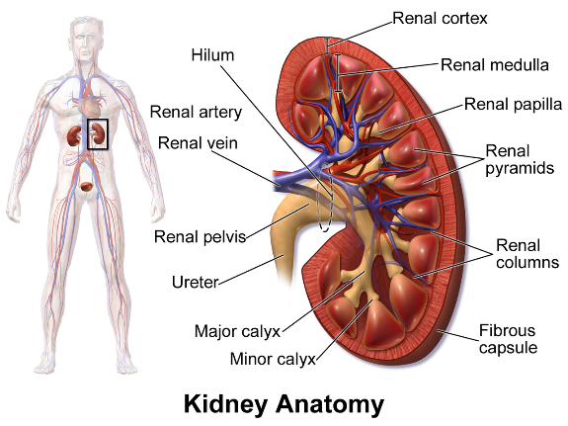Date: August 26, 2019

Topics: Intro to Nephrology, Renal Continuum of Care

Dialysis technology is relatively old and hasn’t been innovated upon in awhile

* 1943: 1st dialysis, only kept alive for a couple weeks due to limited number of spots to access vascular system
* Arteriovenous fistula is now the main way to access vascular system, can be used many times

Shift of Public policy

* 90% of Chronic Kidney Disease (CKD) patients that require dialysis are paid for by the government
* Since dialysis interrupts the rhythm of living/having a job etc., the idea that CKD patients would be able to contribute to society in a normal manner is not always true
* Dialysis patients aren’t always able to get transplants
  + average lifespan after diagnosis = 6 years
  + average wait time on transplant = 5-7 years
* Differences between Doctors’ main goals and patients’
  + Doctors: Keep patient alive until transplant
  + Patients: Quality of Life, less logistical nightmare for dialysis, less life interruption
* Public policy has shifted for the first time in decades to increase Home dialysis and put a focus on kidney transplants, extra funding for CKD innovation
  + Home dialysis has certain advantages – not as tough on the body as 3x/week schedule – 5-6x/week

CKD

* 2 roles of kidneys: Cleansing, Blood Pressure Regulation (hormones)
* Glomerular Filtration Rate – mL/min cleaned, normal is 100ml (per 500ml pumped)
  + At least 500 cc (8oz) a day, should be same amount of waste no matter the water, just difference in concentration



* Hormones
  + Epogen – stimulates marrow to make more blood cells
  + Activated Vitamin D (1,25(OH)2 D) (vs Vitamin D ,25-(OH) D), promotes calcium absorption



* 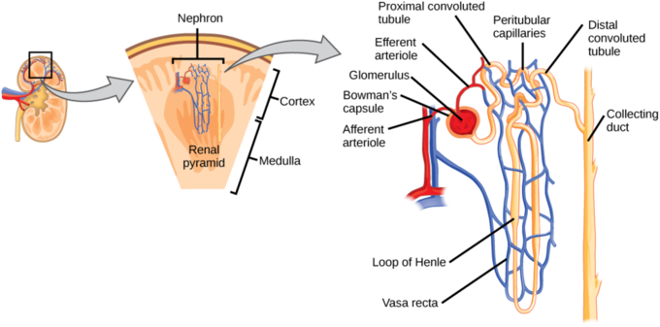Related CKD diseases
  + Renal Anemia – not enough blood cells
  + Mineral Bone Disorder
  + Volume overload

CKD Classification

* I normal or high GFR > 90 ml/min
* II mild 60-90
* III Moderate 30-60, mineral bone disorder can become apparent
* IV Severe 15-30, + renal anemia
* V End Stage < 15 uremia
* V-D Dialysis

UVA CKD Clinic

* 16 doctors, NPs
* Dialysis unit processes about 100 patients a week, each coming 3 times a week