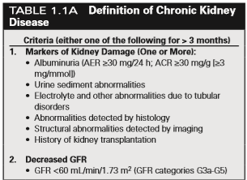Kidney Notes

Chronic Kidney Disease

Chapter 1: Definition, Epidemiology, Cost, and Outcomes

CKD (Chronic Kidney Disease)

* Disorders that result in sustained kidney damage
* Initial decline has no symptoms
* Defined as abnormalities of kidney structure of function present for >3 months, this length is to distinguish from Acute Kidney Injury (AKI)
* Other specifics in Table 1.1A 🡪
* 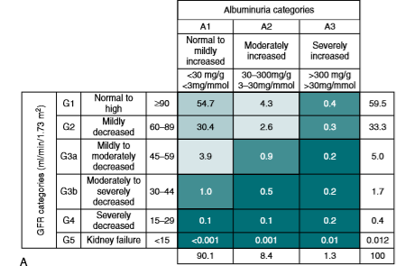Staging is listed in the Table below and is based upon both a decrease in Glomerular Filtration Rate (GFR) and increase in albuminuria concentration, prevalence included
* 11.5% prevalence of CKD in the USA
  + Much more common with increase in age
* Hemodialysis – running blood through machine – filter + dialysate involved
* Peritoneal dialysis – cleansing fluid flows though a tube into part of your abdomen, lining of abdomen (peritoneum) acts as a filter and removes waste products from the blood. Fluid with filtered waste is later removed and discarded
* Up to $90K spent per patient on dialysis
* Recent numbers (2018): <https://www.usrds.org/2018/view/v1_07.aspx>
  + Over $100 Billion, or 23% of the Medicare budget!

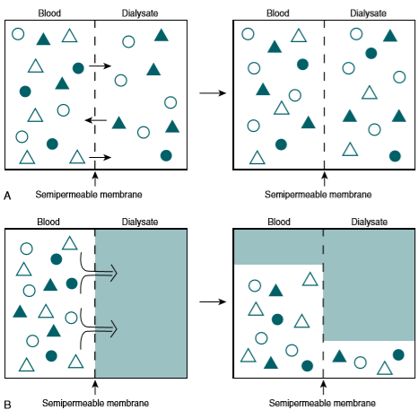Chapter 22: Principles of Hemodialysis

* Early 1900s was tested on animals
* “Successful” dialysis performed by Kolff in 1944: cellophane, antibiotics, heparin as anticoagulant
* Vascular access: Scribner shunt and later the AV fistula
* The most promising Kidney Replacement Therapy (KRT) is transplant
* Dialysis
  + Passage of molecules in solution by diffusion across a semipermeable membrane
  + Equilibrate the blood against an isosmotic dialysate
  + Solutes added to the dialysate at concentrations designed to mimic what is maintained in the kidney
  + Combo of solutes moving down concentration gradient and hydrostatic pressure causing blood to flow across membrane
* Uremia – clinical state reversed by hemodialysis – urine (urea) in the blood
  + Uremic toxins accumulated in the blood, normally eliminated by the kidney
  + GI tract and CNS most targeted/susceptible to bad things occurring in the case of uremia (uremic coma)
  + There is an ever growing list of toxins that are eliminated by the kidney, but even after decades of research, there is not a single toxin or group of toxins responsible for life-threatening uremic syndrome
* Residual Syndrome
  + Despite adequate dialysis, quality of life may suffer due to anemia, osteodystrophy, dialysis amyloidosis, accelerated atherosclerosis, anorexia, disordered sleep, and fatigue
  + Cause of this not fully known, but may be attributed to some larger sized toxins not being removed from the system
* Normal hemodialysis schedules are 3 sessions per week, with a targeted equilibrated Kt/V greater than 1.05
  + K=dialyzer clearance of urea t = dialysis time V=volume of distribution of urea
  + Must take into account residual syndrome, quality of life of patient, and other health factors
* Diffusion
  + Consequence of random molecular movements, driven by temperature, pressure, and concentration
    - Concentration most important for this application because other factors are relatively constant
    - Sometime it is difficult for large molecular weight substances such as albumin to diffuse
  + -J = (DA/X) * dC
    - J = solute flux (mg/min), dC= concentration gradient (mg/mL), A = membrane area (cm2), X=membrane thickness (cm), D=constant coefficient of diffusion (cm2/min)
  + -J/dC = (DA/X) = solute dialysance
  + -J/C = clearance – most used because it is a measure of blood side concentration of membrane
    - When concentration of solute on dialysate side is zero, dC = C and clearance=dialysance (at the beginning of dialysis)
  + (dC/C) /dT = K/V = K
    - First order process – fractional rate of change is constant when dialysate concentration remains zero
* Dialysate solute concentrations are fairly standard – K, Ca, bicarbonate, glucose, some are based on patient needs/drugs being taken
* Hemodialyzers
  + Artificial kidney, inflow is arterial, outflow is venous
  + Synthetic membranes are preferred due to biocompatibility and ability to vary pore size for correct solute diffusion
  + Total membrane surface area of .8 to 2.1m2 – numerous hollow fiber membranes to increase dialyzer efficiency, must be thin enough for transport of solutes; other disadvantages of increasing SA without taking into account various other parameters of the membrane itself
  + Flow
    - Blood flow is 200-500 mL/min
    - Dialysate flow is countercurrent, either single pass or cycled through cartridge to remove waste
    - Find the correct flow such that there is no adhered solvent to fiber causing nonuniform flow
  + KoA Ko = mass transfer coefficient (cm/min), A=membrane area
    - Max clearance achievable for particular dialyzer and solute
    - In practice, when blood and dialysate flow is finite, clearance is lower than KoA – main driver is solute concentration gradient across membrane, not just membrane area A
  + 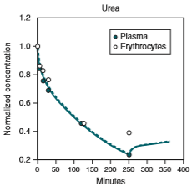Dialyzer performance has increased based on innovations to permeability, porosity, SA, better ability to remove larger molecules
* Hemodialysis
  + Different ways to measure total clearance
    - Instantaneous dialyzer clearance – sample blood on sides of dialyzer while recording blood flow
    - Effective clearance – link clearance to pre and post measurement of blood urea nitrogen (BUN)
    - Delivered clearance -what actually occurs in the body – there is an extra step of solutes diffusing into blood plasma before diffusing into the dialysate
  + Disequilibrium develops among various body compartments, resulting in concentration rebound
  + continuous kidney function will always be better due to maximal solute removal and not as intense fxn
    - 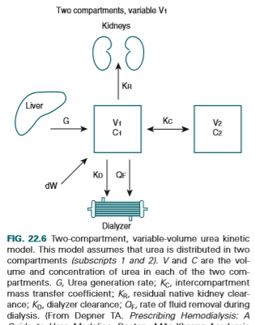Dialysis is innately more intense - each session will see a log decline in toxin concentration
    - Solute access to dialyzer is affected as it is cleared from the blood but remains in other compartments
  + Urea Kinetic Modeling – 2 Compartment Model is more accurate, but single compartment still works somewhat
    - Intracellular and extracellular pools
    - Disequilibrium between compartments are more pronounced for solutes that are larger or have charge; more complex modeling involved
    - Areas of the body with better blood perfusion will have lower urea concentration than other tissues
  + Patient outcome correlates best with dialyzer urea clearance (Kd)
    - Normalized clearance per dialysis Kt/V
      * V=patient’s volume of urea distribution
      * K=native kidney + dialyzer clearance
    - Kt/V = ln (C0/C)
      * Predialysis BUN C0, Postdialysis BUN C
    - Recommended target 2.3
  + Generation of urea depends mostly upon protein intake
    - Even though comsuming proteins result in more urea, it is still important to consume them
    - Link between protein catabolic rate (PCR) and Kt/V is important to understand when modeling
  + Recirculation of blood that has already been dialysized reduces the efficacy of dialysis because the urea has already been partially cleared, resulting in a lower concentration gradient
  + Instead of basing dosing upon absolute blood urea concentration, it is better to use change in urea concentration – avoids mistep of providing less dialysis to those who don’t consume enough protein
    - Minimum Kt/Vurea of 1.2 per dialysis administered 3 times/week
  + Filtration also is a factor – “ultrafiltration,” necessary to maintain fluid balance/ removing excess fluid
    - ~5% of clearance is attributed to filtration, most is from diffusion
    - Larger molecules have better ability to be filtered outt
    - Hemofiltration – replacement of fluid, required 30-80L for a treatment
  + Effective clearance is treatment time dependent
    - Without enough time, solute disequilibrium and failure to remove larger molecules can be factors that affects the efficacy of dialysis
* Mechanics of Hemodialysis
  + Single or multipatient delivery systems for the delivery of dialysate
  + Dialysate is heated to body temperature to avoid hypothermia
  + Patient is exposed to 100-200L of dialysate each treatment
  + Conductivity monitor measures electrical conductivity of product solution for correct electrolyte amount
  + Blood leak monitor at dialysate outflow to ensure the membrane has not ruptured
  + Bicarbonate is used instead of acetate because high flux systems result in overexposure of acetate
    - Bicarbonate is susceptible to bacterial contimination and Ca and Mg precipitation
    - Bicarbonate tanks must be cleaned often
    - Addition of acid concentrate component helps protect against precipitation
  + Water is softened, exposed to charcoal and then filtered, before being mixed with dialysate concentrate
  + Blood Circuit
    - Drawn from arterial lumen in catheter or arterial needle of fistula and returned via venous lumen or venous needle of fistula
    - Peristaltic pump – pulsitile flow
    - Pressure monitor to ensure it is kept in a specific range
      * Bad: kinks in tubing, improper needle positions, hypotension, flow stenosis, blood clotting
    - Air trap and air detector ensure that no air enters the patient – can cause air embolism
  + Anticoagulant is usually given at the beginning of and throughout dialysis to prevent clotting
  + Monitoring of Clearance, hematocrit, and access flow improves outcomes by allowing for proactive adjustment of concentrations, filtration rate, and vascular access failure
* Residual Syndrome is still a big problem and is ever expanding in terms of systems it affects and toxins that are left in the body despite dialysis

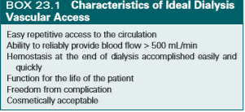**Chapter 23: Vascular Access**

Arteriovenous Fistula – number 1 choice for vascular access

* Best primary patency rate, cumulative patency rate, lowest rate of thrombosis, fewest interventions needed, cheapest to implant and maintain, lower hospitalization rates
* 3 types: simple direct, vein transposition, vein translocation
* 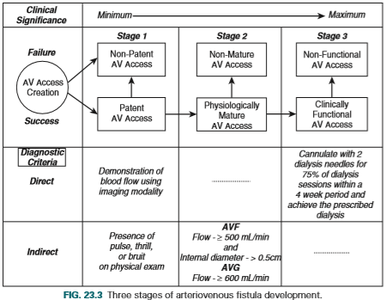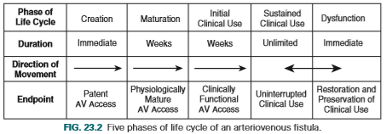Preservation of venous anatomy is most important
* Complications
  + Primarily failure to mature – the population that is dialyzed often have comorbidities that make AVF fail more frequently, up to 60% fail
  + Late failure – venous stenosis and acquired arterial lesions
  + Excessive flow – increase of dialysis access blood flow, linked to high-output heart failure
  + Dialysis Access Steal Syndrome (DASS) – since blood flow must supply hand as well, sometimes too much blood is cut off and can eventually lead to tissue loss if not properly dealt with
  + Ischemic Monomelic Neuropathy (IMN) – nerve damage from low blood flow to extremity
  + Aneurysm
  + Infection – very uncommon
* Secondary AVF – created after an AV access using the outflow veins of that access – usually created after the failure of the first access
  + First AV fistula helps mature vein for SAVF

Arteriovenous Graft (AVG) – second choice for vascular access, 18.3% prevalence

1. Patients with vascular anatomy not favorable for creation of AVF
2. Patients with comorbidities that increase risk for short life expectancy and the time reqd for AVF maturation (often elderly patients)

* Advantages
  + Easy to insert and repair used at multiple anatomical sites
  + Created variety of configurations short maturation time
  + Easy to cannulate large area for cannulation
* 2-3 weeks of maturation before use
* Usually inserted in forearm, upper arm, or thigh
* Complications – occur much more frequently than AVFs
  + Stenosis leading to thrombosis
    - Start with aggressive neointimal hyperplasia (muscle cells go to area of AVG, thickening arterial walls), leading to expanding lesion, restriction of flow and eventual thrombosis
    - Lesions are generally treatable
    - Frequency is 1 – 1.5 per patient per year
  + Infection
    - Can result in significant numbers of patient morbidity because it leads to other acute diseases
    - Patient hygiene most important risk factor, but other AVG-related risk factors (incorrect needle insertion, duration of use, location) contribute
    - Attributable to common skin microorganisms represented by gram-positive bacteria
  + Pseudoaneurysm Formation
    - Disruption of the layers of the AVG leading to a bulging anatomical defect
    - Needle punctures AVG and can create flap – structural damage that is unavoidable
    - Venous stenosis can result in higher pressure in AVG, lead to progressive bulging
    - Can happen earlier if puncture sites are not rotated
  + DASS similar to AVF, usually happens very soon after surgical procedures

Hemodialysis Reliable Outflow (HeRO) Vascular Access Device

* 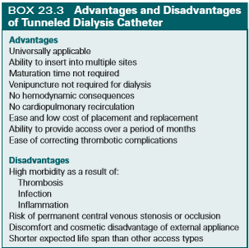Subcutaneous, long-term dialysis access, uses an outflow catheter that is placed into right atrium via subclavian or jugular vein and into superior vena cava
* Graft patency not as good as AVF or AVG
* Less infection than catheter

Dialysis Catheters

* Continues to play an important role in dialysis but is associated with significant morbidity and mortality risk
* 80% of new dialysis patients start with a catheter
* Acute Dialysis Catheter (ADC) and Tunneled Dialysis Catheter (TDC)
* TDC kis placed into central vein
* Used when fistula is impractical because of short patient life expectancy, emergent dialysis, short term bridge backup
* Many redesigns since introduction in the 1980s, especially modifications to the tip design
* Catheter Associated Problems
  + Adequacy of Dialysis – min flow 300ml/min, should be 400
    - More likely that recirculation of blood occurs since in and outflow tips are close to each other
  + Catheter placement
    - Placed in location capable of providing necessary blood flow and in a area that minimizes central vein stenosis
    - Central Venous Occlusive (CVO) disease is more likely with a patient using a central venous catheter – CVO results from chronic mechanic irritation of vessel endothelium
      * Place catheter in location where it is least likely to contact vessel wall, where vessel is less curved
      * IDEA – protective stent to makes this less likely to occur
  + Catheter Dysfunction
    - Insufficient blood flow to perform hemodialysis treatment
    - Early dysfunction usually related to catheter placement or kinked line
    - Late dysfunction is usually result of partial or total thrombosis
      * Extrinsic – thrombosis formed outside of catheter
      * Intrinsic – thrombosis formed inside or surrounding the catheter
      * Usually from fibrin sheath, which is associated with more thrombus formation and infection
    - Infection
      * Exit site infection – external to cuff
      * Tunnel infection – within catheter tunnel, negative blood culture
      * Catheter related bloodstream infection – bacteremia in patient with catheter and no other explanation for positive blood culture, very serious due to possible result in metastatic infection
* ADC
  + More rigid and designed to be placed over guidewire without use of dilators
  + No cuff, not placed using a tunnel, but directly put in target vein
  + Much more likely to have infection

**Chapter 28: Home Hemodialysis**

Dialysis in the US dominated by in-center hemodialysis, but there are newer devices now with less burden and more convenience

Increased convenience and frequency of dialysis if at home

Burden of conventional Hemodialysis (HD)

* 3x/week, 3-4.5 hours/session, travel to and from healthcare facility, recovery from treatment
* Total hours of 29-34/week involved, not including any other healthcare visits

Home Hemodialysis (HHD): Benefits and risks

* Treatment at any time during the day, even at night, can be more often
* No gap in treatment at the end of a dialytic week – death and Cardiovascular disease (CVD) hospitalization was increased on the extra gap day (72 hours between treatments)
* Patients with Left Ventricular Hypertrophy (LVH, might signal CVD) can benefit from intensive HHD
* Hypertension is very common in patients with ESRD – 85% of patients
  + High BP can lead to CVDs
  + Intensive HHD can reduce BP and therefore result in better CVD outcomes
* Mineral and Bone Disease (MBD) also common among ESRD patients, affecting 2/3 patients
  + Clearance of phosphorous is increased when there are more HD treatment hours
  + HHD decreased use of phosphate binders
* Quality of Life – 90% rated as “very important”
  + Physical QoL is extremely impaired among dialysis patients, mental QoL impaired, but not as much