|  |  |  |
| --- | --- | --- |
| **TABLE 1** | | |
| NPI | Gender | State |
| Credentials | Specialty | ABILIFY |
| ACETAMINOPHEN.CODEINE | ACYCLOVIR | ADVAIR.DISKUS |
| AGGRENOX | ALENDRONATE.SODIUM | ALLOPURINOL |
| ALPRAZOLAM | AMIODARONE.HCL | AMITRIPTYLINE.HCL |
| AMLODIPINE.BESYLATE | AMLODIPINE.BESYLATE.BENAZEPRIL | AMOXICILLIN |
| AMOX.TR.POTASSIUM.CLAVULANATE | AMPHETAMINE.SALT.COMBO | ATENOLOL |
| ATORVASTATIN.CALCIUM | AVODART | AZITHROMYCIN |
| BACLOFEN | BD.ULTRA.FINE.PEN.NEEDLE | BENAZEPRIL.HCL |
| BENICAR | BENICAR.HCT | BENZTROPINE.MESYLATE |
| BISOPROLOL.HYDROCHLOROTHIAZIDE | BRIMONIDINE.TARTRATE | BUMETANIDE |
| **………..** |  | Opioid.Prescriber |

|  |  |  |  |  |  |
| --- | --- | --- | --- | --- | --- |
| **TABLE 2** | | | | | |
| antipsychotic | 7 | alpha.adrenergic.agonist | 2 | bronchodilator | 3 |
| opiate | 11 | diuretic | 8 | nitrate | 3 |
| antiviral | 1 | anticonvulsant | 12 | biguanide | 3 |
| corticosteroid | 11 | decarboxylase.inhibitor | 1 | DPP4 inhibitor | 2 |
| biphosphonate | 2 | anti.inflammatory | 7 | supplement | 6 |
| xanthine.oxidase.inhibitor | 1 | antimicrobial | 1 | laxative | 2 |
| benzodiazepine | 6 | anticoagulant | 4 | prostaglandin.analog | 3 |
| antiarrhythmic | 1 | antiplatelet | 1 | anesthetic | 1 |
| antidepressant | 17 | antifungal | 3 | antimetabolite | 1 |
| calcium.channel.blocker | 11 | antigout | 1 | prokinetic agent | 1 |
| antibiotic | 12 | proton.pump.inhibitor | 5 | leukotriene.receptor.antagonist | 1 |
| amphetamine | 1 | cardiac.glycoside | 2 | carboxylic acid | 1 |
| beta.blocker | 12 | antidiarrheal | 1 | NMDA.inhibitor | 2 |
| statin | 8 | carbonic anhydrase inhibitor | 1 | antiemetics | 2 |
| alpha.blocker | 5 | hormone | 5 | thiazolidinediones | 1 |
| muscle.relaxant | 6 | cholinesterase inhibitor | 1 | dopamine agonist | 2 |
| insulin | 9 | H2.blocker | 2 | anti.anginal | 1 |
| ACE.inhibitor | 6 | antilipemic | 2 | immunosuppressant | 1 |
| angiotensin.receptor.blocker | 8 | fibrate | 1 | protectant | 1 |
| anticholinergic | 8 | sulfonylurea | 5 | nucleoside analog | 1 |
| antihistimine | 3 | vasodilator | 1 |

|  |
| --- |
| **TABLE 3** |
| ACETAMINOPHEN.CODEINE |
| FENTANYL |
| HYDROCODONE.ACETAMINOPHEN |
| HYDROMORPHONE.HCL |
| METHADONE.HCL |
| MORPHINE.SULFATE |
| MORPHINE.SULFATE.ER |
| OXYCODONE.ACETAMINOPHEN |
| OXYCODONE.HCL |
| OXYCONTIN |
| TRAMADOL.HCL |

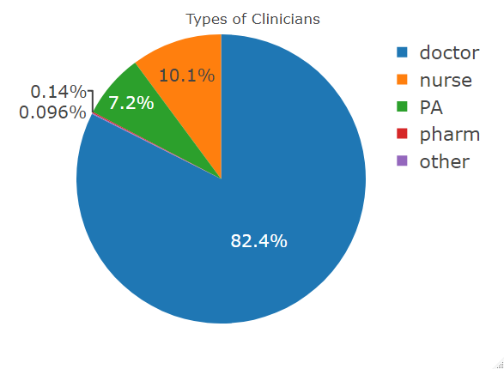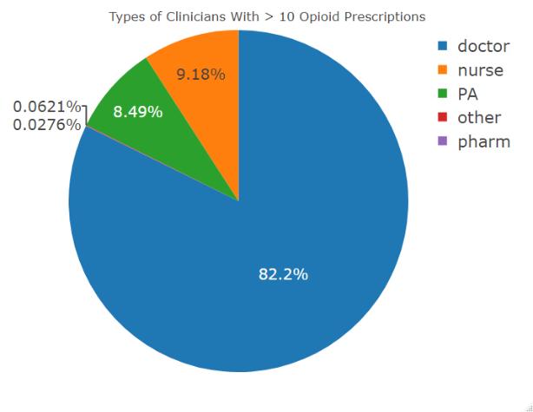

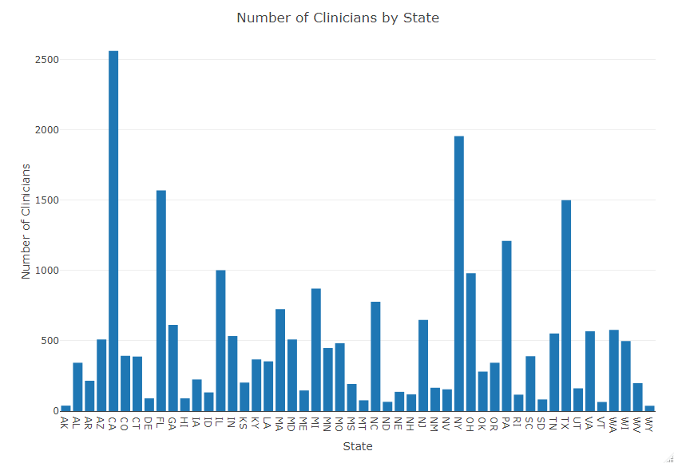

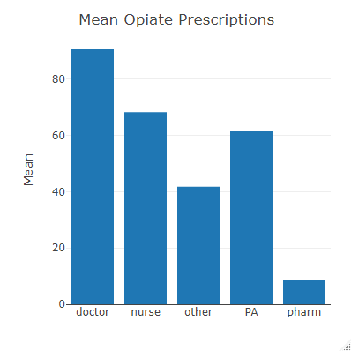 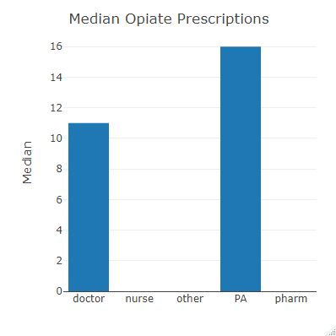

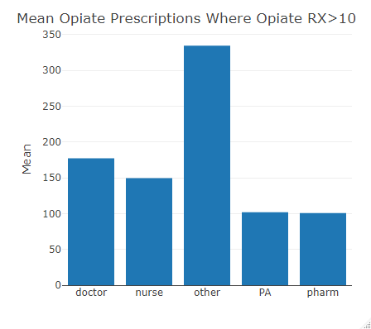 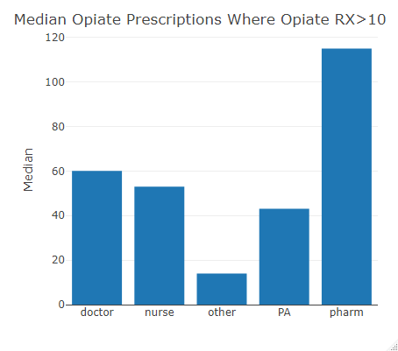

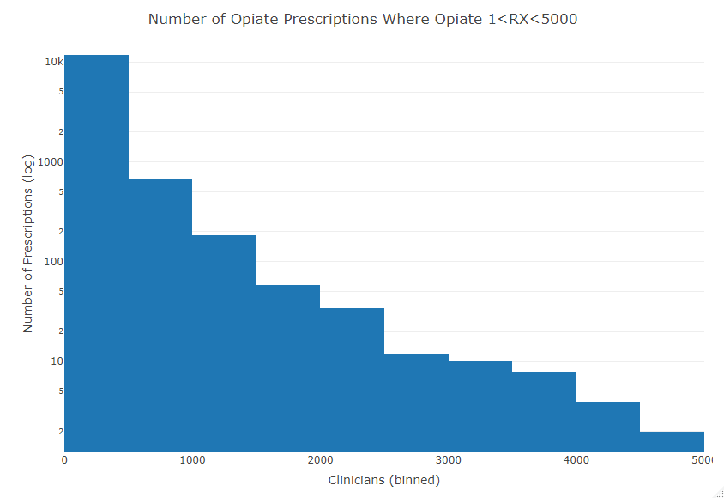

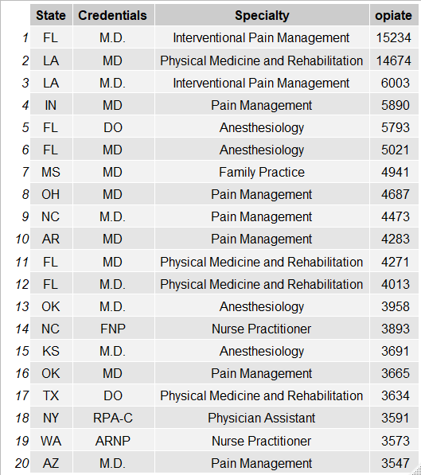

**TABLE 4**: Top 20 Opioid Prescribers

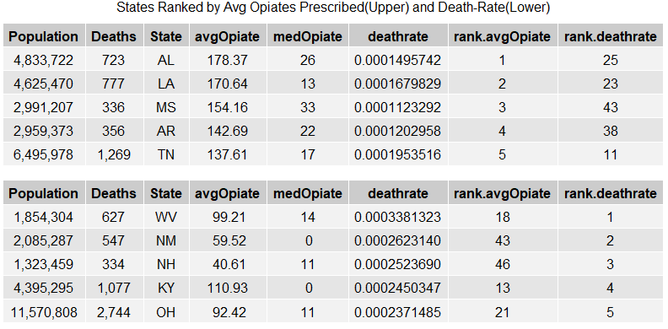

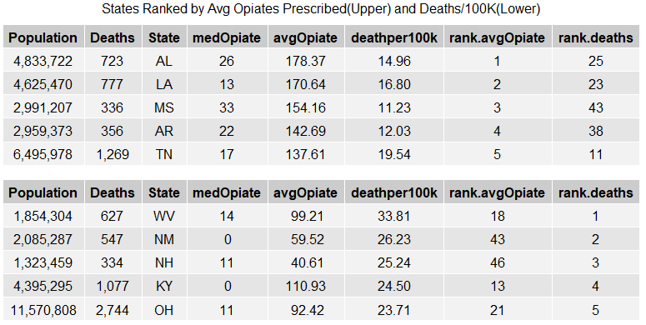

**TABLE 5:**

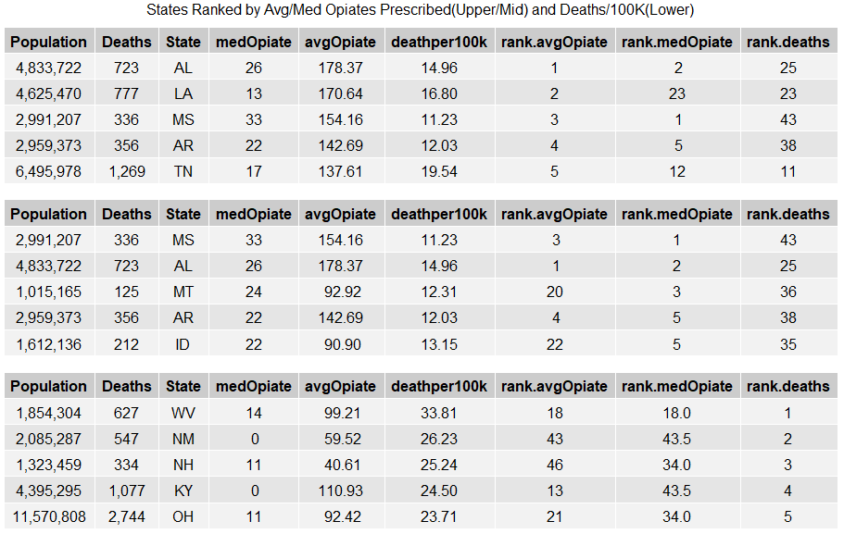

**TABLE 6**

**TABLE 5:**

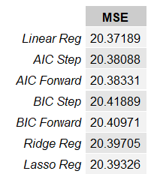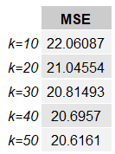

**TABLE 7**