- Given the following database structure and data, write a query that returns a list of all balances for entity named “ABCD” and, for each date shown, if available, the status on that date [defined as the “most recent up to but not exceeding the balance date”].

Database Structure
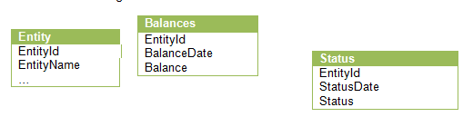
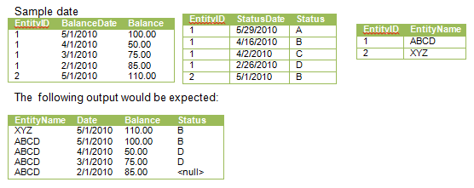
Answer:
select e.EntityName, a.BalanceDate as Date, a.Balance, s.Status
from (
select b.EntityId, b.BalanceDate, MAX(StatusDate) as DATE, b.Balance
from Balances b
left join Status on b.BalanceDate >= StatusDate
group by b.EntityId, b.BalanceDate, b.Balance
) a
left join Status s on StatusDate = a.DATE
inner join Entity e on a.EntityId = e.EntityId
order by a.BalanceDate desc, e.EntityName desc

Using the MAX function, subquery a determines the status date that meets the ‘ most recent up to but not exceeding the balance date’ requirement.
Left joins are used to get all values, including NULL values.
Inner join on Entity gets the entity name for the entity id in Balances and Status.

- Given the structure and data sample from question #1, write a query that returns average balance and most recent status for every entity. For example: given the data example in step 1, the following output would be expected:
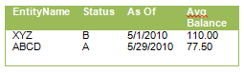
Answer:
select e.EntityName, s2.Status, a.DATE as 'As Of', a.AVG as 'Avg Balance'
from (
select b.EntityId, AVG(b.Balance) as AVG, MAX(s.StatusDate) as DATE
from Balances b
left join Status s on b.EntityId = s.EntityId
group by b.EntityId
) a
inner join Status s2 on s2.StatusDate = a.DATE
inner join Entity e on a.EntityId = e.EntityId
order by e.EntityName desc

Subquery a uses the AVG and MAX functions, along with the ‘group by’ clause, to determine the average balance and most recent status update date for each entity.
Left join is used to get all values, including NULL values.
Inner join on Status gets the status value for the determined most recent status date.
Inner join on Entity gets the entity name for the entity id in Balances and Status.

