|  |
| --- |
|  |

|  |
| --- |
| Academy Tools (Widget) Guide  CID  10/11/2017 |

Table of Contents

Academy Tools (Widget) Overview 2

Setup 2

Overview 2

Add VidWidg to Shared Files 2

Add Google API Key 2

Adding VidWidg to a Homepage Widget 4

Adding VidWidg to a Content Topic Page 5

Customizing VidWidg 5

Contact Us 6

Academy Tools (Widget) Overview

Academy Tools widget is a lightweight widget that provides a hub of an institutions most valuable links. The links are easily recognizable due to preset infographics. The widget is can be customized easily to point to any link and display any image. The setup is also very straight forward and easily configured.

The widget can be downloaded from [GitHub](https://github.com/jbooth3/Widget), and incorporated into your courses in the Learning Environment. Please share any updates or extensions to this widget on GitHub and the Brightspace Community.

Setup

Overview

To incorporate VidWidg in homepage widgets and content topic pages, you’ll first need to:

1. Download *vidwidg.zip* from [Brightspace Community](https://community.brightspace.com)
2. Save and unzip *vidwidg.zip* in the Shared Files directory
3. Add your Google API key to index.html (in the unzipped folder)

Once the VidWidg files (with API key) are available in Shared Files, you can incorporate VidWidg in homepage widgets and content topic pages. This is done by copying, pasting and editing the code from widget.txt in the relevant places in the Learning Environment.

Add VidWidg to Shared Files

After you have downloaded *vidwidg.zip* from [Brightspace Community](https://community.brightspace.com), save and unzip this file in Shared Files:

1. Log into the Learning Environment
2. Select **Admin Tools** (cog icon)
3. Select **Shared Files**
4. From the root directory (/shared/) select **Upload**
5. Drop *vidwidg.zip* in the drop area and click **Save**
6. Browse to *vidwidg.zip* and select **Unzip** in the Action Menu

Add Google API Key

You will need to create a Google API key from the Google Developers Console (see [YouTube Data API Overview](https://developers.google.com/youtube/v3/getting-started) for instructions on this process). **Important**: before generating an API key, make sure you enable YouTube Data API for your project in the Library tab of the Google Developers Console.

Once you have a Google API key:

1. Log into the Learning Environment
2. Select **Admin Tools** (cog icon)
3. Select **Shared Files**
4. Browse to *…\shared\custom_widgets\cs_widgets_master\widgets\vidwidg\index.html*
5. Open the Action Menu for *index.html* and select **Edit File**
6. Select **HTML Source Editor** (see Figure 1)
7. Replace GOOGLE_API_KEY_GOES_HERE with your API key (see Figure 2). Be sure the pasted API key is enclosed in single quotes.
8. 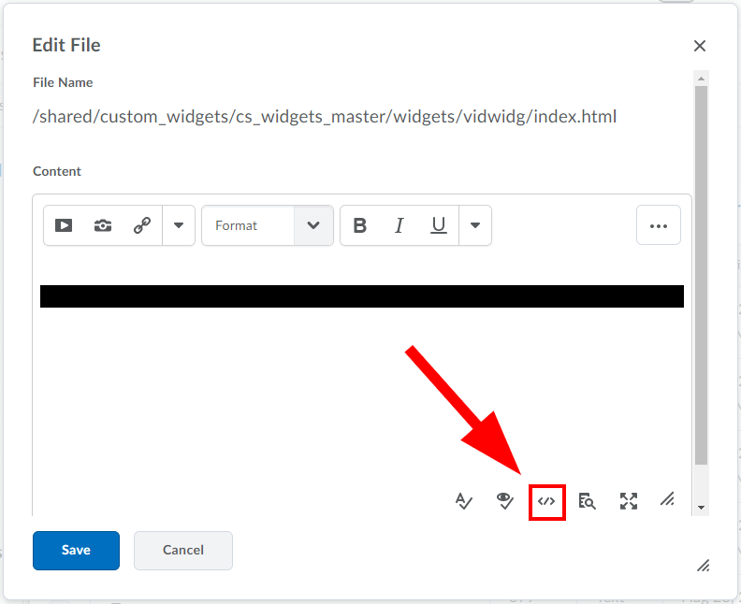Click **Save**

Figure 1. HTML Source Editor icon is located below the content area.

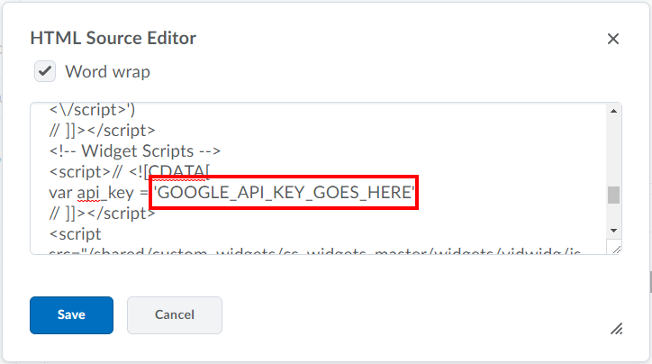

Figure 2. Replace GOOGLE_API_KEY_GOES_HERE with your API key.

Adding VidWidg to a Homepage Widget

To add VidWidg to a homepage widget follow the typical custom widget creation steps ([see Brightspace Documentation: Creating a new custom widget](https://documentation.brightspace.com/EN/le/daylight/admin/creating_custom_widget.htm?Highlight=create%20widget)). Then add the VidWidg code to the widget content.

1. Copy the embed code from *widget.txt:*
   1. Log into the Learning Environment
   2. Select **Admin Tools** (cog icon)
   3. Select **Shared Files**
   4. Browse to *…\shared\custom_widgets\cs_widgets_master\widgets\vidwidg\widget.txt*
   5. Open the Action Menu for *widget.txt* and select **Edit File**
   6. Copy all of file’s contents
2. Paste the embed code in the widget’s content:
   1. Select the **HTML Source Editor** in the **Content** tab of the widget editor (see figure 3)
   2. Paste the embed code (see figure 4)
   3. Update the code as required to configure the widget (see Customizing VidWidg below)
   4. Click **Save**

Figure 3. Paste VidWidg embed code in the HTML Source Editor.

Figure 4. HTML Source Editor icon is located below the content area on the Content tab.

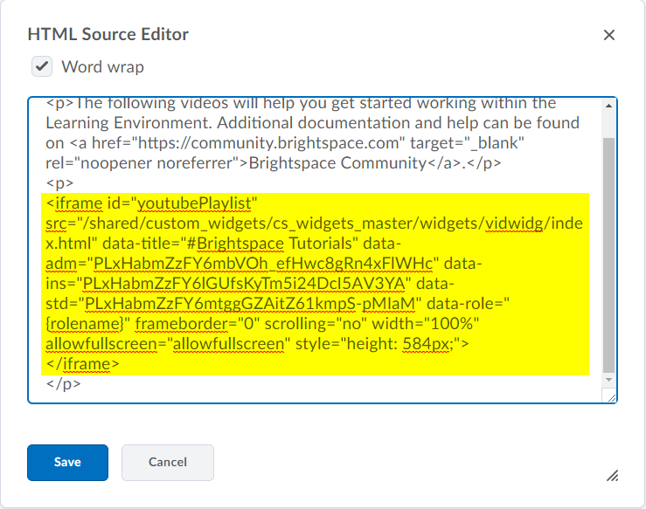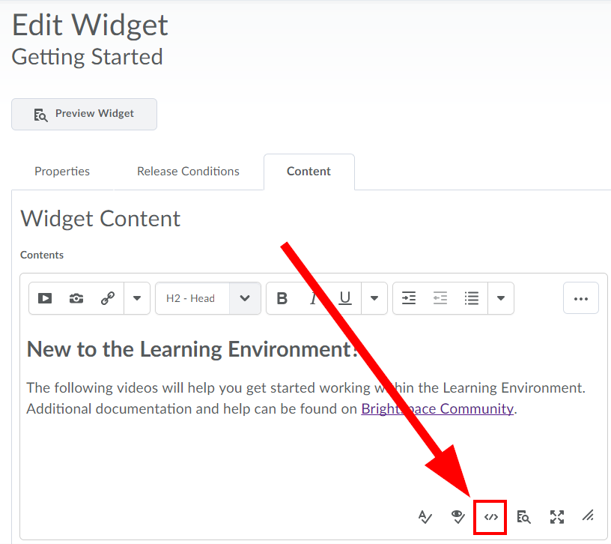

Adding VidWidg to a Content Topic Page

To add VidWidg to a content topic page, **Create a File** in Content following the typical steps (see [Brightspace Documentation: Creating a new topic](https://documentation.brightspace.com/EN/le/content/instructor/create_topic.htm?Highlight=create%20new%20topic)). Then add the VidWidg code to the topic’s content.

1. Copy the embed code from *widget.txt:*
   1. Log into the Learning Environment
   2. Select **Admin Tools** (cog icon)
   3. Select **Shared Files**
   4. Browse to *…\shared\custom_widgets\cs_widgets_master\widgets\vidwidg\widget.txt*
   5. Open the Action Menu for *widget.txt* and select **Edit File**
   6. Copy all of file’s contents
2. Paste the embed code in the topic’s content:
   1. Select the **HTML Source Editor** when editing the topic’s HTML (see figure 5)
   2. Paste the embed code (see figure 6)
   3. Update the code as required to configure the widget (see Customizing VidWidg below)
   4. 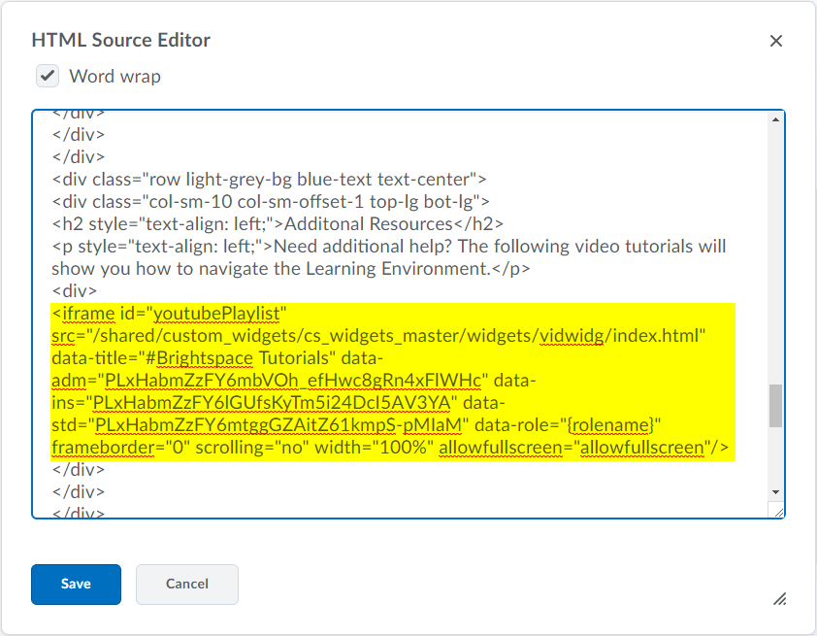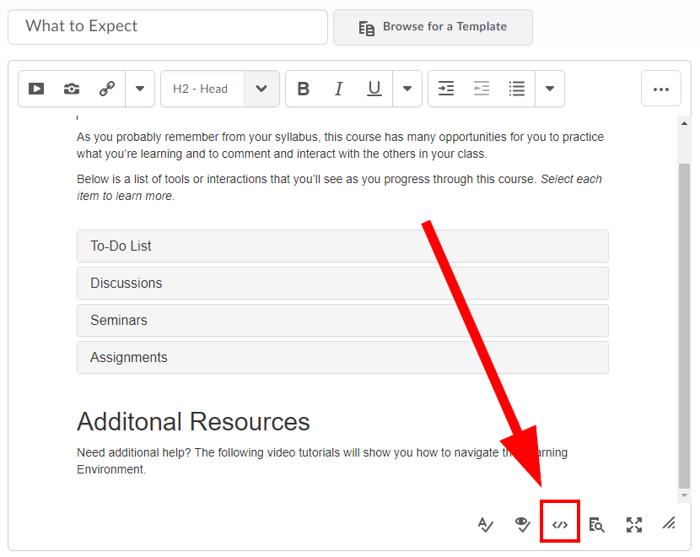Click **Save**

Figure 5. Paste VidWidg embed code in the HTML Source Editor.

Figure 6. HTML Source Editor icon is located below the content area.

Customizing VidWidg

By default, VidWidg is configured to provide different Brightspace Video Tutorial playlists to users that have ‘Learner’, ‘Instructor’, and ‘Administrator’ roles. You can easily change the playlists associated with each role and some of the widget labels by modifying Vidwidg’s embed code.

If your institution uses customized roles (with other names), then you will have to re-configure the widget. This will require some modification of the widget’s *config.js* file and it’s embed code.

Customizing YouTube Playlists

To change the playlists associated with each role, simply replace the YouTube Playlist ID in data-adm, data-ins and data-std attributes in the embed code (found in *shared\custom_widgets\cs_widgets_master\widgets\vidwidg\widget.txt*).

Example

If you want the Learner role to display the [This Week @ NASA](https://www.youtube.com/watch?v=xBMAI7hZS1s&list=PL1D946ACB21752C0E) playlist change:

**From** data-std="PLxHabmZzFY6mtggGZAitZ61kmpS-pMIaM"

**To** data-std="xBMAI7hZS1s&list=PL1D946ACB21752C0E"

Customizing Title

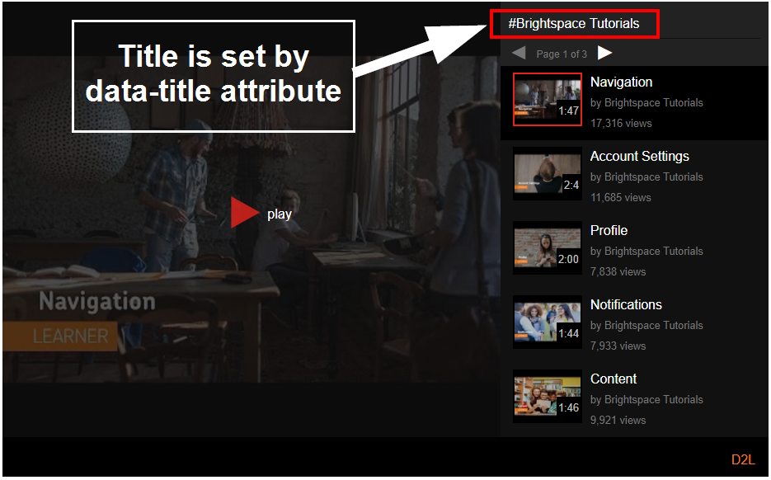The widget title (see figure 7) can be changed by replacing the data-title attribute in the embed code.

Figure 7. Vidwidg title text is determined by the data-title attribute.

Customizing/Adding Roles

If your organization has custom roles defined, then you may need to update config.js and config.min.js files found in *shared\custom_widgets\cs_widgets_master\widgets\vidwidg\js*. To do so:

1. Edit the roles_config variable in *config.js*
2. Minify the edited code using [JSCompress](https://jscompress.com/)
3. Update *config.min.js* with the edited (and minfied) code

Step 1 can be aided with the use of a JSON editor like [JSONMate](http://jsonmate.com/), as illustrated in the example below.

Example

Suppose your institution has an “Assistant” role and you would like users with this role to see the same playlists as other Instructor roles. You can do this by:

1. Opening *config.js* and copying everything after 'roles_config =', e.g.,

{"adm":["Administrator"],"ins":["Instructor","Tutor","Teacher"],"std":["Student","Learner"]}

1. Paste this in the text area at [JSONMate](http://jsonmate.com/)
2. Click on the page outside the text area
3. Click on the **+** beside **ins**
4. Select **Add New Value** and type “Assistant” (see figure 8.)
5. Copy the updated code in the text area, e.g.,

{"adm":["Administrator"],"ins":["Instructor","Tutor","Teacher","Assistant"],"std":["Student","Learner"]}

1. Add the code to your *config.js*, replace the text after ‘role_config =’ that you originally copied

Now, if you want to keep your code minified (this is optional but recommended):

1. Paste the entire content of *config.js* into [JSCompress](https://jscompress.com/)
2. Click **Compress**
3. Copy the compressed code
4. 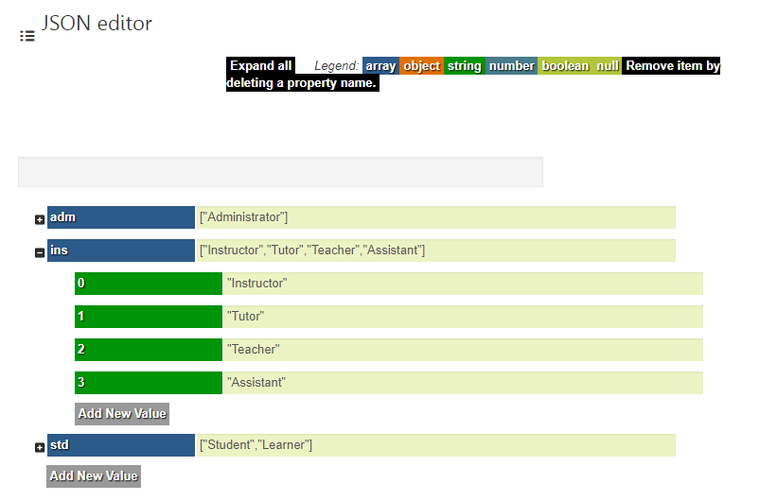Paste your code into *config.min.js*

Figure 8. "Assistant" role added to ins using JSONMate editor.

About D2L

D2L is the software leader that makes learning experiences better. The company’s cloud-based platform is easy to use, flexible, and smart. With Brightspace, organizations can personalize the experience for every learner to deliver real results. The company is a world leader in learning analytics: its platform predicts learner performance so that organizations can take action in real-time to keep learners on track. Brightspace is used by learners in higher education, K-12, and the enterprise sector, including the Fortune 1000. D2L has operations in the United States, Canada, Europe, Australia, Brazil, and Singapore.

Contact Us

**Phone:** 1-519-772-0325 (Worldwide)

**Toll Free:** 1-888-772-0325 (North America)

+44-203-695-8580 (United Kingdom and Europe)

0-800-452-069 (New Zealand)

1-800-778-631 (Australia)

0-800-891-4507 (Brazil)

**Fax:** 1-519-772-0324

**Email:** ContactUs@D2L.com

**Facebook:** facebook.com/D2LInc

**Twitter:** @D2L

**Web:** www.D2L.com

© 2017 D2L Corporation.

The D2L family of companies includes D2L Corporation, D2L Ltd, D2L Australia Pty Ltd, D2L Europe Ltd, D2L Asia Pte Ltd, and D2L Brasil Soluções de Tecnologia para Educação Ltda.

All D2L marks are trademarks of D2L Corporation. Please visit D2L.com/trademarks for a list of D2L marks.