AMATH482 HW02

Joshua Borgman

University of Washington

Josh Borgman

Thursday, February 05, 2015

Contents

1. Introduction and Overview 3

2. Theoretical Background 3

Gabor Transform 3

Spectrograms 3

3. Algorithm Implementation and Development 4

Gabor Transform: 4

Spectrograms 4

4. Computational Results 4

5. Summary and Conclusions 8

Appendix A: 9

Appendix B: 9

# Introduction and Overview

The restrictive relation between obtaining information in the frequency and time domains is a readily apparent problem with unmodified Fourier Transformation of time-variant signals. Throughout this assignment we will aspire to utilize a method of transformation that offers a combination of temporal and frequency information, and observe the benefits and restrictions of this transformation.

# Theoretical Background

## Gabor Transform

The Gabor Transform is an implementation of a windowed Fourier Transform that allows for localization of a signal in both time and frequency domains. The transform is based on a simple modification of the Fourier transform kernel, to yield the Gabor transform kernel:

$$g_{t,ω}\left(τ\right)=e^{-iωτ}g\left(τ-t\right)$$

And the associated transform defined as

* 1. There are several properties of the Gabor Transform that are useful including:  
     The energy is bounded by the Schwarz inequality
  2. The Gabor transform is linear.
  3. The Gabor transform can be inverted.

In application, the Gabor transforms computed by discretizing the time and frequency domains.

Drawbacks of the Gabor (STFT) arise from the trade off between resolution in the time and frequency domains. In other words, one must trade resolution in one domain to increase resolution in another. The Heisenberg relationship must hold, such that a shorter time-filtering window yields less information of the frequency domain and vice versa.

## Spectrograms

Spectrograms allow for visual displays that have both time and frequency resolution. Below is a visual representation of this combination.

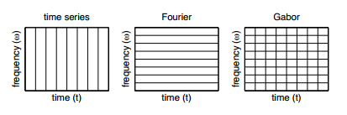

Figure 1: Diagram displaying combination on time and frequency domains

# Algorithm Implementation and Development

## Gabor Transform:

The Gabor Transform is carried out by discretizing the continuous model onto a lattice of time and frequency with sample points given by $ν=mω_{0}$ and $τ=nt_{0}$, respectively. Using these parameters the discrete version of $g_{t,ω}$ is

$$g_{m,n}=e^{\left(i2πmω_{0}t\right)}g(t-nt_{0})$$

And transform

$$\tilde{f}\left(m,n\right)= \int_{-∞}^{∞}{f\left(t\right){\overline{g}}_{m,n}dt}$$

If $0<t_{0}, ω_{0}<1,$ then the signal is oversampled and the time frames yield excellent localization of the signal in both time and frequency. If $t_{0},ω_{0}>1,$ the signal is under sampled and the lattice is incapable of reproducing the signal.

## Spectrograms

Spectrograms were generated by concatenating the absolute value of the shifted frequency content matrices of each subsequent windowing during the Gabor Transform. This matrix was then ploted using the pcolor command with the additional inputs of the steps (t_slide) and the vector of shifted wave numbers.

# Computational Results

The images below contain visualizations of the computational results

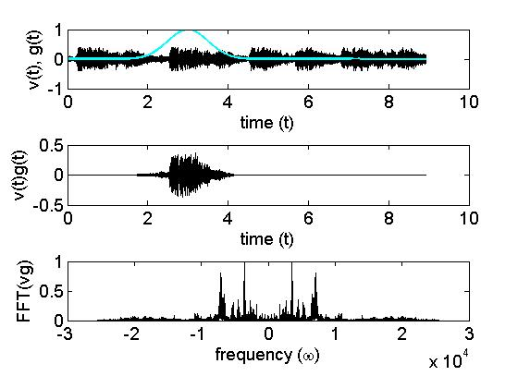

Figure 2: Initial exemplification of Gabor Filter and use seen in both domains.

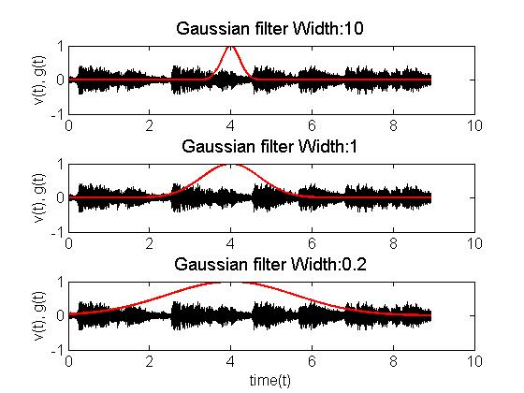

Figure 3: Result of changing width parameter.

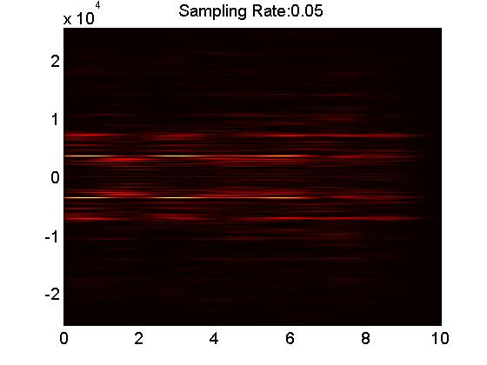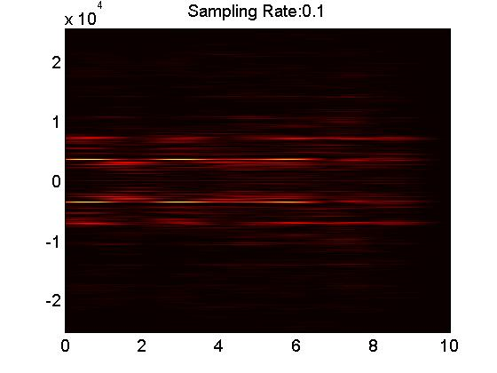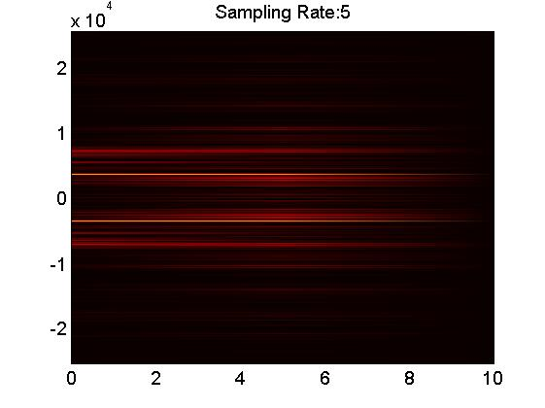

Figure 4: The effect of variation in sampling speeds

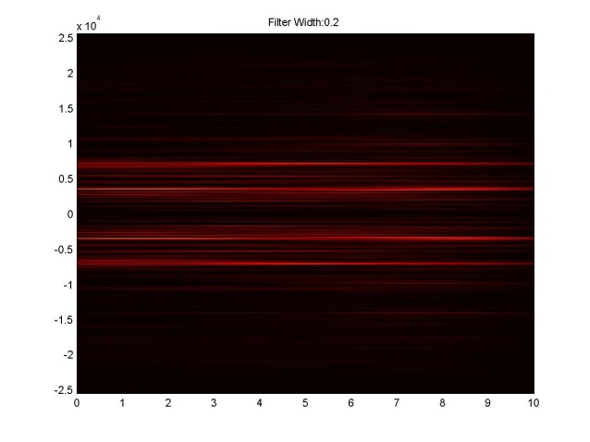

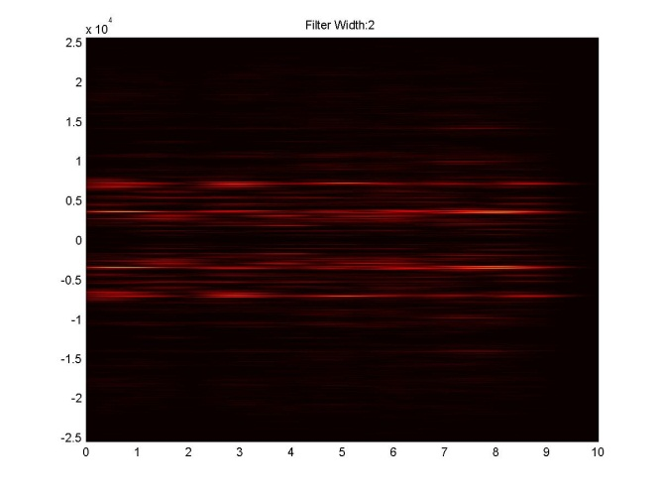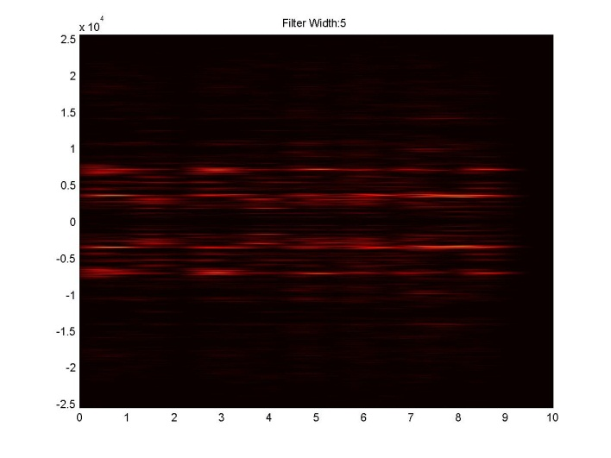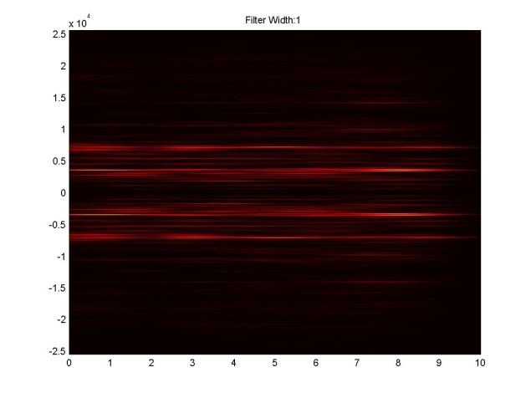

Figure 5: The results of varied filter widths as seen through resultant spectrograms.

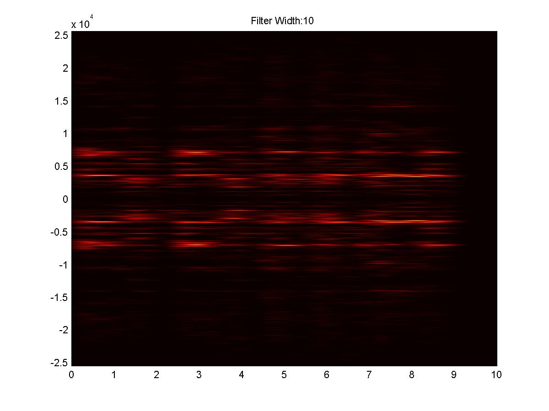

# Summary and Conclusions

The Gabor Transform offers us a unique and widely applicable method by which to transform data to give information in multiple dimensions. This attribute is widely applicable and highly beneficial in areas such as time-frequency analysis and other closely related measurements.

# Appendix A:

# Appendix B:

%Joshua Borgman AMATH482 Homework2:Gabor Transforms

%Part I

clear all, close all, clc

load handel

v = y'/2;

vt = fft(v);

n = length(v); L = 9;

t =(1:length(v))/Fs;

k = (2*pi/L)*[0:n/2 -n/2:-1]; ks = fftshift(k);

figure(1)

subplot(2,1,1) %Time Domain

plot(t, v)

set(gca, 'Fontsize', [12])

xlabel('Time [sec]'), ylabel('Amplitude');

title('Handels Messiah');

subplot(2,1,2)

plot(ks, abs(fftshift(vt))/max(abs(vt)),'k');

set(gca, 'Fontsize', [12])

xlabel('frequency (\omega)'), ylabel('FFT(v)')

%%

%plays audio file

p8 = audioplayer(v,Fs);

playblocking(p8);

%%

%This secion generates Gaussian filters

figure(2)

width = [10 1 0.2];

for j=1:3

g = exp(-width(j)*(t-4).^2);

subplot(3,1,j)

plot(t,v,'k'), hold on

plot(t, g, 'r', 'Linewidth', [2])

set(gca, 'Fontsize', [12])

ylabel('v(t), g(t)')

title(strcat('Gaussian filter Width: ', num2str(width(j))), 'Fontsize', [14]);

end

xlabel('time(t)');

%%

% Creates Gaussian filter with a=2, b=3, shows overlayed filter and such

close(3)

figure(3)

center = 3;

scale = 2;

g=exp(-scale*(t-center).^2);

vg=g.*v;

vgt=fft(vg);

subplot(3,1,1), plot(t,v,'k'), hold on

plot(t,g,'c','Linewidth',[2])

set(gca,'Fontsize',[14])

ylabel('v(t), g(t)'), xlabel('time (t)')

subplot(3,1,2), plot(t,vg,'k')

set(gca,'Fontsize',[14])

ylabel('v(t)g(t)'), xlabel('time (t)')

subplot(3,1,3), plot(ks,abs(fftshift(vgt))/max(abs(vgt)),'k')

axis([-1e4 1e4 0 1])

set(gca,'Fontsize',[14])

ylabel('FFT(vg)'), xlabel('frequency (\omega)')

%%

%Generates movie that scans audio file

figure(4)

vgt_spec=[];

tslide=0:0.1:10;

for j=1:length(tslide)

g=exp(-2*(t-tslide(j)).^2); % Gabor

vg=g.*v; vgt=fft(vg);

vgt_spec=[vgt_spec; abs(fftshift(vgt))];

subplot(3,1,1), plot(t,v,'k',t,g,'r')

subplot(3,1,2), plot(t,vg,'k')

subplot(3,1,3), plot(ks,abs(fftshift(vgt))/max(abs(vgt)))

%axis([-50 50 0 1])

drawnow

pause(0.1)

end

%%

%Generates Spectogram of Piece

figure(5)

pcolor(tslide,ks,vgt_spec.'), shading interp

%set(gca,'Ylim',[-50 50],'Fontsize',[14])

colormap(hot)

%%

%Generates Spectograms for various filters

close all

width = [0.2, 1, 2, 5, 10];

for jj=1:length(width)

figure()

vgt_spec=[];

tslide=0:0.1:10;

for j=1:length(tslide)

g=exp(-width(jj)*(t-tslide(j)).^2); % Gabor

vg=g.*v; vgt=fft(vg);

vgt_spec=[vgt_spec; abs(fftshift(vgt))];

end

pcolor(tslide,ks,vgt_spec.'), shading interp

colormap(hot)

title(strcat('Filter Width: ', num2str(width(jj))));

saveas(jj, strcat('spectogram', num2str(jj), '.jpg'));

end

%%

% See the affect of different sampling rates

samp = [0.05, 0.1, 5];

jj=1;

%for jj=1:length(samp)

figure()

vgt_spec=[];

tslide=0:samp(jj):10;

for j=1:length(tslide)

g=exp(-2*(t-tslide(j)).^2); % Gabor

vg=g.*v; vgt=fft(vg);

vgt_spec=[vgt_spec; abs(fftshift(vgt))];

end

pcolor(tslide,ks,vgt_spec.'), shading interp

set(gca,'Fontsize',[14])

colormap(hot)

title(strcat('Sampling Rate: ', num2str(samp(jj))));

%saveas(jj, strcat('sampelingRates', num2str(jj), '.jpg'));

%end

%%

%Plays piano recording

tr_piano=16; % record time in seconds

y=wavread('music1'); Fs=length(y)/tr_piano;

plot((1:length(y))/Fs,y);

xlabel('Time [sec]'); ylabel('Amplitude');

title('Mary had a little lamb (piano)'); drawnow

p8 = audioplayer(y,Fs); playblocking(p8);

%%

% plays recorder recording

figure(2)

tr_rec=14; % record time in seconds

y=wavread('music2'); Fs=length(y)/tr_rec;

plot((1:length(y))/Fs,y);

xlabel('Time [sec]'); ylabel('Amplitude');

title('Mary had a little lamb (recorder)');

p8 = audioplayer(y,Fs); playblocking(p8);

%%

% Gabor Filtering of MHALL recorder, noted that there are 24 "notes"

y=y';

ygt_spec=[];

tslide=linspace(0,tr_rec, 25);

n = length(y); L = tr_rec;

t =(1:length(y))/Fs;

k = (2*pi/L)*[0:n/2-1 -n/2:-1]; ks = fftshift(k);

notes = [];

for j=1:length(tslide)

g=exp(-2*(t-tslide(j)).^2); % Gabor

yg=g.*y; ygt=fft(yg);

ygt_spec=[ygt_spec; abs(fftshift(ygt))];

subplot(3,1,1), plot(t,y,'k',t,g,'r')

subplot(3,1,2), plot(t,yg,'k')

subplot(3,1,3), plot(ks,abs(fftshift(ygt))/max(abs(ygt)))

%axis([-50 50 0 1])

drawnow

pause(0.2)

end

%%

% Gabor Filtering of MHALL piano, noted that there are 24 "notes"

y=y';

ygt_spec=[];

tslide=linspace(0,tr_piano, 25);

n = length(y); L = tr_piano;

t =(1:length(y))/Fs;

k = (2*pi/L)*[0:n/2-1 -n/2:-1]; ks = fftshift(k);

notes = [];

for j=1:length(tslide)

g=exp(-2*(t-tslide(j)).^2); % Gabor

yg=g.*y; ygt=fft(yg);

ygt_spec=[ygt_spec; abs(fftshift(ygt))];

subplot(3,1,1), plot(t,y,'k',t,g,'r')

subplot(3,1,2), plot(t,yg,'k')

subplot(3,1,3), plot(ks,abs(fftshift(ygt))/max(abs(ygt)))

%axis([-50 50 0 1])

drawnow

pause(0.2)

end