Run Time Governance Lab Outline

Run Time Governance Overview

- Activity Collector
  - Activity events can be reported directly to the Activity Server via REST service, OR
  - Embedded collector to intercept activities, pre-process the information to extract correlation details and business relevant properties, before batching events for distribution to the server.
    - Events can be 'validated' using pluggable event processors, which can be used to block business transactions
- Activity Server
  - Provides a REST interface to enable events to be reported
  - Persists activity information
  - Distributes reported events to subscribed components
- Event Processor Network
  - Subscribes to the Activity Server, to receive reported activity events
  - Distributes activity events through a series of registered networks, that consist of event processors to validate, transform and retransmit events. Processors can be specified using Java, Drools CEP rules and MVEL
- Maintaining Derived Results
  - Information derived by the Event Processor Network can be presented as a set of 'active' collections
  - Components can directly access these collections, or issue queries through a REST API
- Web UI
  - Runtime governance information is provided through a set of gadgets
    - Service Response Time Gadget - displays response time information per service and optionally operation
    - Situations Gadget - table for displaying situations detected by the event processing (for example, SLA violation)
    - Call Trace Gadget - provides a tree based visual display of the call stack associated with a business transaction
    - Service Overview - graphical representation of the services and their dependencies, showing response time and invocation details
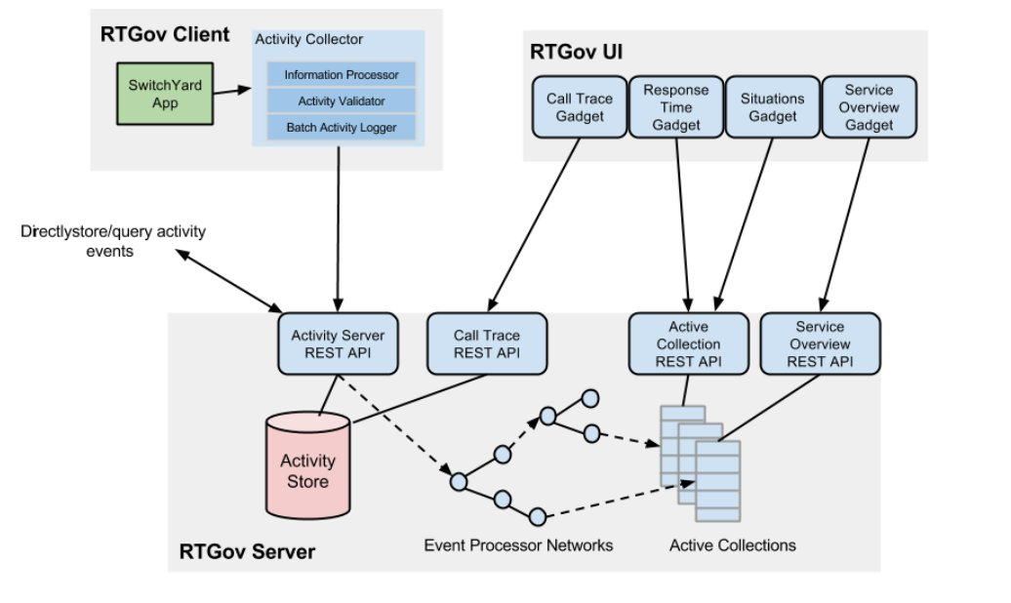
- Activity Collector: Used to collect activity events.
- Activity Server and Store: Used for central activity event storage and querying.
- Event Processor Network: Used for generic event analysis to process the activity events.
- Active Collections: Used for active information management to post-process and cache information for end-user applications.

Run Time Governance Objectives

Review Synchronous and Asynchronous Policy
Review SLA Monitoring and Reporting
Send Messages from Command Line for Policy and SLA messages
- Synchronous Policy to reject a Application for the same user more than once a day
- Asynchronous Policy
Web UI reviewed as time permits

Lab Steps

Run a Synchronous Policy
This is an example of a business policy that has been defined to run synchronously
within the execution environment. The decisions taken by this policy are immediately actionable, allowing them to be used to block the business transaction. In this specific example, if the customer issues multiple requests too quickly, the requests will be rejected, so providing a crude form of throttling.

We will create a Policy that will reject a Application for a User to be submitted more than once a day.
av.json
VerifyLastUsage.mvel
interceptors/ExchangeValidator.java (Application)

Send a SOAP message for the same application twice in a row to receive the error message

Run a Asynchronous Policy

The quickstart example in this section demonstrates how a policy enforcement mechanism can be provided using a combination of the Runtime Governance infrastructure and platform specific interceptors. This example uses an asynchronous approach to evaluate the business policies, only enforcing the policy based on a summary result from the decision making process. The benefit of this approach is that it can be more efficient, and reduce the performance impact on the business transaction being policed. The disadvantage is that the decisions are made after the fact, hence leaves a small window of opportunity for invalid transactions to be performed.

We will create a Policy that will suspend a customers credit if they are approved for over 100000

AssesCredit.mvel
epn.json
interceptor/PolicyEnforcer.java (Application)

