Lab 2

Service Lifecycle Management
with
Design Time Governance
in
Fuse Service Works

Design Time Governance Overview

S-RAMP
- SOA Repository Artifact Model and Protocol (based on the OASIS standard)
- Artifact repository
  - Built on top of ModeShape
  - Stores artifact content and meta-data including:
    - Core properties (name, description, version, etc)
    - Custom ad-hoc properties (name-value)
    - Relationships between artifacts
    - Hierarchical tagging system called Classifiers
  - Rich XPath-like query language to search the repository
  - Atom based REST API
  - Automatic decomposition of artifacts based on type
    - Built in support for common S-RAMP types (XSD, WSDL, etc)
    - Extensible to support additional types (Teiid VDB, switchyard.xml, etc)
- Command Line Interface
  - Supports interactive and batch modes
  - Built-in commands to manage and search for artifacts in the repository
  - Extensible to allow contributing custom commands
- Maven integration
  - Can "mvn deploy" a deployment artifact directly into S-RAMP
  - Able to use S-RAMP artifacts as dependencies in maven projects
- Web UI
  - Based on Errai 2.4
  - Allows granular management of content in the repository
  - Can be used to manipulate all artifact meta-data
Design Time Governance
- Built on top of the S-RAMP artifact repository
- Supports triggering Governance Workflows based on repository changes
  - Embeds jBPM 6 to support workflow execution
  - Maps an S-RAMP query to a workflow definition
- Includes an out-of-the-box Governance Workflow to handle Deployment Lifecycle Management
- Implements several REST services to support Governance Workflows
  - General purpose Notification (email) Service
  - Artifact meta-data Update Service (used to add meta-data to the S-RAMP artifact being governed)
  - Deployment Service used to deploy binary artifacts into runtime EAP systems
    - Supports RHQ
    - Supports JBoss AS CLI
    - Supports direct file copying
    - Can also deploy into a Maven repository
    - Supports multiple, configurable logical deployment targets (for example, DEV, TEST, PROD)
- Web UI
  - Includes a Task Inbox for human tasks created by the Governance Workflows
  - Provides a UI specific to the Deployment Lifecycle Governance Workflow
    - Can drill into a deployment to see its contents
    - Shows the change history for a deployment
    - Provides a way to see which deployments are deployed to which environments

Design Time Governance Objectives

Review and Deploy Default Workflow
Review Configuration and Deploy Application
Review and follow the DTGov Workflow with the Application

Lab Steps

Step 1: Review Default Workflow in JBDS
Step 2: Deploy Default Workflow
Step 3: Review DTGov UI
Step 4: View the DTGov Configuration
Step 5: Modify POM for Distribution Management for the Application
Step 6: Create Link for Production
Step 7: Deploy Application to S-RAMP
Step 8: Walk through Workflow

Step 1: Review Default Workflow in JBDS

a. Import the Project into JBDS
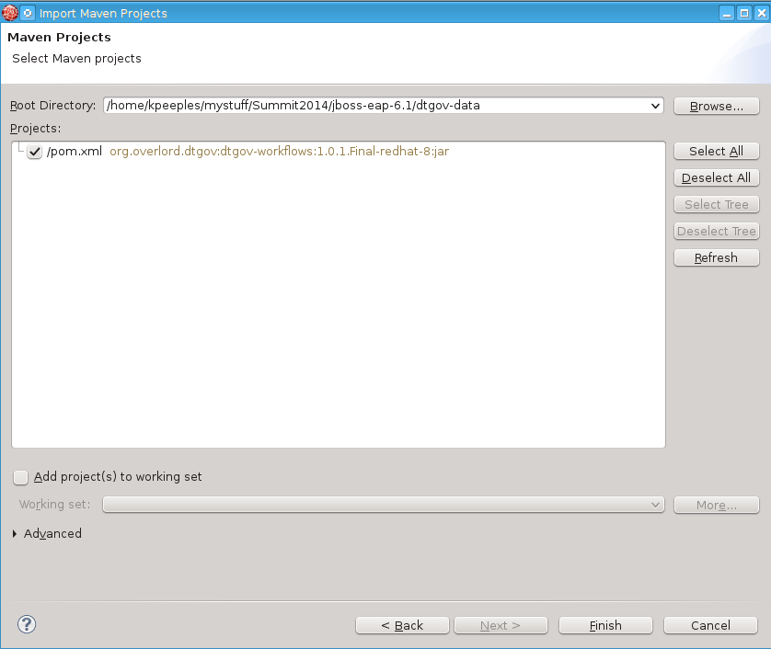

b. Examine the Simple Process BPMN file for the workflow

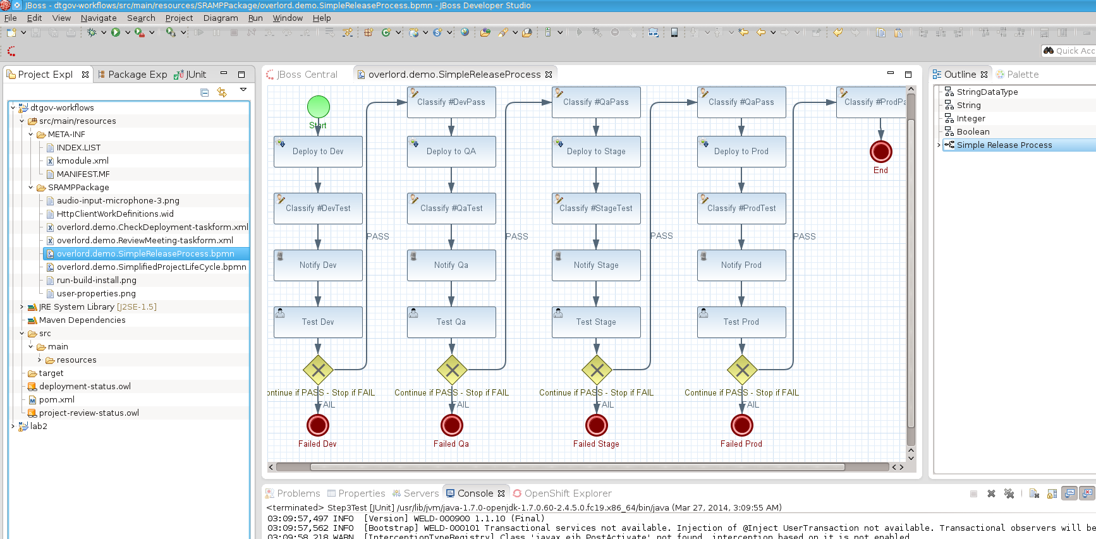
c. Success?

Step 2: Deploy Default Workflow
a. Deploy the default workflow from the Command Line OR use b
mvn clean deploy
b. Deploy the default workflow from JBDS
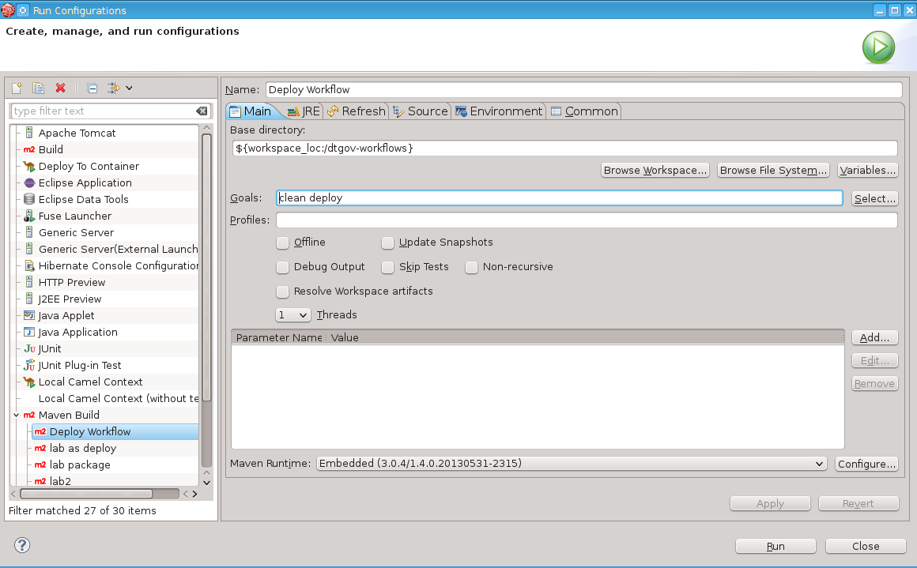
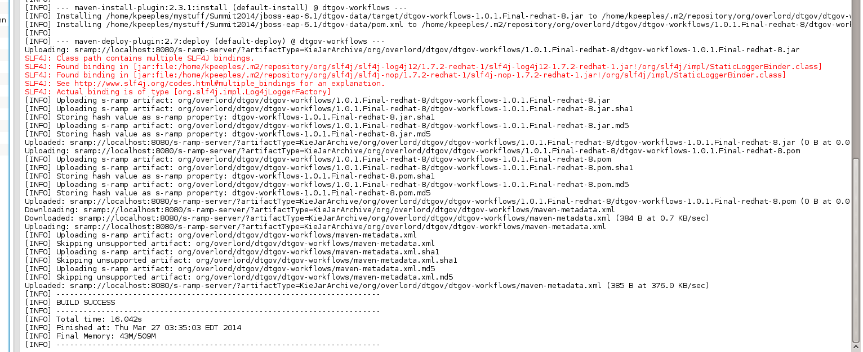
c. Review the console log for the deployed workflow
does not display in the console log but can review in S-RAMP
d. Review the S-RAMP UI
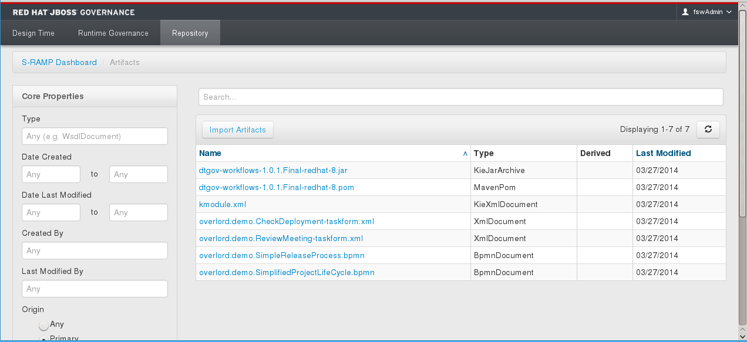
e. Success?

Step 3: Review DTGov UI
a. Review the S-RAMP UI
b. Review the DTGov UI and note the Task Inbox/Deployments.
c. Success?

Step 4: View the DTGov Configuration
a. Review Roles file
# The following illustrates how an admin user could be defined.
#
#admin=PowerUser,BillingAdmin,
#guest=guest
fswAdmin=overlorduser,admin.sramp,dev,qa,stage,prod,manager,arch,ba
dtgovworkflows=overlorduser,admin.sramp
guest=guest
b. Review the DTGov Configuration
# Governance queries
governance.queries=/s-ramp/ext/SwitchYardApplication|overlord.demo.SimpleReleaseProcess|DeploymentUrl={governance.url}/rest/deploy/{target}/{uuid}::NotificationUrl={governance.url}/rest/notify/email/{group}/deployed/{target}/{uuid}::UpdateMetaDataUrl={governance.url}/rest/update/{name}/{value}/{uuid}
governance.queries=/s-ramp/ext/JavaArchive|overlord.demo.SimpleReleaseProcess|DeploymentUrl={governance.url}/rest/deploy/{target}/{uuid}::NotificationUrl={governance.url}/rest/notify/email/{group}/deployed/{target}/{uuid}::UpdateMetaDataUrl={governance.url}/rest/update/{name}/{value}/{uuid}
governance.queries=/s-ramp/ext/JavaWebApplication|overlord.demo.SimpleReleaseProcess|DeploymentUrl={governance.url}/rest/deploy/{target}/{uuid}::NotificationUrl={governance.url}/rest/notify/email/{group}/deployed/{target}/{uuid}::UpdateMetaDataUrl={governance.url}/rest/update/{name}/{value}/{uuid}
governance.queries=/s-ramp/ext/JavaEnterpriseApplication|overlord.demo.SimpleReleaseProcess|DeploymentUrl={governance.url}/rest/deploy/{target}/{uuid}::NotificationUrl={governance.url}/rest/notify/email/{group}/deployed/{target}/{uuid}::UpdateMetaDataUrl={governance.url}/rest/update/{name}/{value}/{uuid}
governance.queries=/s-ramp/ext/ArtifactGrouping[xp2:matches(@name\, 'Project.*')]|overlord.demo.SimplifiedProjectLifeCycle|UpdateMetaDataUrl={governance.url}/rest/update/{name}/{value}/{uuid}

# Deployment targets
governance.targets= dev|http://www.jboss.org/overlord/deployment-status.owl#InDev|copy|/tmp/dev/jbossas7/standalone/deployments
governance.targets= qa|http://www.jboss.org/overlord/deployment-status.owl#InQa|copy|/tmp/qa/jbossas7/standalone/deployments
governance.targets=stage|http://www.jboss.org/overlord/deployment-status.owl#InStage|copy|/tmp/stage/jbossas7/standalone/deployments
governance.targets= prod|http://www.jboss.org/overlord/deployment-status.owl#InProd|copy|/tmp/prod/jbossas7/standalone/deployments
c. Success?

Step 5: Modify POM for Distribution Management for the Application
a. Modify the POM for distribution Management

<extensions>
<extension>
<groupId>org.overlord.sramp</groupId>
<artifactId>s-ramp-wagon</artifactId>
<version>${s-ramp.version}</version>
</extension>
</extensions>

<profile>
<id>deploylab</id>
<build>
<plugins>
<plugin>
<groupId>org.apache.maven.plugins</groupId>
<artifactId>maven-deploy-plugin</artifactId>
<configuration>
<skip>false</skip>
</configuration>
</plugin>
</plugins>
</build>
<distributionManagement>
<repository>
<id>local-sramp-repo</id>
<name>S-RAMP Releases Repository</name>
<url>sramp://localhost:8080/s-ramp-server/?artifactType=SwitchYardApplication</url>
</repository>
<snapshotRepository>
<id>local-sramp-repo-snapshots</id>
<name>S-RAMP Snapshots Repository</name>
<url>sramp://localhost:8080/s-ramp-server/?artifactType=SwitchYardApplication</url>
</snapshotRepository>
</distributionManagement>
</profile>
b. Modify S-RAMP username/password
this is done in the settings.xml. Can also be done in the pom or in the command line argument
c. Success?

Step 6: Create Link for Production
a. Create the link from the command line for production
mkdir -p /tmp/prod/jbossas7/standalone/deployments
ln -sv /tmp/prod/jbossas7/standalone/deployments /home/kpeeples/demos/fsw-simple-demo/installed/fsw/jboss-eap-6.1/standalone/deployments
b. Success?

Step 7: Deploy Application to S-RAMP
a. Settings in settings.xml for repos amd S-RAMP username/password

<settings xmlns="http://maven.apache.org/SETTINGS/1.0.0"
xmlns:xsi="http://www.w3.org/2001/XMLSchema-instance"
xsi:schemaLocation="http://maven.apache.org/SETTINGS/1.0.0 http://maven.apache.org/xsd/settings-1.0.0.xsd">

<profiles>

<profile>
<id>jboss-eap-repository</id>
<repositories>
<repository>
<id>jboss-eap-repository</id>
<name>JBoss EAP Maven Repository</name>
<url>file:///home/kpeeples/jboss-eap-6.1.1.GA-maven-repository</url>
<layout>default</layout>
<releases>
<enabled>true</enabled>
<updatePolicy>never</updatePolicy>
</releases>
<snapshots>
<enabled>false</enabled>
<updatePolicy>never</updatePolicy>
</snapshots>
</repository>
</repositories>
<pluginRepositories>
<pluginRepository>
<id>jboss-eap-repository-group</id>
<name>JBoss EAP Maven Repository</name>
<url>file:///home/kpeeples/jboss-eap-6.1.1.GA-maven-repository</url>
<layout>default</layout>
<releases>
<enabled>true</enabled>
<updatePolicy>never</updatePolicy>
</releases>
<snapshots>
<enabled>false</enabled>
<updatePolicy>never</updatePolicy>
</snapshots>
</pluginRepository>
</pluginRepositories>
</profile>
<!-- Configure the JBoss GA Maven repository -->
<profile>
<id>jboss-ga-repository</id>
<repositories>
<repository>
<id>jboss-ga-repository</id>
<url>file:///home/kpeeples/fsw-6.0.0.GA-redhat-2-repository</url>
<releases>
<enabled>true</enabled>
</releases>
<snapshots>
<enabled>false</enabled>
</snapshots>
</repository>
</repositories>
<pluginRepositories>
<pluginRepository>
<id>jboss-ga-plugin-repository</id>
<url>file:///home/kpeeples/fsw-6.0.0.GA-redhat-2-repository</url>
<releases>
<enabled>true</enabled>
</releases>
<snapshots>
<enabled>false</enabled>
</snapshots>
</pluginRepository>
</pluginRepositories>
</profile>

</profiles>

<servers>
<server>
<id>local-sramp-repo</id>
<username>fswAdmin</username>
<password>redhat1!</password>
</server>
<server>
<id>local-sramp-repo-snapshots</id>
<username>fswAdmin</username>
<password>redhat1!</password>
</server>
</servers>

<activeProfiles>
<!-- Optionally, make the repositories active by default -->
<activeProfile>jboss-eap-repository</activeProfile>
<activeProfile>jboss-ga-repository</activeProfile>
</activeProfiles>

</settings>

b. Deploy the Application to S-RAMP from the command line or JBDS
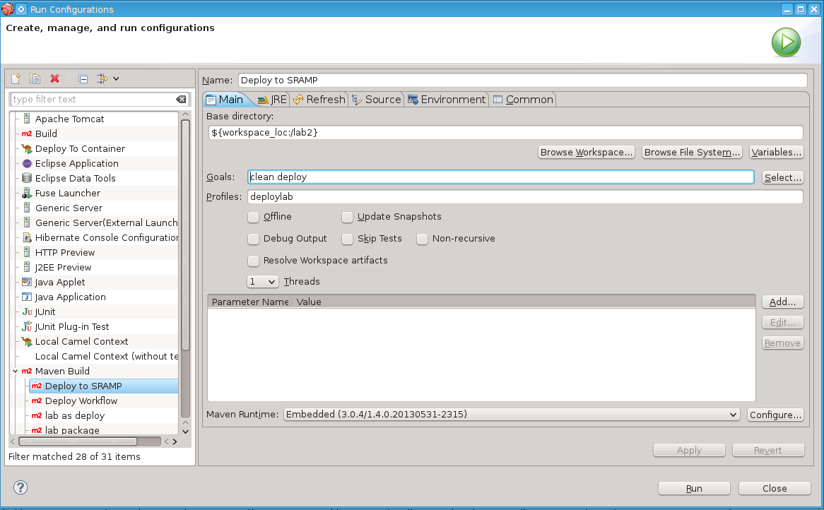
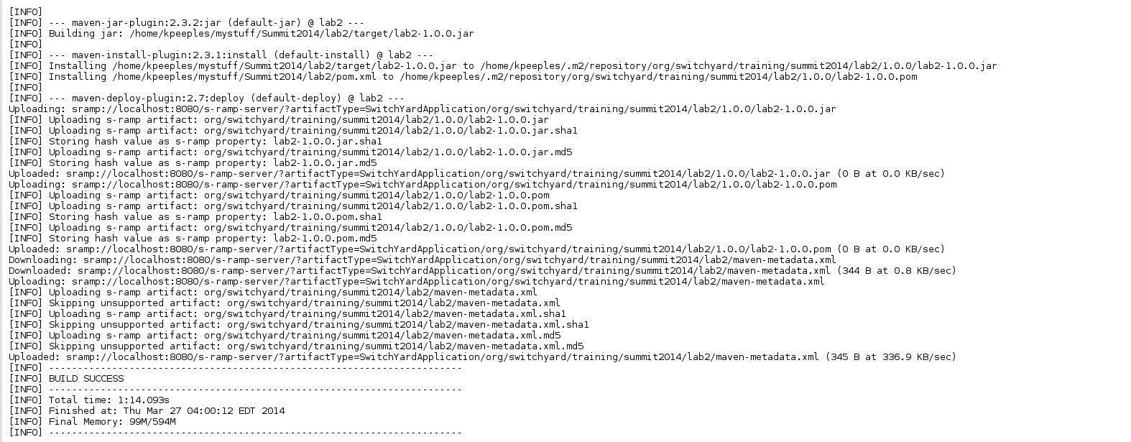
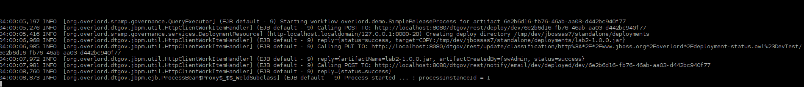
b. Success?

Step 8: Walk through Workflow

a. Open the Browser and browse to localhost:8080/dtgov-ui
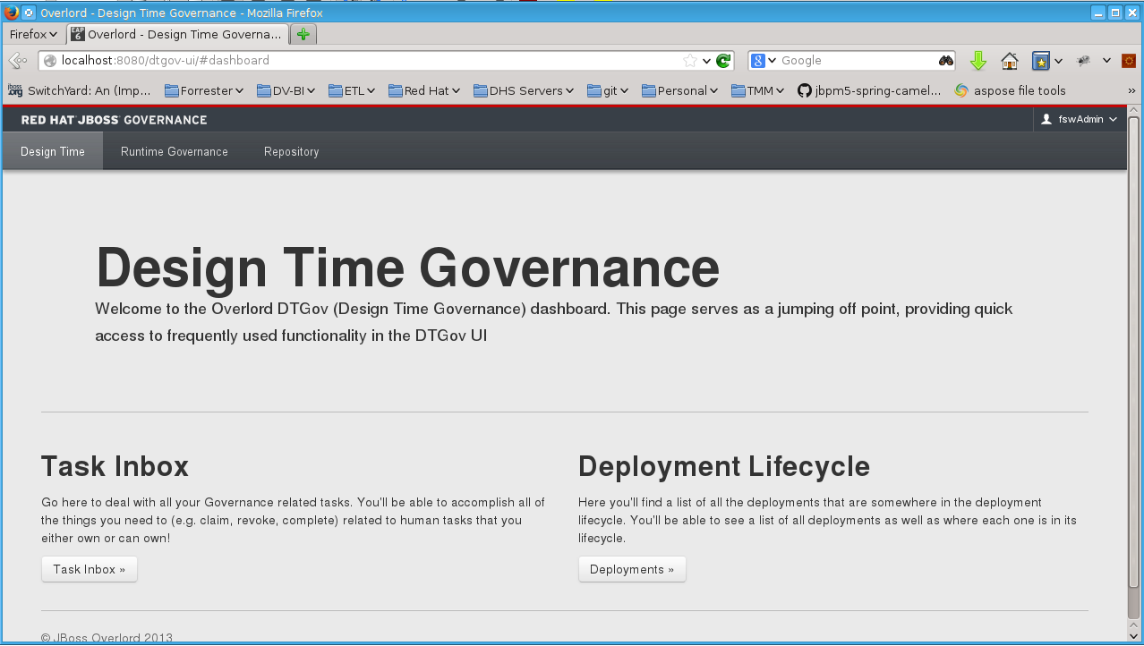
b. View the deployment by clicking the Deployments button
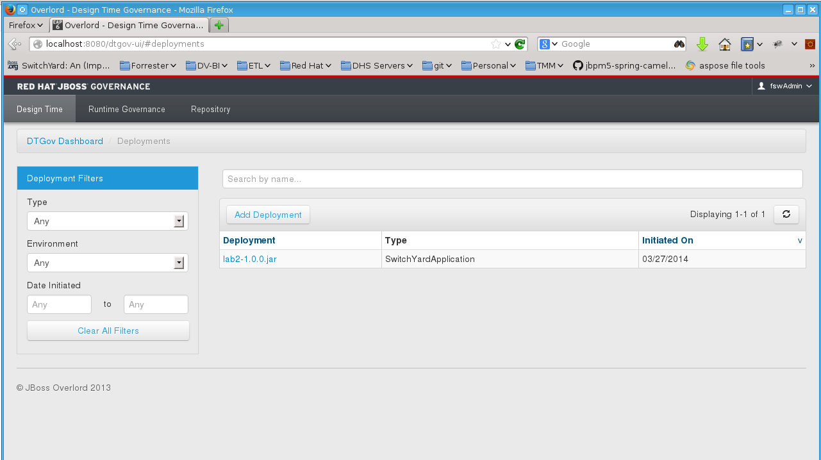

c.Go back to the Task inbox and click on the TestDev Task

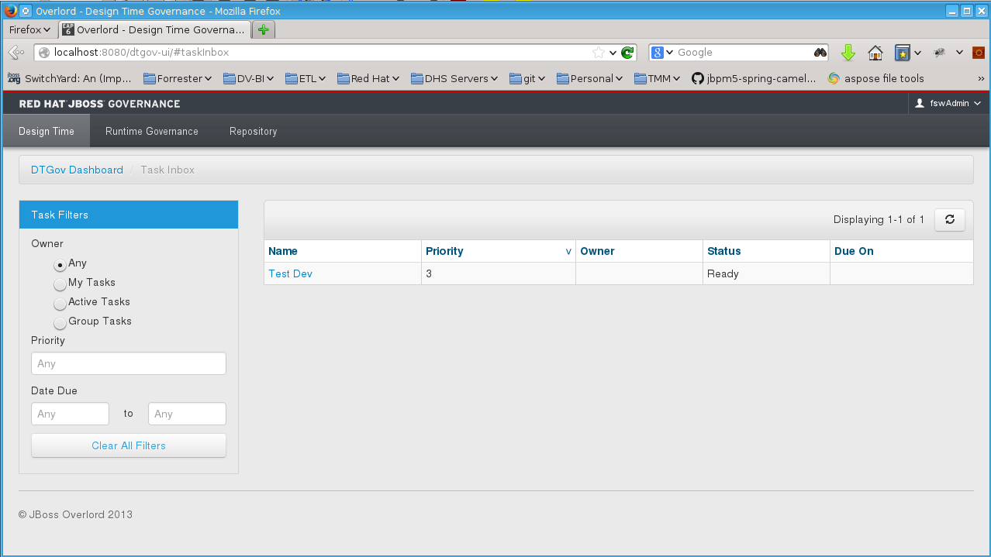

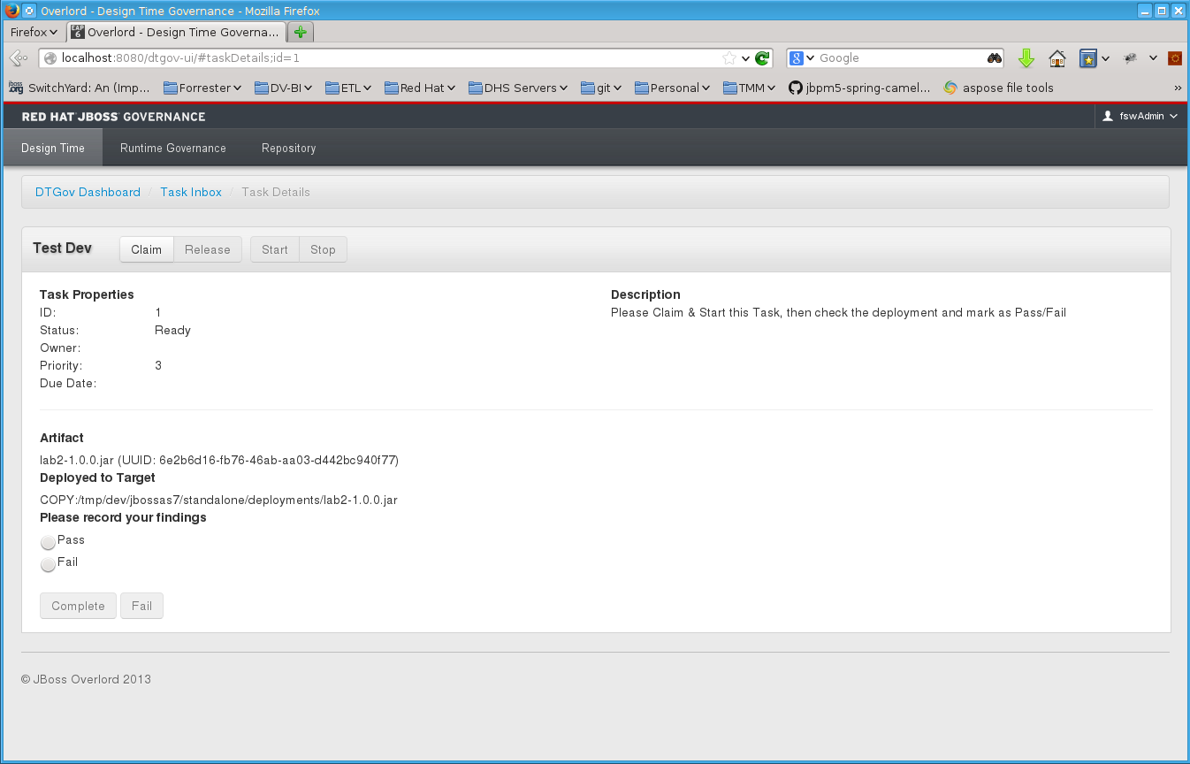
d. Claim the task
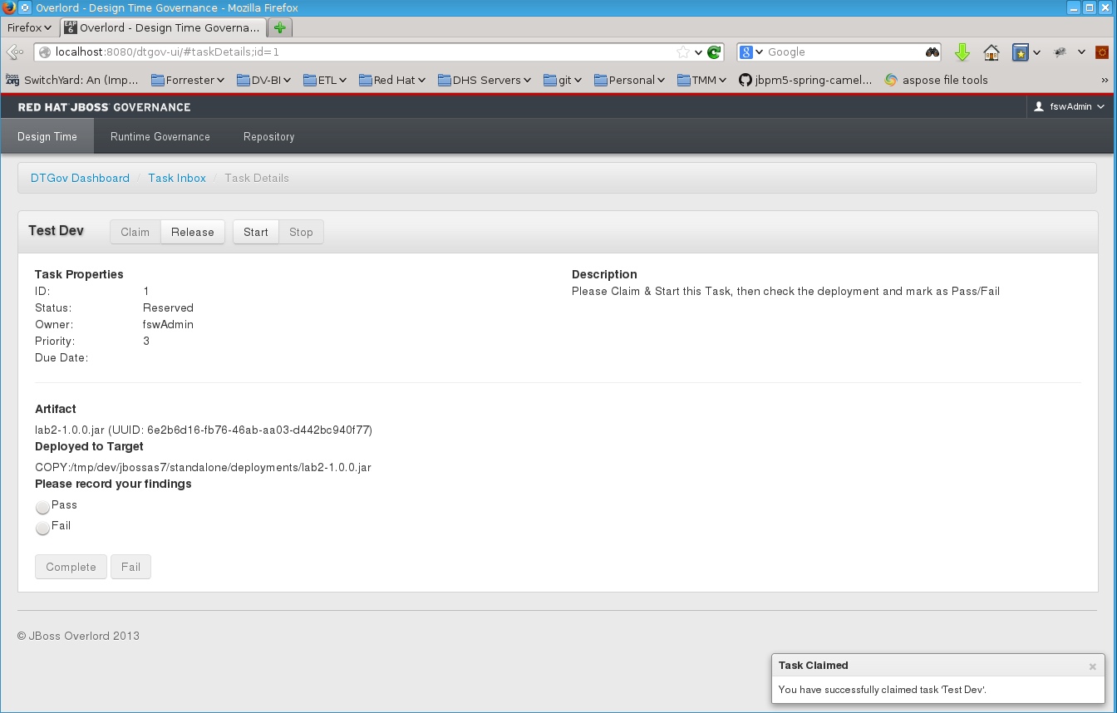

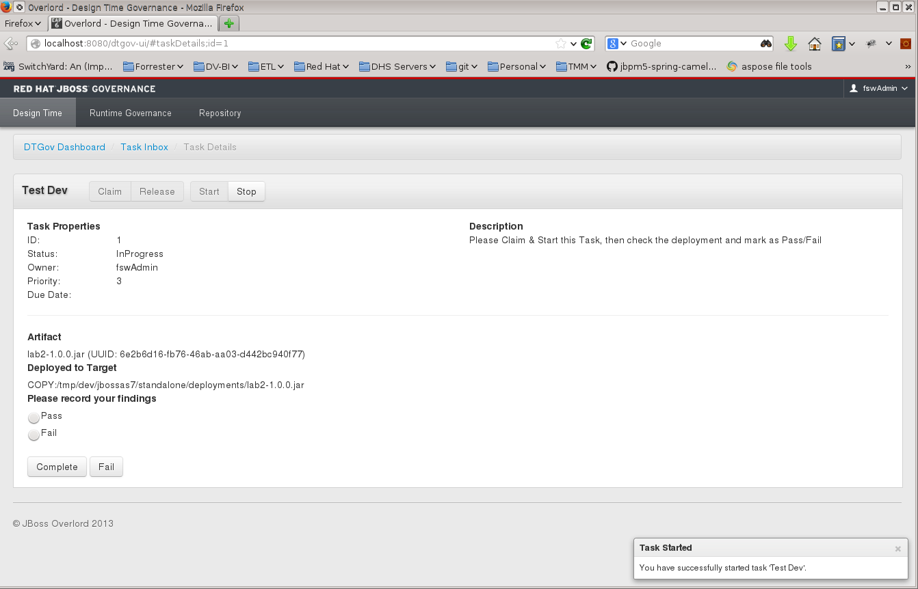
e. Start the task

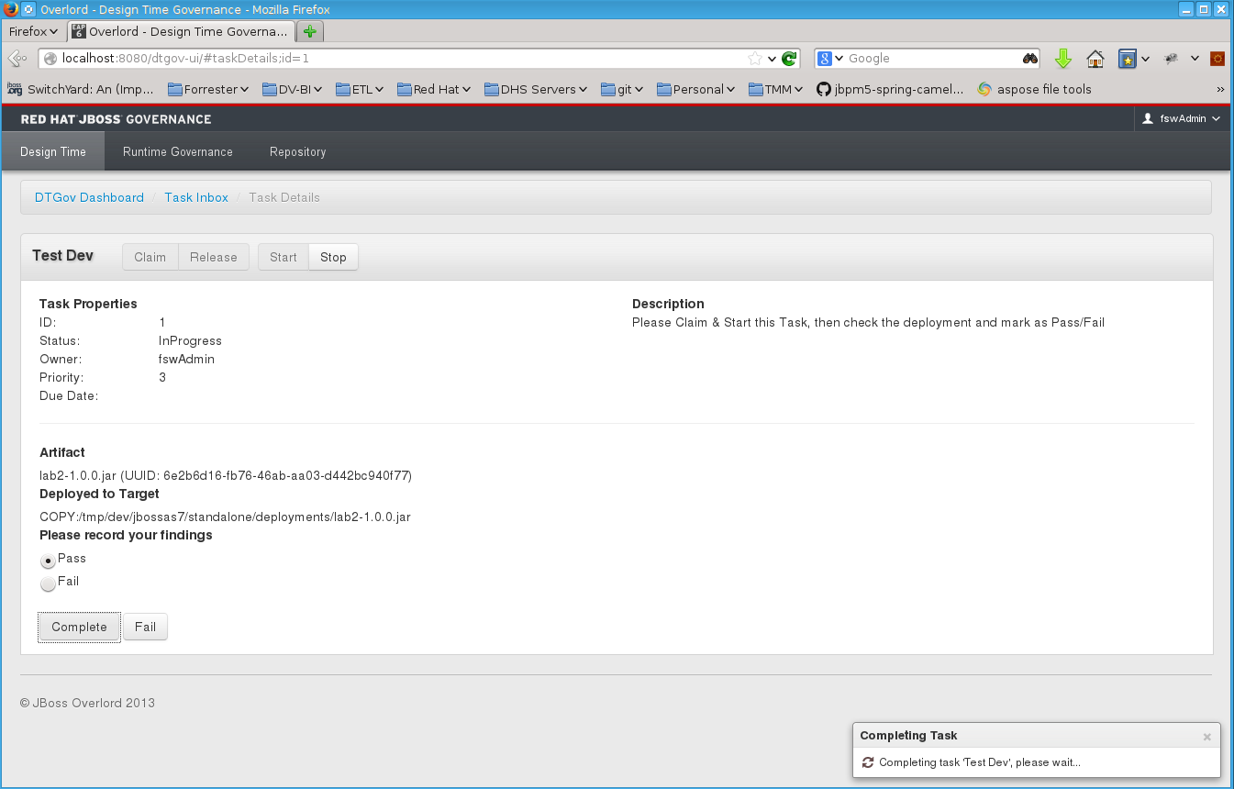
f. Complete the task by passing it

g. Pass the deployment in QA
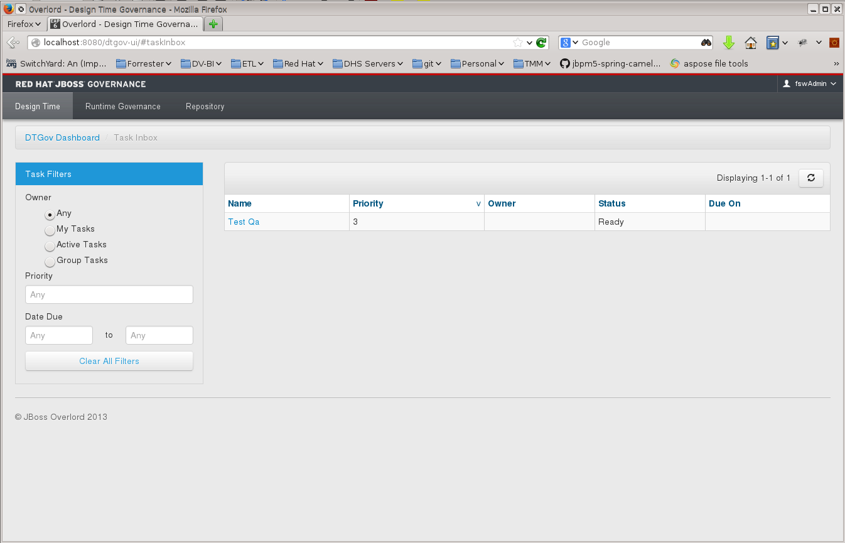
Follow same process as above
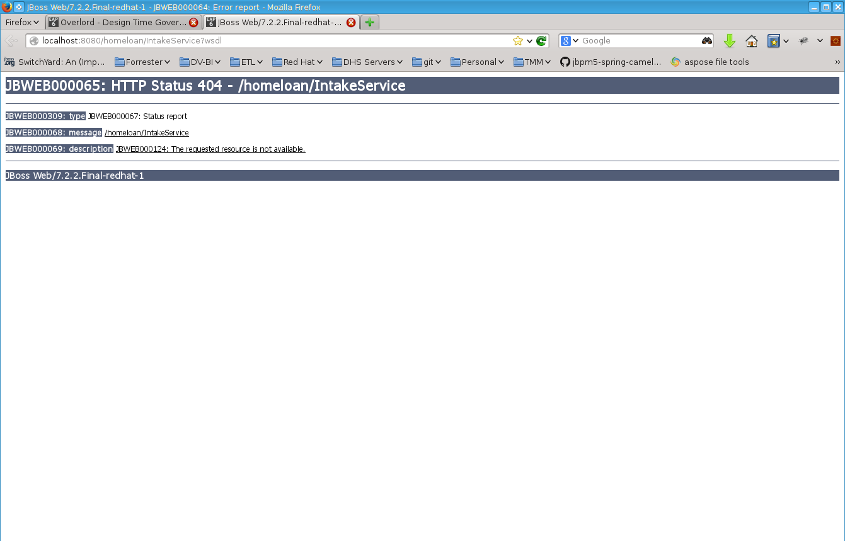
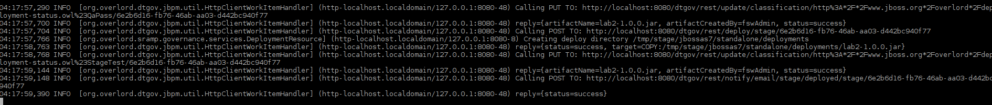
c. Pass the deployment in Stage (At this point the App is deployed after it passes)
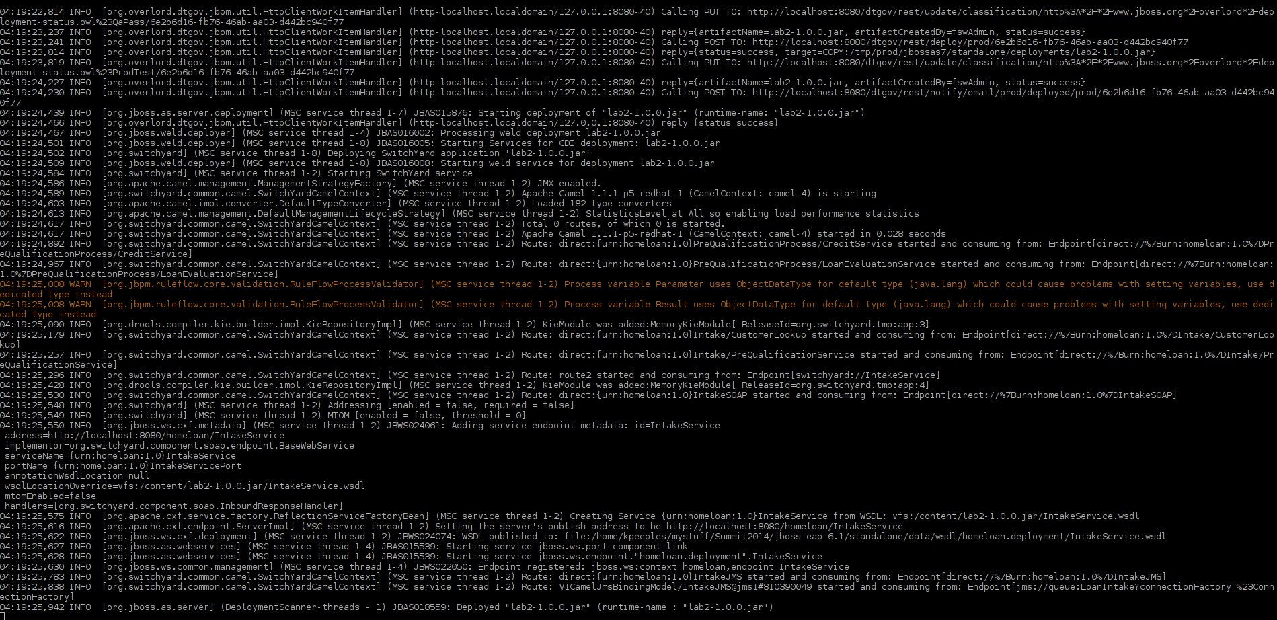
d. Verify the Application
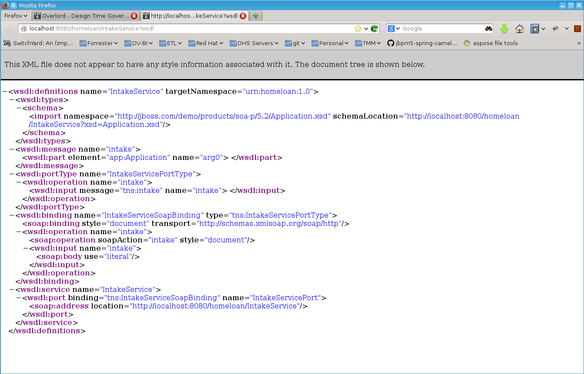
d. Pass the deployment in Production
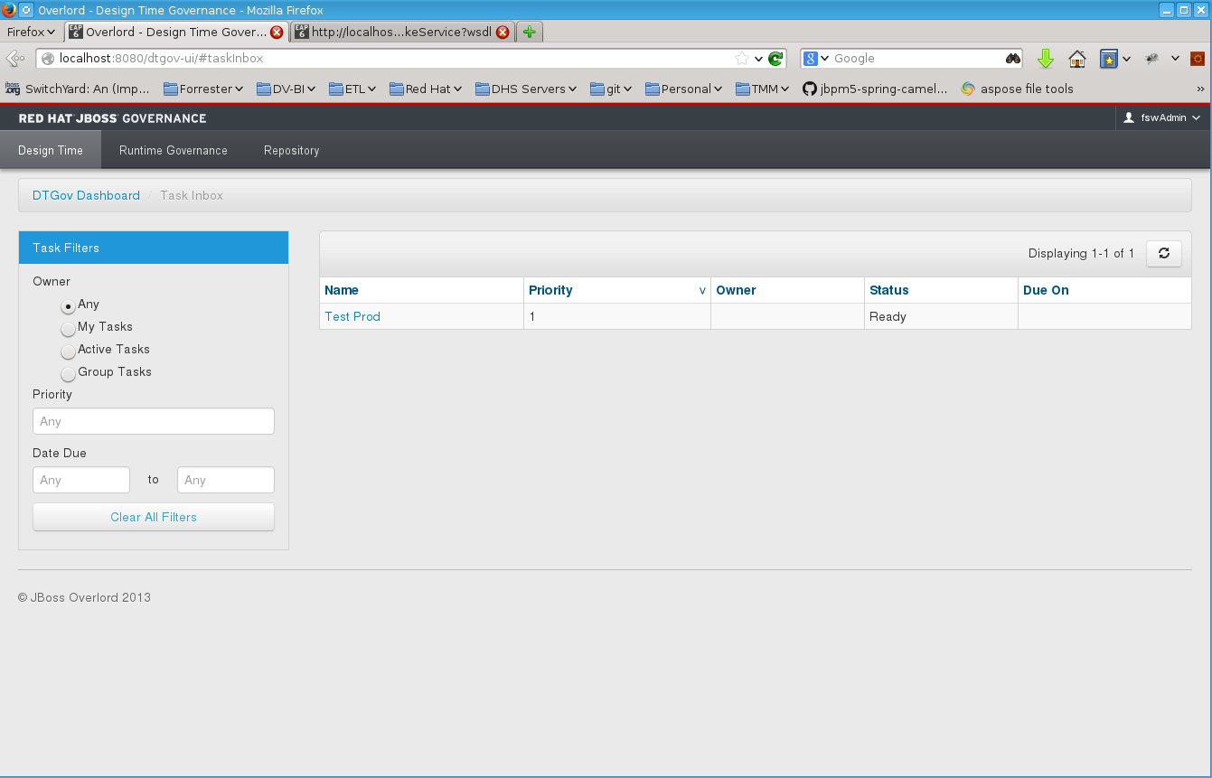

e. Success?

