JBoss Business Rules Management System (BRMS) Quickstart Guide

Version 1.0
November 2010


JBoss Business Rules Management System (BRMS) Quickstart Guide
1801 Varsity Drive™
Raleigh NC 27606-2072 USA
Phone: +1 919 754 3700
Phone: 888 733 4281
Fax: +1 919 754 3701
PO Box 13588
Research Triangle Park NC 27709 USA
Linux is a registered trademark of Linus Torvalds. Red Hat, Red Hat Enterprise Linux and the Red Hat "Shadowman" logo are registered trademarks of Red Hat, Inc. in the United States and other countries.

Microsoft and Windows are U.S. registered trademarks of Microsoft Corporation.

UNIX is a registered trademark of The Open Group.

Intel, the Intel logo, Xeon and Itanium are registered trademarks of Intel Corporation or its subsidiaries in the United States and other countries.
All other trademarks referenced herein are the property of their respective owners.
© 2010 by Red Hat, Inc. This material may be distributed only subject to the terms and conditions set forth in the Open Publication License, V1.0 or later (the latest version is presently available at http://www.opencontent.org/openpub/).
The information contained herein is subject to change without notice. Red Hat, Inc. shall not be liable for technical or editorial errors or omissions contained herein.
Distribution of modified versions of this document is prohibited without the explicit permission of Red Hat Inc.
Distribution of this work or derivative of this work in any standard (paper) book form for commercial purposes is prohibited unless prior permission is obtained from Red Hat Inc.
The GPG fingerprint of the security@redhat.com key is:
CA 20 86 86 2B D6 9D FC 65 F6 EC C4 21 91 80 CD DB 42 A6 0E
Table of Contents

1 Executive Summary 4
2 System Setup 5
2.1 x 5
2.1.1 x 5
3 Running the Examples 6
3.1 Starting the BRMS Console 6
3.2 The Main Console 8
3.3 The Search Feature 8
3.4 Exploring the Sample Repository 10
3.5 QA Testing 20
3.6 Package/Version Control 35
4 What Now? 38

Executive Summary
The JBoss Business Rules Management System (BRMS) is a web-based tool to help author, create, manage and test rules. This quickstart guide will help you get started using the BRMS to author, test, package, and publish rules. It will also walk you through system setup, running the examples, plus authoring new rules, test cases, etc.
SectionError: Reference source not foundpresents some commonly used definitions of cloud computing.
SectionError: Reference source not founddiscusses the phased adoption of cloud computing by enterprises from the use of virtualization, to the deployment of internal clouds and leading to full-functional utility computing using private and public clouds.
SectionError: Reference source not founddescribes the software infrastructure for Red Hat Cloud Foundations.
SectionError: Reference source not founddescribes the software, server, storage, network configuration used for this proof-of-concept.
SectionError: Reference source not foundis a quick overview of Red Hat Cloud Foundation, edition One: Private IaaS Cloud published in a separate reference architecture paper.
SectionsError: Reference source not found,Error: Reference source not foundandError: Reference source not founddescribe the detailed steps for deploying Red Hat Cloud Foundations, Edition One: Hybrid IaaS Clouds.
SectionError: Reference source not foundprovides an overview of Amazon's Elastic Compute Cloud (EC2) including procedures to configure an AWS account, configure an EC2 environment, and start EC2 instances.
SectionError: Reference source not founddefines the workload used.
SectionError: Reference source not foundlists referenced documents.
Future versions of the Red Hat Cloud Reference Architecture will take these concepts further:
- Red Hat Cloud Reference Architecture: Adding self-service
- Red Hat Cloud Reference Architecture: Managing mixed private clouds
- Red Hat Cloud Reference Architecture: Adding public clouds
- Red Hat Cloud Reference Architecture: Creating large-scale clouds

System Setup
x

x
x

x
x

Running the Examples

Starting the BRMS Console
To start the BRMS console, open up a web browser and connect to the following URL:
http://localhost:8080/jboss-brms
You will be redirected to the BRMS login page:

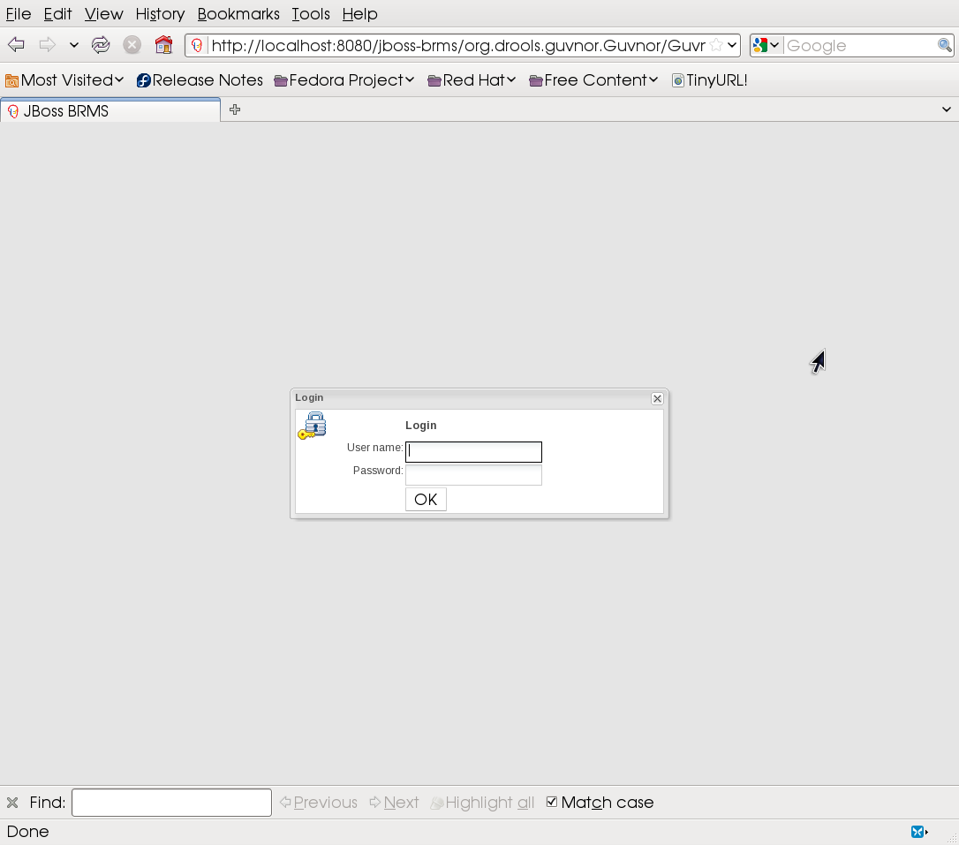
Enter the following credentials:
Username: admin
Password: admin
Select OK.
When you first login to the BRMS console, you will be prompted whether to install a sample repository to acquaint you with BRMS functionality:

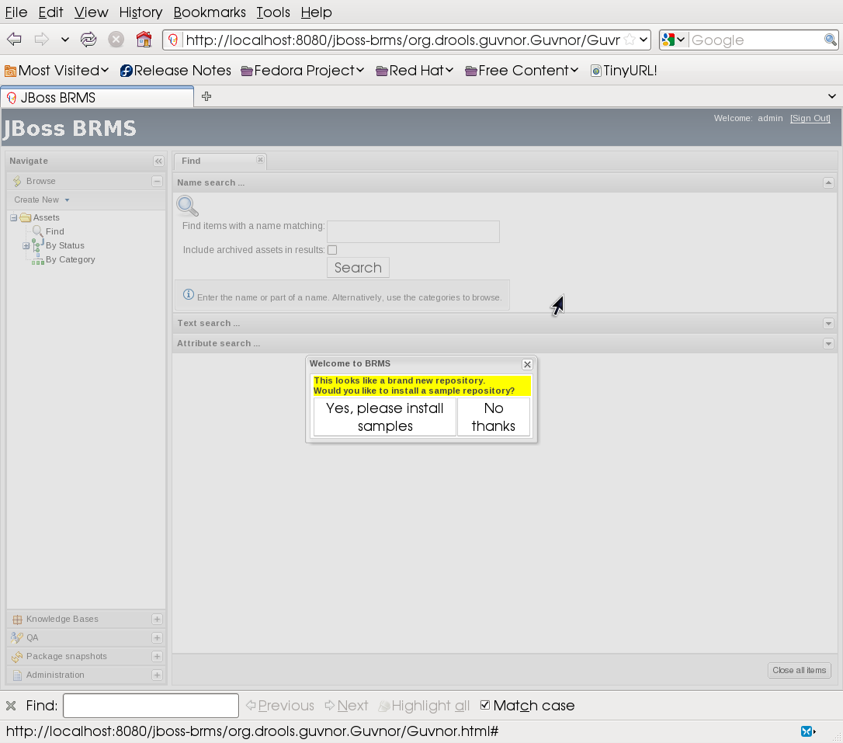

Select Yes, please install samples. You will then be asked to confirm your decision:

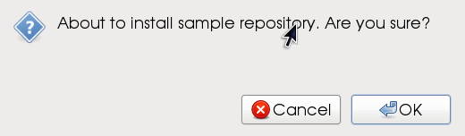

Select OK.
A confirmation dialog will appear:

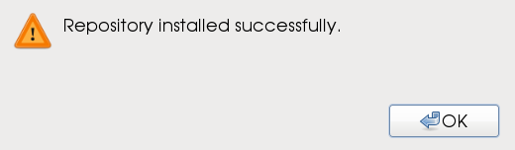

Select OK.

The Main Console
You should now see the BRMS main console. The console is comprised of two basic sections:
- The left-hand pane, comprised of vertical tabs that provide links to model components, QA tooling, package management, etc.
- The main pane, comprised of horizontal tabs that appear whenever an item is selected from the left-hand pane.

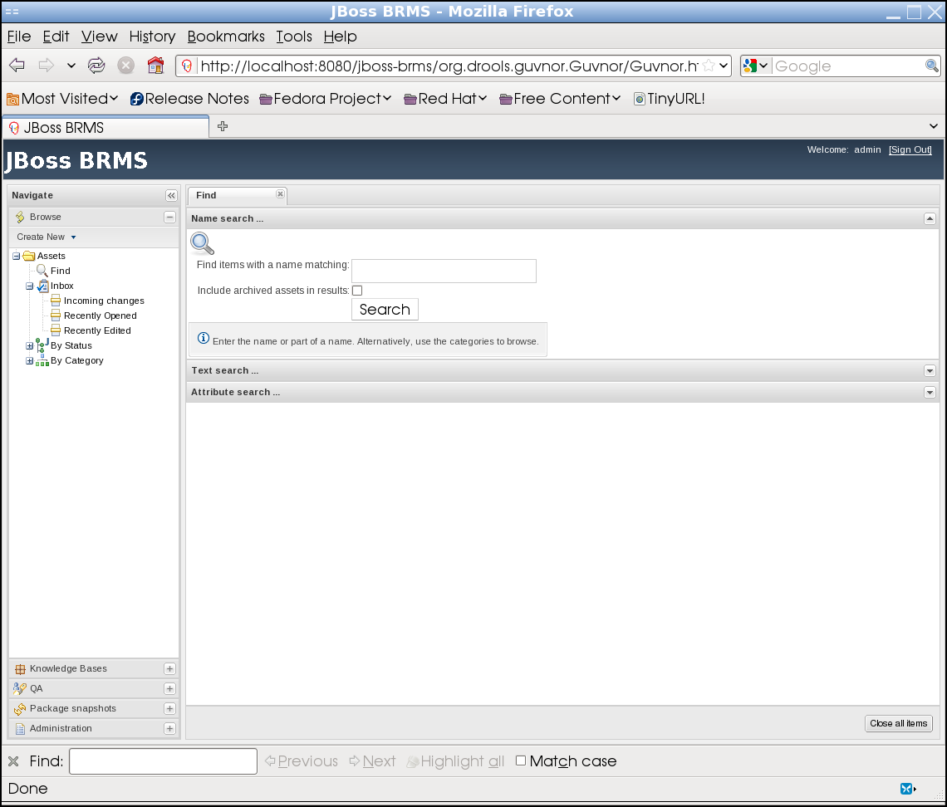
Navigate across the various left-hand pane tabs to familiarize yourself with the BRMS console. Select various components within the tabs to view the results in the main pane. You may want to close each new tab in the main pane to reduce clutter.

The Search Feature
The first tab to appear in the BRMS console main pane is the Find tab. Enter the string No in the Find items with matching field of the Find tab:
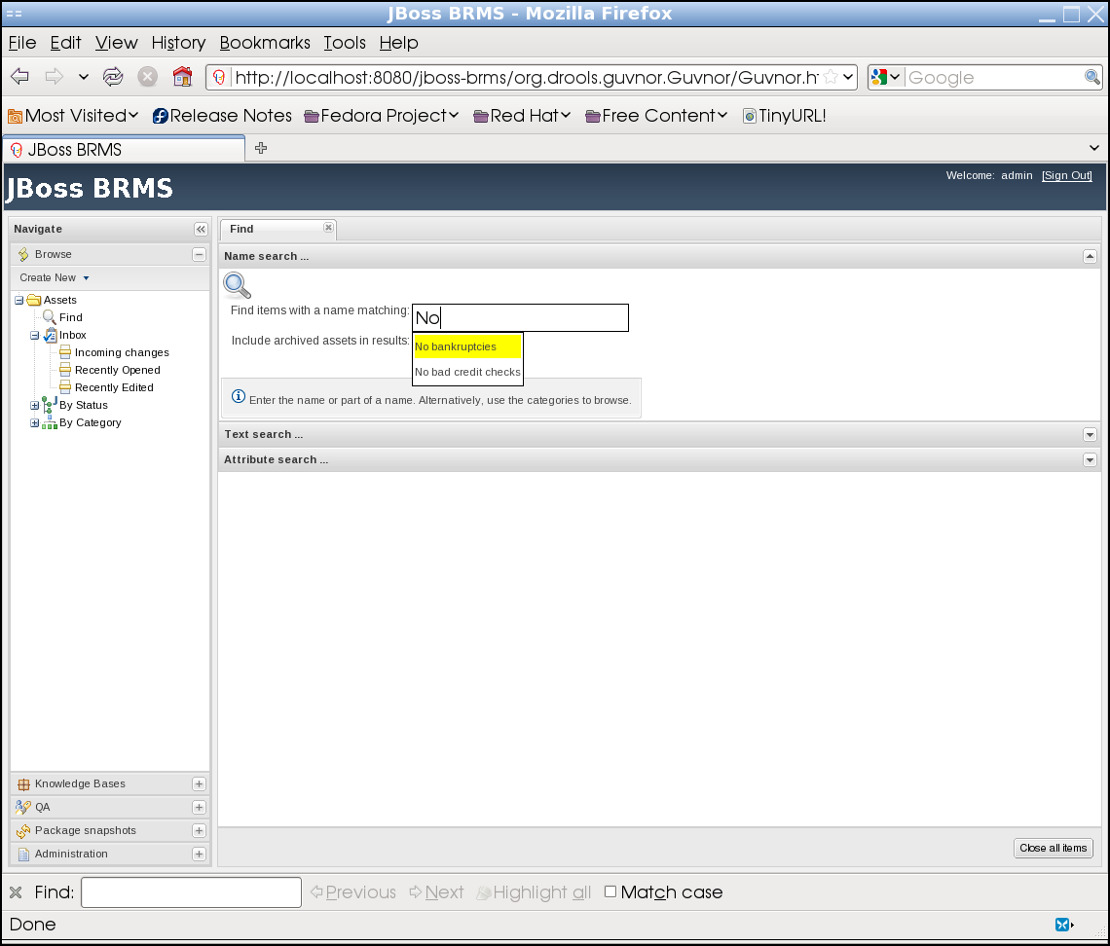

Notice how the field resolves results that match the given string. Select No bankruptcies then Search to view the following results:

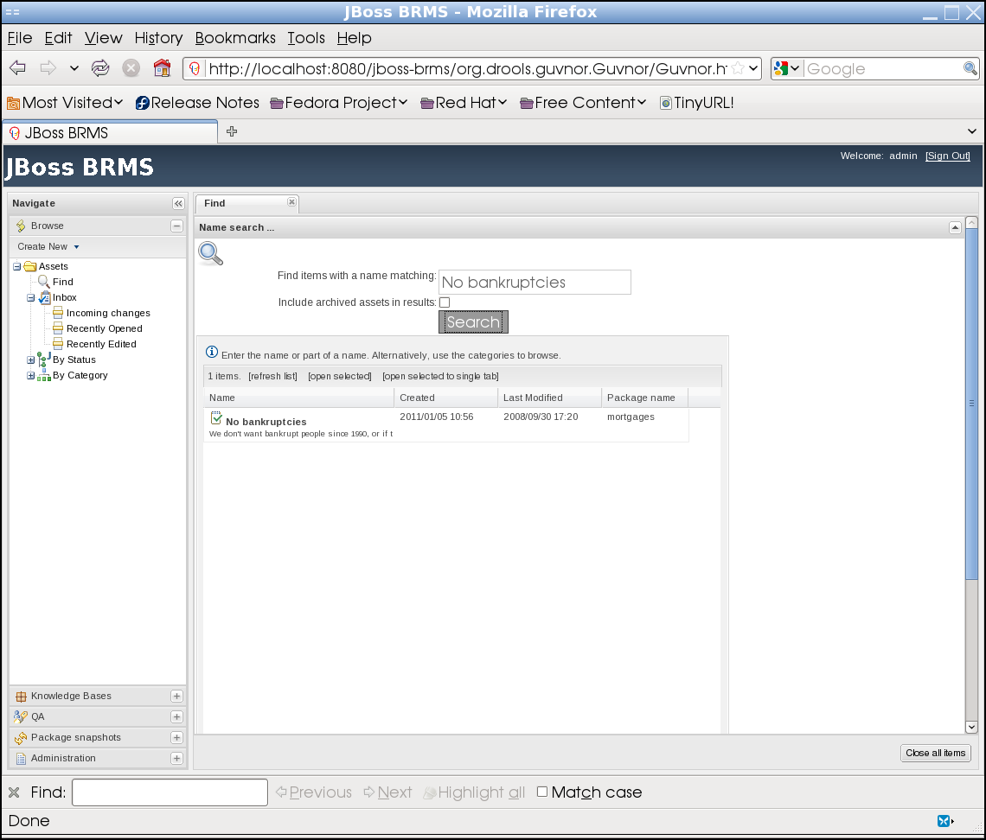

Close the results tab by selecting the 'x' on the tab's upper right corner.

Exploring the Sample Repository
You are now ready to explore the sample repository. From the left-hand pane, go to the Knowledge Bases tab and expand the mortgages package. Select the Business rules assets asset:
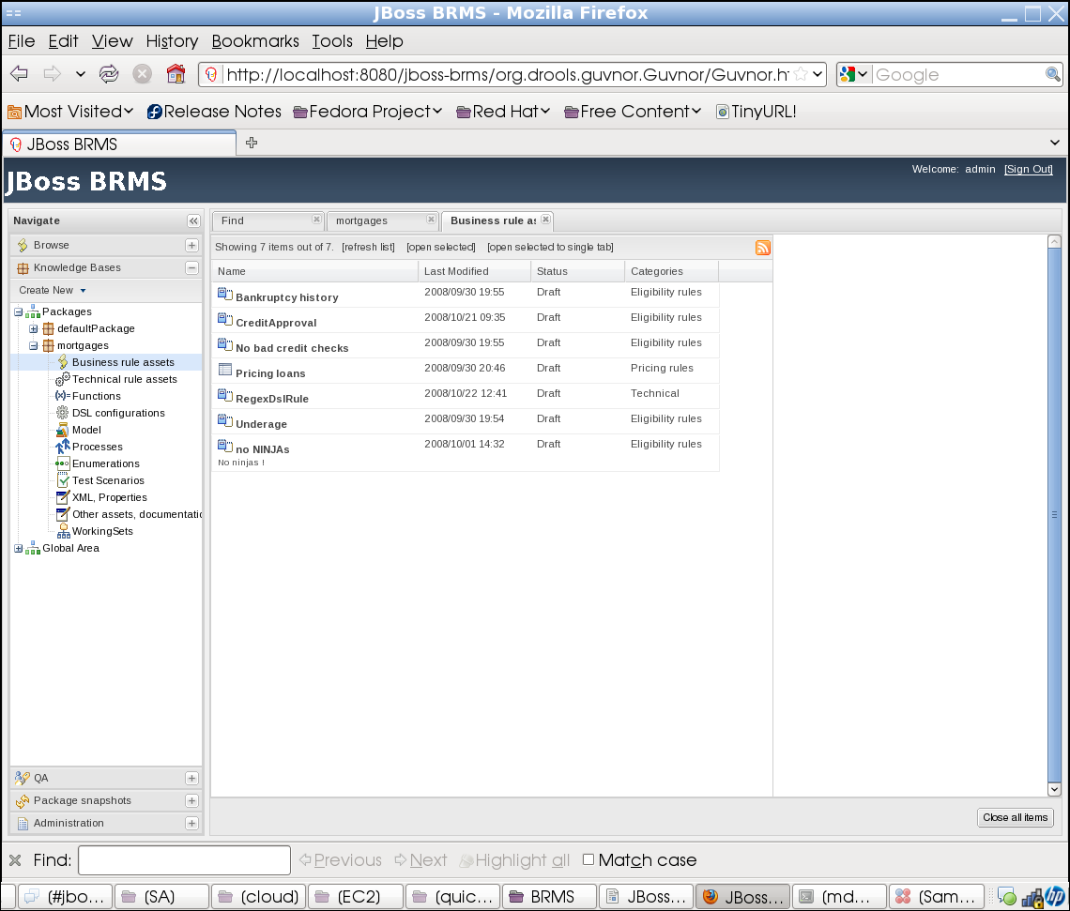

Double-click on Pricing loans. The following will appear:
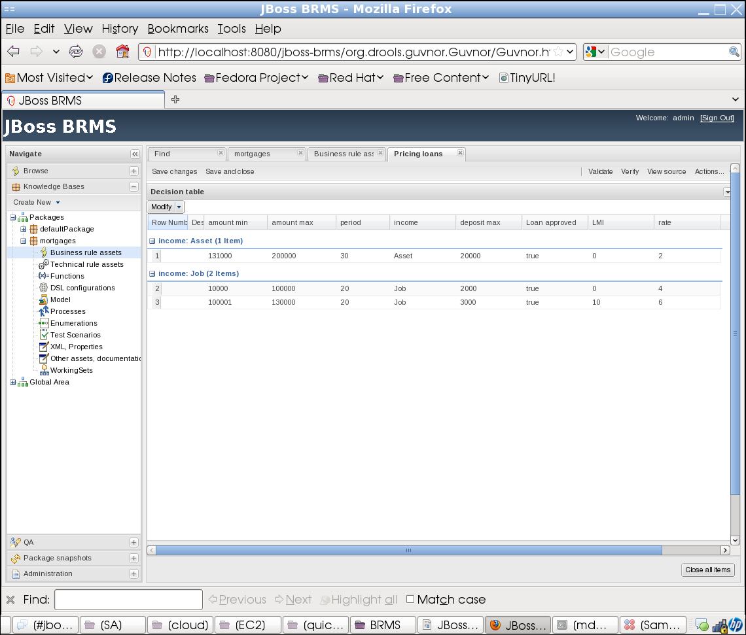
This is a decision table, which is essentially a spreadsheet for storing tabular data used by the rule engine. In this case, it maps incomes, the loan requested, down payments, etc. pertinent to a list of loans.
Select the downward facing arrow in the upper right corner of the decision table. (You might need to move the horizontal scrollbar on the bottom of the table toward the right.) This will display the Java objects mapped to this table.
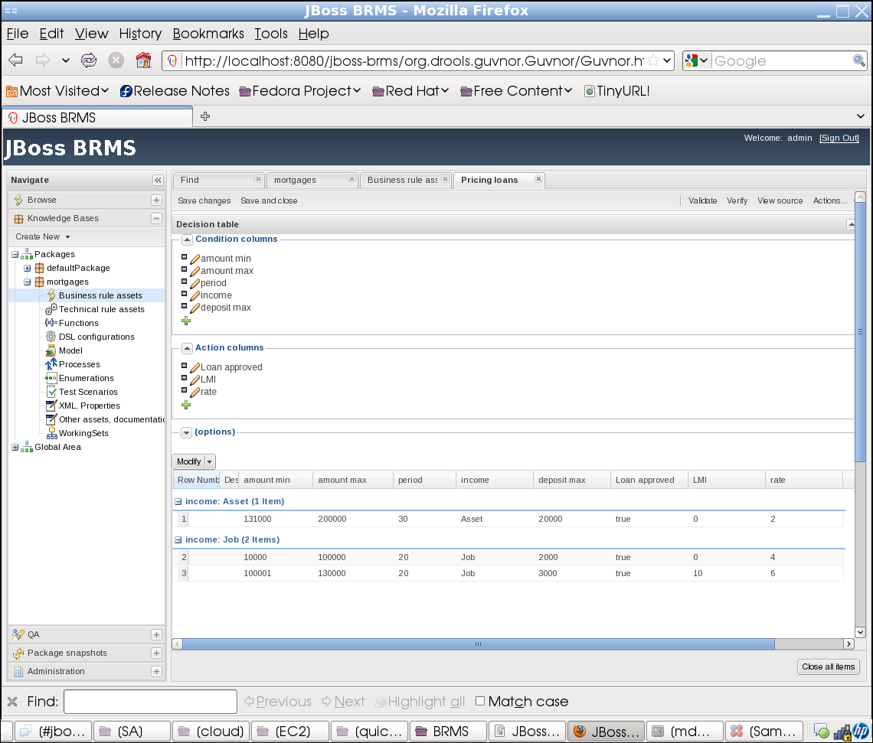

Locate the Condition columns section, then the amount min column. Click on the pencil icon located next to the amount min and note the resulting pop up:

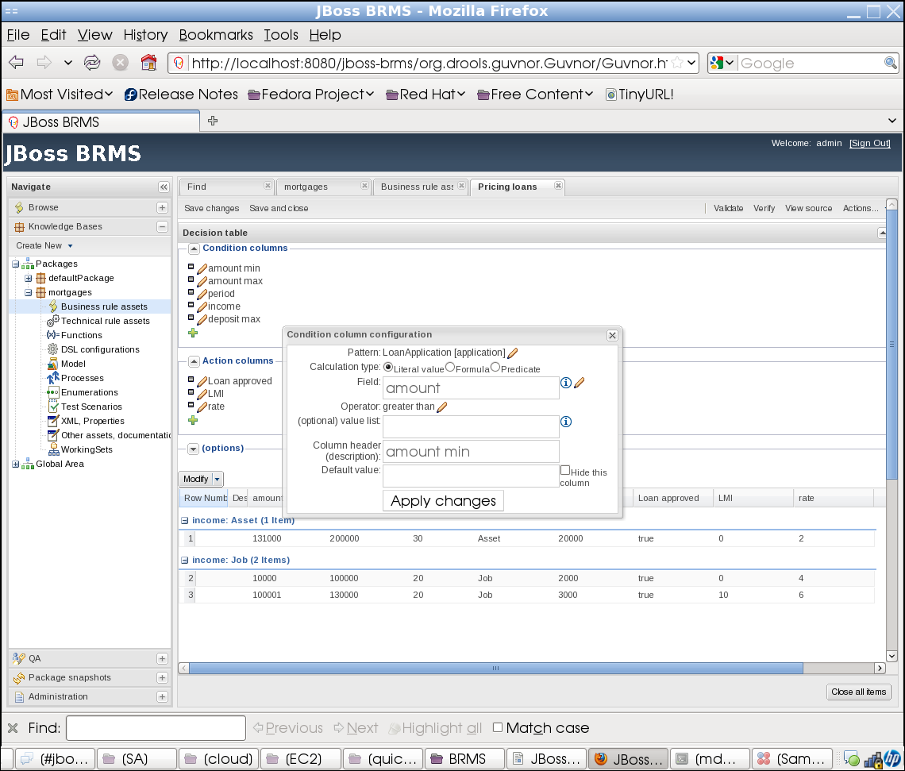
This describes how the amount min column configuration.
Select the 'x' to close the pop up box. Click the upward facing arrow in the upper right corner of the decision table. (You might need to move the horizontal scrollbar on the bottom of the table toward the right.)
Under the Income: Job section, select row 2. (Note the row is highlighted.) Double-click on the 20 value under the period column. The following pop up will appear:
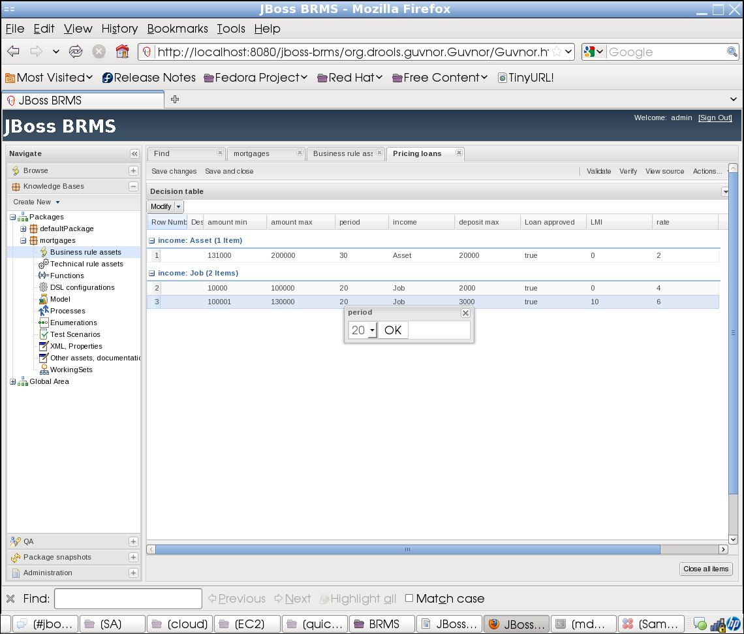
Using the enumerated droplist, change the period value from '20' to '25', then select OK. Note the change in the loan period. (You might want to close some tabs at this point to reduce clutter.)
Return to the mortgages package on the left-hand pane and select on Model. On the resultant pane is a 'domain model' called MortgageModel. Double click on MortgageModel domain model. The following will appear:

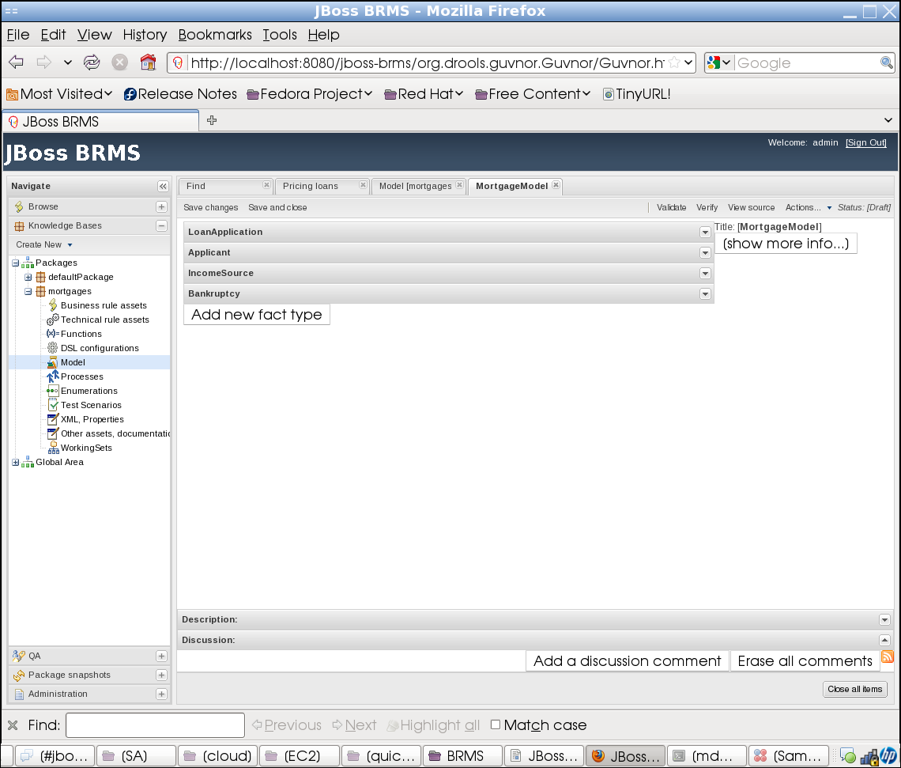

The resultant tab displays a set of 'facts' associated with this domain model. A fact is analogous to a Java object. Select the downward facing arrow to the right of the LoanApplication fact. The following will appear:

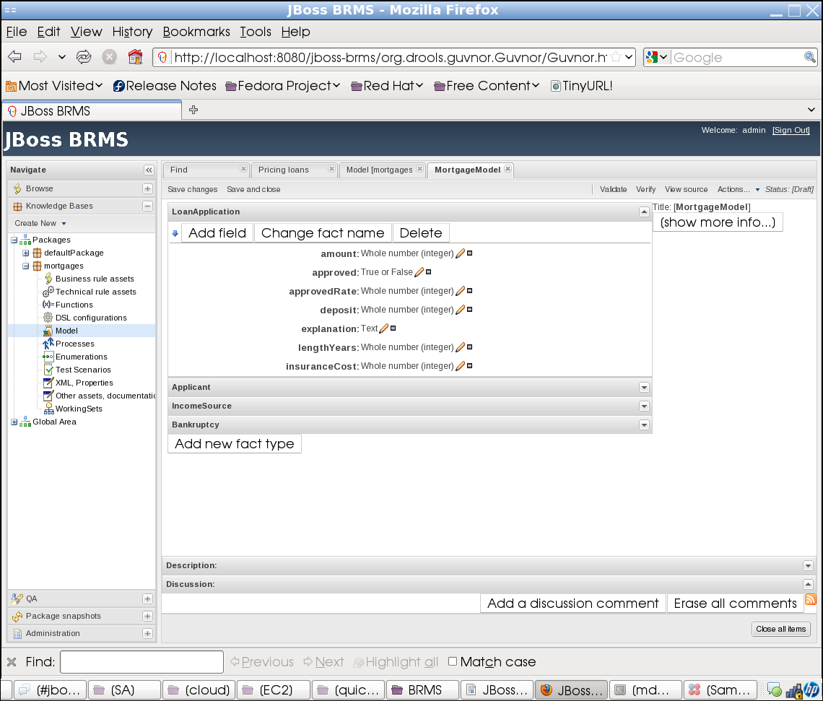
You will now see the member fields of the LoanApplication object. Select the other facts in the domain model to gain a better understanding of how facts can be represented.
Select the Business rule assets located under the mortgages package and double-click on the CreditApproval business rule.

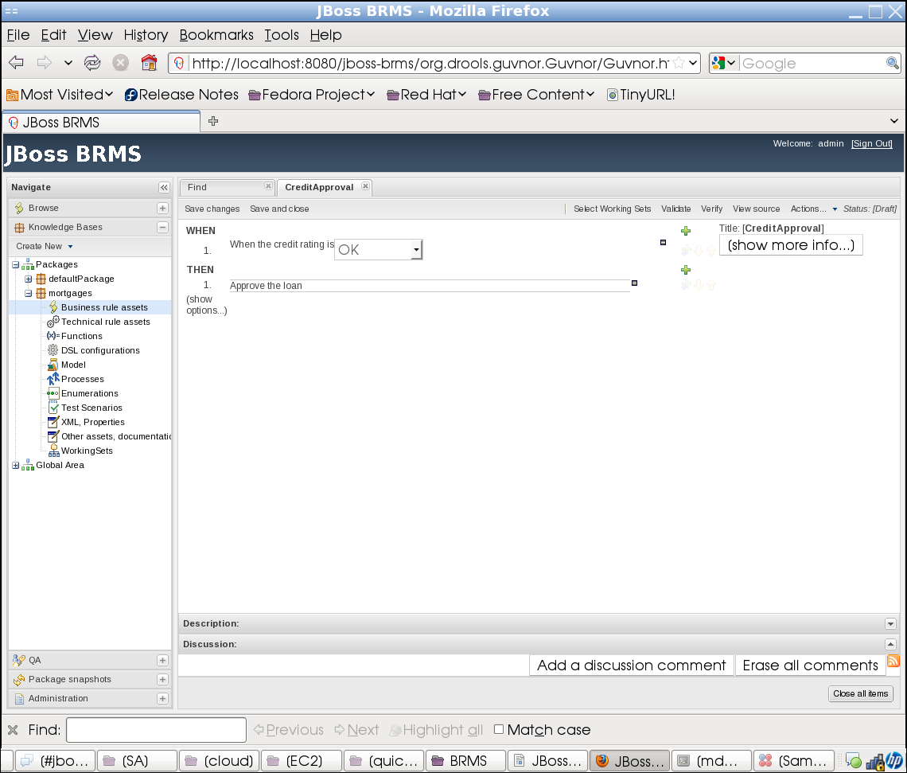
This is an example of the Domain Specific Language (DSL)-based rule. A DSL is used to guide a business user or analyst in writing rules. Note that the technical language typically associated with a rule is replaced with terms such as When the credit rating is and Approve the loan. To view the technical equivalent of this rule, select the View source button on the menu bar:

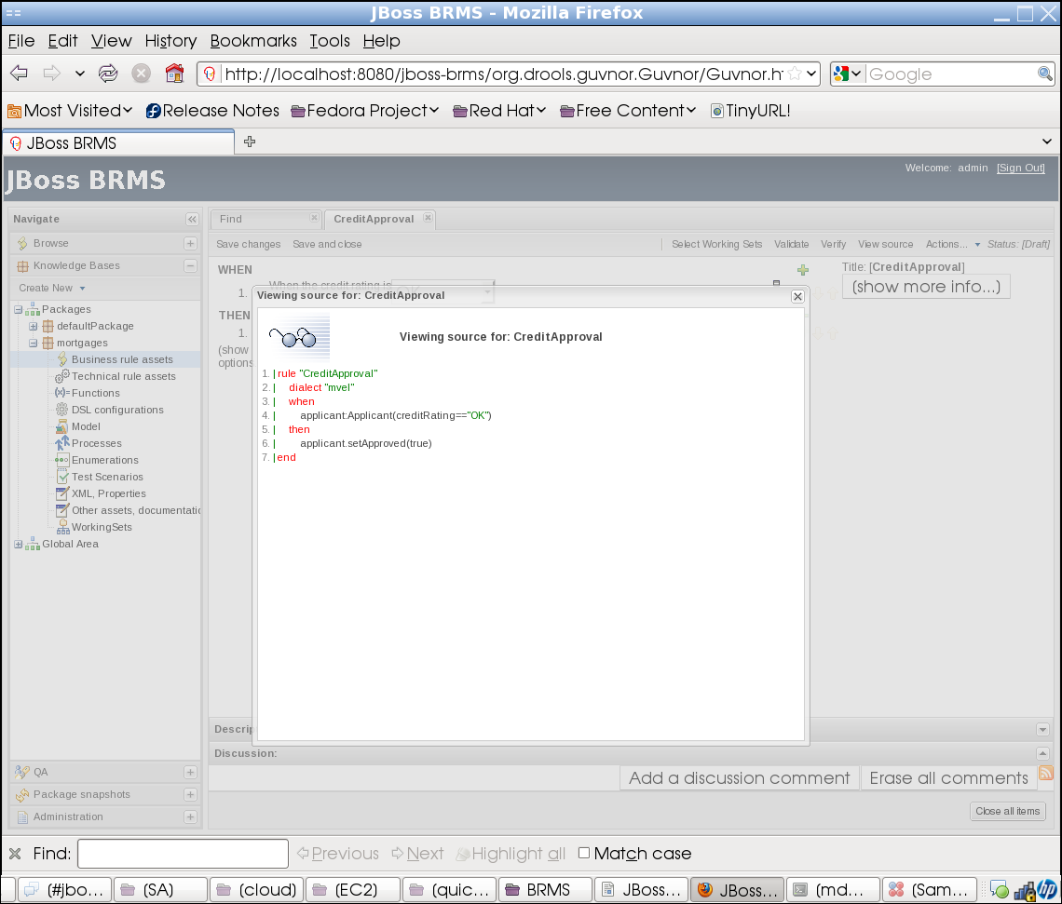
Close the rule source by selecting the 'x' in the upper-right.
You can also view the DSL configuration file used to create this DSL-based rule. Select DSL configurations under the mortgages package, then double click on the ApplicantDsl DSL configuration file:
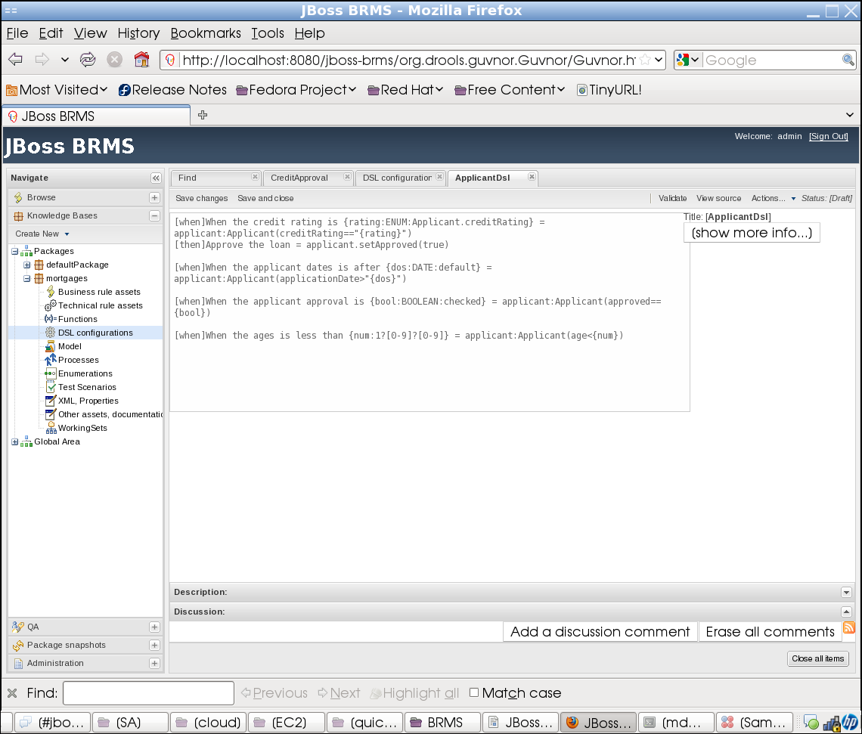

QA Testing
We have explored some of the assets that make up rules. We will now explore how to test rules.
Select Test Scenarios under the mortgage package:

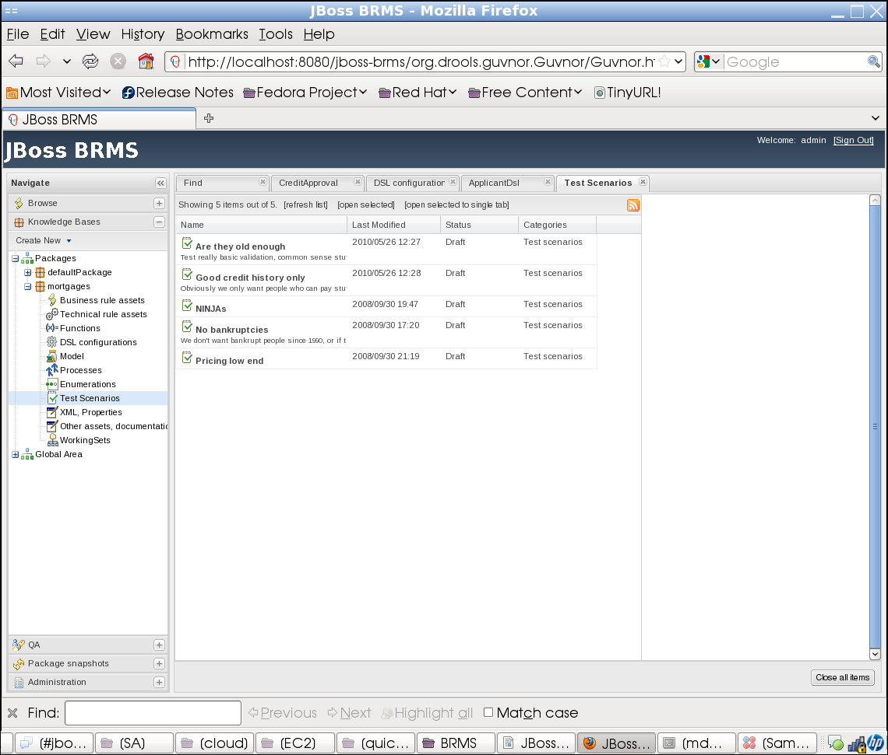

You will see five different test scenarios used to test the existing rule base. Double-click on the Are they old enough scenario:

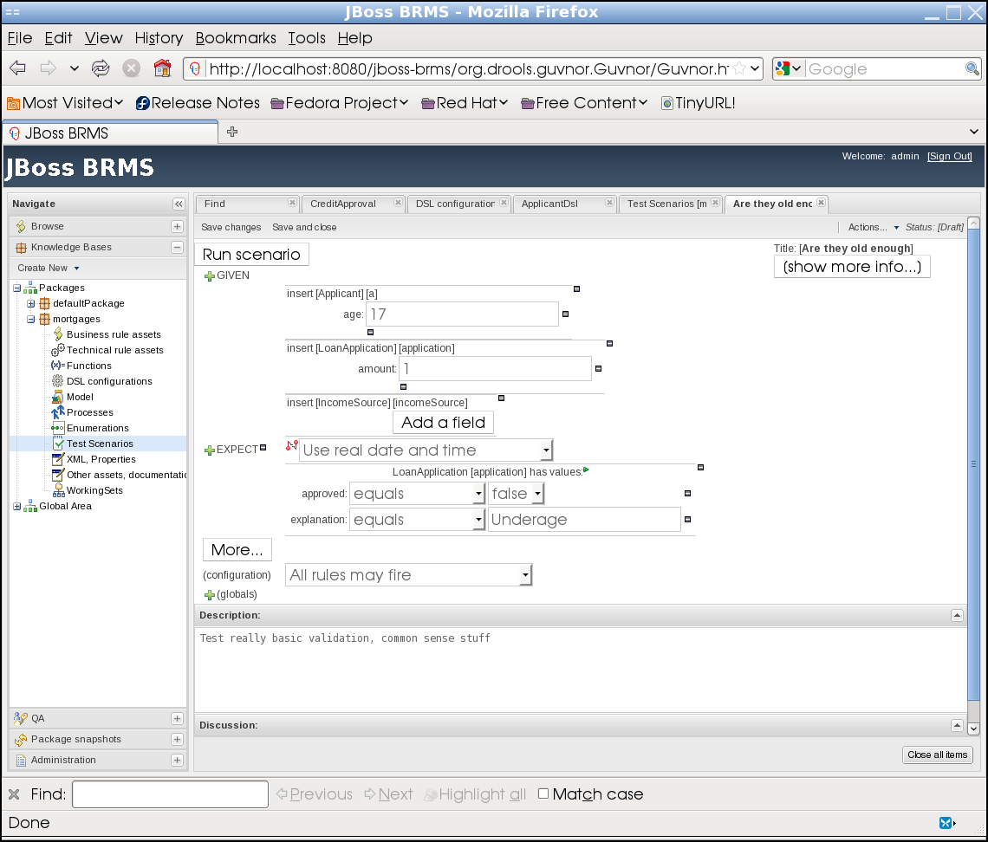
This scenario tests how the rules will fire against an underage (17-year old) applicant. The expected result of the test is that the approved value will be false and the explanation will be Underage.
Select the Run Scenario button. The result of the test should return as 'successful' (that is, the result matched the expected results mentioned previously).

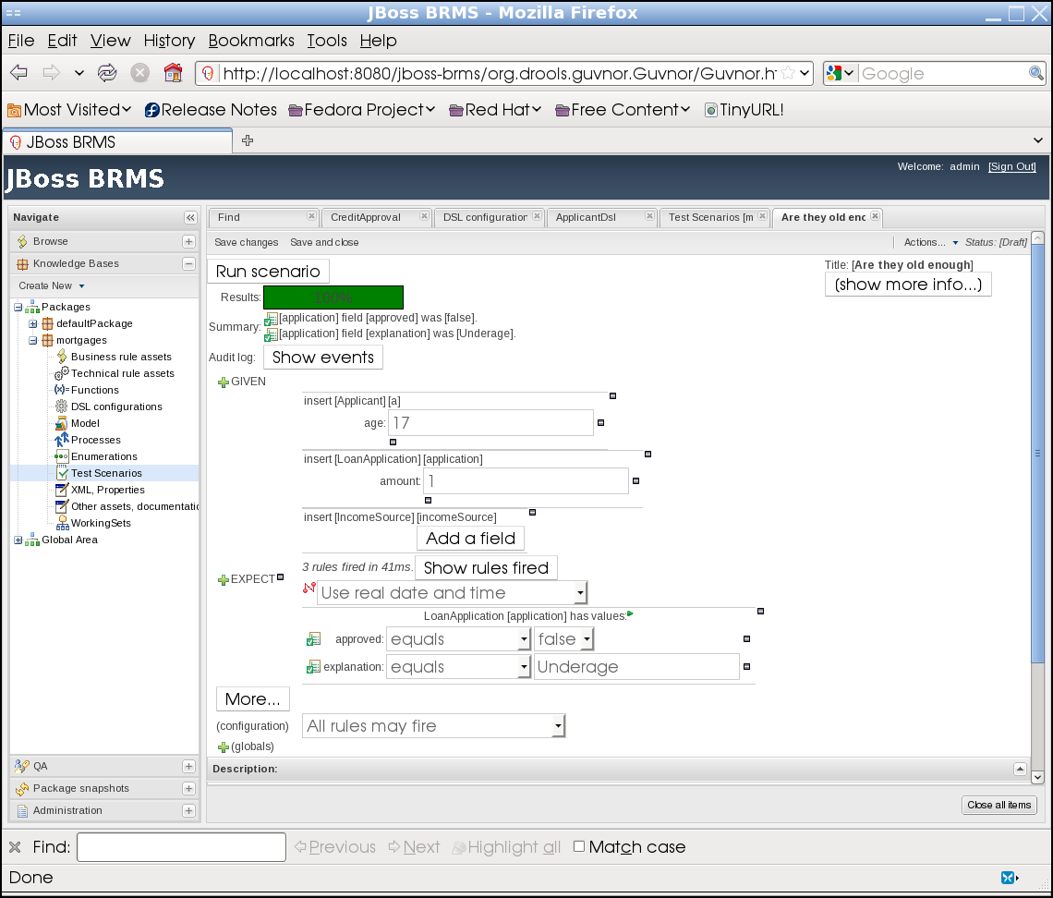
Note the green bar (indicating that all rules fired successfully) and the results of the rule firings below the bar.
You may directly modify the test scenario conditions and re-execute Run scenario to test against similar conditions. For instance, try the following:
- Change the age to 22. Notice that the bar turned to 50% red. This is because the expected result of Underage was not found. (Note: Select the Show events button to see a more detailed explanation of how the rules fired.)
- Change the age back to 17, but set the approved value to true.
You can also execute test scenarios by select the QA left-hand tab, then selecting the mortgages package under Test Scenarios in packages:
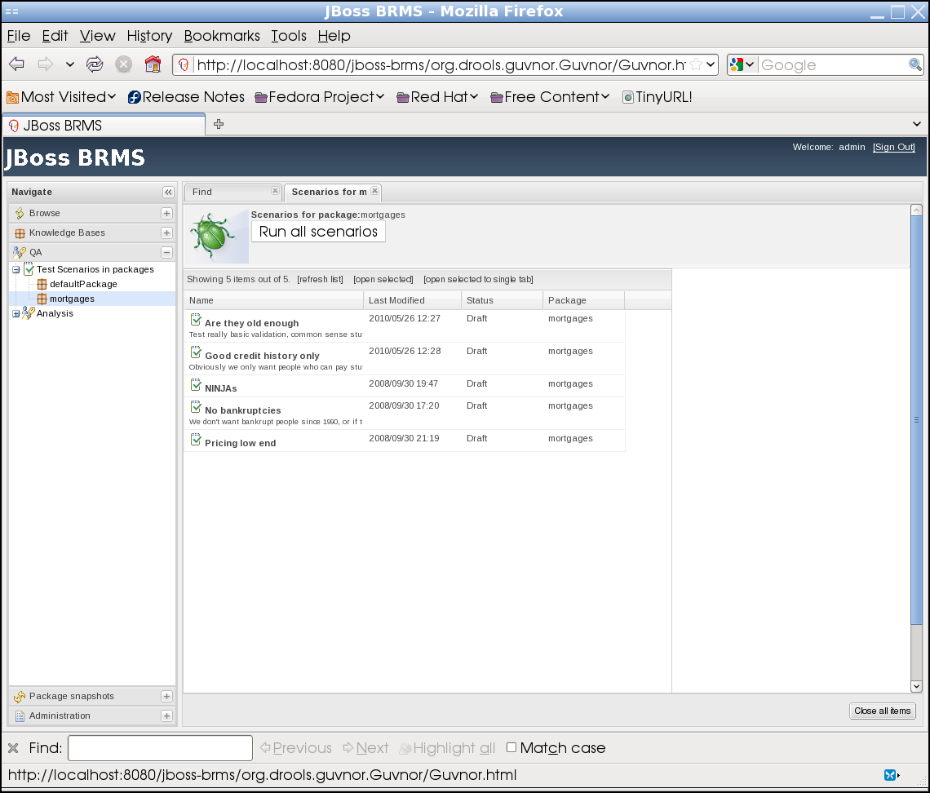
From this screen, you have the option of executing all test scenarios. Select the Run all scenarios button:

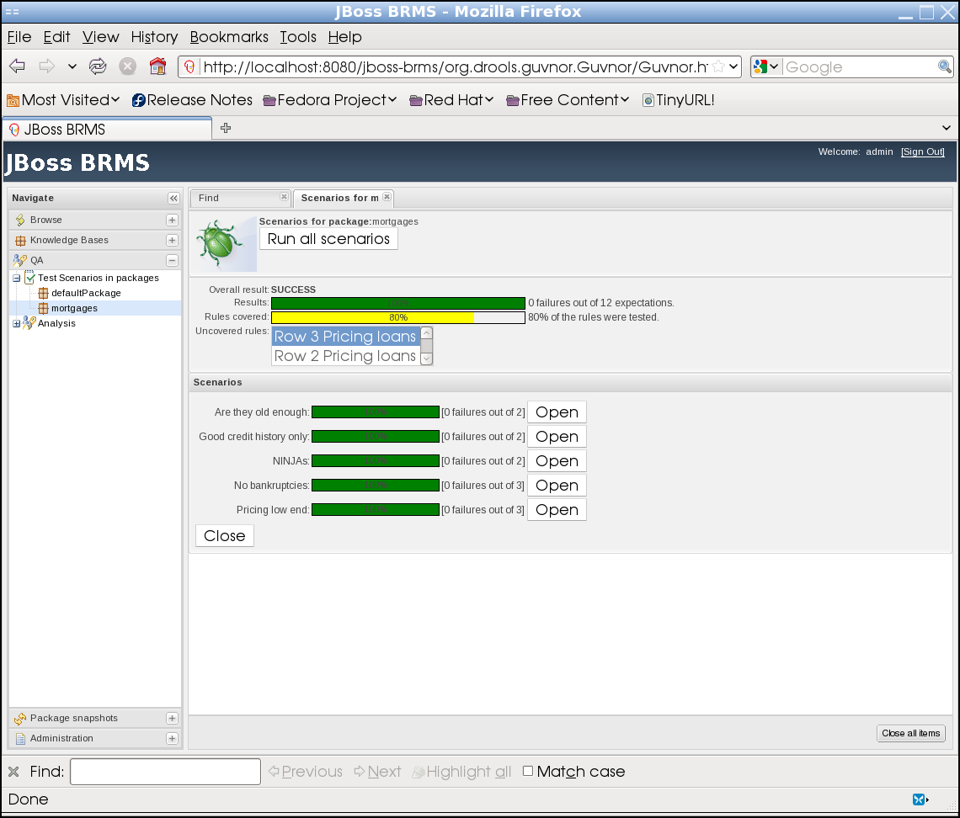
Notice that there were no errors in executing the test scenarios (the green bar), but only 80% of the rules were actually fired (the yellow bar). Below the yellow bar, there are two uncovered rules: Row 3 Pricing loans and Row 2 Pricing loans. Let's create some test scenarios to cover both rules.
Select the Knowledge Bases left-hand tab, then mortgages and Test Scenarios. Double-click on the Pricing low end test scenario. In the upper right corner, select the Actions droplist, then select Copy:

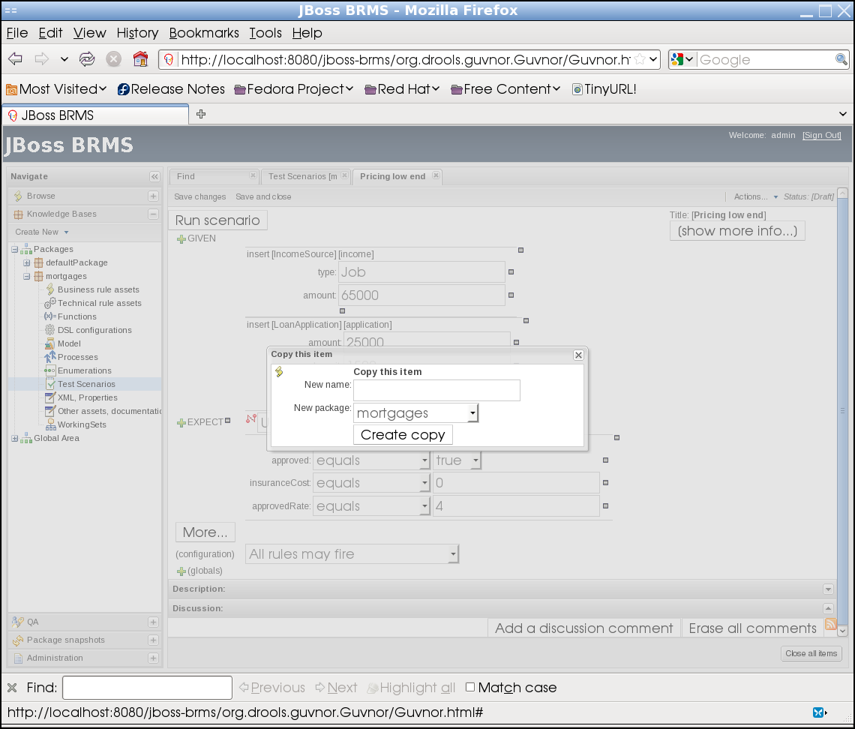
Name this copy as Pricing mid range and select the Create copy button. You will see the following confirmation:

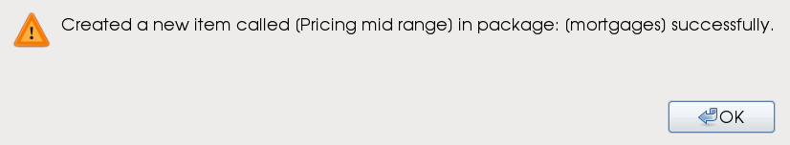
Select OK. Close the recently opened tabs (including Test Scenarios), and reselect the Test Scenarios asset under mortgages. (You may also instead select the refresh list link near the upper left-hand corner of the test scenario.) You will now see the new Pricing mid range test scenario:

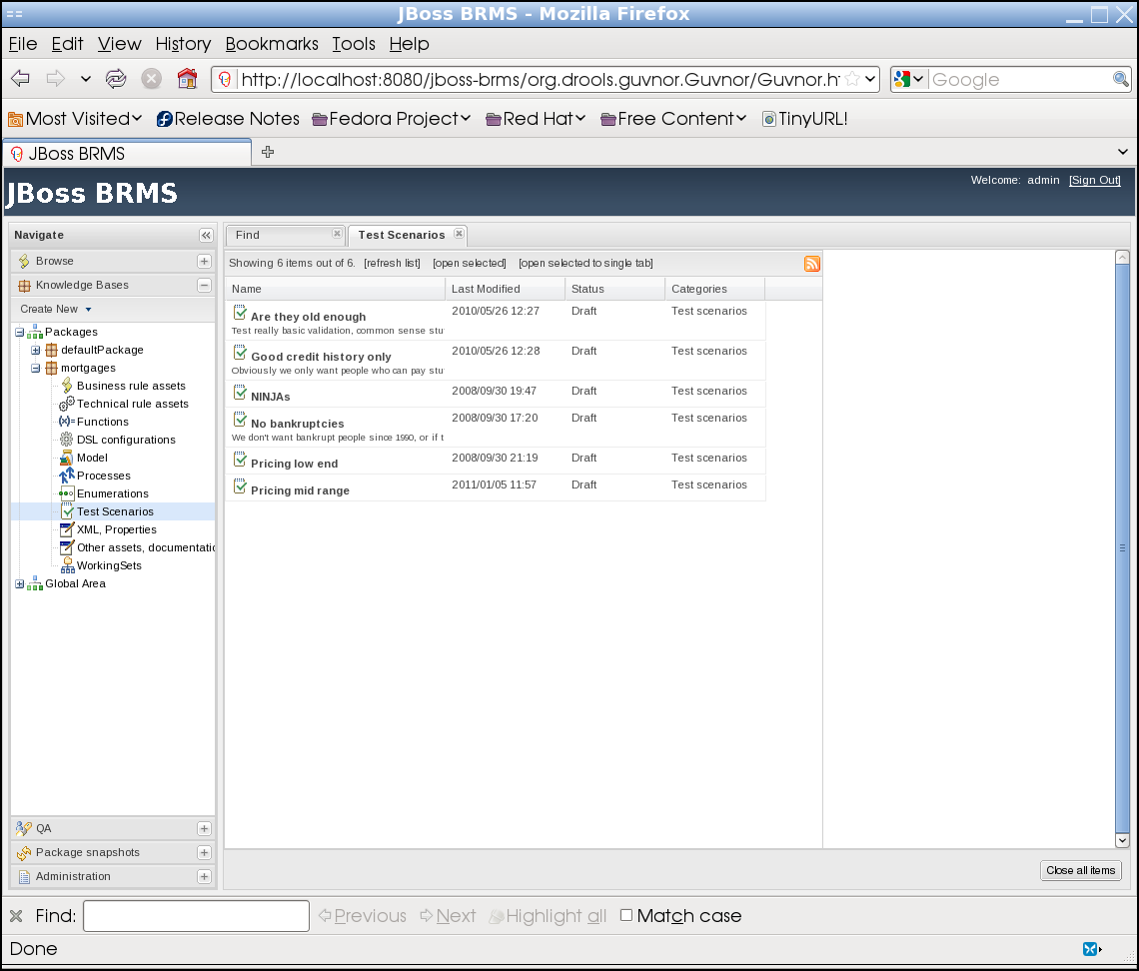

Double click on the Pricing mid range test scenario:
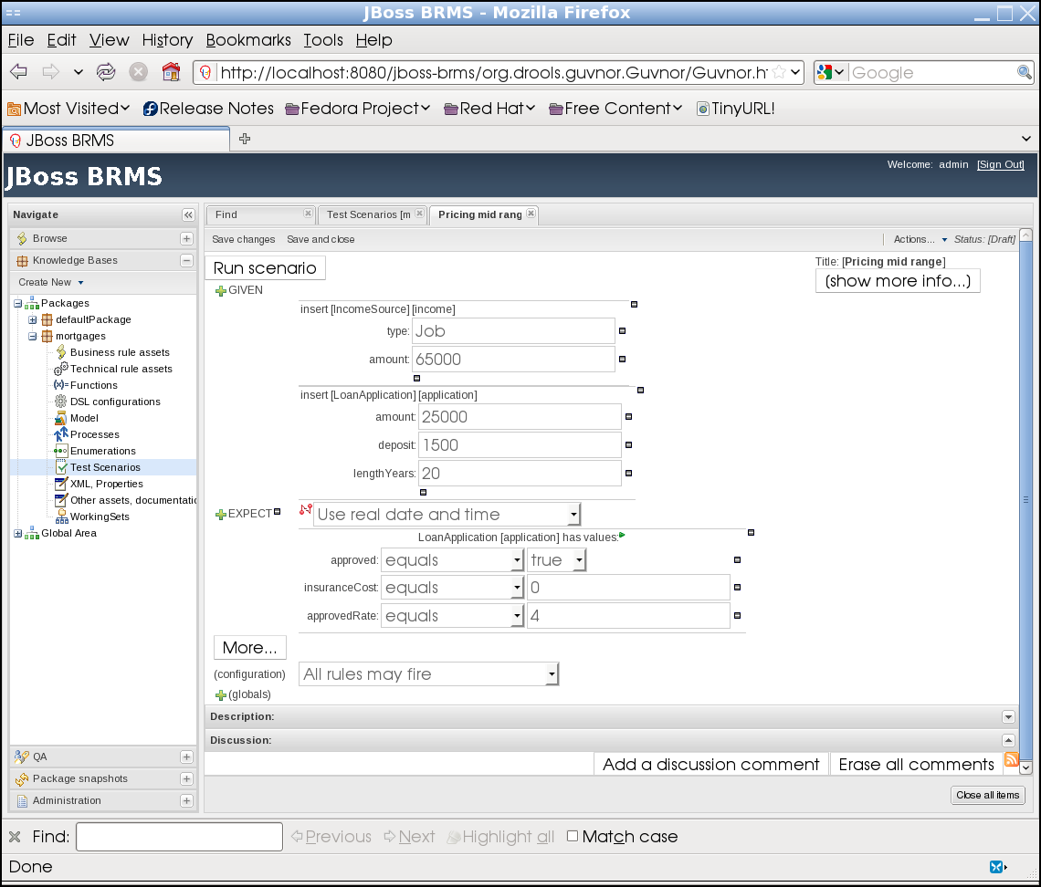

Modify the copied scenario with the following changes:
- Under the GIVEN section, change the amount field of the LoanApplication fact to 110000
- Under the EXPECT section, change the insuranceCost value to 10
- Under the EXPECT section, change the approvedRate value to 6
Your scenario should now look like this:

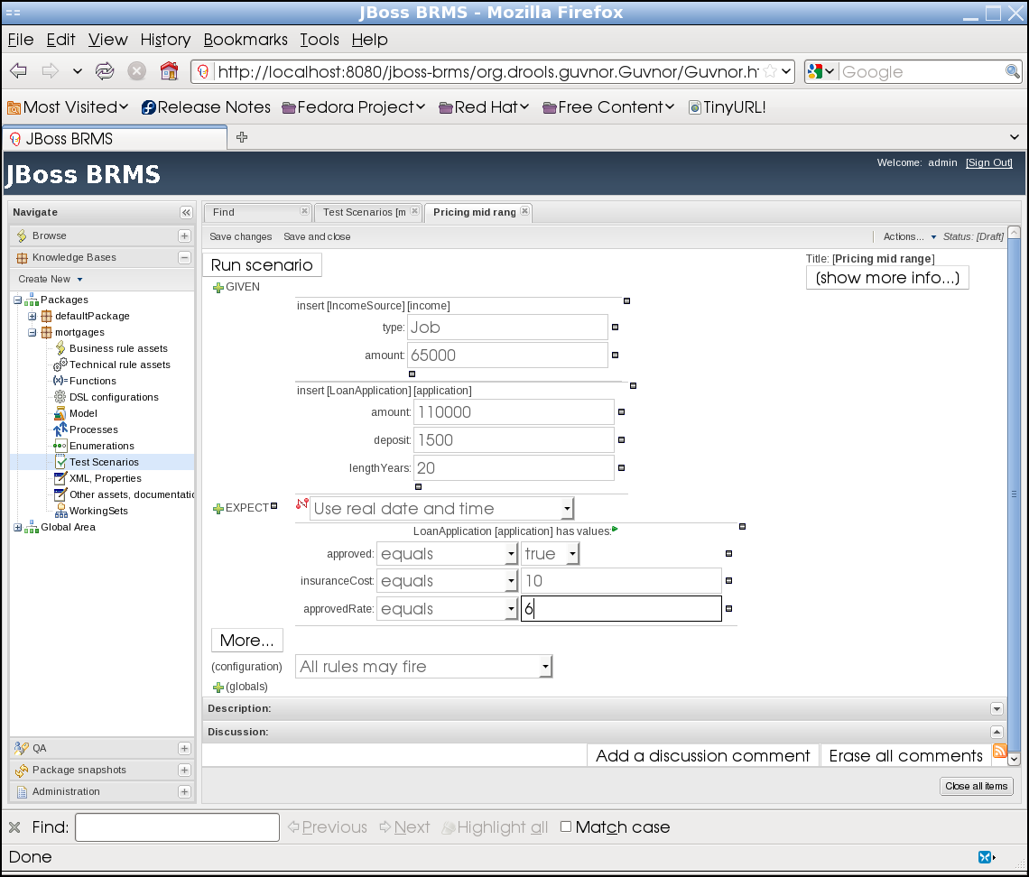

Select the Save changes button. You will be asked to enter a reason for checking in your changes. Enter something similar to below and select Check in:
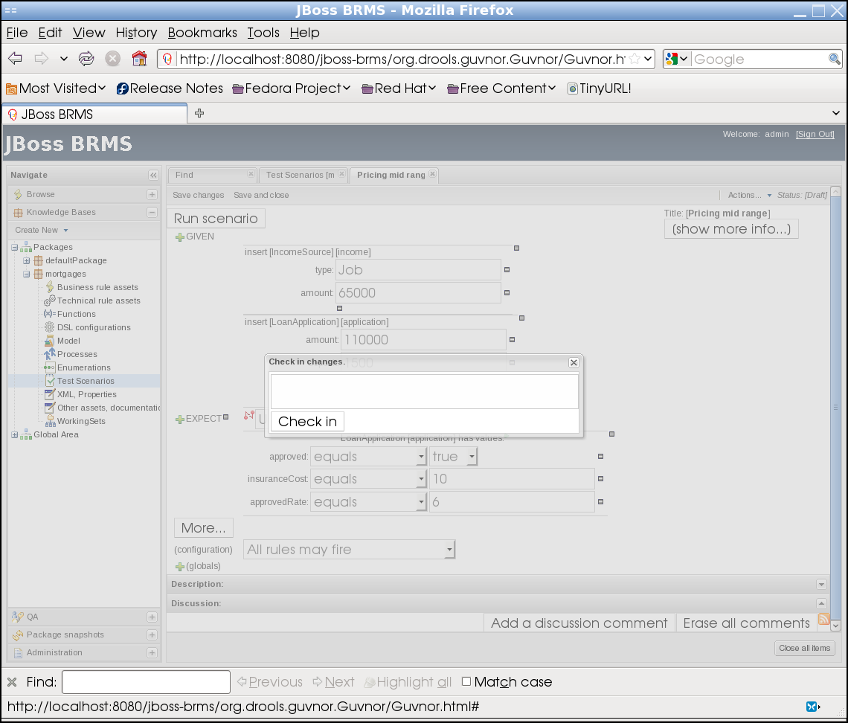
Select the Run scenario button. You will see that the scenario executes properly (indicated by the green bar):

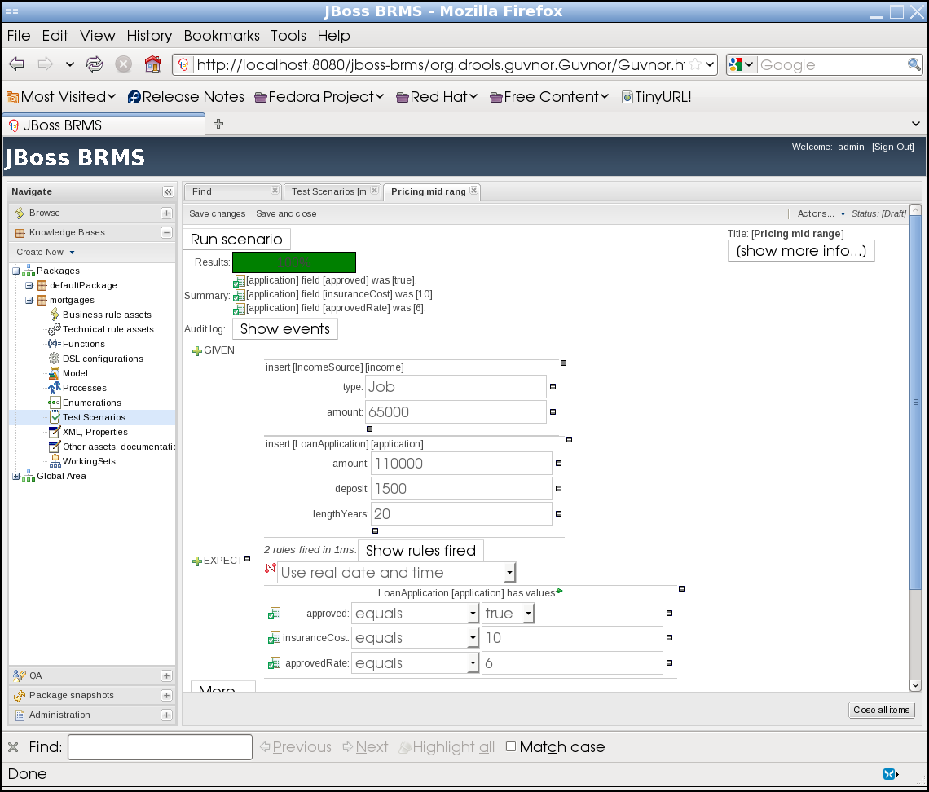
Now, repeat the same process for another test scenario called Pricing high end. (Begin by copying from the newly created test scenario.) Make the following modifications:
- Under the GIVEN section, change the type field of the IncomeSource fact to Asset
- Under the GIVEN section, change the amount field of the LoanApplication fact to 140000
- Under the GIVEN section, change the lengthYears field of the LoanApplication fact to 30
- Under the EXPECT section, change the insuranceCost value to 0
- Under the EXPECT section, change the approvedRate value to 2
Your changes should like as below:

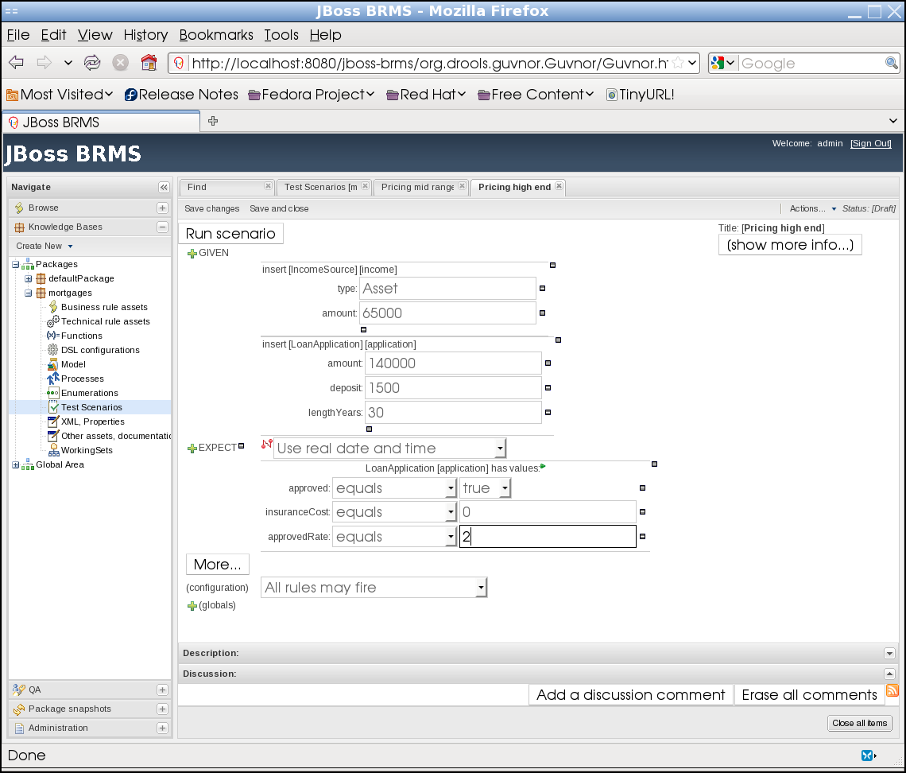

Save the changes, then execute Run scenario. You should see the test results return as successful.
Return to the QA left-hand tab, select mortgages, then select the Run all scenarios button. You should now see the test scenarios completely cover all rules in the mortgages package:

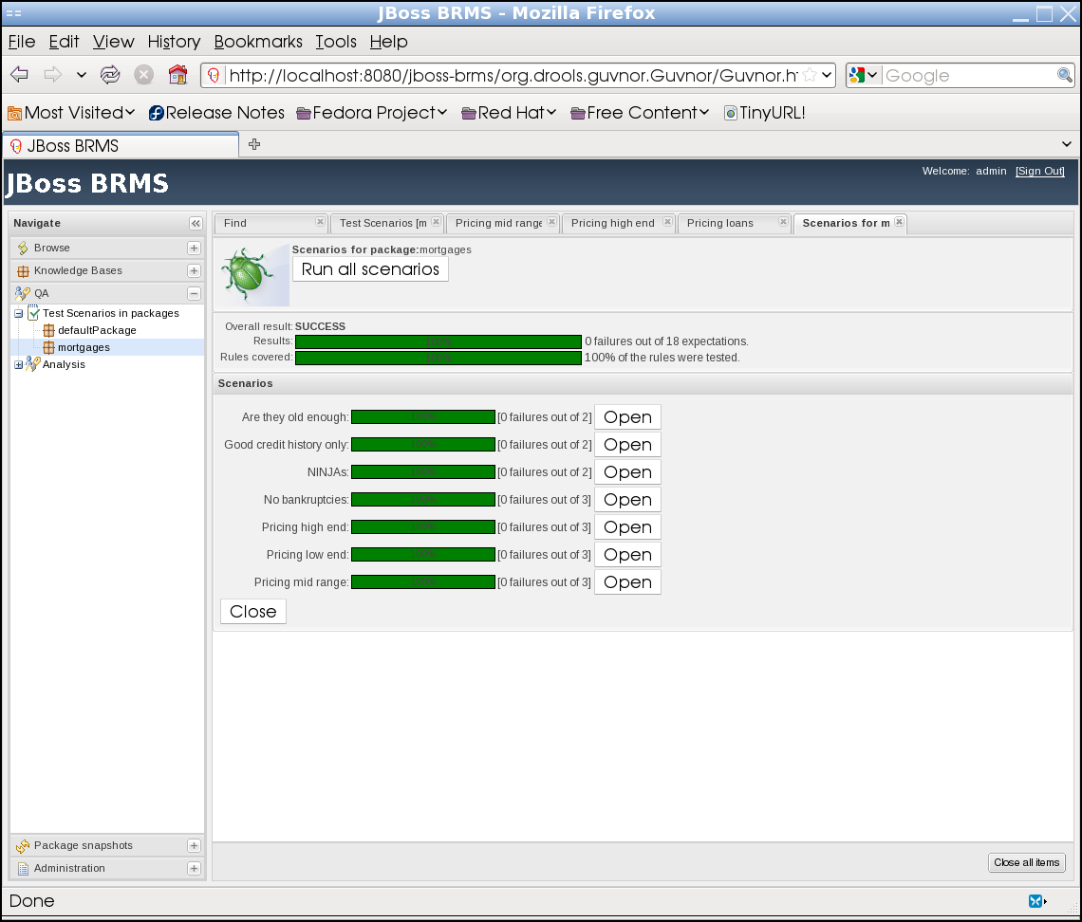

Though you now have complete coverage for your rules, are the testing scenarios themselves adequate for package? To confirm, open the Analysis link on the left-hand QA tab, and select the mortgages link. The following will appear:

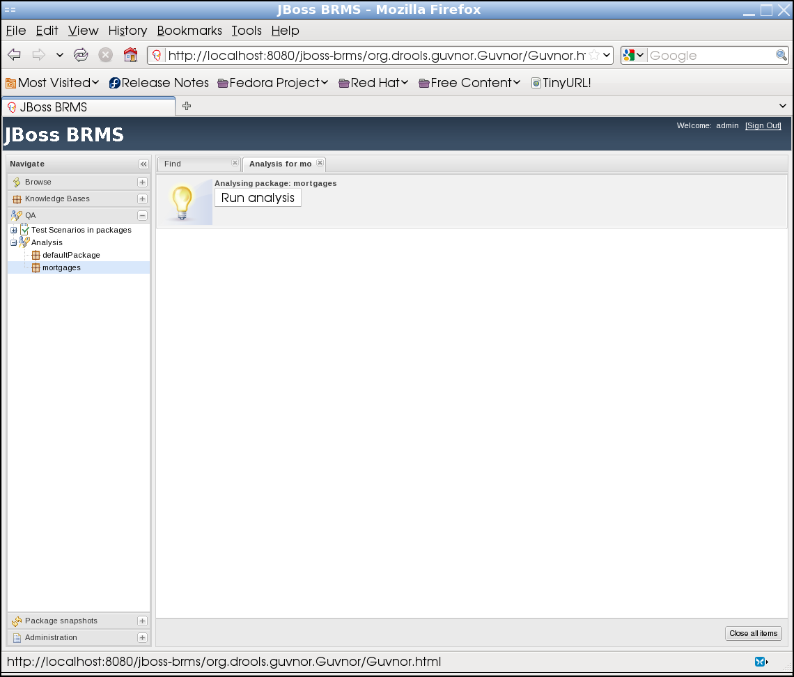

Select the Run analysis button to execute an analysis of your rule package. The results are below:

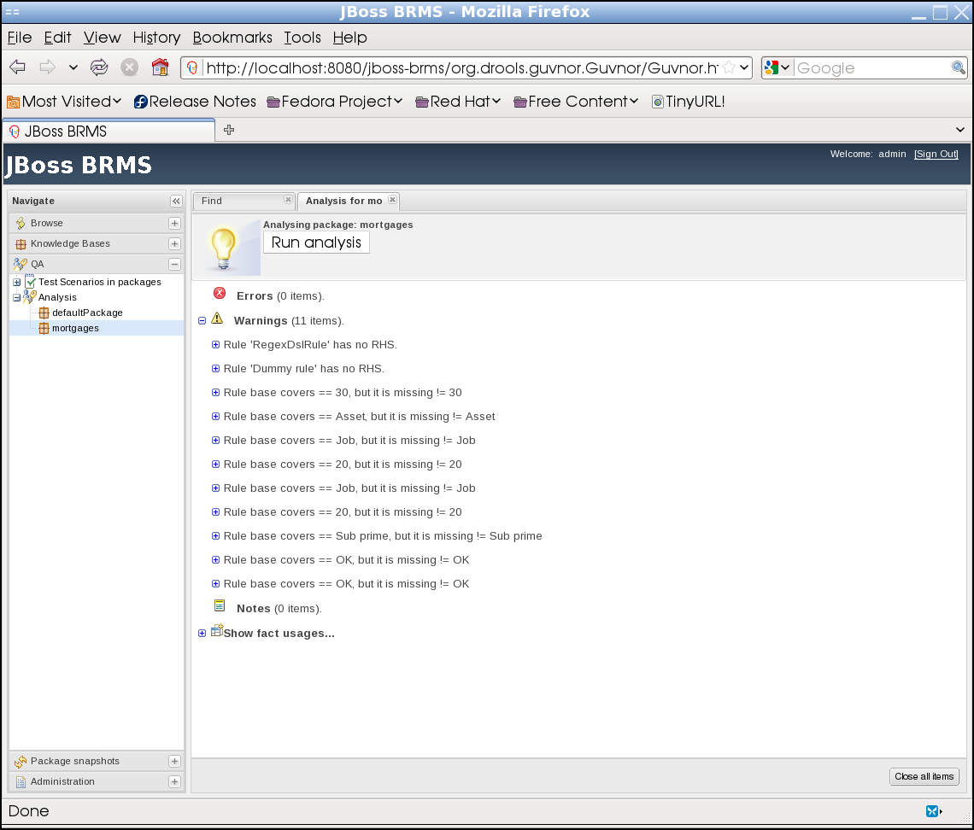

The results provide a detailed description of warnings, notes, and fact usage across your rule package. Peruse the results to familiarize yourself with how this feature can assist in analyzing your rule set.

Package/Version Control
Finally, let's look at BRMS package and version control. Select the Package snapshots left-hand tab, and open the mortgages link. Two packages will appear (poorly named): TEST and ANOTHER. These represent snapshots in time of the entire mortgages package. Typically, you would name these packages will either a version and/or date to maintain more fine-grained control.
Select the TEST package snapshot. You will see the following:

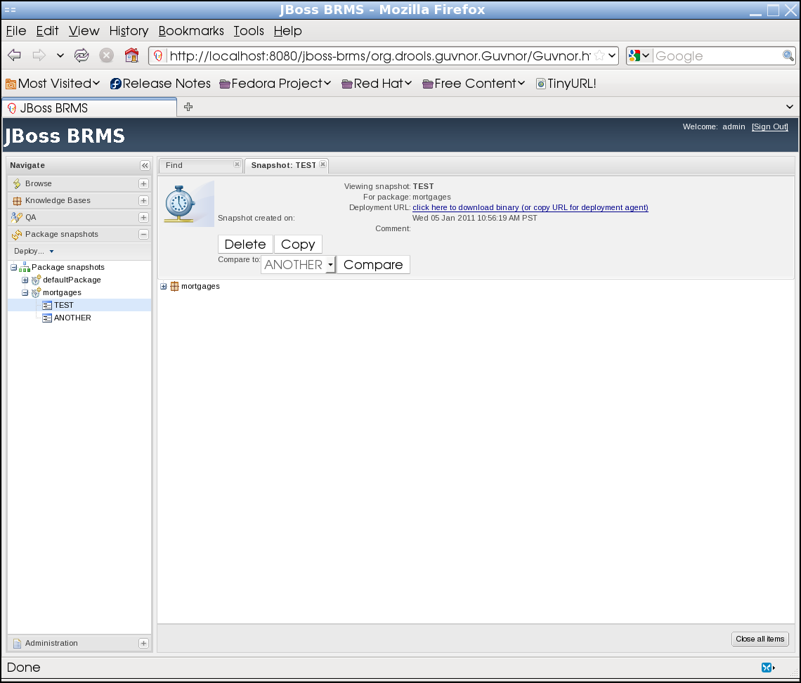
Open the mortgages link and peruse the package snapshot. This will allow you to view the mortgages package as it appeared in a particular point in time.
To create a snapshot of your existing package, select the Deploy... droplist right below the Package snapshots tab name, and select New Deployment snapshot. You will see the following:

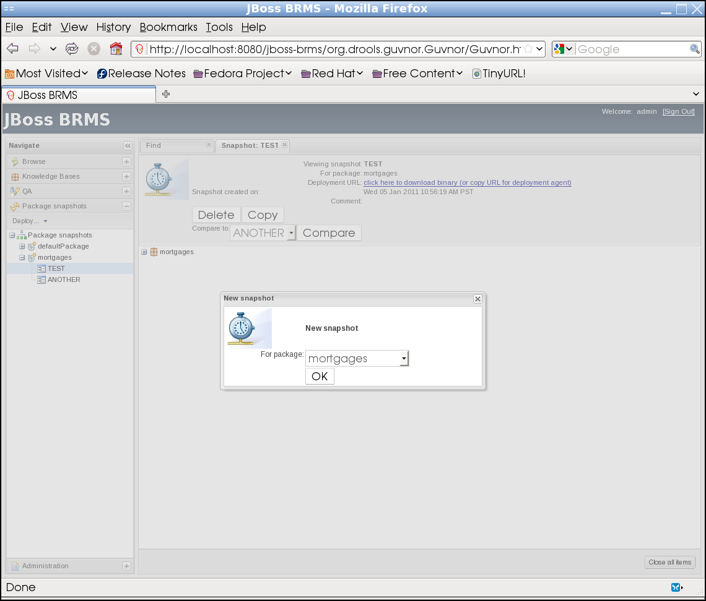

From the droplist, ensure the mortgages should be selected to create a snapshot of the mortgages package, and select the OK button. At this point, you will be asked to name the snapshot:

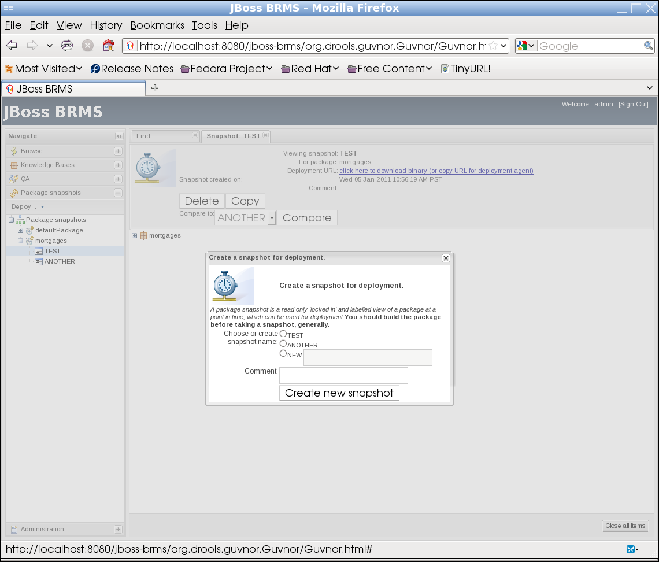

Select the NEW radio button, enter an appropriate name (like “mortgages_2010-10-29”) and optionally enter any comments for this snapshot. Select the Create new snapshot button. You will see the following confirmation:

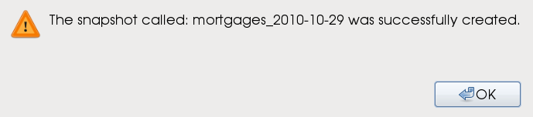
Close and open the mortgages link on the left-hand tab (to refresh), and you will see your new package snapshot.

What Now?
Now that you have completed the BRMS Quickstart guide, you have several resources to assist you in becoming a BRMS professional:
- Call visit https://www.redhat.com/support or call 1-888-GO-REDHAT to get assistance from our 24/7 customer support team. You will need an active subscription to the JBoss BRMS to access customer support.
- Visit the BRMS documentation page at http://docs.redhat.com and select the JBoss Enterprise BRMS link to the left. This provides user guides and rules reference guides for an in-depth understanding of the BRMS Manager and Rules Engine.
- Visit http://engage.jboss.com/forms/jboss-contact-sales to contact a sales representative to assist you in either a subscription or supported evaluation of BRMS.

