ArjunaCore Installation GuideMark LittleAndrew DinnJonathan HallidayMisty Stanley-JonesJBoss.orgJBoss, Inc.

ArjunaCore Installation Guide

Instructions for installing ArjunaCore 4.12.0 on Linux, UNIX, and Windows servers.

Authors

- Mark Little
- Andrew Dinn
- Jonathan Halliday

Copyright
Copyright 2009 JBoss, Inc.

About This Guide

What This Guide Contains
The Installation Guide contains information on how to use ArjunaCore 4.12.0.

Audience
This guide is most relevant to engineers who are responsible for installing ArjunaCore 4.12.0.

Prerequisites
None

Document Conventions
The following conventions are used in this guide:
Convention | Description
Italic | In paragraph text, italic identifies the titles of documents that are being referenced. When used in conjunction with the Code text described below, italics identify a variable that should be replaced by the user with an actual value.
Bold | Emphasizes items of particular importance.
Code | Text that represents program code.
File > Open | A path to a function or dialog box within an interface. For example, File > Openindicates that you should select the Open function from the file menu.
( ) and | | Parentheses enclose optional items in command syntax. The vertical bar (pipe) separates syntax items in a list of choices. For example, any of the following three items can be entered in this syntax: persistPolicy (Never | OnTimer | OnUpdate | NoMoreOftenThan)
Note:  or | A note highlights important supplemental information. A warning highlights procedures or information that is necessary to avoid damage to equipment, damage to software, loss of data, or invalid test results.

Additional Documentation

- ArjunaCore 4.12.0 Release Notes: Provides latebreaking information about ArjunaCore 4.12.0.
- ArjunaCore 4.12.0 Administration Guide: This guide provides instructions for administering ArjunaCore 4.12.0.
- ArjunaCore 4.12.0 Programmer’s Guide: Provides guidance for writing applications.

Contacting Us
Questions or comments about ArjunaCore 4.12.0 should be directed to our support team.

Preparing your system

Before installing the ArjunaCore software, we recommend the following administrative steps be taken, assuming a default configuration for ArjunaCore:

- Install the distribution into the required location.
- ArjunaCore requires a minimum object store for storing the outcome of transactions in the event of system crashes. The location of this should be specified in the properties file using the com.arjuna.ats.arjuna.objectstore.objectStoreDir environment variable, e.g., java - Dcom.arjuna.ats.arjuna.objectstore.objectStoreDir=C:\temp foo.
- By default, all object states will be stored within the defaultStore subdirectory of the object store root, e.g., /usr/local/Arjuna/TransactionService/ObjectStore/defaultStore. However, this subdirectory can be changed by setting the com.arjuna.ats.arjuna.objectstore.localOSRoot property variable accordingly.

Installing and uninstalling services - Windows

There are four scripts provided which will install/uninstall the recovery manager and transaction server services, these files can be found in Services\bin\windows. You must be logged in as an administrator or have administrator privileges to install and uninstall services.

- Recovery Manager
  - InstallRecoverymanagerService-NT.bat - running this script will install the Recovery manager as a Windows service.
  - UninstallRecoveryManagerService-NT.bat - running this script will uninstall the Recovery Manager as a Windows service
- Transaction Service
  - InstallTransactionServerService-NT.bat - running this script will install the Transaction Manager as a Windows service.
  - UninstallTransactionServerService-NT.bat - running this script will uninstall the Transaction Server as a Windows service.
- After running one of the scripts, you should see a message that indicates its success or failure.
- The service should also be visible in the services list from the Control Panel. 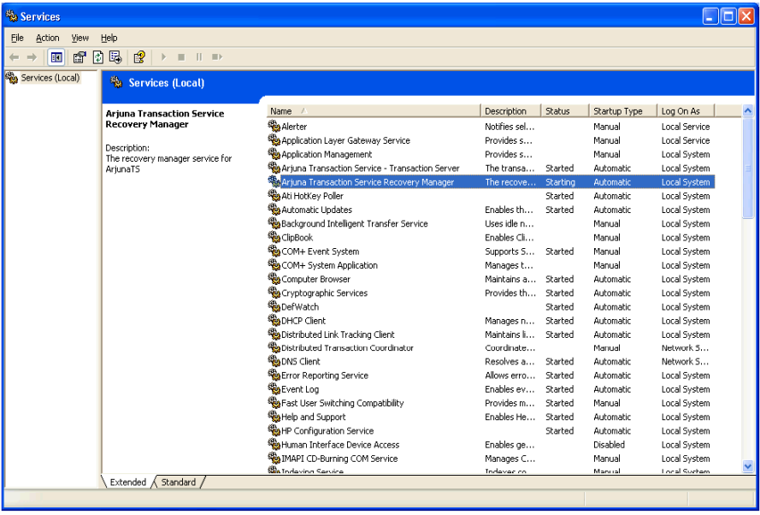

Installing services - UNIX

- Make sure that you are logged in as the user `root', as the installer needs to create files under the directory /etc.
- Change directory to services/installer.
- Make sure the environment variable JAVA_HOME is set to the home directory of the JVM you wish the services to be run as.
  - JAVA_HOME=/opt/java; export JAVA_HOME (for sh)
  - setenv JAVA_HOME /opt/java (for csh)
- Run the installer script: ./install_services.sh
- The following is example output from a computer running the Solaris operating system:
- Adding $JAVA_HOME (/opt/java) to $PATH in
- /opt/arjuna/ats-3.2/services/bin/solaris/recoverymanagerservice.sh
- Adding $JAVA_HOME (/opt/java) to $PATH in
- /opt/arjuna/ats-3.2/services/bin/solaris/transactionserverservice.sh
- Installing shutdown scripts into /etc/rcS.d:
- K01recoverymanagerservice
- K00transactionserverservice
- Installing shutdown scripts into /etc/rc0.d:
- K01recoverymanagerservice
- K00transactionserverservice
- Installing shutdown scripts into /etc/rc1.d:
- K01recoverymanagerservice
- K00transactionserverservice
- Installing shutdown scripts into /etc/rc2.d:
- K01recoverymanagerservice
- K00transactionserverservice
- Installing startup scripts into /etc/rc3.d:
- S98recoverymanagerservice
- S99transactionserverservice

Upon restarting the computer the transaction server and recovery manager service should be started.

Uninstalling a service - UNIX

- Make sure that you are logged in as the user root, as the installer needs to remove files under the directory /etc.
- Change directory to services/installer.
- Run the installer script with the "u" argument:./install_services.sh -u
- The following is example output from a computer running the Solaris operating system:
- Removing startup scripts from /etc/rc3.d:
- S98recoverymanagerservice
- S99transactionserverservice
- Removing shutdown scripts from /etc/rcS.d:
- K01recoverymanagerservice
- K00transactionserverservice
- Removing shutdown scripts from /etc/rc0.d:
- K01recoverymanagerservice
- K00transactionserverservice
- Removing shutdown scripts from /etc/rc1.d:
- K01recoverymanagerservice
- K00transactionserverservice
- Removing shutdown scripts from /etc/rc2.d:
- K01recoverymanagerservice
- K00transactionserverservice

Logging

The recovery manager and the transaction server services produce log files which are located in the services/logs/ directory. There are two log files per service one called <service name>-service.log (e.g. recovery-manager-service.log), which contains information regarding the state of the service (e.g. started, stopped, restarted etc). The other is called<services-name>.log (e.g. recovery-manager.log) this contains information logged from the actual service (e.g. application level logging). To configure what information is logged in these files please edit the appropriate LOG4J configuration files which are located inservices/config/.

ObjectStore Management

Within the transaction service installation, the object store is updated regularly whenever transactions are created, or when Transactional Objects for Java is used. In a failure free environment, the only object states which should reside within the object store are those representing objects created with the Transactional Objects for Java API. However, if failures occur, transaction logs may remain in the object store until crash recovery facilities have resolved the transactions they represent. As such it is very important that the contents of the object store are not deleted without due care and attention, as this will make it impossible to resolve in doubt transactions. In addition, if multiple users share the same object store it is important that they realize this and do not simply delete the contents of the object store assuming it is an exclusive resource.

Additional jar requirements

In order to fully utilize all of the facilities available within ArjunaCore, it will be necessary to add all of the jar files contained in the lib directory of the distribution.

Setting Properties

ArjunaCore has been designed to be highly configurable at runtime through the use of various property attributes, which will be described in subsequent sections. Although these attributes can be provided at runtime on the command line, it is possible (and may be more convenient) to specify them through a single properties file. At runtime ArjunaCore looks for the file jbossts-properties.xml in the following order:

- the current working directory, i.e., where the application was executed from.
- the user’s home directory.
- the etc directory of the ArjunaCore installation; this must be placed in your CLASSPATH.

If found, all entries within this file will be added to the system properties. Obviously non- ArjunaCore specific properties can also be specified in this file. For example:

<property
name="com.arjuna.ats.arjuna.coordinator.asyncCommit"
value="NO"/>
<property
name="com.arjuna.ats.arjuna.objectstore.objectStoreDir"
value="c:\temp\ObjectStore"/>

The name of the properties file can be overridden at runtime by specifying a new file using the com.arjuna.ats.arjuna.common.propertiesFile attribute variable.

Licensing

ArjunaCore no longer require a license key in order to operate.

