JBoss Developer Studio 2.0 To 2.1 Migration Guide

What is JBDS?

JBoss Developer Studio is a set of eclipse-based development tools that are pre-configured for JBoss Enterprise Middleware Platforms and Red Hat Enterprise Linux.

Developers are not required to use JBoss Developer Studio to develop on JBoss Enterprise Middleware and/or Red Hat Linux; however many find these pre-configured tools offer significant time-savings and
value, making them more productive and speeding time to deployment.

This guide will provide you with detailed info on how to migrate from an existing JBDS 2.0 installation to JBDS 2.1.

Installation From Update Site

If you plan to use JBDS 2.1 with JBoss EAP 5 (http://www.redhat.com/docs/en-US/JBoss_Enterprise_Application_Platform/), you will need to first install Sun JDK 6 (http://java.sun.com/javase/downloads/index.jsp).

Fedora/RHEL users can also use 'yum install java-1.6.0-openjdk-devel' to install OpenJDK 6. Note that gcj/gij is NOT supported.

Start JBDS, then go to Help > Software Updates... > Available Software > Manage Sites... > Add...

Paste in the following URL: https://devstudio.jboss.com/updates/2.1/

Note: On some platforms, you may also be able to drag and drop the link from your browser directly into Eclipse.

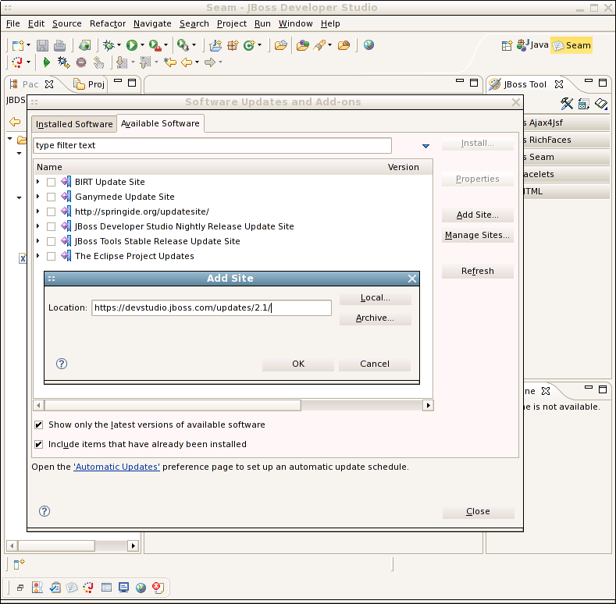
guide/migration-guide_0.png

Enter your username and password. You may be prompted twice.

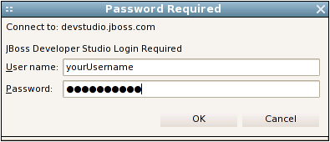
guide/migration-guide_1.png

Select features to update or install, then click Install...

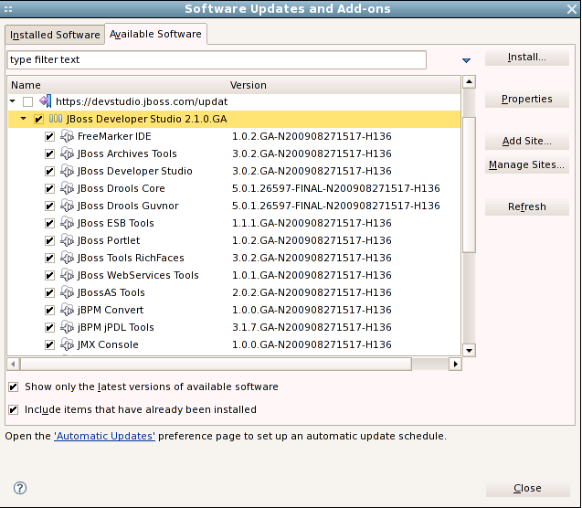
guide/migration-guide_2.png

Install. Restart when prompted.

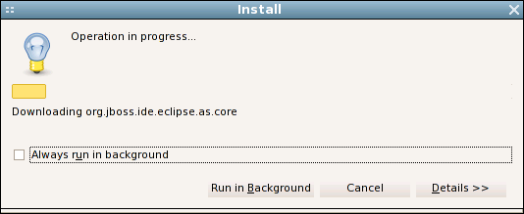
guide/migration-guide_3.png

If the install gets stuck on a particular jar download
(bandwidth saturation, slow mirror, etc.), you can shut down JBDS
and try again.

Ignore any errors you get when starting the second
time - a completed install should resolve them so that when you
restart the third time you will be ready to go.

Enjoy!

Installation of EAP 5 is not covered by this migration guide. See
http://www.redhat.com/docs/en-US/JBoss_Enterprise_Application_Platform/ for full details.

