Edition
1
Hans Dockter
The JBoss Project
JBoss IDE 1.2.0
Quick Start Guide

Hans Dockter, and The JBoss Project
JBoss IDE 1.2.0 : Quick Start Guide

Table of Content
Preface 4
Forward 4
About the Authors 4
Acknowledgments 4
1. Introduction 5
2. JBoss Launch 6
Using the launcher 6
Configuring the servers 6
Debugging 7
Starting JBoss in debug mode 8
Debugging production servers 9
3. Xdoclet Support 10
Code Assist 10
Templates 11
Variables 12
Generation Configuration 13
4. Packaging Support 15
Packaging Configuration 15
5. Deployment Support 17
Deployment Configuration 17

Preface
Preface
i

Forward
The JBoss-IDE started with an XDoclet plug-in for eclipse in the middle of 2002. Then Hans Dockter met Marc as he participated at a JBoss training in Mallorca and they talked about the possibility of developing a JBoss-IDE.

About the Authors
Hans Dockter, is the lead architect of the JBoss-IDE. Hans works as an independent consultant and lives in Berlin, Germany.
Laurent Etiemble, is working as a developper on JBoss-IDE. Laurent works as a consultant and lives in Paris, France.
JBoss Project, headed by Marc Fleury, is composed of over 100 developers worldwide who are working to deliver a full range of J2EE tools, making JBoss the premier Enterprise Java application server for the Java 2 Enterprise Edition platform.
JBoss is an Open Source, standards-compliant, J2EE application server implemented in 100% Pure Java. The JBoss/Server and complement of products are delivered under a public license. With a huge amount of downloads per month, JBoss is the most downloaded J2EE based server in the industry.

Acknowledgments
I’d like to thank Thomas Deichsel and Frank Henze from media-style.com for their wonderful interface design.

Introduction
Chapter
1
JBoss-IDE offers you:
- A very comfortable and sophisticated support for XDoclet.
- The debugging and monitoring of JBoss servers and the controlling of there life cycles.
- An easy way to configure the packaging layout of archives (packed or exploded)
- A simple way to deploy the packaged and/or exploded archive to a JBoss server
Some part of the J2EE development process is not yet covered. That is J2EE specific project management (templates and wiazrds). This has still to be done. Anyway, the main focus for the next version is on these topics.

JBoss Launch
Chapter
2
The JBoss-IDE offers you an easy way to launch a JBoss server inside Eclipse or to connect a remote one. Here are the main features:
- Configure as many servers as one likes
- Launch, shutdown or terminate servers from within eclipse or connect to remote ones
- Access the console-output of the servers and monitor their log files

Using the launcher
To use the JBoss-IDE launcher select Windows > Show View > Other > JBoss-IDE > Server Navigator from the main menu bar. The Server Navigator is the control center. Select Windows > Customize Perspective > Other > Default Server to add a menu and buttons to the toolbar for controlling a default server that you can select via Windows > Preferences > Launcher Preferences.
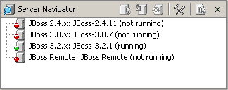
Server Navigator View

Configuring the servers
To configure a particular server choose Configuration from the context menu of the server navigator or Run > Debug from the main menu bar (this only works if you are in a Java perspective).
To add a server you have to select the server-type and choose New via the right-mouse button or the button at the bottom of the tree. The new instance is a node of the server-type. Via selecting this node you can configure this instance. If you configure a JBoss 3.x.x instance you have to choose a JDK as the JRE as JBoss 3.x needs a library that is only contained in the JDK. Anyway, the Launcher will give you notice of that.
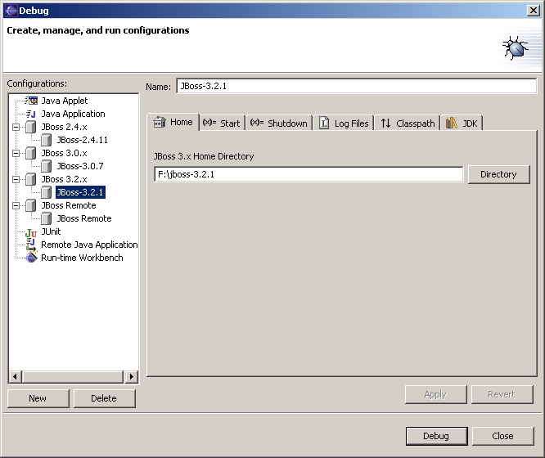
Overview of JBoss servers’ configurations

Debugging
In Sun's JDPA (Java Platform Debugger Architecture) debugging of a JVM is always remote and done via the JDWP (Java Debugging Wireless Protocol). If you debug a Java application from within eclipse the JVM for this application is launched as an own process and the eclipse debugger connects to this JVM via JWDP. In regard to debugging there is no difference between debugging an application started from within eclipse or started outside of eclipse. What is different is that you have a hook to the process if you start from within eclipse and due to that you are capable of controlling the life cycle and the console I/O of the application.
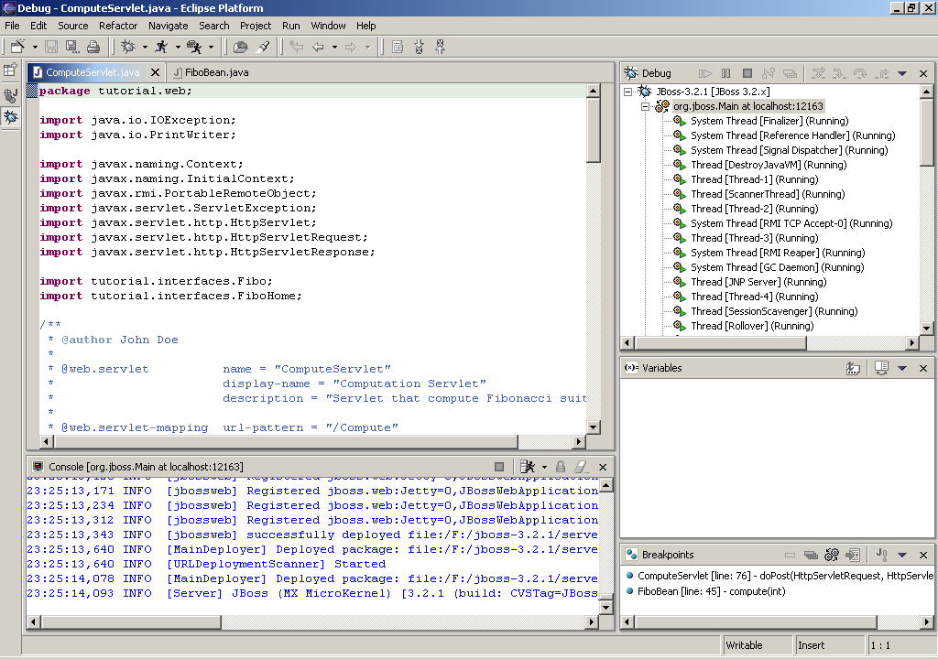
Inside launch of a JBoss 3.2.1 server
Of course if you want to debug an outside application, this application has to be started in debug-mode.

Starting JBoss in debug mode
The JBoss run script has so far defined no argument for starting JBoss in debug mode. Of course a production server shouldn't be launched from within eclipse therefore is has to be started in debug mode by hand. For details see the jdpa docs3. Here are examples for Jboss 3.x.x with Java 1.3.x and 1.4.x:
1.3: java -Djboss.home={jboss-home} -classpath {jboss-home}/bin/run.jar -Xdebug
-Xrunjdwp:transport= dt_socket,server=y,suspend=n,address=10250 org.jboss.Main
1.4: java -Djboss.home={jboss-home} -classpath {jboss-home}/bin/run.jar -Xdebug
-Xrunjdwp:transport= dt_socket,server=y,suspend=n,address=10250 org.jboss.Main
The value for the address is arbitrary; it just has to be unused.

Debugging production servers
Until Java 1.4 starting a Java-app in debug-mode meant deactivating the JIT or HotSpot, which is usually not acceptable for a production server. In Java 1.4 this has changed. Extract from the documentation:
The Java HotSpot[TM] virtual machine now uses "full-speed debugging". In the previous version of HotSpot, when debugging was enabled, the program executed using only the interpreter. Now, the full performance advantage of HotSpot Technology is available to programs running with debugging enabled. The improved performance allows long running programs to be more easily debugged. It also allows testing to proceed at full speed and the launch of a debugger to occur on an exception ... Setting a breakpoint only inhibits compilation (full speed execution) for the method containing the breakpoint. Execution reverts to the interpreter during some debug operations such as single-stepping and when method entry/exit or watchpoints are set.
As of version 1.4.1, full-speed debugging is available with both the Java HotSpot Client Vm (default) and Java HotSpot Server VM (invoked with the -server command-line flag). In the Java 2 SDK v1.4.0, full-speed debugging was available only with the Java HotSpot Client VM.
This is great news as it allows debugging of production servers. There is the limitation that only one debugger at a time can connect to the debugged JVM.

Xdoclet Support
Chapter
3
The XDoclet support offers you:
- A code assist with context dependent proposals
- Ability to defined user-defined templates
- A graphical front end to configure the XDoclet configurations
- Ability to add any doclet or subtask and configure their attributes
- Ability to activate/deactivate configurations with check boxes

Code Assist
If you are in the Java editor and within a Javadoc environment, when you activate the code assist via CTRL+Space you get a set of proposals, which belong to 4 categories:
- Javadoc tag
- Eclipse javadoc template
- XDoclet namespace tag
- XDoclet template
If the code assist is used at a cursor position after a valid XDoclet structure an appropriate proposal is given to you. If the XDoclet structure is invalid no auto completion by the code assist takes place and the auto completion is passed to the standard eclipse auto completion processor. If the XDoclet structure is valid but there is no possible auto completion, nothing happens except a beep. For an example of code assist, see figure below.
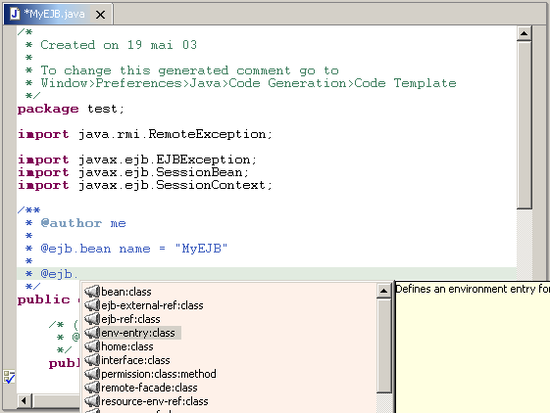
Example of code assist
The proposals made by the code assist do depend on the context you are in. Examples are the type of the current class, if the cursor is positioned in the javadoc of a method, what kind of method, etc. The conditions that determine this are defined in the xtags.xml of the particular XDoclet module. Some xtags.xml files are contradictory in the information they give in regard to the context the elements apply to. And if for example the level tag of an element says class and the condition tag says method the code assist can’t solve this. These are bugs in the xtags.xml!
Values can be variables. For example the proposed value for the attribute @ejb.bean jndi-name is computed out of the classname. If the classname is AddressBean the offered proposals are Address and AddressBean. The values are computed with a regular expression applied to the actual classname. You can change the regular expression to your need. See Subsection Variables.

Templates
If you select Windows > Preferences > JBoss-IDE > XDoclet > Assist > Templates you can define your templates. You have to pay attention that the selected elements don’t apply to different conditions, for example one is only valid for a method the other only for a class.
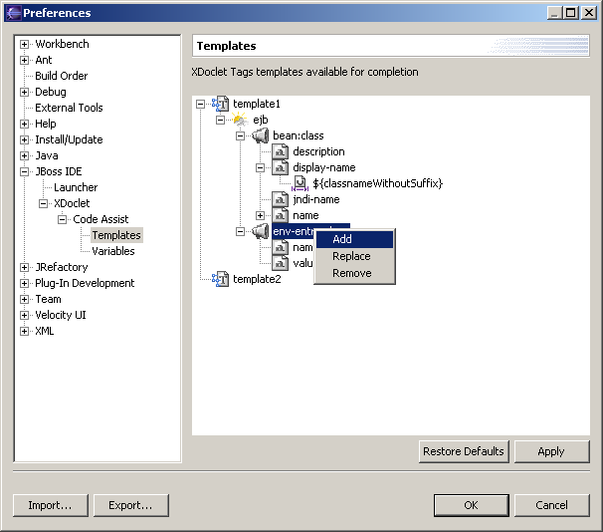
Definition of custom templates

Variables
If you select Windows > Preferences > JBoss-IDE > XDoclet > Assist > Variables you can change the regular expressions, which belong to a certain variable. Quite likely that the only change that might be interesting for you applies to the expression for the variable Classname Subset and change the word Bean to something else. If you change the expressions more deeply you have to take into consideration that the value that is used by the code assist is the group(1) result after applying the expression to the system variable.
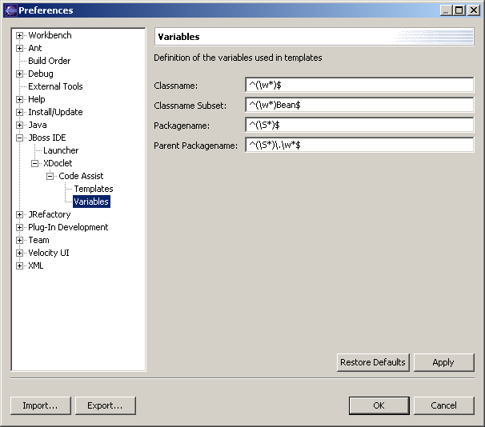
Modification of variables used for proposal

Generation Configuration
JBoss-IDE provides a nice view to configure the way XDoclet will be run on a project. A project can have many generation configurations, and each one of them can be enabled or disabled by simply clicking on a check box. An example of generation configuration for a Java project is above.
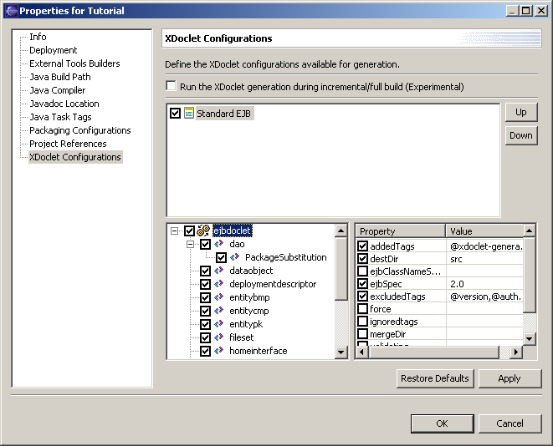
Overview of the generation configuration
To define a generation configuration, simply right click in the upper space. You can create configuration from scratch or use a set of predefined configurations.
All the generation configurations checked will be transformed into an Ant build file which can be run inside or outside Eclipse. Right click on the Project, and you will see the following popup menu:
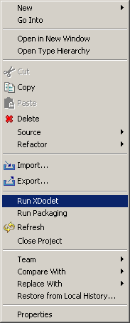
Project contextual menu with the Run XDoclet item
Clicking of this item will launch Ant on the generation configuration previously setup.

Packaging Support
Chapter
4
The Packaging support offers you:
- A graphical front end to configure the packaging
- Definition of packed or exploded packaging configuration
- Inclusion of any file or folder inside the workspace or in the file system
- Ability to set-up prefix for fined grained packaging layout
- Ability to activate/deactivate configuration with check boxes

Packaging Configuration
JBoss-IDE provides a nice view to configure the way packaging will be run on a project. A project can have many packaging configurations, and each one of them can be enabled or disabled by simply clicking on a check box. An example of packaging configurations for a Java project is above.
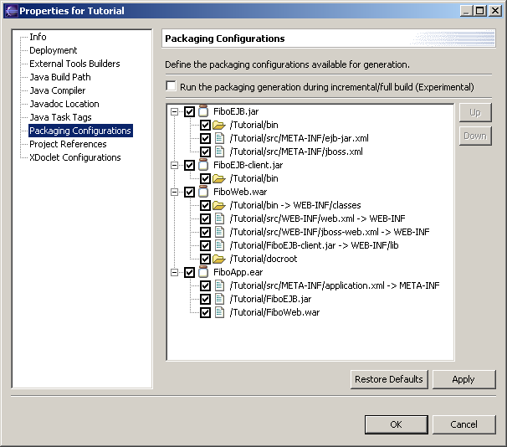
Overview of the packaging configuration
To define a packaging configuration, simply right click in the area. You can create configuration from scratch or use a set of predefined configurations.
All the packaging configurations checked will be transformed into an Ant build file, which can be run inside or outside Eclipse. Right click on the Project, and you will see the following popup menu:
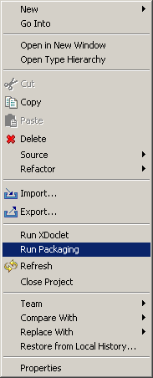
Project contextual menu with the Run Packaging item
Clicking of this item will launch Ant on the packaging configuration previously setup.

Deployment Support
Chapter
5
The Deployment support offers you:
- A graphical front end to configure the deployment targets
- Automatic definition of file system target from JBoss debug launch configurations
- Definition of user-defined deployment target
- Deployment/Redeployment/Undeployment of any resource of the workspace
- Decorator to tell that the resource is deployed

Deployment Configuration
JBoss-IDE provides a nice view to configure the deployment targets that will be available. If you select Windows > Preferences > JBoss-IDE > Deployer you can see and define your own deployment targets in addition to those that are automatically defined from the launch configurations.
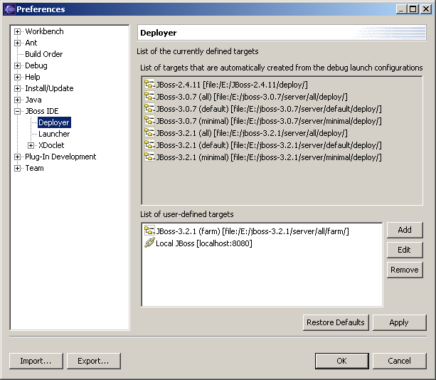
Overview of the deployment configuration
To define a deployment target, simply use the buttons on the right.
To deploy a resource, right click on it, and you will see the following popup menu:
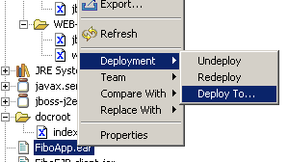
Resource contextual menu for deployment operations
If you select the “Deploy to…” item, a dialog will appear to let you choose on which target you want to deploy the resource.
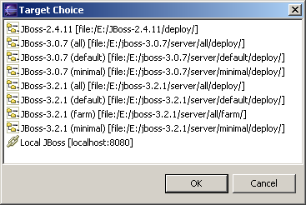
Deployment target selection
Note that after deployment, a decorator is present to tell that the resource has been deployed. This information is only valid during the workspace session.
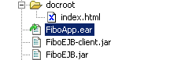
Deployment decorator

