I. Revision History: March 15, 2015 - Third version

II. Introduction
a. Currently, incoming students are subjected to surveys and lectures to learn information about college resources. Since this form of education has a low retention rate, there is need for a more engaging program or interface so students can have this knowledge more deeply embedded.
b. We will solve this problem by creating a serious game which simulates scenes and interactions on campus, allowing the student to learn by role-playing.

III. Positioning
a. Problem Statement or Opportunity: creating a short serious game that teaches incoming students about certain campus resources in an entertaining and engaging manner.
b. Key stakeholders: our clients in the center for Academic Advisement here on the University of Delaware campus
c. Key goals for the users of the product:
i. Some primary goals we have for the users of the product is for them to learn about Degree Audit on UDSIS, critical dates on the academic calendar, know the roles/responsibilities of advisors, and know where to obtain resources to allow them to be academically successful (such as tutoring and the writing center).
ii. Some secondary goals we have include informing students of the campus layout, how their major connects to their career goals, the resources available through the career development center, how the career development process works, and alert them to other opportunities such as undergraduate research, study abroad, etc.
iii. We also aim to teach the user these things in an engaging and entertaining manner.
IV. Product Overview
a. Solution envisioned: The UDiscover game will be composed of 5 educational videos each followed by a short game that tests user knowledge of the topics covered. The users, typically freshmen or transfer students, will learn about different resources on campus and understand how to use these resources to enrich their college experience. Our goal as a team is to provide our clients with an educational game that is so effective, it will dramatically increase the percentage of correct responses regarding student resources.

V. Summary of Key Features
a. Central navigation screen (UD campus)
b. Role-play type central game
c. Proficiency test via mini games
d. Supplemental videos to educate the user

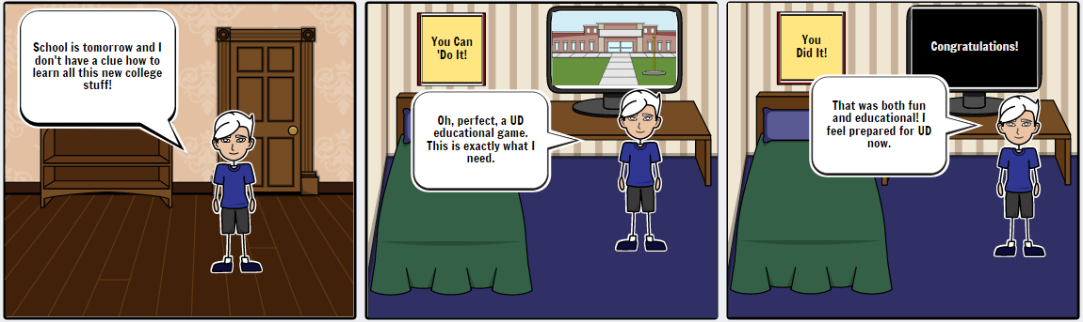

Example:
First, the user would watch a detailed video that explains how to register for classes for Spring Semester. (Visual and Narrative) After, they would participate in a Trivia game, testing their knowledge on the content they watched.
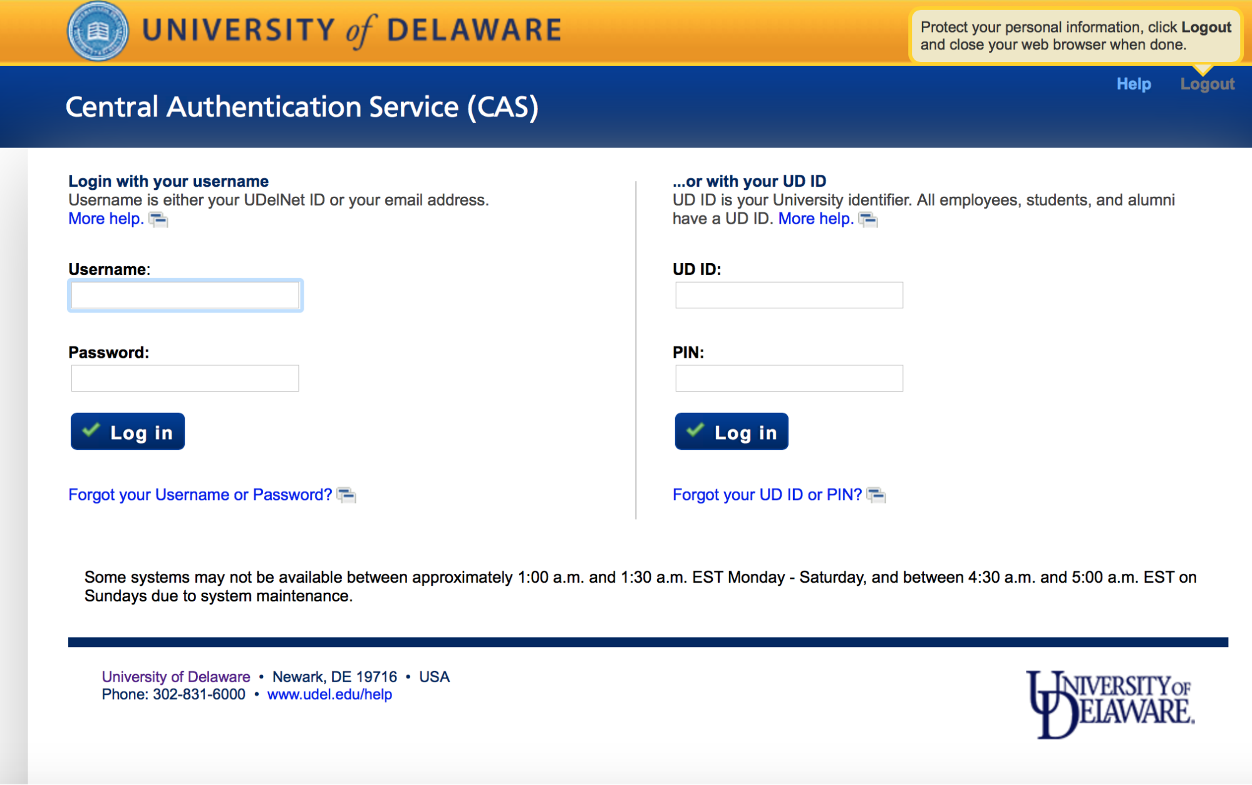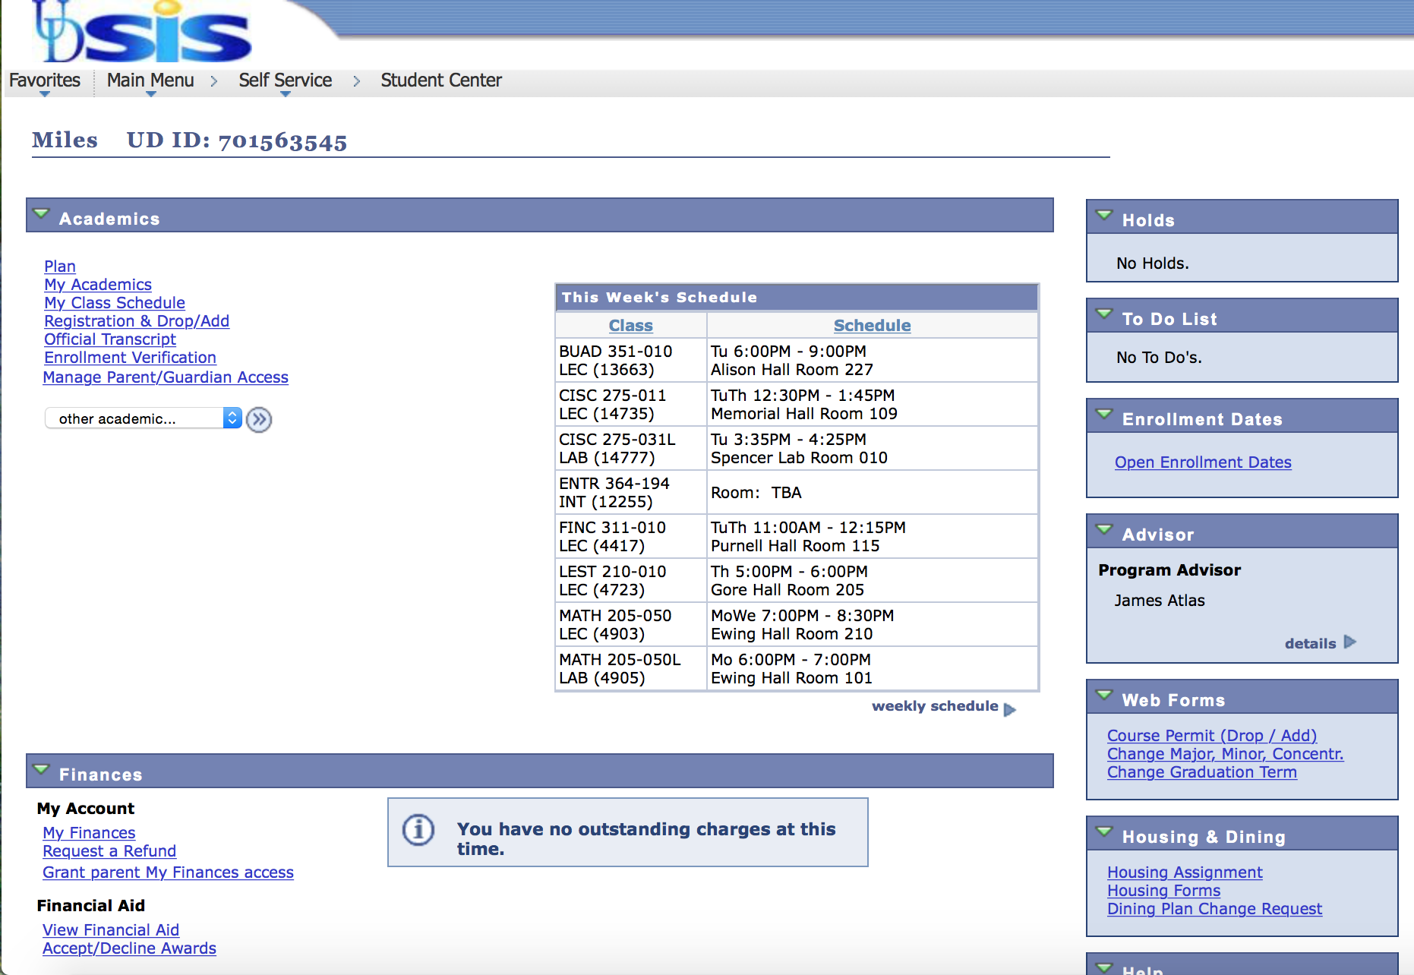

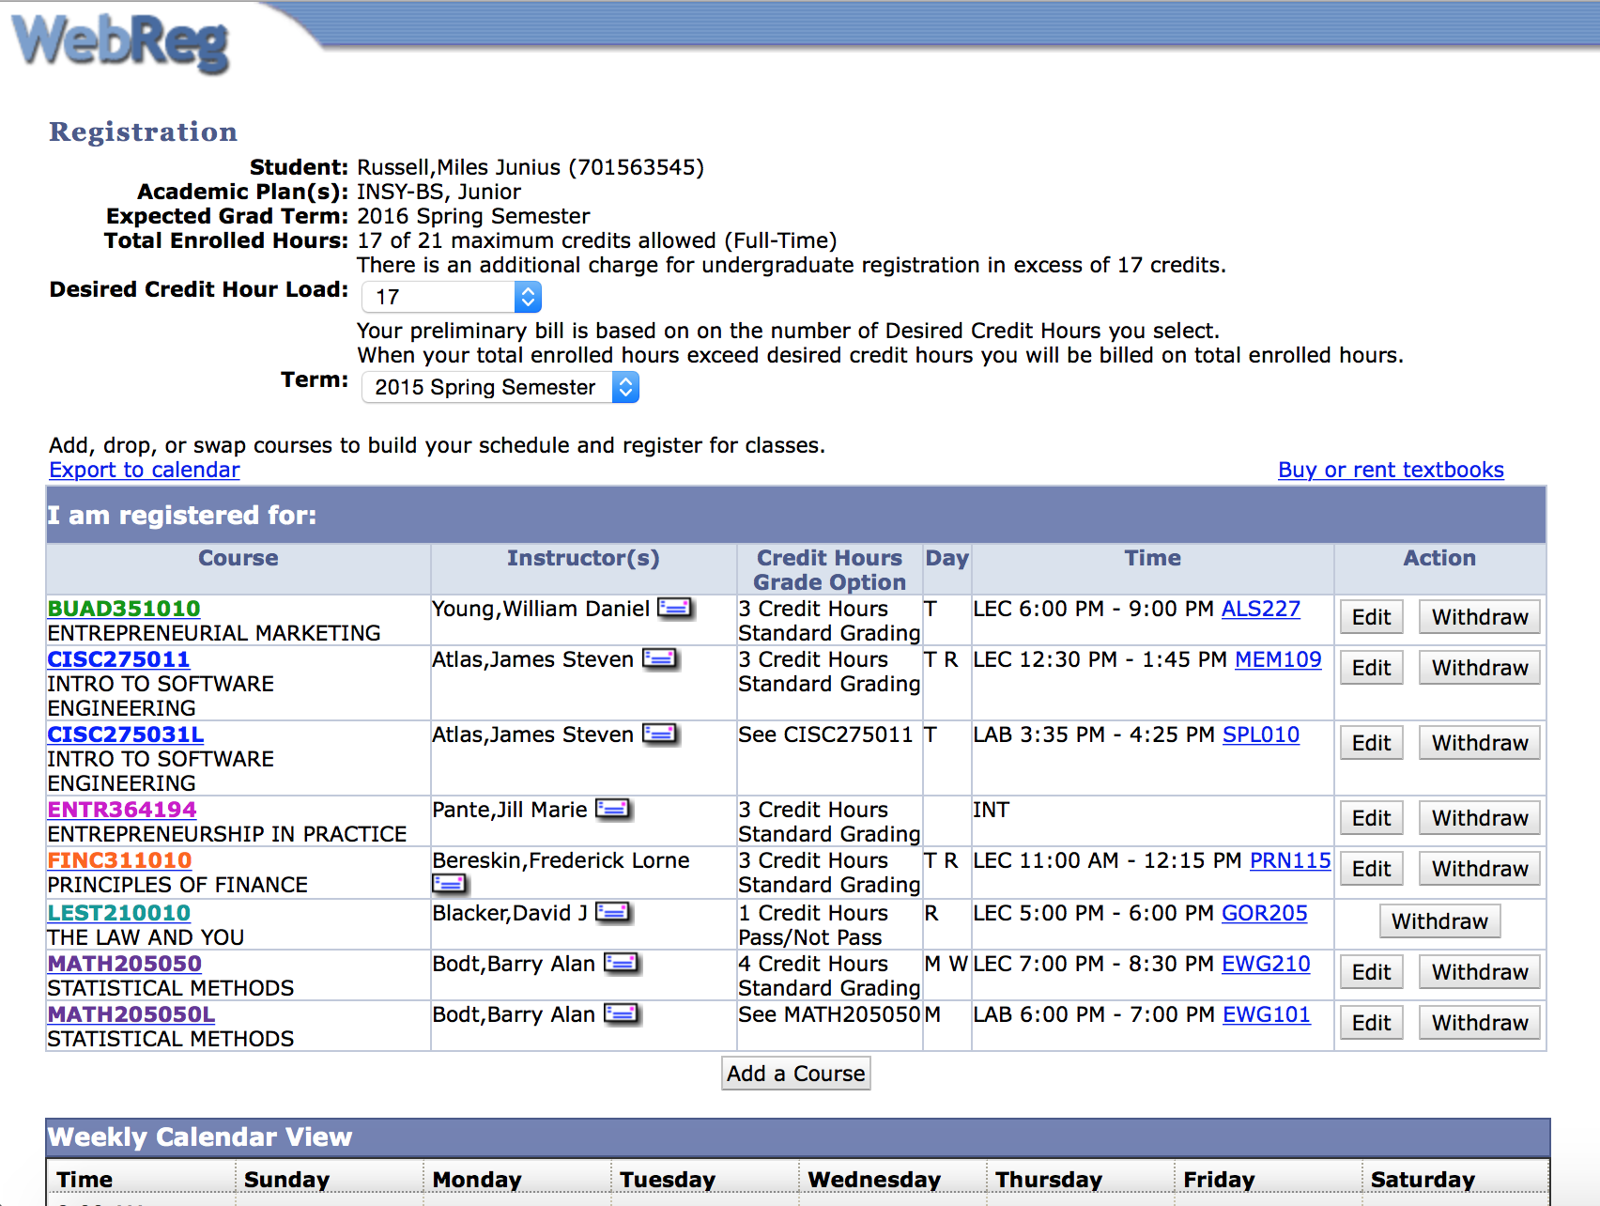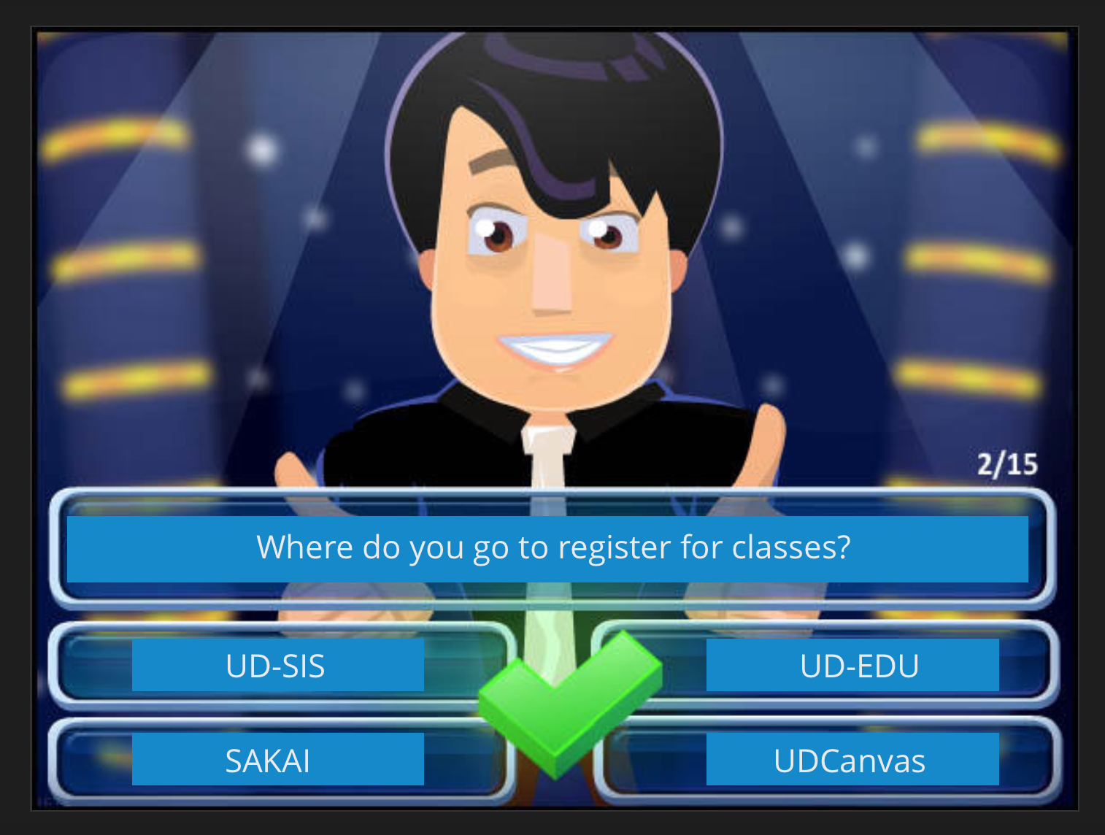

UDiscover Content Outline

Educating the users on how to locate student resources on the University of Delaware Website will fulfill all of the goals/requirements. If they know how to navigate through the Udel website, they will be able to find the resources successfully in the future.

- Video Time = 5 minutes
- Game Time = 10 minutes

------------

Video 1
Online Resources
· University of Delaware Website
o Important Calendar Dates (Free Drop Add, Withdraw, Freshmen Midterm Grades, Spring Registration – Location of Academic Calendar)
· Sis – How to login, How to Change Major, Access student records
· Sakai
· Canvas
· Course Search/ Catalog
*Academic Expectations

Goals Fulfilled:
· Students know the critical dates on the academic calendar (drop add)
· Students know where to go to change their majors or to research changing their majors

Questions:
1. How confident are you using Udel Sis, To Register for Classes, Finding information in course catalog
2. When is the deadline for adding or dropping a class (free drop/add period)?
3. When is the deadline to withdraw from a course (and receive "W") without academic penalty?
4. Where can you find critical dates on the UD academic calendar?

GAME:
------------
Video 2
Academic Help
· Academic Enrichment Center
· Math Center
· Writing Center
· Physics Center
· Library
· Online Academic Workshops
· Advisor – role of student as advisee/ role of advisor

Goals Fulfilled:
· Students know their roles and responsibilities as advisees and for the advisors
· Students know where to obtain resources to help them be academically successful- Math tutoring, writing center

Questions:
- For each of the following resources indicate whether you are familiar with the resource and if you used it (in-person or online) during your first semester at UD.
- Academic advisor, Math Tutoring, office of academic enrichment, writing center
- Indicate the quality of your interactions with the following people at your institution with your academic advisor
- How much does your institution emphasize the following?
· Providing support to help students succeed academically
· Using learning support services (tutoring services, writing center, etc.)

GAME:
------------
Video 3
Student Help
· Student Financial Services
· Student Health
· Center for Counseling and Student Development
· University Police Department

Goals Fulfilled:
Students know where to obtain resources to help them be successful

Questions:
- For each of the following resources indicate whether you are familiar with the resource and if you used it (in-person or online) during your first semester at UD.
- Career Services, Counseling Center, Library, online academic workshops, student health center
GAME:
------------

Video 4
Career Help
· Career Services
· Choice of major connects to career goals
· Career development process

Goals Fulfilled:
· Students have knowledge of the Career Services Center
· Students know how their choice of major connects to their career goals.
· Students are aware of career development process
· Students begin to assess their interests and abilities

Questions:
- What services does Career Services offer?
- What are the steps of the career development process?

GAME:

------------

Video 5
Opportunities
· Undergrad Research
· Study Abroad
· Service Learning

Goals Fulfilled:
· Students are knowledgeable about on-and off-campus opportunities available to them to help them grow as individuals (e.g., Undergraduate Research, Study Abroad, Service Learning)

Questions:
1. For each of the following resources indicate whether you are familiar with the resource and if you used it (in-person or online) during your first semester at UD.
· Study abroad programs, undergraduate research office

GAME:

------------

