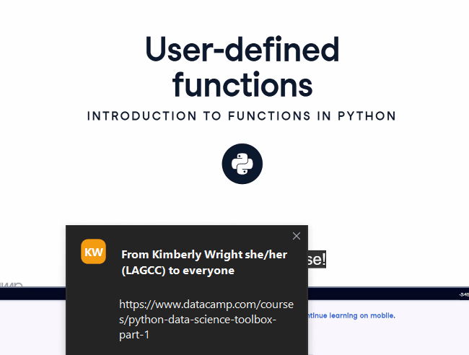
You’re asking exactly the right question, Jean — and honestly, with your SQL practice and your interest in real-world business scenarios, you’re already halfway in the door. Let’s build you a clean, practical roadmap so you can go from “learning SQL” to “doing real data analytics with SQL.”
Below is a structured, no-nonsense guide grounded in the best resources from the web and tailored to how you learn.
🚀 How to Start Learning Data Analytics Using SQL
🎯 1. Understand What “Data Analytics with SQL” Actually Means
Data analytics with SQL is about extracting, cleaning, transforming, and interpreting data directly from relational databases.
According to GeeksforGeeks, SQL is widely used across industries to analyze sales, customer, and financial data, and is essential for making business decisions.
🧱 2. Start With the Core SQL Foundations
These are the building blocks every analyst must master:
Essential SQL Concepts
- SELECT, WHERE, ORDER BY
- Filtering with AND/OR/NOT
- Joins (INNER, LEFT, RIGHT, FULL)
- Aggregations (SUM, COUNT, AVG, MIN, MAX)
- GROUP BY and HAVING
- Subqueries and CTEs
- Window functions (ROW_NUMBER, RANK, LAG, LEAD)
FreeCodeCamp highlights these as the critical concepts for data analysts.
🧪 3. Learn Through Hands-On, Analyst-Focused Tutorials
Here are the best starting points (all beginner-friendly):
🔹 DataLemur SQL Tutorial (Free)
Step-by-step lessons designed for analysts and data scientists, starting from SELECT and filtering to joins and window functions.
🔹 Coursera – Data Analysis Using SQL
Beginner-friendly, structured, and teaches how to extract insights efficiently from databases.
🔹 Udacity – SQL for Data Analysis
Covers cleaning data, optimizing queries, and advanced joins — very aligned with real analytics workflows.
🧰 4. Practice With Real Data (This Is Where You Level Up)
Since you’re already working with SBA loan data in your project, you’re in a perfect position to practice:
Try these exercises:
- Find trends (e.g., loan approvals by business type)
- Aggregate metrics (e.g., average loan amount by state)
- Join multiple tables (applicants + business types + loan outcomes)
- Create CTEs to simplify complex logic
- Use window functions to rank applicants or calculate rolling metrics
This mirrors exactly what analysts do in finance, government, and business intelligence.
📊 5. Build Mini Projects (Your Portfolio Starts Here)
A few project ideas you can do with SQL alone:
These projects show employers you can turn raw data into decisions.
🧭 6. Recommended Learning Path (Simple & Effective)
Week 1–2: SQL Basics
SELECT, WHERE, ORDER BY, filtering
→ Use DataLemur or FreeCodeCamp
Week 3–4: Joins + Aggregations
Practice with real datasets
→ Use SBA data or public datasets
Week 5–6: CTEs + Window Functions
This is where analytics becomes powerful
→ Follow FreeCodeCamp’s advanced SQL concepts
Week 7+: Build Projects
Turn your learning into portfolio-ready work
💡 Pro Tip (Based on Your Learning Style)
You thrive with example-driven explanations and real business scenarios, so lean heavily on:
- Real datasets (SBA, sales, customers)
- Writing queries that answer business questions
- Templates and repeatable patterns (CTEs, joins, aggregations)
This will accelerate your growth faster than theory alone.
If you want, I can also build you a personalized SQL learning plan, or even help you design SBA-based analytics projects that match what real analysts do.
Absolutely, Jean — let’s build you a personalized SQL learning plan that fits your style: structured, example-driven, practical, and tied to real business scenarios like the SBA loan datasets you’ve been working with.
This plan is designed to take you from solid fundamentals → confident analyst-level SQL → portfolio-ready projects.
📘 Your Personalized SQL Learning Plan
🧭 Phase 1 — Foundations (1–2 weeks)
Goal: Build a rock-solid base so everything later feels natural.
What to Learn
- SELECT, FROM, WHERE
- ORDER BY
- Basic filtering (AND, OR, NOT)
- DISTINCT
- Basic functions (UPPER, LOWER, LENGTH)
How You Should Learn (based on your style)
- Use example-driven tutorials (DataLemur, FreeCodeCamp)
- Practice with small, realistic tables (customers, payments, addresses)
Mini-Exercises
- Return all borrowers with names starting with “A”
- Filter loans above a certain amount
- Clean messy text fields (trim spaces, fix casing)
🧱 Phase 2 — Joins + Aggregations (2–3 weeks)
Goal: Become fluent in combining tables and summarizing data — the core of analytics.
What to Learn
- INNER, LEFT, RIGHT, FULL joins
- GROUP BY
- HAVING
- Aggregations: SUM, COUNT, AVG, MIN, MAX
- Basic date functions
How You Should Learn
- Use your loan_504 and loan_7a schemas
- Write queries that answer business questions
Mini-Exercises
- Count loans by state
- Average loan amount by lender
- Join borrower + loan tables to find top borrowers
- Identify lenders with above-average approval amounts
🧪 Phase 3 — CTEs + Subqueries (2 weeks)
Goal: Learn to break down complex logic into readable steps.
What to Learn
- WITH (CTEs)
- Subqueries in SELECT, FROM, WHERE
- Nested logic
How You Should Learn
- Take messy business questions and break them into steps
- Use CTEs to make your queries readable and reusable
Mini-Exercises
- Find the top 5 lenders by total loan volume
- Identify borrowers who received more than one loan
- Create a CTE that calculates loan totals, then filter on it
🧠 Phase 4 — Window Functions (2–3 weeks)
Goal: Unlock analyst-level SQL — ranking, running totals, comparisons.
What to Learn
- ROW_NUMBER, RANK, DENSE_RANK
- LAG, LEAD
- PARTITION BY
- Running totals
- Moving averages
How You Should Learn
- Use real SBA-style questions
- Compare borrowers, lenders, loan amounts over time
Mini-Exercises
- Rank lenders by loan volume within each state
- Compare each borrower’s loan amount to their previous one
- Calculate rolling 3-month loan totals
📊 Phase 5 — Real Analytics Projects (3–4 weeks)
Goal: Build portfolio-ready work that proves you can think like an analyst.
Project Ideas Tailored to You
Deliverables
- A clean SQL script
- A short write-up explaining your insights
- Optional: a simple visualization (Excel, Power BI, or even text summaries)
🧰 Phase 6 — Optimization + Best Practices (1–2 weeks)
Goal: Write SQL that is clean, fast, and professional.
What to Learn
- Index basics
- Query optimization patterns
- Clean naming conventions
- How to structure large SQL files
- Commenting and documentation
Mini-Exercises
- Rewrite a slow query using CTEs
- Add indexes to speed up joins
- Refactor messy SQL into readable blocks
🧨 Phase 7 — Interview-Style SQL Practice (Ongoing)
Goal: Build confidence for real analyst roles.
Where to Practice
- DataLemur
- LeetCode SQL
- StrataScratch
- Mode Analytics SQL tutorials
Focus Areas
- Joins
- Window functions
- Aggregations
- Business logic questions
🎯 Your Weekly Schedule (Simple + Realistic)
3 Days per Week (1 hour each)
- 20 min learning
- 40 min hands-on practice
1 Weekend Session (1–2 hours)
- Build or extend a mini-project
- Document your insights
This matches your structured, detail-oriented style and keeps you progressing without burnout.
🔥 Want me to take this further?
I can also build you:
- A 7-day starter plan
- A full 12-week SQL curriculum
- A project-based plan using ONLY your SBA loan schemas
- A daily practice routine
- A SQL cheat sheet tailored to your weak spots
Just tell me what direction you want to go.

