See if you can emulate the clip tool (Toolbox>Analysis Tools>Extract>Clip):

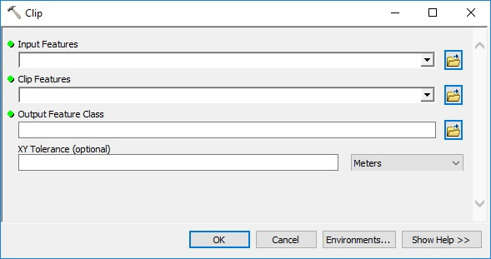

For now let’s not worry about XY Tolerance. I started the .py file for you. It will need to be saved as an .pyt to work in arc.

L:\Public\jbousqui\Code\GitHub\H2O_BEST\arc_tools\MJ\clip_excercise.py

Goals:

* Familiarize with how to use arcpy functions in a script
* Familiarize with using functions
* Familiarize with some of the inputs for .pyt front end