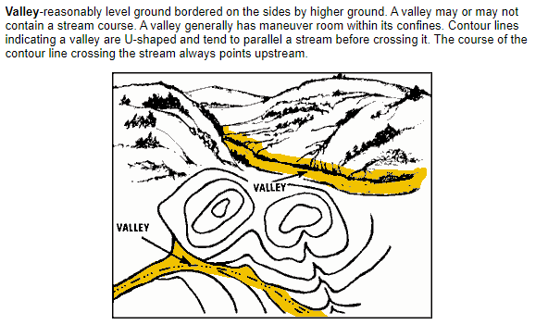
Terrain Features on Topographic Maps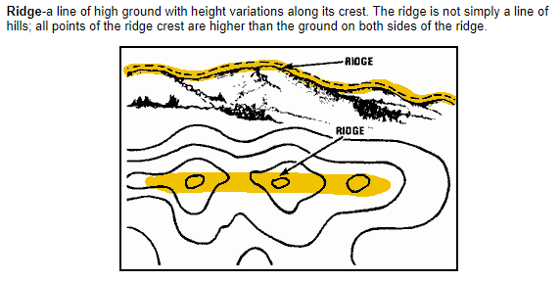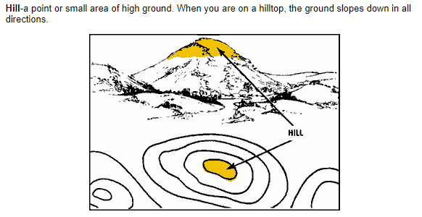

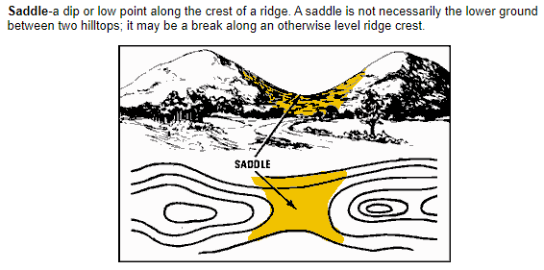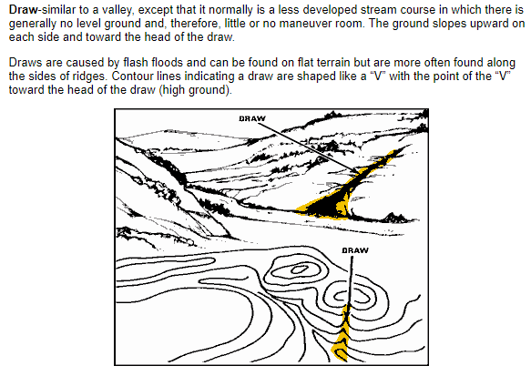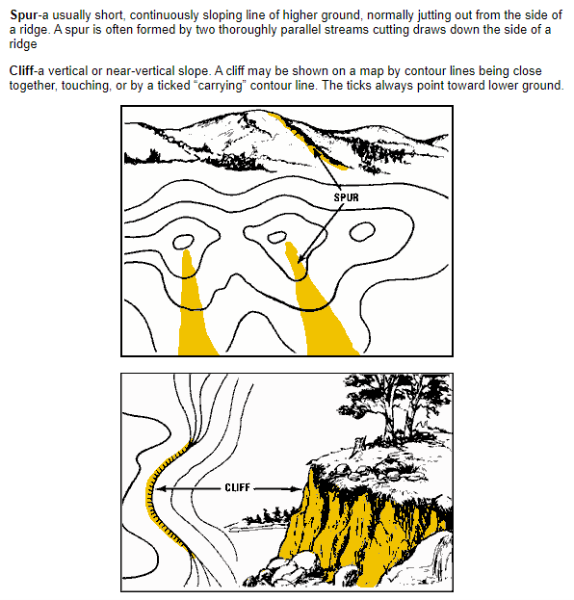

Starting Position: Greenway Middle School
We started at Greenway Middle School and headed South. We were headed up hill, so we climbed the draw to stay out of sight. We stopped by a school to repack supplies, eat, and make a plan. Moving out to the hilltop we spotted Greenway. It was painfully close, maybe 500 yards, like we hadn’t covered any ground. From there we walked down into the saddle and up to the next hilltop. We kept following the Ridge and generally moving South until we got to a large flat hilltop and took a break. When we started again we walked down a long spur that had a steep slope to our right until we got down to a valley. We walked along the road as it gradually climbed and there, on our right we found another school that we were able to take shelter at. The entire journey was only about 3km.

