NEW PHYTOLOGIST SPECIAL ISSUE

**Long-term responses of life-history strategies to climatic variability in flowering plants\***

James D. Boyko1, Eric R. Hagen1, Jeremy M. Beaulieu1, and Thais Vasconcelos1

1*Department of Biological Sciences, University of Arkansas, Fayetteville, Arkansas, 72701 USA*

**\***Email for correspondence: jboyko@uark.edu

**Abstract (max. 300 words)** [TV still over 300 words, but probably okay for the thesis]

* Understanding the evolution of life history strategies within flowering plants is a long-standing goal in evolutionary biology. Increasingly, biologists have sought to explain the distribution of annuals and perennials based on their association with broad climatic variables such as temperature or precipitation. However, these efforts have focused on specific clades or geographic areas and, due to methodological limitations, have not allowed joint modeling the evolution of both climatic niches and life history strategies.
* Here, we combine data on life history strategy and geographic distribution for 9,993 flowering plant species and a recently developed modeling framework which accounts for rate heterogeneity and joint evolution of continuous and discrete traits to evaluate two hypotheses: (1) annuals tend to evolve in highly seasonal regions prone to extreme heat and drought, because they can rapidly take advantage of short beneficial climatic conditions for reproduction, and (2) annuals tend to have faster rates of climatic niche evolution than perennials, due to their higher vagility and shorter generation times.
* We show that annuals tend to have hotter climatic optima than perennials. However, patterns related to precipitation and seasonality variables were mainly clade specific, pointing towards a lack of generality in how these variables influence evolutionary transitions between strategies across all flowering plants. Also contradicting our predictions, no significant differences in rates of niche evolution between annuals and perennials was observed.
* Temperature, in particular how hot it gets during the warmest season of a year, is the main climatic factor influencing the evolution of annual life history strategy in flowering plants. Annuals are favored in this type of climate due to their ability to escape heat stress as seeds, but are outcompeted by perennials in regions where extreme heat is uncommon or inexistent. Precipitation and seasonality are less important factors, perhaps due the existence of alternative mechanisms for drought tolerance in perennial species.

**Introduction**

Flowering plants have evolved into multiple types of life history strategies to survive environmental challenges (Grime 1977; Stearns, 1992). For instance, resprouting plants can have underground systems to persist through fire and drought (e.g. Rando et al., 2016; Howard et al., 2019.) and large trees can become deciduous or have scales to protect their growing buds during freezing conditions (Raunkiaer, 1934; Edwards et al., 2017). Other plants have increasingly shortened their life cycles so that germination, fertilization, and seed release all happen through the favorable season of a single year, allowing avoidance of the unfavorable season in the form of seeds (Mulroy and Rundel, 1977). The latter describes the life history strategy of annual plants, which are semelparous (i.e. reproduce just once before death, Stearns, 1992). This is opposite to the vast majority of flowering plant species, which are mostly iteroparous (i.e. present multiple reproductive events) and characterized by a perennial life history strategy with adaptations to survive an indefinite number of unfavorable seasons (Raunkiaer, 1934; Friedman, 2020).

The interest in finding environmental correlates associated with the evolution of different life history strategies in flowering plants follows the observation that species with annual and perennial strategies are unevenly distributed in the globe (Figure 1; Raunkiaer, 1934; Ricklefs and Renner 1994; Friedman, 2020). The distribution of plants with perennial strategy is non-linear, as they are disproportionately diverse both in areas where freezing is constant, such as higher latitudes and alpine habitats (Billings and Mooney 1968; Givnish 2015), and warmer tropical climates (Grime, 1977). On the other hand, annuals are most representative in mid-latitudes in areas subjected to prolonged drought, such as desert and mediterranean habitats (Mulroy and Rundel, 1977). Though annuals are considerably less common than perennials across the angiosperm tree of life (Friedman, 2020), they can represent over 50% of the floristic diversity in some of those regions (Figure 1b; Raunkiaer, 1934).

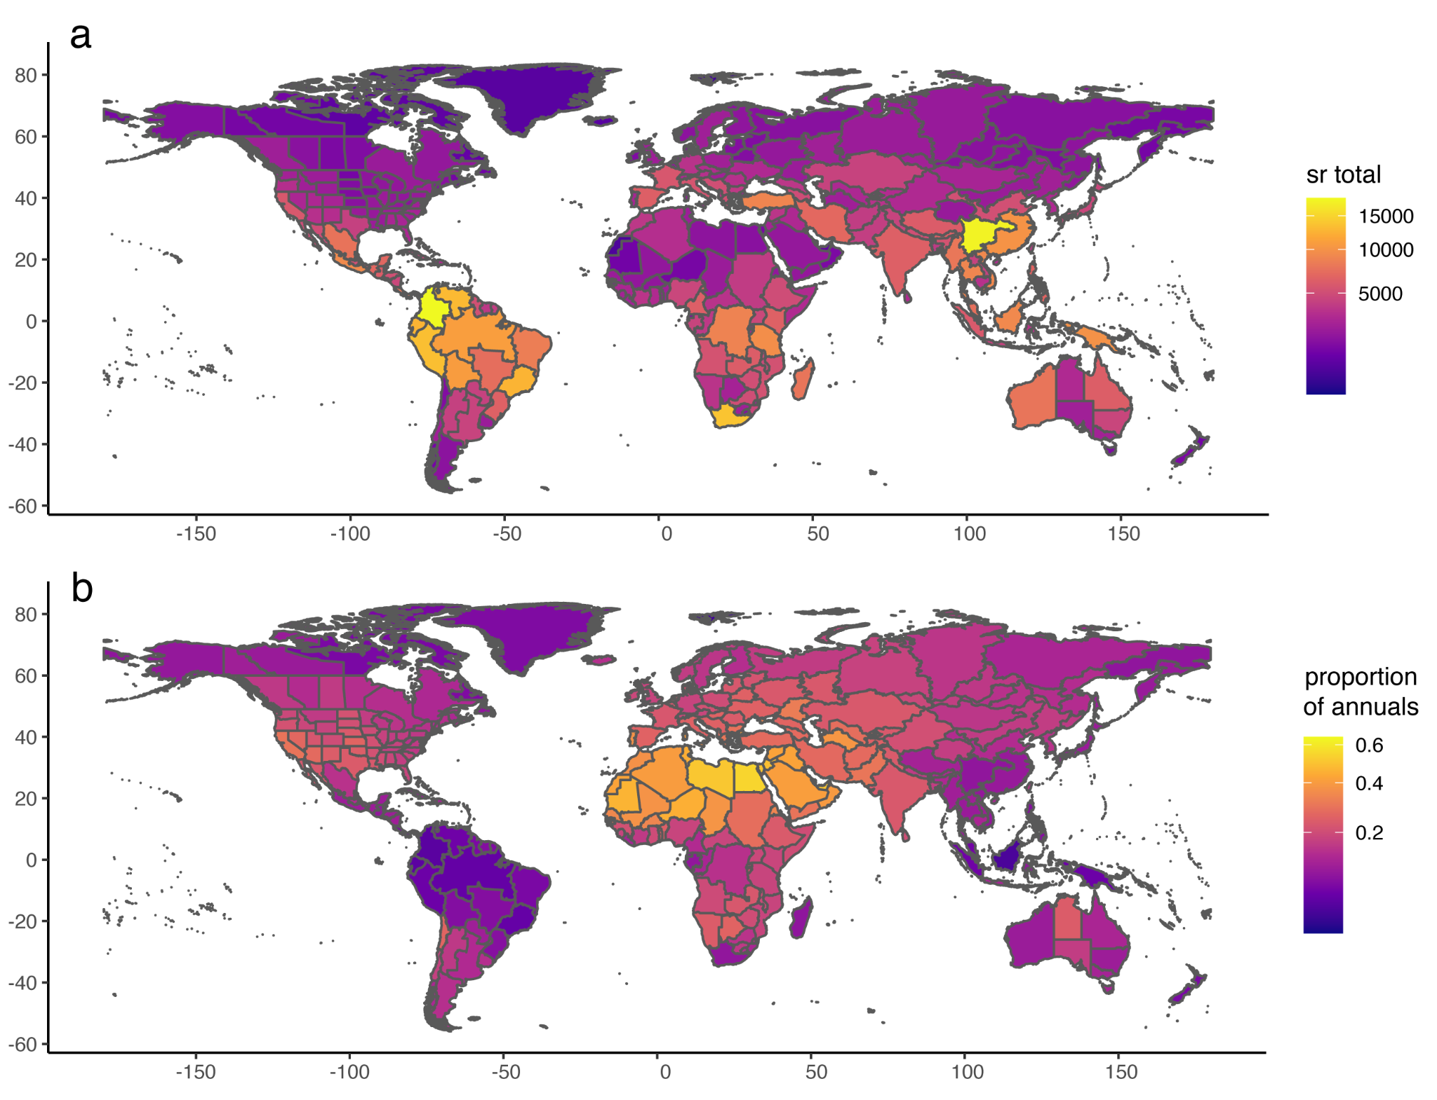

**Figure 1.** Global distribution of vascular plant diversity and proportion of annual plants. (a) Total species richness of vascular plants by botanical country according to the WCVP database (WCVP, 2022*), and (b) Proportion of annual plants in relation to total species richness. Y-axis: longitude; x-axis: latitude.

Although the uneven distribution in the proportion of different life form across the globe have been long recognized (Raunkiaer, 1934; Stebbins, 1974; Grime 1977; Friedman, 2020), there is still much discussion on what are the historical drivers leading to this pattern and in particular regarding the role of climate. For instance, according to the theory of life history strategies in plants, annuals are more likely to evolve where climate is seasonal, but seasonality is somewhat predictable, because they can rapidly take advantage of short beneficial climatic conditions for reproduction (Cole, 1954; Friedman, 2020). Support for this has been found in clades typical of mediterranean habitats, such as *Heliophila* (Brassicaceae) in Africa (Monroe et al., 2019) and *Bellis* (Asteraceae) in Europe (Fiz et al. 2002) as well as in grasses (Poaceae) (Humphreys & Linder, 2013). Others have argued that evolution of the annual life form is linked to occupation of generally warmer environments (Stearns 1992), and support for this has been found in temperate clades such as Montiaceae (Ogburn and Edwards, 2015). Similarly, annuals would be excluded from alpine environments where frost is common due to high seedling mortality (Givnish, 2015). Finally, some have argued that both temperature and precipitation combined, as well as how seasonal they are across the year, are relevant in explaining the evolution of different strategies, as it has been shown in *Oenothera* (Onagraceae) (Evans et al. 2005). In other words, temperature (in particular extremes heat and frost), precipitation (especially drought) and seasonality have all been found to influence evolutionary transitions between annuals and perennials strategies through the evolution of flowering plants. However, studies have so far focused on specific clades or geographic areas and it is unclear which patterns are general enough to hold when multiple clades are considered in the same analytical framework.

Another pattern that has not been thoroughly explored is how flexible lineages evolving under different life history strategies are to adapt to changing climatic circumstances. Whereas the different life history strategies likely evolved in response to particular climatic pressures, they may also impact long term biogeographical patterns of lineages evolving under them. For example, the evolution of the annual habit is linked to a series of traits associated with securing reproduction and increased vagility, like selfing (Stebbins 1950; Aarssen, 2000) and relatively high investment in seed production (Friedman, 2020). For those reasons, annuals are considered to be generally good invaders (Pannell et al., 2015; Linder et al., 2018) and, in fact, many of the worst invasive plants in the world are annuals (Holzmueller and Jose, 2009). Furthermore, due to their generally shorter generation times, annuals may also present faster rates of phenotypic evolution (e.g. Smith and Beaulieu, 2009), which perhaps make them able to adapt faster to changing environmental conditions (Andreasen and Baldwin, 2001).

Here, we assess the dialectical relationship between climatic factors and the evolution of life history strategies in flowering plants. To that end, we apply recent theoretical developments in trait evolution models (Boyko et al. in prep; Chapter x of this thesis) to explicitly incorporate the impact of climatic niche variation on the evolution of life history strategies. We account for the heterogeneity of evolutionary histories in flowering plants and the habitats associated with them by analyzing a broad sample of clades where multiple transitions between annual and perennial strategies are observed. Two specific hypotheses are addressed: (1) annuals tend to evolve in warmer and drier climates, or where seasonality is stronger, more often than perennials; and (2) annuals tend to have faster rates of climatic niche evolution than perennials, because of their higher invasibility and shorter generation times. We expect to find mixed support for our hypotheses due to clade specific evolutionary patterns. Some clades will undoubtedly have more heterogeneity in transition rates between life history strategies, whereas other clades may have exclusively unidirectional transitions, and yet others may have no heterogeneity at all. However, due to our large dataset and the ability to account for rate heterogeneity in our model, we expect that we can illuminate the generalities of the long-term responses of life-history strategies to climatic variability in flowering plants.

**Methods**

*Phylogenetic and life history datasets*

To build a dataset of life history strategies for a set of flowering plant clades, we used the recent release of the World Checklist of Vascular Plants dataset (WCVP, 2022*; note: this data is part of a dataset to be officially released in November 2022. The dataset was made available for manuscripts that are part of a *New Phytologist* special issue to be published in 2023), which includes life form data following the Raunkiaer (1934) system. The Raunkiaer system classifies different life history strategies in flowering plants based on the position of the buds in relation to the soil at the end of the growing season and on how plants protect growing buds during the unfavorable seasons. We scored as “annuals” all species marked as “Therophytes” (including combinations such as “Climbing therophyte” and “Semiaquatic therophyte”) or “Biennials” in the WCVP dataset. All other life forms, such as “Cryptophytes”, “Nanophanerophytes”, and “Phanerophytes”, were scored as “perennials”.

Following this scoring, the proportion of “annuals” to “perennials” in the WCVP dataset is around 1:5. In other words, annual plants are considerably less common than perennials and therefore it is more common to find clades where all species are perennials than clades where evolutionary transitions between annual and perennial strategies are observed. However, due to modeling constraints (ref), we had to restrict our set of clades to groups that presented multiple evolutionary transitions between different life history strategies. Selecting only groups where both life history states are present is not the ideal scenario, because excluding groups consisting only of perennials may bias our view of how different life histories and climatic niches impact each other across evolutionary time. On the other hand, our analytical framework accounts for hidden heterogeneity that would come from a character independent continuous trait evolution, partially mitigating this source of bias.

The set of clades selected for our analyses is not restricted to a single taxonomic rank and includes any clade that matched the criteria: (1) both annuals and perennial strategies are observed; (2) time calibrated phylogenetic tree is available in the literature; and (3) phylogenetic tree includes from c. 50 to c. 1000 tips and at least 10% of the known species diversity assigned to that clade. The clades selected were: the families Balsaminaceae (Rose et al., 2018), Gesneriaceae (Roalson and Roberts, 2016), Onagraceae (Freyman and Hohna, 2019), Orobanchaceae (Schneider and Moore, 2017), Polemoniaceae (Rose et al., 2018), and Solanaceae (Sarkinen et al., 2013). The Malvaceae subfamilies Eumalvoideae and Grewioideae (Hoorn et al., 2019), the Apiaceae subfamily Apioideae (Banasiak et al., 2013), the Poaceae subfamilies Pooideae and Panicoideae (Spriggs et al., 2014), and the Primulaceae subfamily Primuloideae (de Vos et al., 2014). The Asteraceae tribe Cardueae (Park and Potter, 2015), the Brassicaceae tribes Alysseae, Arabideae, Brassiceae, Cardamineae, Chorisporeae, Erysimeae, Euclidieae, Heliophileae, Lepidieae, Thelypodieae (Huang et al., 2019) and Cremolobeae, Eudemeae, and Schizopetaleae (“CES-clade”; Salariato et al., 2016), the Plantaginaceae tribe Antirrhineae (Gorospe et al., 2020), the Primulaceae tribe Lysimachieae (Yan et al., 2018), the Rubiaceae tribes Rubieae and Spermacoceae (Ehrendorfer et al., 2018; Neupane et al., 2017). The genera *Chamaecrista* (Fabaceae, Vasconcelos et al., 2020). *Croton* (Euphorbiaceae, Arevalo et al., 2017), *Hypericum* (Hypericaceae, Nurk et al., 2013), *Lupinus* (Fabaceae, Drummond et al., 2012) and *Salvia* (Lamiaceae, Kriebel et al., 2020). All clades combined sum 33 phylogenetic trees and 9,993 tips and lineages are distributed globally. We also completed the life form scoring by adding data collected from the literature, so that each clade had a maximum of 30% missing data (a list of literature consulted can be found as Sup data).

*Distribution points and climatic data*

We standardized all species names in the 33 phylogenetic trees following the GBIF taxonomic backbone with the R packages taxize (Chamberlain and Szöcs, 2013) and downloaded occurrence points that had preserved specimens associated with them using functions of the R package rgbif (Chamberlain and Boettiger, 2017), resulting in a dataset of 3,158,632 occurrence points. This dataset was filtered according to the native distribution range of genera and species using the shapefiles of the Working Group on Taxonomic Databases for Plant Sciences (TDWG) for level 3 botanical countries (ref) combined with the WCVP dataset. This filtering was particularly important to exclude the invasive range of several species, keeping only native ranges according to the expertise of taxonomists. Other irregularities such as points in the sea, outliers, duplicated coordinates for the same species and centroids of countries were also removed using a similar protocol as Vasconcelos et al. (2021).

Based on our hypotheses, and because there is no consensus in the literature of what type of climatic variables correlate with evolutionary transition of annual and perennial strategies, we used the climate data from CHELSA (Climatologies at high resolution for the earth’s land surface areas; Karger et al., 2017). In total, eight climatic variables divided into three groupings were tested (Table 1): (1) mean variables, including BIO 1: Mean Annual Temperature (MAT), BIO 12: Mean Annual Precipitation (MAP) and Aridity Index (AI; the higher the more humid); (2) seasonality variables, including BIO 4: Temperature Seasonality and BIO15: Precipitation Seasonality; and (3) variables associated with climatic extremes, including BIO17: Precipitation of Driest Quarter (drought), BIO5: Maximum Temperature of the Warmest Month (heat) and BIO6: Minimum Temperature of the Coldest Month (freezing conditions). All variables were analyzed in their finer scale of 30arc sec (1km in the equator?). To summarize climatic data for each species, we used functions of the R packages sp and rasters (Bivand et al., 2013; Hijmans et al., 2015) to extract a value for each filtered occurrence point based on the climatic layers we assembled. To mitigate the impact of collecting bias, we filtered these points so that no more than one occurrence point for every 1 x 1 degree cell for each species was included. The value of each remaining point was then log transformed and used to calculate mean and within species variance (Labra et al., 2009) for each species, which was used as error measurement in downstream analyses.

**Table 1.** Inequalities describing how expectations of climatic optima and variance will differ for each climatic variable. When θa > θp, we expect the climatic optima for that variable to be greater for annuals than perennials. When θa < θp, we expect the climatic optima for that variable to be greater for perennials than annuals. For all variables, we expect annuals to present higher rates of climatic niche evolution (σ2) for annuals than perennials.

|  | Mean vars | | | Seasonality vars | | Extreme vars | | |
| --- | --- | --- | --- | --- | --- | --- | --- | --- |
|  | BIO1 | BIO12 | AI | BIO4 | BIO15 | BIO5 | BIO6 | BIO14 |
| Estimated θ | θa > θp | θa < θp | | θa > θp | | θa > θp | | θa < θp |
| Estimated σ2 | σ2a > σ2p | | | | | | | |

*Trait evolution analyses*

Our analysis is conducted with two complementary goals in mind. First, we wish to accurately model the potential link between climatic niche evolution and life history characters within each of our 33 clades. This is done by fitting a set of 10 hOUwie models with 50 stochastic mappings per iteration and adaptive sampling enabled. hOUwie is a recently developed model which explicitly models the joint evolution of discrete and continuous characters (Boyko et al. in prep; Chapter x). Each of the fitted model structures can be parameterized such that it is either character dependent or character independent. Character dependent models test for an explicit difference in climatic niche evolution between annual and perennial lineages whereas character independent model structures assume no difference. Furthermore, several models have a mixture of character dependent and independent processes, allowing some differences between parameters to depend on life-history and other parameters to be fixed as equal. Finally, we include character independent models which allow for trait-independent rate heterogeneity. These types of models have been shown to be important as robust null hypotheses and to account for the possibility that our model selection without HMIMs would be biased towards correlation as a consequence of detecting rate heterogeneity without true correlation (Boyko and Beaulieu in prep. Chapter x). In the context of this study, these models account for the fact that climatic niche evolution is likely to be variable throughout the phylogeny regardless of potential correlation with life-history.

The parameters we allow to vary in our model are rates of transition between annual and perennial (q), the phenotypic optima of the climatic niche (theta), and the rate of climatic niche evolution (sigma square). We conduct model averaging and compare several parameter estimates within hOUwie to test for: (1) a relationship between climatic optima and life history strategy (theta), (2) whether evolutionary transition rates are greater from perennial to annual across all climatic variables (q), and (3) whether evolutionary rates of annuals are greater for annuals than perennials across all climatic variables (sigma). The differences between the climatic niche optima of annuals and perennials are expected to depend on the particular climatic variable being modeled (Table 1). For each clade, we test whether there is a signal of correlation between the climatic variable and life history strategy by examining the differences between parameter estimates.

To determine the model averaged parameter estimates we first reconstructed the probabilities of each tip state. This step is done for every fitted model and is necessary because the potential inclusion of hidden states means that there may be additional uncertainty in the tip states. Second, we multiply the probability of each tip state by the parameter value associated with that state. In the case of character independence, the parameter value associated with the observed tip states will always be the same. This step leaves us with a set of parameter values for each extant tip. Finally, we conduct model averaging by weighting each tip’s parameter values by the AIC weight of the model fit it is associated with. These tip values are then categorized as either annual or perennial and the mean of each discrete category is taken for each clade. We note that any differences in parameter estimates within a clade are significant since they represent parameter estimates from a model set. Each tip will always have the same observed state (unless explicitly coded as unknown), but their hidden state may differ. Thus, all estimated parameters are averaged over hidden rate classes based on the associated observed character and joint probability of the underlying regime.

The second part of our analysis is conducted to test whether the associations we detect within clades are broadly consistent across clades. We use phylogenetic paired t-tests to assess whether model averaged parameter estimates associated with life history strategy are consistently different across clades (Revell, 2012). We used the whole seed plant phylogeny based on molecular data from Smith and Brown (2018; “GBMB” tree) as a template to generate a backbone phylogeny that includes each of the 33 clades as individual tips (Figure 2a), using the R packages phangorn (Schliep, 2011) and ape (Paradis et al., 2004) to prune out all other tips.

**Results**

*Multi-clade analysis with hOUwie: model selection*

In general, we found a mix of support for character dependence and independence depending on both the clade and climatic variable being analyzed (Figure 2b). Certain clades, such as *Lupinus* and Pooideae, had consistent support for some form of character dependence, whereas other clades, such as Orobanchaceae and *Chamaecrista*, showed little correlation between life history strategy and climatic niche evolution. However, these patterns are only broad overviews and do not distinguish between the way that the character dependent relationship exists. What is shown in Figure 2 is the sum of the AIC weights for all models with some relationship between the parameters of climatic niche evolution and life history strategy. To determine whether our hypotheses are supported by the modeling results, we examine the model averaged parameter estimates for annual and perennial lineages.

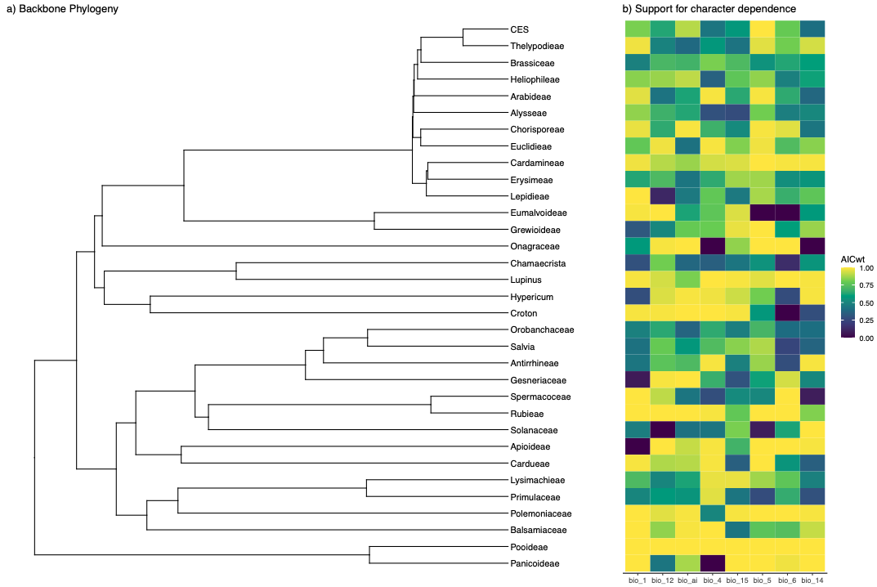

**Figure 2.**Mean: Bio 1, bio 12, and ai, Seasonality: bio 4 and bio 15 Extremes: bio 5, bio 6, bio 14 Which clades have support for correlation? (i.e. CD > CID)

First we outline the difference in estimates related to long term average temperature, precipitation, and aridity. For BIO1 (Table S1), the difference in climatic optima ranged from 12.4 degrees Celsius (°C) higher in annuals in Gesneriaceae to 7.37°C higher in perennials in *Croton*. All clades but Apioideae, Grewioideae, Solanaceae, *Hypericum*, Primulaceae, Balsaminaceae, and *Croton* had a pattern of higher temperature θannuals than θperennials. For BIO12 (Table S5), the difference in climatic optima ranged from 492.1mm more precipitation in annuals in Gesneriaceae to 3601mm more precipitation in perennials in Polemoniaceae. All clades but Gesneriaceae, *Chamaecrista*, Spermacoceae, Thelypodieae, Brassiceae, Orobanchaceae, Lysimachieae, Cardamineae, and Lepidieae had a pattern of higher precipitation in θperennials than θannuals. Finally, for AI (Table S8), the difference in climatic optima ranged from 930.5AI more humid in annual habitats in Thelypodieae to 834131.9AI more humid in perennial habitats in *Lupinus*. *Lupinus* was clearly an outlier in θannuals for humidity, the next closest difference was for Polemoniaceae with 8954.6AI more humidity in perennials. Nonetheless, all clades but Thelypodieae, Brassiceae, Spermacoceae, Orobanchaceae, and Gesneriaceae showed a higher humidity optima for θperennials than θannuals.

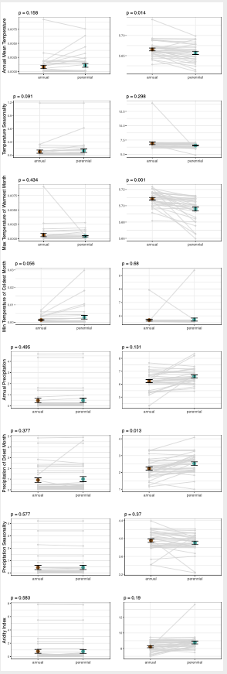

**Figure 3.** Model averaged parameter estimates for sigma.sq and theta for each given observed state (annual and perennial) averaged over all clades. Grey lines represent individual clade comparisons between estimates associated with each observed state. Foreground points are the mean values of each parameter estimate.

Next we outline the difference in estimates related to temperature and precipitation seasonality. For BIO4 (Table S2), and excluding outliers, the difference in climatic optima ranged from 660.9°C standard deviations higher in annuals in Lupinus to 31.6°C standard deviations higher in perennials in Spermacoceae. All clades but Cardamineae, Gesneriaceae, Rubieae, Cardueae, Chorisporeae, Orobanchaceae, and Spermacoceae had a pattern of greater temperature variability in annuals than perennials. For BIO15 (Table S7), the difference in climatic optima ranged from 27.8mm CV (coefficient of variation) more precipitation variation in annuals in Lupinus to 28.0mm CV more precipitation variability in perennials in *Croton*. All clades but Polemoniaceae, Primulaceae, Cardueae, Antirrhineae, Thelypodieae, Arabideae, Brassiceae, Apioideae, Orobanchaceae, Cardamineae, Erysimeae, and *Croton* had a pattern of more precipitation variability in annuals than perennials.

Finally we outline the difference in the most extreme climatic conditions of a year as they are measured by temperature and precipitation. For BIO5 (Table S3), the difference in climatic optima ranged from 16°C higher max temperature in annuals in Chorisporeae to 0.28°C higher max temperature in perennials in Balsaminaceae. For BIO6, and ignoring outliers for which models failed to converge (Table S4), the difference in climatic optima ranged from 6.87°C minimum temperature in annuals in Pooideae to 2.65°C minimum temperature in perennials Primulaceae. All clades but Polemoniaceae, Croton, Hypericum, Lepidieae, Onagraceae, Erysimeae, Grewioideae, Solanaceae, Primulaceae, Antirrhineae, and Balsaminaceae had a pattern of lower minimum temperature of the coldest months in perennials than annuals. For BIO14 (Table S6), the difference in climatic optima ranged from 2.39mm of precipitation during the driest month in annuals in Erysimeae to 32.4 mm of precipitation in the driest month in perennials in *Hypericum*. All clades but Erysimeae, *Croton*, Brassiceae, Thelypodieae, CES, Apioideae, Lepidieae, Gesneriaceae, Lupinus, Orobanchaceae, and Cardamineae had a pattern of lower minimum precipitation of the driest months in annuals than perennials.

*General patterns: parameter estimates*

When averaging all models, phylo.t.test comparisons between parameter estimates show slight differences in sigma squared across all variables (Figure 3), but none of these differences were significant (phylo.t.test p > 0.05). Significant differences in climatic optima between annuals and perennials (θannuals ≠ θperennials) were observed for three out of the eight climatic variables analyzed (Figure 3): (1) mean annual temperature, where annuals tend to have higher values than perennials (θannuals > θperennials; phylo.t.test p = 0.01); (2) maximum temperature of the warmest month, where annuals tend to have higher values then perennials (θannuals > θperennials; phylo.t.test p < 0.001) and precipitation of the driest month, where annuals tend to have lower values than perennials (θannuals < θperennials; phylo.t.test p = 0.01). Though the some parameter values of other variables are coherent with our hypotheses, no significant differences between climatic optima of annuals and perennials were observed for mean annual precipitation, aridity index, minimum temperature of the coldest month and for none of the variables representing climatic seasonality (phylo.t.test p > 0.05).

When looking at individual clades, the maximum temperature of the warmest month was the climatic variable where the strongest pattern was observed. For this variable, the only exception to the general pattern was Balsaminaceae (24.53°C in annuals, 24.82°C in perennials). Maximum difference in optima values are observed in the Brassicaceae tribes Chorisporeae (32°C in annuals and 15.6°C in perennials), Euclidieae (27.59°C in annuals, 13.90°C in perennials), and Thelypodieae (32.79°C in annuals, 19.8°C in perennials).

Transition rates tended to be higher for annuals to perennials (0.045-0.097 transitions per million years) than perennials to annuals (0.036-0.085 transitions per million years). We note that in cases where the discrete character was influenced by the continuous character (character dependent models), there is the potential for a great deal of variation in the ancestral state (Figure 4). This is because, even though a purely discrete process may favor an entirely annual or perennial life history, when accounting for a reconstruction of the climatic niche, the most probable discrete state will depend on the continuous character distribution. For example, the ancestral state for Apioideae had a marginal probability of 99% annual when life history was reconstructed alongside the climatic optima for the warmest temperature of the hottest month, but a probability of 100% perennial when reconstructed alongside the optima for annual precipitation.

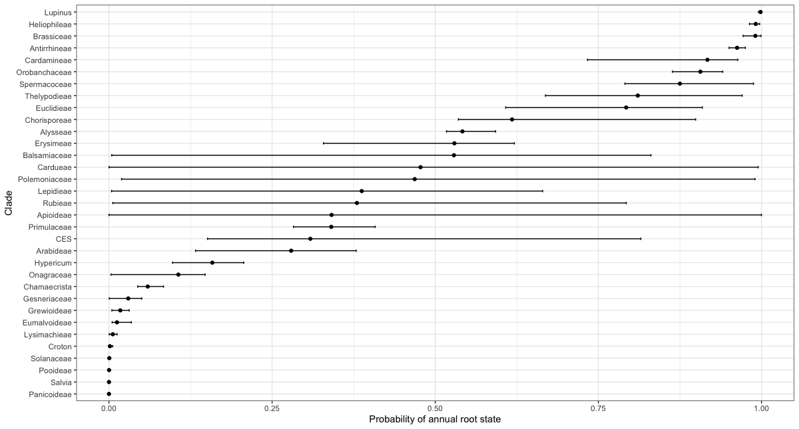

**Figure 4.**Error bars show the range of root probabilities depending on a given bioclimatic variable.

**Discussion**

*Ancestral state reconstruction can be sensitive to climatic associations*

Although not directly related to our main hypotheses, our results challenge, as others have (e.g. Carlquist, 1974; Baldwin, 2007), the traditional idea that annuality is always a “derived” condition in flowering plants. In fact, for 13 out of 33 clades we analyzed, the root state was recovered as an “annual” life form with greater than 50% certainty and several transitions to perennial life form. This in itself is interesting, but we note that there was a great deal of variation in the ancestral state reconstruction depending on the particular climatic variable. Some clades such as Apioideae, Rubieae, or Balsamiaceae could be reconstructed with a highly certain annual state or highly certain perennial state depending on the climatic variable being modeled. This highlights both the importance of joint modeling and the inherent uncertainty of reconstructing ancestral states. In cases where uncertainty was highest, the best supported model was often a character dependent model in which the phenotypic optima was allowed to vary (OUM). This stark difference occurs because the probability of the OU model can be quite sensitive to root states (Butler and King 2004, Ho and Ane 2014). Under an OU model, the influence of the root state decays through time in proportion to the strength of selection (alpha) and thus the selection of the root state can have a large impact on the model’s fit to the data.

This also highlights the sensitivity of ancestral state reconstruction to the particular model and dataset being fit, especially when conducted independently of factors that may influence the evolution of a discrete character. Climate, for example, has been found to be an important factor influencing the evolution of many different discrete traits in plants, such as fruit type (Vasconcelos et al. 2021) and underground storage organs (Tribble et al. 2021). In that way, we show the importance of joint modeling to understand the evolution of discrete traits that respond to climate. Finally, it is important to note that the high amount of uncertainty depending on the bioclimatic variable was not the case for all character dependent models. *Lupinus*, Heilophileae, Solanaceae, Pooideae and other clades showed high amounts of support for character dependence and highly certain ancestral state reconstructions across all climiatic variables. This shows that there is also the potential of increasing the overall certainty of the reconstruction if both the discrete and continuous character had the same likely regime reconstructed at the root.

*Annuals do not have faster rates of climatic niche evolution*

Previous literature point towards lineages with shorter generation times having faster rates of evolution (e.g. Mooers and Harvey, 1994; Smith and Beaulieu, 2009). We found that this is not the case for annuals, and there are some possible reasons for this. First, although annuals do tend to have a faster development in their post-germination phase (Grime, 1977; Friedman 2020), their generations are not necessarily shorter because annuals can also have relatively longer seed dormancy and can remain in the form of seeds for many years (Venable and Lawlor, 1980; Nunney, 2002; Kooyers, 2015). In that way, their generation times can be in fact much longer in the pre-germination phase, leading to the incorrect assumption that the visible aboveground, post-germination phase represents the whole life cycle.

Second, many annuals are self-compatible due to the necessity of guaranteed fertilization in a single reproductive event (Aarssen, 2000). Selfing has long been considered an evolutionary dead-end in plants (Stebbins, 1950) because inbreeding depression reduces genetic diversity of selfing populations, precluding adaptation to changing environments (Takebayashi and Morrell, 2001; Escobar et al. 2010; Shimizu and Tsuchimatsu, 2015; but see Igic and Busch, 2013) which may constraint rates of niche evolution in annuals despite their generally higher vagility. In areas of constant disturbance, such as in areas of anthropogenic influence, annuals will be favored due to their higher vagility and their short reproductive window between germination and seed dispersal (Grime, 1977). Though this may make them look like they are generally better invaders, they are poor competitors against perennials in more stable environments and thus are “confined” to habitats where heat is very extreme (Grime, 1977).

*Lack of general rules for most variables, including seasonality and precipitation*

As the accessibility of data and methods to test trait evolution hypotheses using phylogenetic comparative frameworks increased, multiple studies found that temperature, precipitation and seasonality variables are relevant in explaining the evolution of different life history strategies in plants (e.g. Fiz et al., 2002; Evans et al., 2005; Humphreys and Linder, 2013; Ogburn and Edwards, 2015; Monroe et al., 2019). Our results show that some of these previously documented patterns are clade or area specific and do not hold as a generality across all flowering plants when multiple clades are considered in the same analytical framework. For instance, we found no significant difference in optima values for mean annual precipitation and aridity index across all clades, and the lack of strong signal for drought as an important factor in the evolution of annual strategy was unanticipated. We did recover a significant difference between θannuals and θperennials for precipitation of the driest month (p < 0.05) with annuals tending to have a drier optima, but this pattern was not observed in 11 out of 33 clades analyzed; in one third of the clades, perennials, not annuals, tend to have a lower optimum for this variable. The reason for this lack of strong correlation with precipitation may be the existence of other forms of compensatory mechanisms to deal with extreme drought in perennial plants. Several mechanisms of vegetative tolerance to desiccation have evolved in perennials, including, but not restricted to, changes in photosynthesis pathways (Ehleringer et al., 1991), presence of subterraneous structures (Howard et al., 2019), succulence of leaves and stems (Ogburn and Edwards, 2010), and senescence of photosynthesis structures during dry seasons (Munné-Bosch and Alegre., 2004). In that way, evolutionary pathways to survive drought are diverse and evolving an annual lifestyle is not the sole mechanism to escape drought available for plants.

A similar lack of significant association was found for all variables related to seasonality, and for minimum temperature of the coldest month, a variable associated with freezing temperatures. In those cases, θannuals and θperennials are not significantly different from each other across all clades, meaning that there is little support for the role of these climatic variables as general rules governing how life history strategies evolve in plants. Here, the relevance of these variables are probably clade specific and related to particularities of their geographical distributions. For example, in groups where species distribution varies from dry lowland to humid alpine environments, such as *Lupinus* (Drummond et al., 2012; Givnish, 2015) and the Brassicaeae tribe Arabideae (Koch et al., 2012), θperennials was found to be lower. In those cases, perennials may indeed be associated with a frost tolerance strategy, due to somewhat well distributed events of frost in mountains that lead to high seedling mortality in annuals (“winter by night and summer by day”; Givnish, 2015). However, in groups such as Balsaminaceae, Onagraceae, and Solanaceae, where their distribution ranges from tropical to temperate biomes (e.g. Wagner et al., 2007) and most perennial species are restricted to humid tropical forests where frost does not occur, annuals are the strategy found in areas where occasional events of frost are present, such as mediterranean habitats (Pescador et al., 2018). In that way, our results do not support these variables as strong generalities for the whole of flowering plants, but we also do not discard their importance in some groups, depending on their geographical distribution.

*Annual strategy as a heat avoidance mechanism*

The one constant pattern we found across almost all analyzed clades relates to their response to extreme heat. In 32 out of the 33 clades, we found θannuals to be consistently higher for maximum temperature of the warmest month. This points towards a generality in the way flowering plants evolve in response to survival in areas subject to extreme heat, where adult mortality is high and surviving as a seed through the hottest seasons may be an option (Venable, 2007; Angert et al., 2007). Both annuals and perennials are probably equally sensitive to heat stress in their adult form (Raunkiaer, 1934; Teskey et al., 2015; Arif et al., 2022), but annuals can evade the hottest season in the form of seed, which is one of the most resistant plant structures (e.g. Janzen, 1984). Annuality then becomes a type of heat avoidance mechanism.

In *Impatiens* (Balsaminaceae), the group that was constantly found to go against this general pattern, many of the annuals occur in temperate regions of North America, Europe, and Asia, whereas many perennials are native to the warmer tropical areas (Grey-Wilson 1980; Ruchisansakun et al., 2016). They are mainly summer annuals (i.e. complete their life cycle during the summer), in contrast to other species in our dataset which are winter annuals (complete life cycle during winter; e.g. Mulroy and Rundel, 1977). Though to our knowledge there is no list of species at a global scale that distinguish winter from summer annuals, nor there are any evolutionary studies comparing these two different types of life history strategies, we suspect that the fact that we find a strong support for maximum temperature of the warmest month as an important variable means that most annuals, at least in our dataset, are probably summer annuals. That would be also consistent with the idea of mediterranean and subtropical deserts, where summers are the most unfavorable season for plants, generally favor the evolution of annuals. On an evolutionary stand-point, this further supports the lack of alternative pathways for heat tolerance in vegetative structures in plants. This is a worrying scenario for most environments dominated by perennials, given that extreme heat and heat waves tend to become increasingly frequent (Teskey et al., 2015).

**CONCLUSIONS**

This study provides the first broad scale analysis of life history strategy evolution in flowering plants in relation to their distribution across a climatic gradient. We show how multi-clade analyses can change previous ideas based on a few groups. As predicted, we found mixed support for most climatic variables tested, due to clade specific evolutionary patterns. However, this approach also allowed us to find at least one generality in the long term responses of life history evolution in relation to climate. Temperature variables, and specifically extreme heat, were found to have a consistent effect in all clades, pointing towards a generality that annual semelparous strategy probably often evolves as a heat avoidance mechanism, possibly due to the lack of alternative evolutionary pathways to survive heat stress in plants. Finally, we also show how climatic variables have a huge influence in the evolution of correlated discrete traits once a joint modeling approach is considered. Besides answering our research questions, this analysis also provides an example of how to use hOUwie for future users.

**References**

Aarssen LW. 2000. Why are most selfers annuals? A new hypothesis for the fitness benefit of selfing. *Oikos* **89**(3): 606–612.

Andreasen, K., & Baldwin, B. G. (2001). Unequal evolutionary rates between annual and perennial lineages of checker mallows (Sidalcea, Malvaceae): evidence from 18S–26S rDNA internal and external transcribed spacers. Molecular biology and evolution, 18(6), 936-944.

Angert, A. L., Huxman, T. E., Barron‐Gafford, G. A., Gerst, K. L., & Venable, D. L. (2007). Linking growth strategies to long‐term population dynamics in a guild of desert annuals. Journal of Ecology, 95(2), 321-331.

Arévalo, R., van Ee, B. W., Riina, R., Berry, P. E., & Wiedenhoeft, A. C. (2017). Force of habit: shrubs, trees and contingent evolution of wood anatomical diversity using Croton (Euphorbiaceae) as a model system. Annals of botany, 119(4), 563-579.

Arif, M., Jan, T., Munsif, F., Zaheer, S., Rasul, F., Mian, I. A.,

Muhammad Arif, Talha Jan, Fazal Munsif, Sajjad Zaheer, Amanullah, Fahd Rasul, Ishaq Ahmad Mian, Muhammad Riaz, Shah Fahad, Shah Saud, Muhammad Adnan, Muhammad Hamzah Saleem, Bibi Haleema, Fazal Jalal, Muhammad Zamin, Kawsar Ali, Bushra Khan

& Khan, B. Extreme High Temperature and Plant Life. In Climate Change and Ecosystems (pp. 61-70). CRC Press.

Baldwin, B. G. (2007). Adaptive radiation of shrubby tarweeds (Deinandra) in the California Islands parallels diversification of the Hawaiian silversword alliance (Compositae–Madiinae). American Journal of Botany, 94(2), 237-248

Banasiak, Ł., Piwczyński, M., Uliński, T., Downie, S. R., Watson, M. F., Shakya, B., & Spalik, K. (2013). Dispersal patterns in space and time: a case study of Apiaceae subfamily Apioideae. Journal of Biogeography, 40(7), 1324-1335.

Billings, W. D., & Mooney, H. A. (1968). The ecology of arctic and alpine plants. Biological reviews, 43(4), 481-529.

Bivand, R. S., Pebesma, E., & Gomez-Rubio, V. (2013). Applied spatial data analysis with R (2nd ed.). Springer. https://asdar-book.org/.

Butler, M. A., & King, A. A. (2004). Phylogenetic comparative analysis: a modeling approach for adaptive evolution. The American Naturalist, 164(6), 683-695.

Carlquist, S. J. (1974). Island biology. Columbia University Press.

Chamberlain, S. A., & Szöcs, E. (2013). taxize: taxonomic search and retrieval in R. F1000Research, 2.

Chamberlain, S. A., & Boettiger, C. (2017). R Python, and Ruby clients for GBIF species occurrence data (No. e3304v1). PeerJ Preprints.

Cole, L. C. (1954). The population consequences of life history phenomena. The Quarterly review of biology, 29(2), 103-137.

de Vos, J. M., Hughes, C. E., Schneeweiss, G. M., Moore, B. R., & Conti, E. (2014). Heterostyly accelerates diversification via reduced extinction in primroses. Proceedings of the Royal Society B: Biological Sciences, 281(1784), 20140075

Drummond, C. S., Eastwood, R. J., Miotto, S. T., & Hughes, C. E. (2012). Multiple continental radiations and correlates of diversification in Lupinus (Leguminosae): testing for key innovation with incomplete taxon sampling. Systematic biology, 61(3), 443-460.

Escobar, J. S., Cenci, A., Bolognini, J., Haudry, A., Laurent, S., David, J., & Glémin, S. (2010). An integrative test of the dead‐end hypothesis of selfing evolution in Triticeae (Poaceae). Evolution: International Journal of Organic Evolution, 64(10), 2855-2872.

Edwards, E. J., Chatelet, D. S., Chen, B. C., Ong, J. Y., Tagane, S., Kanemitsu, H., ... & Donoghue, M. J. (2017). Convergence, consilience, and the evolution of temperate deciduous forests. The American Naturalist, 190(S1), S87-S104.

Ehleringer, J. R., Sage, R. F., Flanagan, L. B., & Pearcy, R. W. (1991). Climate change and the evolution of C4 photosynthesis. Trends in ecology & evolution, 6(3), 95-99.

Ehrendorfer, F., Barfuss, M. H., Manen, J. F., & Schneeweiss, G. M. (2018). Phylogeny, character evolution and spatiotemporal diversification of the species-rich and world-wide distributed tribe Rubieae (Rubiaceae). PloS one, 13(12), e0207615.

Evans, M. E., Hearn, D. J., Hahn, W. J., Spangle, J. M., & Venable, D. L. (2005). Climate and life‐history evolution in evening primroses (Oenothera, Onagraceae): a phylogenetic comparative analysis. Evolution, 59(9), 1914-1927.

Fiz, O., Valcárcel, V., & Vargas, P. (2002). Phylogenetic position of Mediterranean Astereae and character evolution of daisies (Bellis, Asteraceae) inferred from nrDNA ITS sequences. Molecular Phylogenetics and Evolution, 25(1), 157-171.

Freyman, W. A., & Höhna, S. (2019). Stochastic character mapping of state-dependent diversification reveals the tempo of evolutionary decline in self-compatible Onagraceae lineages. Systematic Biology, 68(3), 505-519.

Friedman, J. (2020). The evolution of annual and perennial plant life histories: ecological correlates and genetic mechanisms. Annual Review of Ecology, Evolution, and Systematics, 51, 461-481.

Givnish, T. J. (2015). Adaptive radiation versus ‘radiation’and ‘explosive diversification’: why conceptual distinctions are fundamental to understanding evolution. New Phytologist, 207(2), 297-303.

Gorospe, J. M., Monjas, D., & Fernández‐Mazuecos, M. (2020). Out of the Mediterranean region: worldwide biogeography of snapdragons and relatives (tribe Antirrhineae, Plantaginaceae). Journal of Biogeography, 47(11), 2442-2456.

Grey-Wilson, C. (1980). Impatiens of Africa. CRC Press.

Grime, J. P. (1977). Evidence for the existence of three primary strategies in plants and its relevance to ecological and evolutionary theory. Am. Nat. 111, 1169–1194. doi: 10.1086/283244

Hijmans, R. J., Van Etten, J., Cheng, J., Mattiuzzi, M., Sumner, M., Greenberg, J. A., & Hijmans, M. R. J. (2015). Package ‘raster’. R Package, 734.

Ho, L. S. T., & Ané, C. (2014). Intrinsic inference difficulties for trait evolution with Ornstein‐Uhlenbeck models. Methods in Ecology and Evolution, 5(11), 1133-1146.

Holzmueller, E. J., & Jose, S. (2009). Invasive plant conundrum: What makes the aliens so successful?. Journal of Tropical Agriculture, 47(1), 18-29.

Hoorn, C., van der Ham, R., de la Parra, F., Salamanca, S., ter Steege, H., Banks, H.,

HannahBankshWimStarcBertie Joanvan HeuvencRobLangelaancFernanda A.CarvalhoiGuillermoRodriguez-Forerod

& Lagomarsino, L. P. (2019). Going north and south: The biogeographic history of two Malvaceae in the wake of Neogene Andean uplift and connectivity between the Americas. Review of Palaeobotany and Palynology, 264, 90-109.

Howard, C. C., Folk, R. A., Beaulieu, J. M., & Cellinese, N. (2019). The monocotyledonous underground: global climatic and phylogenetic patterns of geophyte diversity. American journal of botany, 106(6), 850-863

Huang, X. C., German, D. A., & Koch, M. A. (2020). Temporal patterns of diversification in Brassicaceae demonstrate decoupling of rate shifts and mesopolyploidization events. Annals of botany, 125(1), 29-47.

Humphreys, A. M., & Linder, H. P. (2013). Evidence for recent evolution of cold tolerance in grasses suggests current distribution is not limited by (low) temperature. New Phytologist, 198(4), 1261-1273.

Igic, B., & Busch, J. W. (2013). Is self‐fertilization an evolutionary dead end?. New Phytologist, 198(2), 386-397.

Janzen, D. H. (1984). Dispersal of small seeds by big herbivores: foliage is the fruit. The American Naturalist, 123(3), 338-353.

Karger, D. N., Conrad, O., Böhner, J., Kawohl, T., Kreft, H., Soria-Auza, R. W.,

Niklaus E. Zimmermann, H. Peter Linder

& Kessler, M. (2017). Climatologies at high resolution for the earth’s land surface areas. Scientific data, 4(1), 1-20.

Koch, M. A., Karl, R., German, D. A., & Al-Shehbaz, I. A. (2012). Systematics, taxonomy and biogeography of three new Asian genera of Brassicaceae tribe Arabideae: An ancient distribution circle around the Asian high mountains. Taxon, 61(5), 955-969.

Kooyers, N. J. (2015). The evolution of drought escape and avoidance in natural herbaceous populations. Plant science, 234, 155-162.

Kriebel, R., Drew, B., González‐Gallegos, J. G., Celep, F., Heeg, L., Mahdjoub, M. M., & Sytsma, K. J. (2020). Pollinator shifts, contingent evolution, and evolutionary constraint drive floral disparity in Salvia (Lamiaceae): evidence from morphometrics and phylogenetic comparative methods. Evolution, 74(7), 1335-1355.

Labra, A., Pienaar, J., & Hansen, T. F. (2009). Evolution of thermal phys- iology in Liolaemus lizards: Adaptation, phylogenetic inertia, and niche tracking. The American Naturalist, 174(2), 204–220.

Linder, H. P., Lehmann, C. E., Archibald, S., Osborne, C. P., & Richardson, D. M. (2018). Global grass (P oaceae) success underpinned by traits facilitating colonization, persistence and habitat transformation. Biological Reviews, 93(2), 1125-1144.

Monroe, J. G., Gill, B., Turner, K. G., & McKay, J. K. (2019). Drought regimens predict life history strategies in Heliophila. New Phytologist, 223(4), 2054-2062.

Mooers, A. Ø., & Harvey, P. H. (1994). Metabolic rate, generation time, and the rate of molecular evolution in birds. Molecular phylogenetics and evolution, 3(4), 344-350.

Mulroy, T. W., & Rundel, P. W. (1977). Annual plants: adaptations to desert environments. Bioscience, 27(2), 109-114

Munné-Bosch, S., & Alegre, L. (2004). Die and let live: leaf senescence contributes to plant survival under drought stress. Functional Plant Biology, 31(3), 203-216.

Neupane, S., Lewis, P. O., Dessein, S., Shanks, H., Paudyal, S., & Lens, F. (2017). Evolution of woody life form on tropical mountains in the tribe Spermacoceae (Rubiaceae). American Journal of Botany, 104(3), 419-438.

Nunney, L. (2002). The effective size of annual plant populations: the interaction of a seed bank with fluctuating population size in maintaining genetic variation. The American Naturalist, 160(2), 195-204.

Nürk, N. M., Scheriau, C., & Madriñán, S. (2013). Explosive radiation in high Andean Hypericum—rates of diversification among New World lineages. Frontiers in genetics, 4, 175

Ogburn, R. M., & Edwards, E. J. (2010). The ecological water-use strategies of succulent plants. In Advances in botanical research (Vol. 55, pp. 179-225). Academic Press.

Ogburn, R. M., & Edwards, E. J. (2015). Life history lability underlies rapid climate niche evolution in the angiosperm clade Montiaceae. Molecular Phylogenetics and Evolution, 92, 181-192.

Pannell, J. R., Auld, J. R., Brandvain, Y., Burd, M., Busch, J. W., Cheptou, P. O.,

Jeffrey K. Conner, Emma E. Goldberg, Alannie-Grace Grant, Dena L. Grossenbacher, Stephen M. Hovick, Boris Igic, Susan Kalisz, Theodora Petanidou, April M. Randle, Rafael Rubio de Casas, Anton Pauw, Jana C. Vamosi, Alice A. Winn

& Winn, A. A. (2015). The scope of Baker's law. New Phytologist, 208(3), 656-667.

Paradis, E., Claude, J., & Strimmer, K. (2004). APE: analyses of phylogenetics and evolution in R language. Bioinformatics, 20(2), 289-290.

Park, D. S., & Potter, D. (2015). Why close relatives make bad neighbours: phylogenetic conservatism in niche preferences and dispersal disproves Darwin's naturalization hypothesis in the thistle tribe. Molecular Ecology, 24(12), 3181-3193.

Pescador, D. S., Sánchez, A. M., Luzuriaga, A. L., Sierra-Almeida, A., & Escudero, A. (2018). Winter is coming: plant freezing resistance as a key functional trait for the assembly of annual Mediterranean communities. Annals of botany, 121(2), 335-344.

Ruchisansakun, S., Van Der Niet, T., Janssens, S. B., Triboun, P., Techaprasan, J., Jenjittikul, T., & Suksathan, P. (2016). Phylogenetic analyses of molecular data and reconstruction of morphological character evolution in Asian Impatiens section Semeiocardium (Balsaminaceae). Systematic Botany, 40(4), 1063-1074.

Smith, S. A., & Beaulieu, J. M. (2009). Life history influences rates of climatic niche evolution in flowering plants. Proceedings of the Royal Society B: Biological Sciences, 276(1677), 4345-4352.

Spriggs, E. L., Christin, P. A., & Edwards, E. J. (2014). C4 photosynthesis promoted species diversification during the Miocene grassland expansion. PloS one, 9(5), e97722.

Rando, J. G., Zuntini, A. R., Conceição, A. S., van den Berg, C., Pirani, J. R., & de Queiroz, L. P. (2016). Phylogeny of Chamaecrista ser. Coriaceae (Leguminosae) unveils a lineage recently diversified in Brazilian campo rupestre vegetation. International Journal of Plant Sciences, 177(1), 3-17.

Raunkiaer, C. (1934). The life forms of plants and statistical plant geography; being the collected papers of C. Raunkiaer. The life forms of plants and statistical plant geography; being the collected papers of C. Raunkiaer

Revell, L. J. (2012). phytools: an R package for phylogenetic comparative biology (and other things). Methods in ecology and evolution, (2), 217-223.

Ricklefs, R. E., & Renner, S. S. (1994). Species richness within families of flowering plants. Evolution, 48(5), 1619-1636.

Roalson, E. H., & Roberts, W. R. (2016). Distinct processes drive diversification in different clades of Gesneriaceae. Systematic Biology, 65(4), 662-684.

Rose, J. P., Kleist, T. J., Löfstrand, S. D., Drew, B. T., Schoenenberger, J., & Sytsma, K. J. (2018). Phylogeny, historical biogeography, and diversification of angiosperm order Ericales suggest ancient Neotropical and East Asian connections. Molecular Phylogenetics and Evolution, 122, 59-79.

Salariato, D. L., Zuloaga, F. O., Franzke, A., Mummenhoff, K., & Al-Shehbaz, I. A. (2016). Diversification patterns in the CES clade (Brassicaceae tribes Cremolobeae, Eudemeae, Schizopetaleae) in Andean South America. Botanical Journal of the Linnean Society, 181(4), 543-566.

Särkinen, T., Bohs, L., Olmstead, R. G., & Knapp, S. (2013). A phylogenetic framework for evolutionary study of the nightshades (Solanaceae): a dated 1000-tip tree. BMC evolutionary biology, 13(1), 1-15.

Schliep, K. P. (2011). phangorn: phylogenetic analysis in R. Bioinformatics, 27(4), 592-593.

Schneider, A. C., & Moore, A. J. (2017). Parallel Pleistocene amphitropical disjunctions of a parasitic plant and its host. American Journal of Botany, 104(11), 1745-1755.

Shimizu, K. K., & Tsuchimatsu, T. (2015). Evolution of selfing: recurrent patterns in molecular adaptation. Annual Review of Ecology, Evolution, and Systematics, 46, 593-622.

Smith, S. A., & Brown, J. W. (2018). Constructing a broadly inclusive seed plant phylogeny. American journal of botany, 105(3), 302-314.

Stearns, S. C. (1992). The evolution of life histories (Vol. 249, p. xii). Oxford: Oxford university press.

Stebbins, G. L. (1950). Variation and evolution in plants. In Variation and evolution in plants. Columbia University Press.

Takebayashi, N., & Morrell, P. L. (2001). Is self‐fertilization an evolutionary dead end? Revisiting an old hypothesis with genetic theories and a macroevolutionary approach. American Journal of Botany, 88(7), 1143-1150.

Teskey, R., Wertin, T., Bauweraerts, I., Ameye, M., McGuire, M. A., & Steppe, K. (2015). Responses of tree species to heat waves and extreme heat events. Plant, cell & environment, 38(9), 1699-1712.

Tribble, C. M., May, M. R., Jackson-Gain, A., Zenil-Ferguson, R., Specht, C. D., & Rothfels, C. J. (2021). Unearthing modes of climatic adaptation in underground storage organs across Liliales. bioRxiv.

Vasconcelos, T. N., Alcantara, S., Andrino, C. O., Forest, F., Reginato, M., Simon, M. F., & Pirani, J. R. (2020). Fast diversification through a mosaic of evolutionary histories characterizes the endemic flora of ancient Neotropical mountains. Proceedings of the Royal Society B, 287(1923), 20192933.

Vasconcelos, T., Boyko, J. D., & Beaulieu, J. M. (2021). Linking mode of seed dispersal and climatic niche evolution in flowering plants. Journal of Biogeography.

Venable, D. L., & Lawlor, L. (1980). Delayed germination and dispersal in desert annuals: escape in space and time. Oecologia, 46(2), 272-282.

Venable, D. L. (2007). Bet hedging in a guild of desert annuals. Ecology, 88(5), 1086-1090.

Wagner, W. L., Hoch, P. C., & Raven, P. H. (2007). Revised classification of the Onagraceae. Systematic Botany Monographs.

WCSP (2022). 'World Checklist of Selected Plant Families. Facilitated by the Royal Botanic Gardens, Kew. Published on the Internet; http://wcsp.science.kew.org/ Accessed on [xx] [Note: this data is part of a dataset to be officially released in November 2022. The dataset was made available for manuscripts that are part of a special issue on the WCVP to be published by New Phytologist in 2023.]

Yan, H. F., Zhang, C. Y., Anderberg, A. A., Hao, G., Ge, X. J., & Wiens, J. J. (2018). What explains high plant richness in East Asia? Time and diversification in the tribe Lysimachieae (Primulaceae). New Phytologist, 219(1), 436-448.