Figures
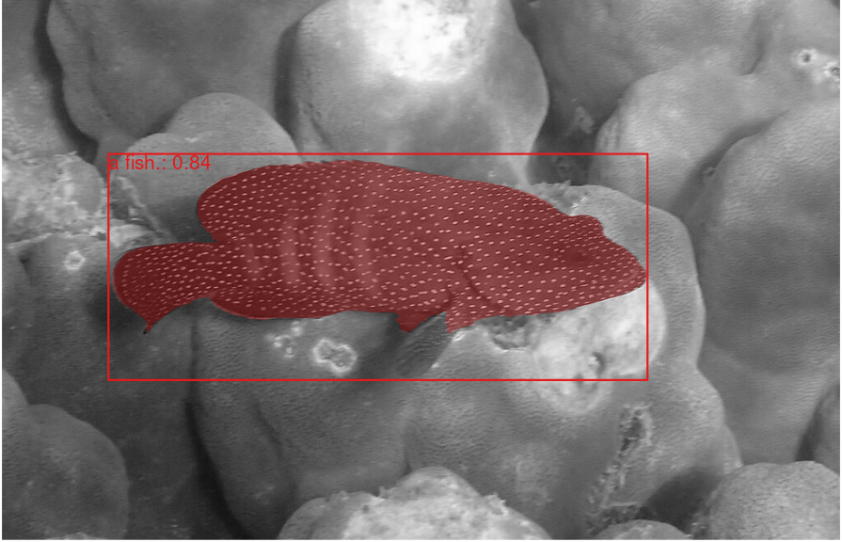

Figure 1 Result of grounded segmentation. Plot produced by plot_seg_results. Confidence score for the object detection (0.84) along with the label (“fish”) are shown in the top left of the bounding box.
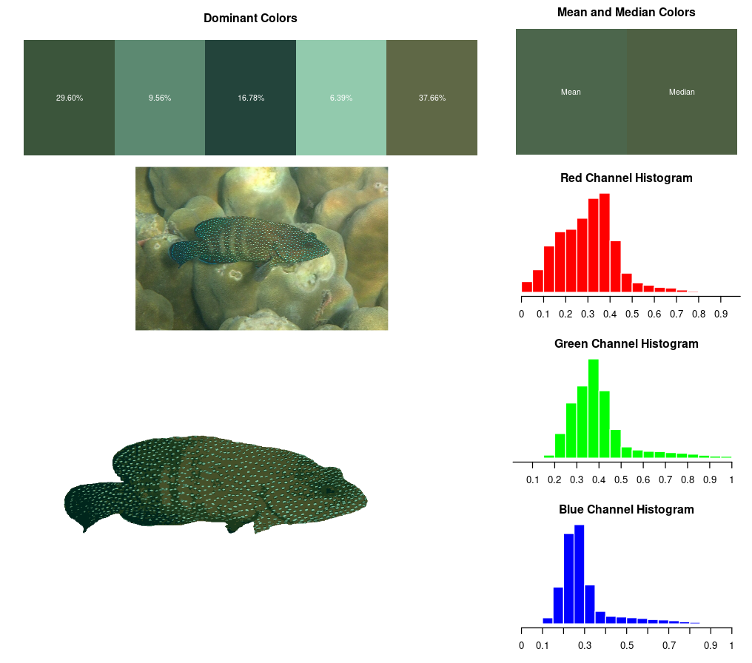

Figure 2: Results of color analysis plotted by plot_color_info. The dominant colors are displayed across the top along with the mean and median colors of the final mask. The right shows the red, green, and blue histogram values between 0 and 1. In the bottom left, the original image and final mask (recolorized based on dominant colors) are shown.
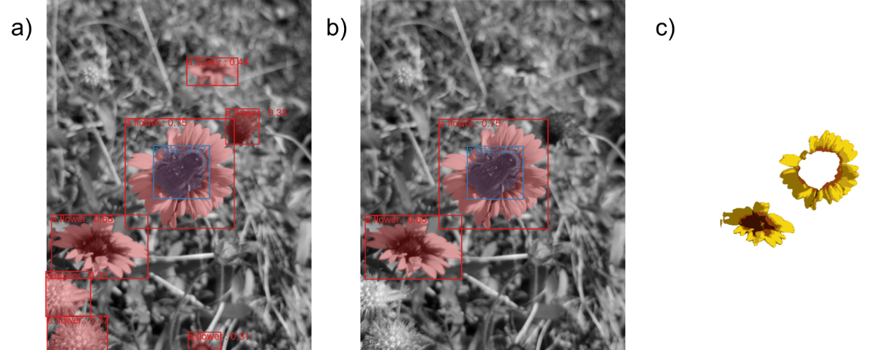
Figure 3: An example illustrating multiple instances of the same object (flower). a) All objects detected. b) Objects above a 0.5 score threshold. c) The final mask for all flowers above a 0.5 confidence threshold and the bee object removed.
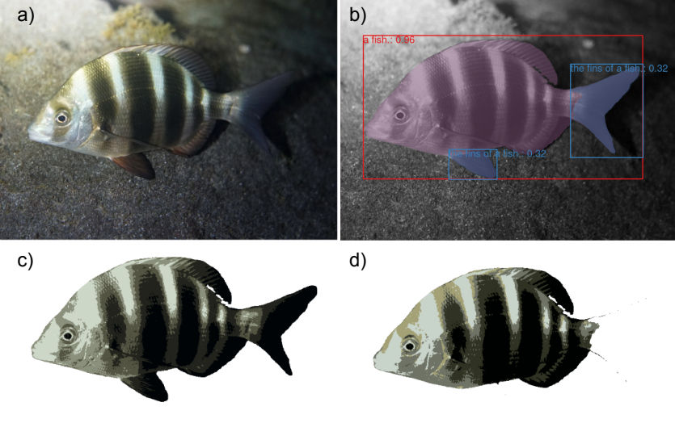

Figure 4: a) The original image. b) Object detections (bounding boxes) and segmentations (red and blue colored masks) of the original image. c) The recolorized image when the entire “fish” object is used. d) The recolorized image when detected “fins” are removed from the “fish” mask. The lighter colors (notice around the eye) appear lighter better matching the original image.

