2 BASIC

2.1 Introduction

An understanding of the workings of BASIC is necessary if it is required to incorporate machine code routines within BASIC programs, or if special utilities, e.g., ‘Renumber’, are to be written.

2.2 Memory map of BASIC

BASIC is rather greedy on the RAM – here is how it uses its memory:
#0000 – #00FF – almost all is used by BASIC – see Chapter 5.
#0100 – #010F – used when converting floating-point numbers to
strings.
#0110 – #01FF – the normal 6502 stack area.
#0200 – #02FF – partially used by the non-standard parts of BASIC
(e.g., DRAW and MUSIC).
#0300 – #03FF – an input/output area used by the 6522. This is not

RAM.
#0400 – #04FF – not used by BASIC – reserved for use with the disk
system.
#0501 – ( #9C) – 1 – the BASIC program occupies memory as far as
indicated by the address in locations #9C and #9D.
( #9C) – ( #9E) – 1 – any simple numeric variables are stored here,
along with the identification of each string variable.
( #9E) – ( #A0) – 1 – numeric arrays are stored in this area, along with
the identification of string arrays.
( #AO) – ( #A2) – this area of memory is unused. It can be seen that
pointer #A0 reaches up to meet pointer #A2 coming down.
(gA2)+1 – (#A6) – this area is used for storing both permanent and
temporary strings of data. Temporary strings are only cleared
when there is no more room below #A2, or when the FRE function is used.
#9800 – #9BFF – a copy of the standard character set is created here
when a HIRES command is executed.
#9C00 – #9FFF – a copy of the alternate character set is moved here
for use in HIRES.
#A000 – #BFDF – video memory used in HIRES mode.
#B400 – #B7FF – the standard character set when in TEXT mode.
gB800 – #BBFF – the alternate character set when in TEXT mode.
#BB80 – #BFDF – the video memory when in TEXT mode. Note
that this overlaps part of the alternate character set.
# BFEO – #BFFF – unused.

2.3 The format of a program

A program is stored in a completely different way from its external appearance. If you enter a simple program and then use PEEK to see what has been entered, you will not find evidence of either the program keywords (such as SHOOT) or of line numbers.
Each line is stored in its correct place in the program in an exact way. Consider the example:

10 POKE4,3 20 END
Here is how that is translated:
#0501,2  #503,4  #505  #506  #507  #508  #509  #50A,B  #50C,D  #50E  #50F  #510,1  #512 | Link address to the next line in the program – in this case,  #50A. (Remember that the low byte of the address is  always first.)  Two-byte binary form of the line number, e.g., #0A.  A one-byte ‘token’ which means ‘POKE’ – #B9. All BASIC  keywords have a unique token value, always between t80  and #FF, as this conserves memory and makes it quicker  to execute an instruction (Table 2.1, page 12, gives a list of  all possible tokens).  The ASCII code for ‘4’ – 434.  The ASCII code for comma – #2C.  The ASCII code for ‘3’ – #33.  An end of line indicator of #00.  The link to the next line – #510.  Line number 20.  Token for END – 080.  End of line – #00.  End of program’s link field – always contains a value < 256. In other words, #511 must be zero, but #510 could be anything.  Start of free space.
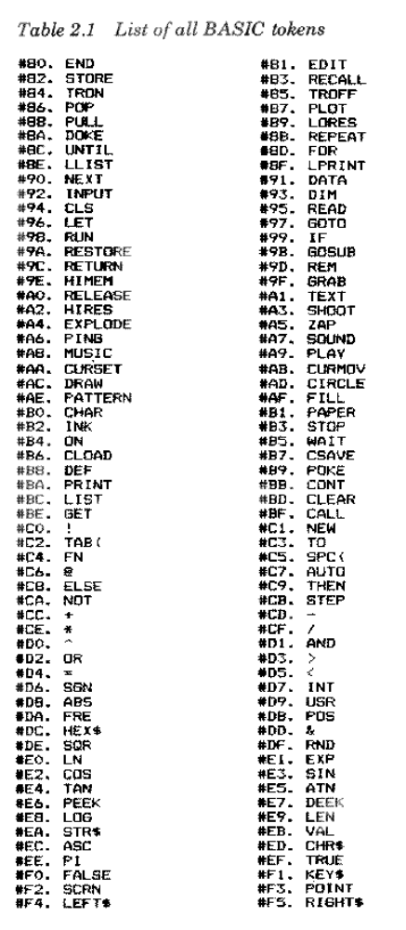
Note that the tokens listed are those for Vl.l ROMs. The only differences for V1.0 ROMs are:
‘STORE’ is ‘INVERSE’ and ‘RECALL’ is ‘NORMAL’.
The use of the link address is to allow a quick method of locating a specific line. You can try this yourself by typing:

I = #501: REPEAT: J = I: I =DEEK(I): UNTIILI <256: PRINT J
which finds the highest address of your program. Since the links affect the ‘LIST’ command, you can have endless fun altering the links of a program so that, for instance, a program lists itself backwards!
Since the line number is always stored in a 2-byte binary format, it must be realized that there is no saving in having a line number of 5 as opposed to 50 000 – except where a GOTO or GOSUB occurs. GOTO 12345 takes up 6 bytes, but GOTO 5 only needs 2 bytes.

2.4 Pointers

As mentioned in the memory map, there are a number of pointers used by BASIC to separate a program from its variables and arrays. Not all of these are useful: #9A is the start of the BASIC pointer, but BASIC refuses to work if you move it from its normal value of #500.
The most important pointer is that at #9C which gives the address of the start of BASIC variables – or the end of the BASIC program + 1. Printing the DEEK of #9C is often more useful than the FRE command since it gives you the exact position of the end of your program. When a program is saved, this pointer is used to give the upper address limit. It follows, therefore, that by adjusting the pointer at #9C you can save more than just the BASIC program using a single CSAVE – though remember to DOKE the correct value before you do anything else after you have loaded back. The Oric assumes that #9C is always correct, adding or subtracting values as a program is altered.
When a BASIC program is loaded the upper load address is automatically stored back at #9C. Version 1.0 owners should beware of loading machine code programs in on top of BASIC programs since the #9C pointer will then point to the end of that machine code section. The solution to this is to either correct #9C or load machine code routines before loading a BASIC program. Version 1.1 owners need not worry about this particular fault.

HIMEM
The HIMEM command is often most unhelpful – especially on V1.0 machines. In cases where you cannot persuade your machine to do HIMEM correctly, simply DOKE #A6 with the value before running the program. If you wish this to be done as part of your program, you will also have to alter #A2 to the same value as #A6, otherwise strings will be placed in the wrong part of memory.

2.5 Numeric variables

All calculations are done in ‘floating-point’ arithmetic. This means that an expression such as ‘1+1’ presents as much difficulty as ‘3.1415+9.7373’.
When you assign a value to a variable, as in ‘LET A=52’, this variable is stored away in a 7-byte area comprising:
Two bytes containing the identification ‘A’.
Five bytes containing the floating-point representation of the number. The exact format of these 5 by’tes will be described in Chapter 6.
The identification is simply the first two characters of the variable’s name, or one character followed by #00. The top bit in each of these can be set for the different types of variables – for a normal numeric variable both bits are clear.
For the fastest possible calculations, always use simple numeric variables. It must be stressed that ‘10 I=I+4’ is slower than ‘10 I=I+ J’.

2.6 Integer variables

These are stored in the same amount of memory as for normal variables, but the format is different:
1. Two bytes of identification (as before) with the topmost bits set in both bytes.
2. A 2-byte binary value of the integer stored in twos-complement form with a high byte followed by a low byte (i.e., against the usual convention).
3. Three unused bytes containing zero!

The advantage of using integer variables is only where it would save the use of INT. Contrary to many magazine articles stating the opposite, there is no saving in a program that uses integer variables (but see integer arrays!).

2.7 String variables

Any string variable has two components:
1. An identification of the variable’s name, occupying 2 bytes, as for numeric variables. To identify the variable as a string the second byte has the top bit set. This identification is followed by the length of the string, the address of the string, and two spare bytes.
2. The string of characters must be located somewhere in memory.

The first component is in the area between (#9C) and (#9E) – as for any numeric variable. The second component, however, can be in two distinct areas:
- If a program assigns a definite value to a string variable, with either READ or LET, then the first component of the string points to the place in the program where the string has been entered. So, unlike some other computers, the Oric does not waste memory space by repeating the same set of characters.
- If a string is modified in some way, e.g., LEFT$ is used, or one string is moved to another then the resultant string is placed in the string temporary space which lies between the top of available memory and the end of array space. The pointer to the next string space works backwards through memory so that new arrays can be added without the need to reorganize the strings. Since a string could be created that makes an earlier version redundant, it should be noted that the string area will eventually become full. When this happens, or when the FRE function is called, a subroutine known as ‘garbage collection’ is entered and all unwanted strings are removed. Garbage collection can occur at any time when a string is being created and can take several minutes to complete. The length of time that garbage collection takes is in direct proportion to the quantity of permanent strings.

2.8 Arrays

Each element of an array is stored in the same format as an equivalent single variable, but without the wasted space. For the integer arrays only 2 bytes are needed per number stored.
An array is stored in sequential order in memory, e.g., consider the array A(1,1,1). The array is stored working on a left-to-right basis:
A(0,0,0),A(1,0,0),A(0,1,0),A(1,1,0),A(0,0,1), etc.
For each array there is an overhead of at least 7 bytes in the memory area between pointer #9E and #A0
This area is made up as follows:
1. Two bytes identifying the array name – exactly as for variables, with the top bits set or cleared to indicate the type of array.
2. A 2-byte binary length which gives the exact amount of memory occupied by this array (excluding the text part of a string).
3. One byte which gives the number of dimensions.
4. For each dimension, working from right to left, there is a 2-byte number which gives the dimension plus one (remember that you can have a zero subscript when accessing part of an array). This number is stored with the high byte followed by the low byte.

2.9 READ and DATA

It is often useful to be able to use READ in a more controlled way – reading from a particular line of DATA, Some more advanced BASICs have this facility – this is often known as RESTORE N, where N is the line number from which DATA is to be read.
The READ command does not keep account of the next line number from which to read, but instead uses #B0 store the last address in memory where DATA was read. After each READ command, the line number used is stored in #AE,F so that an error message can report on the current data line (for ‘OUT OF DATA’, etc.). Writing to #AE,F will have no effect on READ operations.
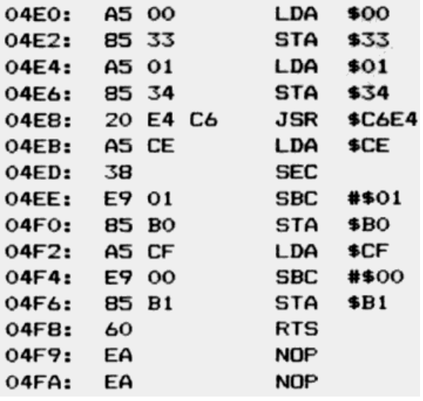

A RESTORE N FACILITY
Only a very short machine code program is needed to give BASIC this facility, which has been listed below in Program 2.1. Although the routine has been put at address #4EO, it will work at any spare memory location.
Version 1.1 ROM owners should change #4E8 to ‘JSR #C6B9’.
The machine code routine takes the line number stored at address 0,1, calls a ROM routine to find the address of that line, and stoics that address minus 1 at #B0 to #Bl.

USING RESTORE N
A BASIC program has been listed below (Program 2.2), for V1.0 owners, which demonstrates how to call the machine code routine. Program 2.3 is the listing for V1.1 owners – the only difference is the JSR address in machine code.
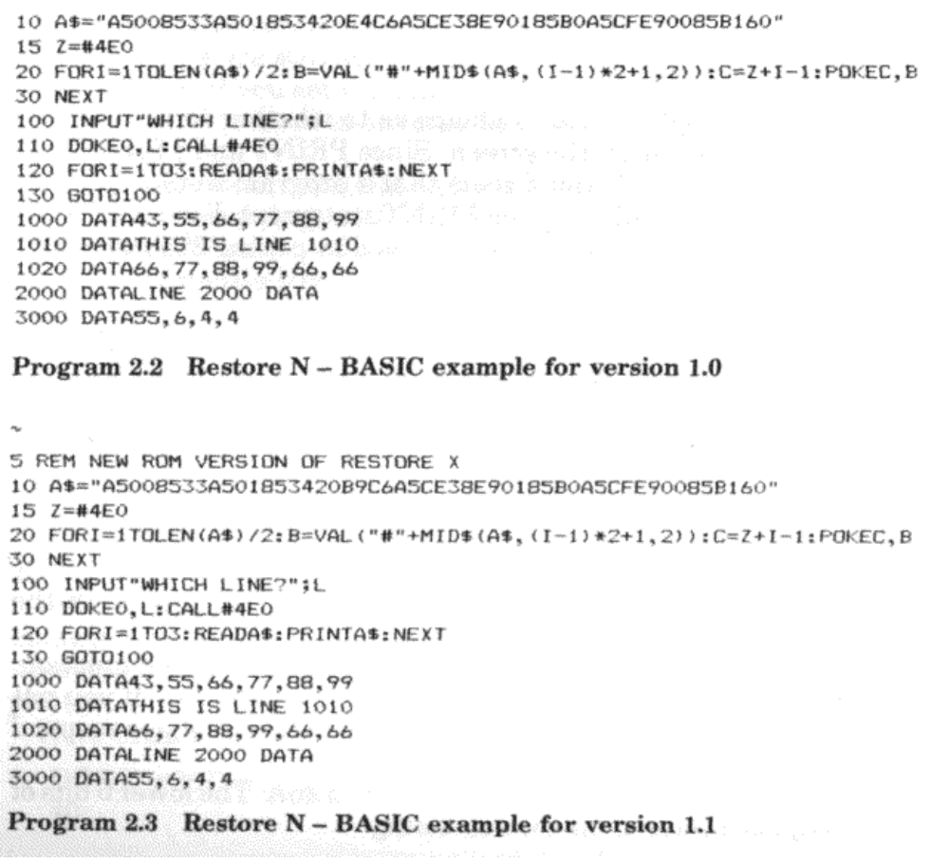

2.10 Using RND

The RND function will start from the same sequence of numbers every time you start up an Oric, providing the argument which follows RND is positive. Although it is not made clear in the manual, when the argument is negative this starts off a new sequence of random numbers.
It follows that in order to make RND truly random, you must supply it with an initial negative random seed. One of the software timers, incremented 100 times per second, can be employed here. Unless you do a WAIT command, and providing there has been some sort of user input (to delay the machine by an unknown time), you can use the third timer at #276,7. For example:
5 GET Z$
10 A=RND( – DEEK(#276))
Note that A itself is not a very random number – it will usually be a number smaller than 0.01 – but any RND afterwards should be correctly balanced between 0 and 1.

2.11 Using a printer
It is often required to make a choice as to whether to print something on a printer or on the screen. Since PRINT and LPRINT are different commands, it would seem that a program would need two separate lines to handle any one PRINT statement. Fortunately for us, the LPRINT command can be achieved by poking 255 into #2F1 and using PRINT. This will stay in force until either:
- A proper LPRINT command has finished.
- The program returns to command mode.
- Address #2F1 is reset to zero.

Note that this affects all types of PRINT – even the printing of prompts on INPUT commands!

2.12 The Oric’s status bytes

There are two locations in page 2 which are concerned with the status of the keyboard and the screen.
The first of these is at #20C and controls the CAPS lock function. This location is 127 when CAPS is off and 255 when on. If you put any other value into 420C, then the Oric will no longer respond correctly.
The most important status location is at #26A. The lower 6 bits of this byte each have their own meaning:
BIT 0 – cursor ON when set.
BIT 1 – screen ON when set.
BIT 2 – not used.
BIT 3 – keyboard click OFF when set.
BIT 4 – ESC has been pressed.
BIT 5 – columns 0 and 1 protected when set.

This means that you can POKE into #26A in order to turn off keyboard click, etc., rather than the unpredictable method of printing control characters.
For example, POKE #26A,10 turns off keyboard click and the cursor.

2.13 INVERSE and NORMAL

Version 1.0 owners will recognize these two commands as they crop up when listing all the tokens. Version 1.1. users have STORE and RECALL instead, but what did INVERSE and NORMAL actually do?
Although the commands do not actually work, on the V1.0 machine there are still some instructions that relate to them. The theory is that if you set the top bit when displaying a character on the screen, it is printed in ‘inverse’ colours – this has been explained in Chapter 1.
What remains in old ROM Orics is the code which OR’s location #2F7 (the inverse flag) with any character as it is printed. Unfortunately, PRINT nearly always strips off the top bit – otherwise it would be possible to use POKE #2F7,128 to create an INVERSE facility on the old ROM Oric. You can have some fun though putting different values into #2F7 and watching PRINT go haywire!
Incidentally, the only place where PRINT does not take off the top bit (again, only for version 1.0 Orics) is where control-D double height is in force, and when the second line is printed.

2.14 Creating windows of text

The normal way of presenting 27 lines of scrolling text is by no means fixed. It is possible with just a handful of DOKE commands to make just part of the screen scroll up – leaving the rest of the screen untouched. This has many uses where part of the screen is being plotted.
Here are the DOKEs needed for version 1.0 machines:
- DOKE #26D with the start address where scrolling is to begin minus 40.
- POKE #26F with the number of lines which are to be scrolled.
3. You must clear the screen after doing these commands.

For version 1.1 ROMs, the procedure is:
1. DOKE #27A with the start address of the screen.
2. DOKE #278,DEEK(#27A)+40.
3. POKE #27E with the number of lines to scroll.
4. DOKE #27C, (PEEK( #27E) – 1) *40 – this is the number of characters to be scrolled up and must agree with location #27E.

The CLS command should be issued after setting up a different format for the screen.

2.15 Controlling PRINT

On version 1.1 machines the PRINT @ facility allows you to print at any place on the screen. This is also provided on 1.0 machines by way of an add-on machine code routine in the manual, but no explanation is given on how it works. If you wish to use the general PRINT subroutine in a machine code program, you will need to know a little about how PRINT works in this respect.
There are two locations which control where the next PRINT goes to: #268 – the number of lines down – and #269 – the number of lines across. These are relative to the start of the screen as defined by #26D (version 1.0) or #27A (version 1.1). On version 1.1 machines you also have to write the address of the start of the line to #12,3.
On version 1.0 follow this example of moving to D lines down and A characters across:
100 POKE #268,D – 1:PRINT:POKE #269,A
Here is the same line for version 1.1:
100 POKE#268,D:POKE4269,A:DOKE#12,DEEK(#27A)+(D – 1) *40
To avoid large numbers of solid blocks appearing everywhere, it is recommended that you turn off the cursor before moving around the screen.

2.16 Bugs in BASIC

Most people will be aware of one or two problems with version 1.0 BASIC, the most notable example being the TAB function, which is quite useless (although the previous section should help with the problem).
In this section, we look at all the bugs and, where relevant, how they can be overcome. First of all, here are the quirks found in version 1.0 machines.
1. TAB and COMMA do not work correctly. It is best to use either SPC or, alternatively, POKE #269 with the TAB position.
2. STR$, when packing a positive number, puts the attribute ‘2’ at the front instead of a space. This often results in green numbers! The cure is to use MID$ to take off the unwanted character or to define a new STR$ function using the & function.
3. ELSE does not work under several conditions, for different reasons, so it is best to simply avoid the command altogether.
4. HIMEM is not set correctly on power-up. The solution is to always put in a HIMEM command at the start of the program, e.g., HIMEM #97FF.
5. When in high-resolution mode, the message ‘SAVING’ is still output to address #BB80 – putting one line of junk onto the screen. There is no easy cure for this problem, apart from writing your own save-to-tape routine. If you are saving a high-resolution screen, then first copy it to a free area of memory and save that part of memory.
6. When the printer is in the middle of either an LLIST or a series of LPRINTs, characters are often corrupted into ‘squiggles’. This is because the interrupt routines which read the keyboard frequently conflict with the use of the printer. The solution is to stop the clock (CALL #ED01) before printing and to start it again after printing is complete (CALL #ECC7). If you are using LLIST, then you can type:
CALL #ED01: LLIST
and then use the Reset button underneath.
7. When you use CLOAD from within a program, BASIC unkindly ends the program once the load is complete. To get around this, you could do a series of CALL instructions instead of CLOAD. Chapter 4 contains all the necessary information.
8. The function HEX$ has an unfortunate tendency to print just the hash sign for zero. This condition should be specially tested for in your program.
9. The GET command refuses to believe that you have pressed the single quote key and instead returns an empty string (“ “). It is important that you test for this condition before using one of the functions such as ASC.
10. If a print line starts with control characters – e.g., ESC N, etc. – then the protected columns 0 and 1 are used, overwriting any PAPER and INK attributes. Always start the line with a non-attribute character, such as space,
1
11. The alternate character set is exactly one bit out of place! The purpose of the alternate character set, when not modified for a special use, is to provide a ‘chunky’ graphics capability. The format of such characters is identical to that used in the BBC’s CEEFAX system, allowing a resolution of 80 chunks across by 84 chunks down. Each character cell contains six such chunks, which means that 64 graphics definitions are required to allow for all possibilities. The Oric’s character set has in fact been set up for this. Characters between 32 and 95 contain all variations between a totally blank cell and a filled cell. However, in version 1.0 the entire character set must first be divided by 2 (and therefore shifted to the right) before it can be used. This can be done either with a simple BASIC loop:
FORI = #B900TO #BAFF: POKEI,PEEK(I) /2: NEXTI
or by using a short machine code routine:
LDY 000
LOOP: LSR B900, Y
LSR BA00, Y
DEY
BNE LOOP
RTS
12. If the single quote character is found at the start of a DATA item, then because of confusion with the REM facility, the rest of the DATA line is ignored. Use double quotes around any DATA items containing single quotes.
13. When loading in a machine code program, be warned that the ‘end of BASIC’ pointer at #9C,D is altered to reflect the end address of the machine code.
To overcome this you could either reset the value at #9C to #9D after the load or make it a rule to always load the machine code routines first.
14. In the instruction POKE N, #8, the hexadecimal sign upsets BASIC, and zero will be POKEd. Always use a decimal value or a variable instead. This fault is the reason why you will often see decimal numbers mixed with hexadecimal numbers in this book.
The DOKE command does not suffer from this fault.
15. One interesting bug is that POINT will work in text mode!
- When loading a file, the filename is only printed when it is actually supplied within the CLOAD”” command
.
- Although potentially useful, it is still a fault that makes the screen scroll down when the cursor is moved too high.
The following faults lie in version 1.1 ROMs:
1. ELSE fails to work should the colon character occur in quotes after the ELSE. For example: IF A=1 THEN PRINT ELSE PRINT “HELLO:”.
2. One very obscure problem arises when:
(a) The cursor has been turned off.
(b) A character is placed at the very spot where the cursor would have been.
(c) That character is ‘inverse’ – between 128 and 255.
When this happens, and providing interrupts are running, that character is forced back to ‘normal’ mode – losing the top bit of the character.
One solution for this problem is to force the current cursor position to a place on the screen (or even off the screen!) where it can do no harm. This is done by poking locations Ø268 and t269 as described earlier.
3. One very minor bug is that going into HIRES when in control – S mode results in BASIC writing to the wrong part of the screen. Make sure that you have enabled the screen before using the HIRES command.

