3. USING MACHINE CODE

3.1 Advantages of machine code

BASIC, though easy to use, hard to misuse, and ideal for simple programs, has two serious drawbacks:
1. It is very slow to run.
2. It can often (but not always) use up a large amount of memory space.
One alternative language, FORTH, although faster than BASIC, is quite difficult to use. It is unlikely that you would ever see a program on the market which used FORTH, for the simple reason that the FORTH language would have to be sold as well.
Machine code, on the other hand, can be loaded and executed on all Oric machines. Indeed, in many cases a machine code program will be easier to convert to a different machine than its BASIC equivalent.
The speed of a computer like the Oric is not always appreciated. A simple machine code instruction takes two microseconds to complete, whereas any single BASIC command will take at least 2 milliseconds.
If you intend using machine code you will quite definitely need two things, in addition to this book:
1. A book on the programming of the 6502.
2. An assembler/disassembler program. The one used in the preparation of this book was ORICMON from Tansoft I.td. Without such a program, you will have to work out the machine code instructions by hand. An assembler allows you to enter just a three character mnemonic – such as LDA – and it works out the actual machine code values – e.g., LDA # is #A9.

A full discussion of machine code is beyond the scope of this book, but at the end of this chapter you will find some advice on the more difficult aspects of this subject. The book 6,502 Software Design by Leo Scanlon is particularly recommended as both a tutorial and a reference guide.

3.2 Storing machine code

A programmer has no choice as to where a program written in BASIC resides – he or she is stuck with the area #501 upwards.
A machine-code programmer has the whole of the machine available, at least in theory. If a machine code program will never return to BASIC, or use a subroutine in the ROM, then that program can be located anywhere between #400 and #B4FF, and can use the area #00 to #2FF as a scratchpad area (not forgetting to allow a certain amount of room for the stack).
The programs and subroutines in this book are of the kind that always return to BASIC, so it is important not to upset BASIC too much. This means not overwriting certain RAM areas in pages 0 and 2 and allowing BASIC to create variables and strings. You can use HIMEM to limit BASIC’s memory, and can thereafter use the remaining memory for your own needs. Chapter 5 explains which areas of page 0 and page 2 RAM are used by BASIC.
If you are writing an add-on machine code program in order to manipulate a BASIC program, then you really want to put your program in a place which is unused. The most common of these are:
1. The stack area – from #110 upwards – can be used by short programs. Providing that you do not do many GOSUB, FOR, or REPEAT commands, you will be able to use up to about #1CO. The stack area is never cleared by BASIC, except during normal use.
2. From #400 to #4FF, 256 bytes are available. Be warned, however, that the Oric disk system makes use of this area.
3. The first 256 bytes of each character set are unused, so programs can be put at #B400 to #B4FF and #B800 to #B8FF (or in HIRES mode at #9800 to #98FF and #9C00 to #9CFF). Although the Reset button on the Oric causes the character set to be regenerated these areas are not affected.
4. Since the alternate character set is rarely used the entire area between #B800 and #BB7F is available for a machine code program. This area of RAM is ideal for facilities like Renumber.
5. Another ‘hidden’ area lies between #BFEO and #BFFF. This area will only be overwritten if HIMEM is incorrectly set, and survives the commands ‘HIRES’, ‘TEXT’, and the Reset button.

3.3 Types of machine code program

When you write a program that is all in machine code you do not need to worry about interfering with BASIC. If your program calls the BASIC ROM for certain functions you should keep clear of the same areas of RAM that the particular subroutine uses. For instance, if using the MUSIC command keep away from the parameter area #2E0 to #2EF.
Since a machine code program can be made to autorun at the start address of the load, it makes sense to use this feature and make your program start at the earliest address.
If you are using an Assembler program, such as ORICMON, you will also have to avoid the area of RAM used by that program.
A common type of machine code program is used when a BASIC program needs an extra facility, or perhaps a machine code subroutine is used to speed up part of the program. In this case the BASIC program will often use DATA statements in order to set up the machine code. A more efficient way, for larger sections of code, is to load in a separate machine code file from tape or disk.
Another method is to put the machine code after the BASIC code and modify the #9C pointer before saving to encompass the machine code. The first instruction in the program should reset the pointers #9C, #9E, and #A0 back to the end of the program.
For example:
BASIC program #501 – #lF00
M/C program #2800 – #2E00

Before saving, DOKE #9C, #2E00. In the program:

1 DOKE #9C, #1F02:CLEAR
An example of a BASIC program creating a machine code subroutine can be found below in Sec. 3.4.
The third type of machine code program occurs where a BASIC program is being modified. Normally such a routine will be loaded separately from the BASIC, although you must remember to reset the #9C pointer on version 1.0 machines – this can often be done by the machine-code routine itself.

3.4 Creating a machine code program

Nearly all the programs in this book have been listed in terms of the assembly mnemonics and the actual machine code. In order to set up the programs you are best advised to use a machine code monitor/ assembler package. If such a facility is not available, you can quite easily use a short BASIC program to read in machine code.
Program 3.1 is an example of a program to read in a short section of code by using DATA statements.
The program itself is very useful, as it totally disables the use of control – C. This works by testing for ASCII code 3 in a routine that is patched into the slow interrupt link.
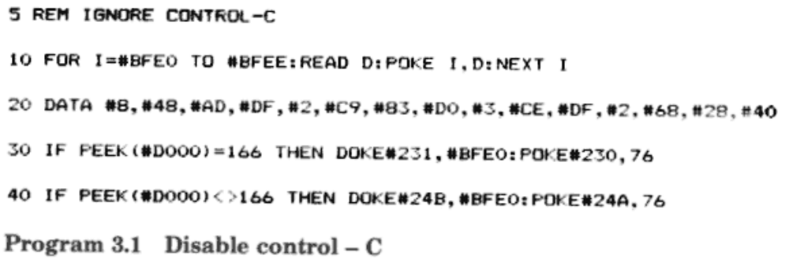

3.5 Calling a machine-code routine

A machine code program which is completely self-contained can be automatically run by using the AUTO command. Alternatively, a CALL can be used to start the program off.
Where a BASIC program calls a m/c subroutine, CALL is often used. If a CALL is to return to BASIC the subroutine must end with the RTS (#60) instruction. Do not worry about saving registers when writing such a subroutine.
CALL is also useful when entering add-on subroutines, such as ‘Renumber’, when it is used as an immediate command.
In addition to CALL NN, there are several alternatives:
l. USR and & functions.
2. ! – the extension command.

From the point of view of a machine code subroutine, CALL NN is much the same as!, and USR(X) is identical to &(X). One difference is in the setting-up. For the extension command ‘!’ you DOKE the start address into #2F5, and for ‘&’ you DOKE the address into #2FC. The USR facility uses DEFUSR in order to set up the start address.
The difference between ‘&’ and ‘!’ (or USR and CALL) is that & is a function that returns a value; the ! command can only take in values. The rest of this chapter will only deal with & and !, although the same considerations apply for CALL and USR.

3.6 Passing information to machine code routines

The most common method of passing small amounts of data to a machine code routine is with the DOKE and POKE commands. For small data areas, such as for addresses, use the area #0 to #B in page 0. Chapter 5 will help you in determining other areas of memory available.
The! and & keywords can both take parameters, e.g., &(A1*3), and this will be explained in Sec. 3.11.
A machine code routine could read a BASIC variable, but this would involve quite a bit of searching and conversion.

3.7 Patching into BASIC

Although BASIC is in unalterable ROM, there are several cases where it jumps out to an area of RAM. The reasons for doing this are:
1. It lets programmers patch in extra facilities.
2. It allows for add-ons, such as disks.
3. It can he more efficient to write some instructions in page 0.

Each of the patch areas has been listed below, with the address for version 1.1 ROMs given in brackets:
At #1A – a jump vector to the routine that prints ‘READY’. By changing this jump to your own routine it is possible to:
1. Trap errors.
2. Prohibit control – C.

See the ON – ERROR facility of Chapter 8.
At #E2 lies a very important subroutine. At #E2 the address at #E9,#EA is incremented. Then at #E8, the contents of the address at #E9, #EA are loaded. This provides a very fast subroutine for reading in characters from the program.
After getting the next character, the routine jumps back into ROM. It is a very simple matter to alter the routine at #E2 in order to jump to your own subroutine. By doing this, you can look for special instructions (perhaps ‘IMPLODE’ and ‘PONG’!). ~~~ important consideration is that you jump back into the ROM as though nothing had happened – remember to save all the registers.
#228 ( 4244) is the address of the ‘fast’ interrupt jump. By altering the jump address at #229,A (#245,6) you can provide your own interrupt handler.
#230 ( #24A) is the address of the ‘slow’ interrupt routine. Control is passed to here at the end of the fast interrupt routine. Although 3 bytes are reserved here, there is only the single-byte instruction RTI present normally.
#228(4247) contains the jump vector for the NMI (Non-Maskable Interrupt) routine, which on the Oric connects to the ‘Reset button’.
On version 1.1 only, there are a few extra jump vectors located in page 2 which are concerned with input/output:
l. #238 links to the screen output routine used by BASIC commands like PRINT.
2. #23B jumps to the subroutine which finds which key was last pressed.
3. #23E jumps to the printer output subroutine.
4. #241 contains a jump to the subroutine that prints messages on the top line of the screen. Changing this jump could be useful if you want to stop messages like ‘Loading’ from showing.

By far the most useful of these patches is the slow interrupt jump which allows you to make the maximum use of the system’s interrupts.

3.8 Interrupts

The purpose of an interrupt is to stop a program temporarily and to enter a special subroutine in order to handle a priority condition. An interrupt on a computer will often be caused by a peripheral (such as a card-reader) announcing that it has data to transfer.
The Oric takes its interrupt line from the 6522 VIA device which is capable of causing an interrupt for a variety of reasons. Unless the Oric is loading or saving to the cassette port, the 6522 is set up to create an interrupt at exact intervals of 10 000 machine cycles – or every 10 ms. In other words, the machine is interrupted every one-hundredth of a second. (You should be warned that some BASIC instructions may cause an interrupt to be missed – e.g., PRINT.)
The length of time between interrupts is stored on the 6522’s timer-1 latch at #306,7. By altering locations #306,7 you affect:
1. The repeat rate on the keyboard.
2. The flash rate of the cursor (but not the automatic flash of the VDU chip).
3. The speed of the WAIT command.
4. The speed of processing is inversely affected. This happens because the interrupts ‘steal’ time from the processor; the more time spent in interrupt handling, the less is available for the main task.

When an interrupt occurs, and providing that the ‘fast interrupt’ jump vector has not been altered, the following events take place:
- The three software timers are decremented by one. These are 16-bit counters located in page 2 of memory and will be discussed in Sec. 3.9.
- If the first timer has reached zero, after counting down from 3, the keyboard is scanned in a search for any keypress.
3. If the second timer has reached zero, counting down from 25, the cursor is flashed on or off.

Note that the timers being discussed are merely counters in RAM, and should not be confused with the timer-1 and timer-2 of the 6522.
When an interrupt occurs, the 6502 jumps to the address given by locations #FFFE and #FFFF. As was discussed in Sec. 3.7 this address is in page 2 of RAM, and the jump into ROM can be modified for one’s own requirements.
If the fast interrupt routine does jump into ROM the last operation is to jump back to the slow interrupt location in page 2, containing the RTI instruction.
You would use the fast interrupt patch if you wanted to add some processing before the keyboard is scanned. The slow interrupt link allows you to add some processing after the keyboard has been scanned.
If you intend to modify the interrupt routines, remember:
1. Save all the registers that you use, and restore them before you finish.
2. Save any locations that might be in use by the system. For instance, if your interrupt routine calls the SOUND command you will need to save locations #2E0 to #2EF and #204 ( #204 is used when checking your SOUND parameters).

At the end of your interrupt routine, you will usually either execute the RTI instruction if all interrupt processing is complete, or jump back into the normal ROM interrupt routine (to read the keyboard, etc.).
Writing interrupt routines is much more difficult than writing a normal subroutine. For one thing, testing can frequently crash the whole machine, and often a fault will not show up for a long time. Two important points are:
1. Remember to save any location that could be used by both your interrupt routine and the main program.
2. Do not assume the state of any of the processor flags. Be especially wary of the decimal flag – use CLD or SED if you are doing any addition or subtraction.

Several programs in this book modify the interrupt patches, and by understanding how these work you will be able to create your own routines.

NON-MASKABLE INTERRUPT

The Reset button on the Oric does not in fact connect to the RESET line of the 6522. Instead, it activates the Non-Maskable Interrupt (NMI) line of the 6502. Whereas a normal interrupt can be disabled, the NMI causes an unconditional jump to the address contained in locations #FFFA, #FFFB. On the Oric, this is a jump instruction in page 2 of memory which on the Oric normally leads to a ‘warm-start’ routine in ROM. This sets up the 6522, clears the screen, initializes the character sets, and returns to command mode in BASIC.
When writing machine-code programs it is customary to alter the appropriate address in page 2 (see Sec. 3.7) so that pressing the reset button restarts the machine code program. The button can be disabled by typing POKE DEEK (#FFFA),64.
The ‘BRK’ instruction causes an interrupt, but sets the BRK flag in the 6502 processor. It is used by some machine code monitors as a terminating command – just as RTS is used to return to BASIC after a CALL instruction.
Use RTS instead of BRK if your machine code monitor expects it.

3.9 Software timers

This subject was mentioned when interrupts were discussed. There are three 16-bit counters stored in RAM, maintained by the interrupt routine. The first two timers are in permanent use on the Oric: the first counts three interrupt cycles (normally 30 ms) before each keyboard read while the second counts 25 interrupts (250 ms) before flashing the cursor on or off. The third software timer is only used occasionally by the system – for WAIT, TEXT, and (in version 1.0 only) when using the HIRES command. This means that it is available for use within your own program. With very little trouble, you can time events to one-hundredth of a second.
Remember that the software timers will only be decremented when interrupts have been enabled.
Each of the three timers occupies 2 bytes, in the normal tradition of the low byte first, starting at #272. Therefore, the all-important third timer is located at #276,7. The WAIT command can be simulated by a simple use of DOKE and DEEK into location #276, but with the advantage that the program can do further work while the third timer is counting.
Although it is a simple matter to set up this timer, there are a number of subroutines in ROM which handle each of the timers.
The A, X, and Y registers need to be set up as follows:
A – set to the timer number minus one. For instance, the third timer requires a value of two.
Y – set the Y register to the low part of the timer value.
X – set the X register to the high part of the timer value.

Here is a table of calls which relate to the software timers:

Name | Version 1.0 | Version 1.1
Start 6522 Clocks | #ECC7 | #EDE0
Stop 6522 clocks | #ED01 | #EE1A
Update timers etc | #ED1B | #EE34
Clear all timers | #ED70 | #EE8C
Read a timer into X Y | #ED81 | #EE9D
Write XY into a timer | #ED8F | #EEAB
Wait for time X Y | #EDAD | #EEC9

8.10 Machine code advice

As mentioned previously, a book on machine code is essential, not only to teach the subject but as a constant guide to the 6502. This section covers some of the more error-prone areas of programming, in the hope that you may learn from my own mistakes!

BRANCHES
The following observations may be useful:
1. Any branch will depend on one bit within the processor status register. Branch instructions work in pairs, e.g., BEQ, BNE; BCS, BCC.
2. The operand in the branch instruction gives the number of bytes, forward or backward, to jump. If this number is between 0 and #7F the branch is forward in memory; otherwise the jump is to a previous location. When a backward branch is required the operand is #100 minus the number of locations that you are jumping. For example: 1200 BNE 11C2 results in an operand of (#100 – (#1202 – #11C2)) = #CO.
Any good machine code monitor will work out branch offsets for you. An assembler will allow you to enter either an absolute address or a meaningful label.

COMPARE
A newcomer to 6502 programming can become confused with the CMP instruction when testing less-than or greater-than conditions.
The compare instruction works in a similar way to subtract as regards the use of the carry flag. When a subtraction is done, the carry flag is used to indicate a borrow when the value being subtracted is greater than the accumulator. The advantage of the compare instruction is that the A, X, and Y registers are not affected.
When writing a compare instruction do a mental subtraction of the value given in the instruction from the register value (A, X, or Y). If the result is zero, the zero flag is set. If the result is positive, including zero, the carry flag is set; otherwise it is cleared.

THE BIT INSTRUCTION
BIT is probably the least used of all the instructions – CMP is often used instead.
Like the compare instruction, BIT only alters flags in the processor status register.
If you wanted to examine a number of locations, picking out one bit, then you would load the accumulator with the bits to examine and just use BIT with each address. If you used the AND instruction, you would need to keep reloading the accumulator.
BIT also traps bits 6 and 7 of the location you are examining, reflecting them in the overflow and negative flags.
Because BIT does not affect the A, X, and Y registers, you can use BIT in a sneaky way to conserve memory. Consider the program:
TRY1 LDA #1
BNE CARRY-ON
TRY2 LDA #2
BNE CARRY-ON
TRY3 LDA #3
CARRY-ON:
This can be replaced by:
TRY1: LDA #1
#2C
TRY2: LDA #2
#2C
TRY3: LDA #3
CARRY-ON:
The ‘2C’ is the opcode for the 3-byte version of BIT. Here we use the fact that BIT does not alter the accumulator in order to skip past one or two load instructions. You will find this kind of confusing programming when you disassemble the Oric’s ROM.
The saving is so small as to be not worth the trouble, but it does demonstrate an interesting programming technique.

THE STACK
When using the stack remember:
1. In a subroutine you must leave the stack as you find it. This means that if you execute 5 PHA instructions, you must balance them with 5 PLA instructions. This is important because the RTS instruction will be expecting a return address on the stack.
2. To follow up the last point, here is a common mistake:
1000 PHP
1001 JSR 1234
1234 PLP; attempt to pass processor stack.
3. When saving all the registers on the stack, use a sequence such as:

PHP PHA TXA PHA TYA PHA
When you want to restore the registers, remember to reverse the order:
PI.A TAY PLA TAX PLA PLP
If you are saving an area of memory on the stack you will need to reverse the loop when loading back from the stack. For example, if this is your save routine:
LDX #F
A:
LDA 2EO,X
PHA
DEX
BPL A

then the reverse procedure is:
LDX #o
A:
PLA
STA 2EO,X
INX
CPX #10
BNE A

The stack provides the only way of examining the complete processor status register:

PHP PLA
Similarly, to set up the processor status register in one go:
LDA #47
PHA
PLP

DECIMAL INSTRUCTIONS
When a program goes unaccountably wrong always consider the state of the decimal flag. The normal state for the decimal flag is off. Many ROM subroutines will expect the decimal flag to be cleared, so remember the CLD instruction.
The decimal flag is only recognized when using either the ADD or SBC instructions, whereas INC and DEC will always work in binary.

SHIFT AND ROTATE
When using any of the shift or rotate instructions, remember:
1. There is always one bit coming away from the byte. This is always saved in the carry flag.
2. There is always one bit coming into the byte. This is either zero for shift instructions or the old carry flag for rotate instructions.
3. The rotate instructions work on 9 bits at a time. Therefore, if you rotate 0000 0001 to the right, the 1 will not appear on the left until a further rotate instruction.

CLEAR CARRY AND SET CARRY
Two simple rules apply here:
- Clear the carry flag before doing an addition. If adding numbers longer than 8 bits, leave carry alone after the first clear carry instruction; for example:
CLC  LDA 0  ADC 2  STA 0  LDA 1  ADC 3  STA 1  INCREMENT AND DECREMENT  Important points:  1.  2.  . | INC and DEC take no notice of the decimal flag – they always work in binary.  INC and DEC do not either use or alter the carry flag. If you want to increment a 16-bit value, use a branch instruction, as in:
INC 42
BNE B
INC 43
B:

 | When decrementing numbers, you have to use a compare instruction:
DEC 42
LDA 42
CMP #FF
BNE C
DEC 43
C: NOP
3. | When using INC or DEC with several bytes, remember that you can only safely do one set of INC or DEC instructions at a time. The following example employs such faulty logic:
INC 42 INC 42 BNE A INC 43
A NOP
RETURN FROM INTERRUPT

Remember to use RTI to finish an interrupt routine. The only difference between RTI and RTS is that with RTI the 6502 saves the processor flag on the stack. This means that an interrupt routine need not save the processor status register.

SUBROUTINES
When the jump to subroutine instruction is executed, the return address is saved on the stack. This address is saved high byte followed by low byte (this follows the 6502 convention of a low address being stored in the lower location). This return address on the stack is always one less than the real return address – the 6502 adds one to the program pointer before executing each instruction.

SEI AND CLI
On the Oric an interrupt can occur at any time. If you want to disable interrupts (which will stop the keyboard from being scanned and the cursor flashing) you can use the SEI instruction. CLI (clear interrupt disable) enables interrupts again.
Note that SEI does not stop the 6522 clocks from running, but it does prevent interrupts from being generated when the clocks reach zero.
SEI should be used when your program is using the stack area in a non-standard way.

3.11 Using the! extension command

The ! command allows you to create your own BASIC command. When BASIC encounters the ! token it jumps to the address stored at #2F5,6, assuming it to be a normal subroutine.

PASSING DATA
PEEK and POKE provide one way to send data between your extension subroutine and BASIC, but a better way is to put the data after the ! command, as you would do for any other BASIC command.
The pointer #E9, #EA will be identifying the byte following the! command as you enter your subroutine. You can (and must) use this pointer to extract all the data pertaining to the command. When you exit from your subroutine #E9, #EA must be pointing to the byte following the last byte in your command.
In order to look at each character, you can call subroutines at #E2 (which increments #E9, #EA) or #E8 (which does not increment #E9,#EA). After the call the next character is passed in the accumulator. This can be used to pass over delimiters, such as commas.

USING THE FORMULA EVALUATION ROUTINE
If you want the extension command to work with expressions (such as X+ Y) as well as fixed-format data, you may need to call the ROM subroutine which evaluates an expression.
This subroutine (at #CE8B for version 1.0 ROMs or #CF17 for version 1.1 ROMs) only needs the WE9, #EA pointer to be set up. At the end of the subroutine the #E9, #EA pointer will be correctly set to the character following your expression. Note that the expression evaluated can contain the normal BASIC functions, e.g., !X*SQR(Y), but be warned that the subroutine assumes that all words have been compacted into tokens – including such things as the +,–,*, and / operators. As in BASIC, expressions must be terminated with a comma, colon, or 000 (i.e., the end of a BASIC line).
There are two possible types of answer returned:
1. A string of characters. The information about this string is stored in an area of memory pointed to by the address #DR, WD4. In this temporary area there are three bytes: length (one byte) and address of string (two bytes). When the formula results in a string, location #28 is set to OFF. Once you have finished with the string, you must release the temporary area it used by calling either #D712 (version 1.0) or gD7CD (version 1.1).
2. A floating-point number. This number is stored in the floating-point accumulator (see Chapter 6). Location 028 is set to zero to indicate a numeric result.
If you want to convert the number into a signed 2-byte integer, you can simply call #D871 (version 1.0) or #D92C (version 1.1). This will return Y as the low byte and A as the high byte. For an example of usirv ! see Chapter 4.

3.12 Using the & extension function routine

Whereas ! can only be passed data, the % function not only expects data to be passed but also returns a value. The & facility assumes that g2FC, #2FD points to the machine code routine.

PASSING DATA
There are two types of data that can be passed – a string of characters or a number. In both cases, & must have an argument following, surrounded by parenthesis. For example, &(A$), &(4.3+S).
The formula evaluation takes place automatically on the argument, and the results are exactly the same as described in Sec. 3.11.
When a number is passed, you can either take it or leave it, but a string requires extra action.
If your subroutine has been passed a string, you must call subroutine #D7F1 (version 1.0) or #D8AC (version 1.1) in order to free up the temporary string space. This will also extract the necessary information, storing the length in the accumulator and the address of the string in #91, #92.

RETURNING DATA
Returning data will usually be the final thing that the subroutine does. Location #28 should be set to zero if you are returning a number, or #FF if the result is a string.
To return a number you simply leave that number in the floating-point accumulator at #DO to #D5 – see Chapter 6.
Returning a string is a little more complicated, since you must first allocate an area for it. This is done by putting the length (in bytes) into the accumulator and calling #D4FO (version 1.0) or #D5AB (version 1.1). This will leave the address of the new string at #D1, #D2. Once you have put the string at this address, you must finish the subroutine with:
PLA
PLA
JMP #D539 (for version 1.0)
JMP #D5F4 (for version 1.1)
When returning a floating-point number, you exit with the usual RTS instruction.

EXAMPLE: THE INSTR FUNCTION
On some computers you will find the ‘INSTR’ function. This searches for a string of characters within another string, returning its position, if found.
For example, INSTR(“ABCD”,”BC”,1) is 2 (the last parameter 1 indicates the start position of the search).
The subroutine of Program 3.2 simulates the INSTR function. The function is called by a statement such as: A=&(“T$,S$,N”).
String S$ is searched for within string T$, starting at position N. The quotes are used since R can only take one parameter; this means that you can only use simple variables (such as A$) in the actual statement.
The listing will work unchanged for version 1.0 owners, but users of version 1.1 ROMs should make the following adjustments:
9800 JSR D8AC
981D JSR CF17
982D JSR CF17
983D JSR CF17
9840 JSR D92C
987B JSR D499

To use INSTR, you must first type DOKE #2FC, #9800.

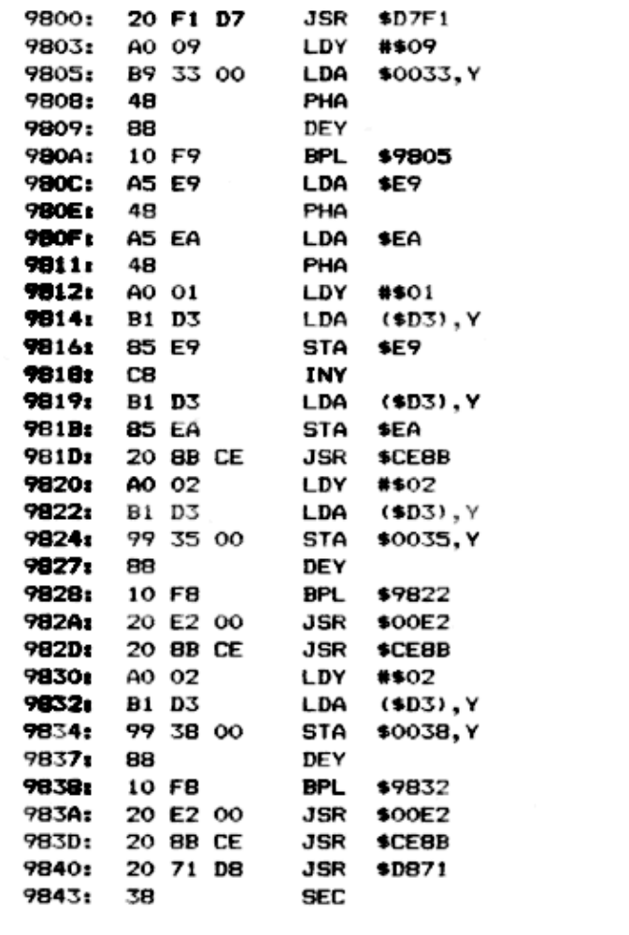
- 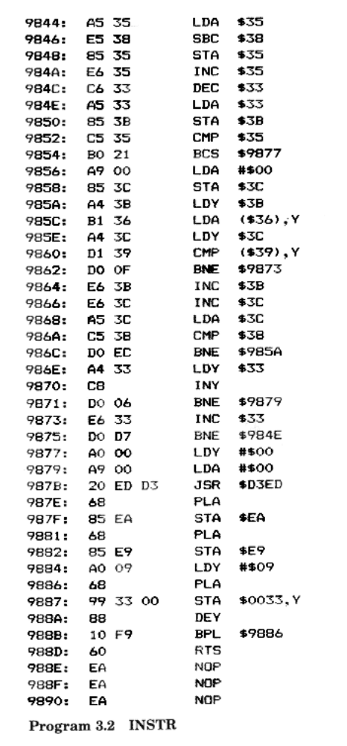

3.13 A real-time clock
Program 3.3 is a short program to give your programs a clock that can return the current time of day.
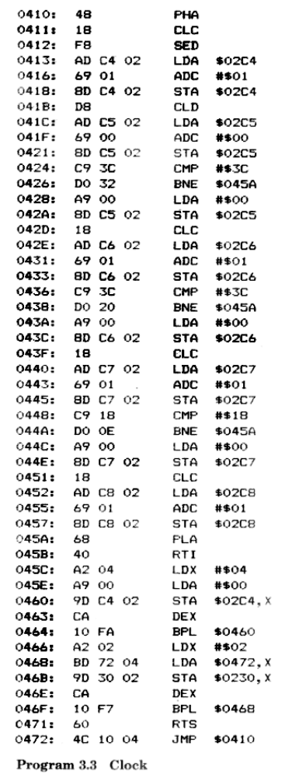
The time can be set up (and read back) using PEEK and POKE from the following locations:
#2C5 Seconds
#2C6 Minutes
#2C7 Hours
#2C8 Days
Location #2C4 is used to store one-hundredth second intervals – but this is not in a suitable form for reading.
Owners of version 1.1 ROMs should change the instruction at #46B to STA 24A,X. To start the clock CALL#45C.

ACCURACY
The clock will stay fairly accurate, except when certain commands are used. The most serious problems will arise when doing any tape saving or loading. A minor loss of time can happen during any sound command and when scrolling occurs.

3.14 Relocater program

To complete this chapter, here is a program that allows you to move a machine code program to a different address (Program 3.4). All 3-byte instructions are modified, where necessary, reflecting the new start address.
Since a program may reference locations near to itself, but not actually part of the program, the relocater needs five addresses:
#70, #71 Start address of whole area.
#72#,73 End address of whole area.
#78, 079 Start address of actual program.
#7A, #7B End address of actual program.
#7C, #7D New start address of program.
The routine can only cope with instructions – it cannot handle data. If your program has imbedded data, you will have to use the utility in stages.
For example, to move the instruction: 1000 INC 1234 to #2000 (assuming that 1234 is a location that will now become 2234), you would need to set up the following addresses:
#70, #71 – 00 10
#72, #73 – 34 12
#78, #79 – 00 10
#7A, #7B – 02 10
#7C, #7D – 00 20

The routine is entered from address #440 and does not have any calls to the ROM.
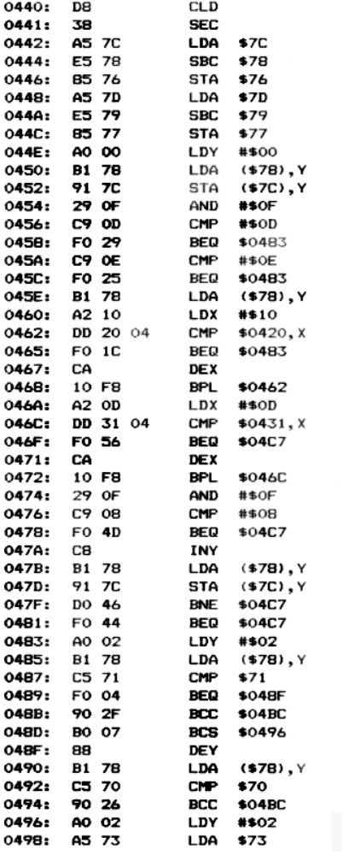

(listing continues)

