9. STRETCHING THE ORIC TO ITS LIMITS

9.1 Introduction

This chapter presents a few ideas that are more interesting than practical. It is hoped that these last few programs will encourage further experimentation – perhaps to improve the methods used.

9.2 Speech synthesis program
The first thing to be said here is that you should not expect too much of this program!
Speech synthesis is normally done with the help of a special add-on piece of hardware. The two programs below show that a limited form of speech synthesis is possible on an unexpanded Oric. The speech produced is frequently unintelligible, requires about 2K per second of speech, but can add a touch of magic to a dull program.
The program here fills up about 15K of memory in around 7 to 10 seconds (depending on the content of the message).

USING THE PROGRAM
There are two very short programs (it is just the data that is bulky!).
The first reads from the cassette port and produces a stream of data in memory. The second reverses the process, but puts out the speech through the loudspeaker via the sound chip.
The best way to create a message (at least when you first experiment) is to set up the cassette recorder so that as you record, the signal goes directly to the Oric. On many cassette recorders, this is done by disconnecting the recording jack, so that the internal microphone is used, but leaving in the earphone jack. If your cassette recorder cannot do this, or has a five-pin connector, you will have to record the message on the cassette recorder and then play it back.
For best results speak loudly, clearly, slowly, and very near to the microphone. If you are recording on to tape, play your voice back at a very high volume. You will find that music will not come out in a recognizable form, although pure tones (such as whistling) come out clearly, but much faster.
If you have difficulties at first, try different levels of playback, and above all remember to speak S-L-O-W-L- Y!
Words containing the letters T, S, and D will sound better than letters such as P, L, and R.
To record a message, type CALL #420 once all the connections have been made, and start talking immediately! After about 10 seconds of constant speech the program should return to you. If not, then something has gone wrong – the Reset button should get you out of trouble.
When you are ready to hear the Oric’s interpretation of your message, type in:
PLAY 1,0,0,0:SOUND1,1,1:CALL #480.
Prepare to be disappointed for the first few attempts!

THE THEORY BEHIND THE PROGRAM
The first program at #420 works as follows:
l. Interrupts are disabled – we need full use of the machine and the cassette also needs to be used.
2. Locations 2,3 are used to point to the next address where data is stored.
3. At #42D, the cassette input bit is cleared by reading from port B.
4. When #30D contains #52, then one bit has been received from the cassette input port; otherwise counter X is increased – measuring the gaps between input bits.
5. When a bit is received, or the counter reaches 255, the value of the counter is stored at the next address as pointed to by (2,3)
6. When the pointer at (2,3) reaches #3400, interrupts are enabled again and the program returns to BASIC.
Obviously, you can change the lower and upper limits of the data area to suit your needs. Once the data has been input, you can edit it – for example, to remove any delay at the front of the message. The data can then be stored on tape, or incorporated into a larger program.
The second program has to work in reverse of the first, turning the series of counts into a series of clicks. Providing that these clicks are separated by the same time interval as the gaps between each bit in the original signal, you should get an approximation of the speech. The main problem encountered when developing the idea was that the ROM subroutine which writes to the 8912 sound chip is incredibly inefficient. From #4AD to #4C6 you will find a considerably faster routine to write value X into register A.
The second program alternates between sending a volume of 7 and a volume of 13 to channel A. The SOUND 1,1,1 command will have set up a frequency that is beyond both human hearing and the capabilities of the loudspeaker, so the basic sound signal does not show up during pauses.
Here is how the program at #480 functions:
1. Disables interrupts to get the maximum use of the machine.
2. Sets up the pointer (2,3) to the start of the data area.
3. Delays depending on the next byte of data. The NOP instructions act as a fine tune to get the best results. Two-millionths of a second can make all the difference to this program!
4. Sets the volume to either 7 or 13, and writes this to register 8 of the 8912 chip.
5. When the pointer (2,3) reaches #3400, enables interrupts and returns to BASIC.

CHANGES FOR VERSION 1.1 ROMS

Four changes are required if you own a version 1.1 ROM:
#420 JSR #E76A
#451 JSR #E93D
#480 JSR #E76A
#4D2 JSR #E93D

PROGRAM LISTINGS
There are two – Programs 9.1 and 9.2
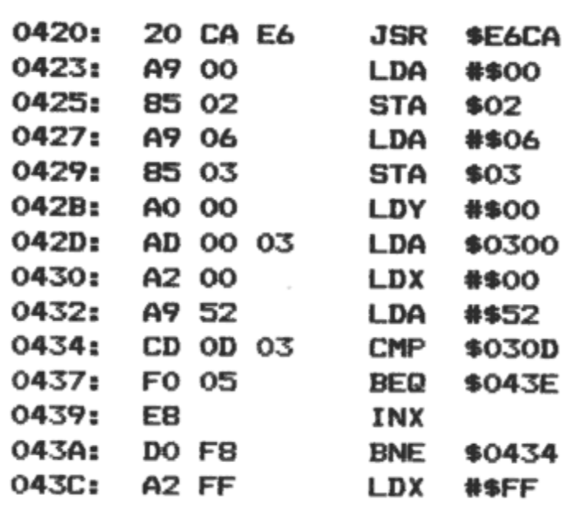
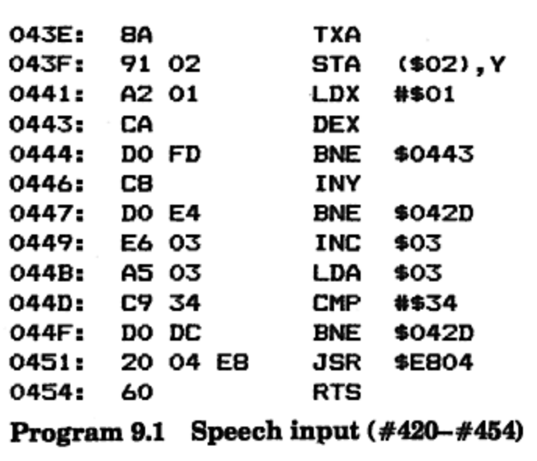

Program 9.2 follows.
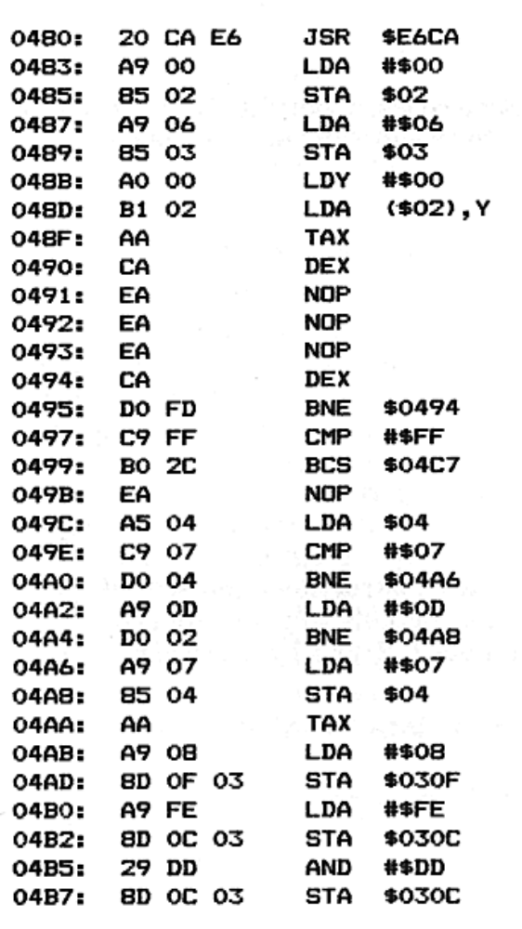
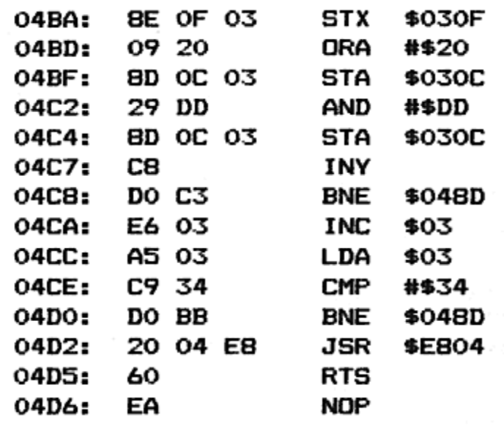

9.3 Extra 6502 op-codes
Out of the 256 possible instruction codes, about 100 would appear to be unused. However, if you try to execute any of these, one of three things can happen:
1. The machine crashes.
2. The instruction acts like a NOP, and alters nothing.
3. The instruction obeys a combination of instructions.

The first of these is very puzzling – it appears that the 6502 itself halts, refusing to obey any more commands until it is reset (not by the NMI button underneath the Oric). These instructions, which we might give the mnemonic KILL, have instruction codes ending in #2 – e.g., #22 – except for the valid instruction #A2.
The second category is not very important, except that, in doing nothing, the instructions are still useful in protecting a program from being understood! A disassembler program will usually be unable to cope with any unknown instructions and will often be misled into passing over real instructions in your program!
Just as real instructions can take 1, 2, or 3 bytes, so can our new ‘NOP’ instructions:
One-byte NOP instructions: #1A, #3A, #5A, #7A, #DA, #EA, #FA.
Two-byte NOP instructions: #64, #74, #D4, #F4.
Three-byte NOP instructions: #0C, #1C, #3C, #5C, #7C, #9C, #DC, #FC.
The third category are the most interesting instructions – hybrid op-codes. Some instructions on the 6502 do two operations at once. These are instruction codes ending in #3, #7, and #F. You may find that instructions ending in #B also do a combination of things, but not to any fixed pattern.
What happens to these instructions is that they execute two instructions in quick succession. For op-codes ending in 3, combine that op-code with an ending of 6, followed by the same op-code with an ending of 1. For example, #23 is #26 and #21, or:
ROL NN
AND (NN,X)
This is not a particularly useful combination, yet interesting nonetheless.
Similarly, op-codes that end in 7 are combinations of 6 and 5. For instance, #27 is #26, #25, or:
ROL NN
AND NN
Finally, op-codes that end in 4F are combinations of #E and #D. So #2F is the same as #2E and #2D, or:
ROL NNNN
AND NNNN

IMPORTANT NOTE
There is no guarantee that the hidden op-codes act in the same way on all 6502 microprocessors. It is fairly likely that all Oric machines behave in the same way, but it is still a risky business to rely upon any undocumented instruction.

9.4 Multitasking in BASIC

Fundamentally, a computer such as the Oric can only execute one instruction at a time. This is done at such a speed that a computer can appear to run two or more programs concurrently.
This happens on the Oric every hundredth of a second, in order to handle interrupts, and the impression is given that two things are happening at once – the cursor flashing on and off is an example.
As some of the programs in this book have shown, it is quite possible to use interrupts to run a small machine code program as a background task. It is more of a problem to be able to cope with two BASIC programs running simultaneously, and such is the purpose of the routine in this section.
149

THEORY
The major problem with switching between two BASIC programs is that they need their own versions of page 0, stack, and page 2 memory. Since copying 1500 bytes of data is a time-consuming task, even for machine code, we can only afford to interchange the running of the two programs about every twelfth of a second. Any less than that and we would be spending too little time on the actual programs; any more and the interchange would become more noticeable.
The program uses #8100 to #83FF to store the first three pages of the BASIC program 1 and #8400 to #86FF for BASIC program 2.
The multitasking is called by the slow interrupt vector, i.e., every hundredth of a second. If the counter at #87FF is not either 0 or 8, the routine simply returns; otherwise it switches from its current place in the program to the other position, moving about all the important locations that BASIC uses. Instead of having two different BASIC programs which are swapped in and out, this utility works by allowing one BASIC program to have two independent sections running. All BASIC statements will work – including CALL.

USING THE PROGRAM
A special part of the routine starts the procedure, by setting the counter at #87FF to 255. This gives the ‘first’ program a chance to split off into a different section. It will be about two seconds before the machine will switch to the ‘second’ program. The BASIC program example will demonstrate this (Program 9.3).
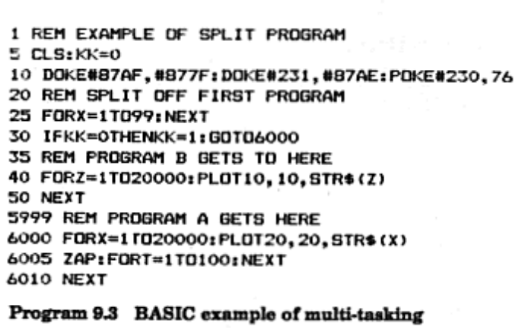

Firstly, #87AF is DOKEd with #877F – this makes the very first interrupt go to the special routine at #877F, instead of the normal address at #8700.
Then the slow interrupt patch is entered – at #231 for version 1.0 (as listed) or at #24B for version 1.1 – please use the appropriate address. Finally, location #230 (version 1.0) or #24A (version 1.1) is POKEd with 76.
Once this last instruction is complete and the first interrupt occurs (which will happen some time during the FOR... NEXT loop), the current BASIC circumstances are saved as the starting point for program 2.
Program 1 will then continue until 247 interrupts have passed, and has ample time to switch to line 6000, preventing the second program from following.
When the second program does get to line 30, it will find KK equal to 1, and will drop through to line 40.

PROGRAMMING LIMITATIONS
Since only the first three pages of memory are being switched, both the BASIC program and its variables are being shared between the programs. Once the program has separated into two paths, you will get into trouble if you try to set up variables in each section since they keep their own account of the end of variables, strings, etc. It is a good idea to have one section creating the variables and the other only using variables set up before the multitasking began.
Although you can have a lot of fun experimenting with this idea (try pressing control-C!), there are many pitfalls, and its practical use may be limited.
Note that the machine code areas ought to be protected by a HIMEM #80FF command.
To stop the programs multi-tasking, cancel one of the programs (the other will carry on while you are typing!) and enter either POKE #230,64 (for version 1.0) or POKE #24A,64 (for version 1.1).
PROGRAM LISTING
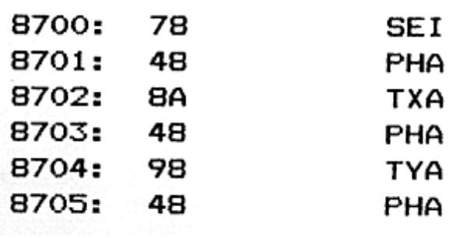
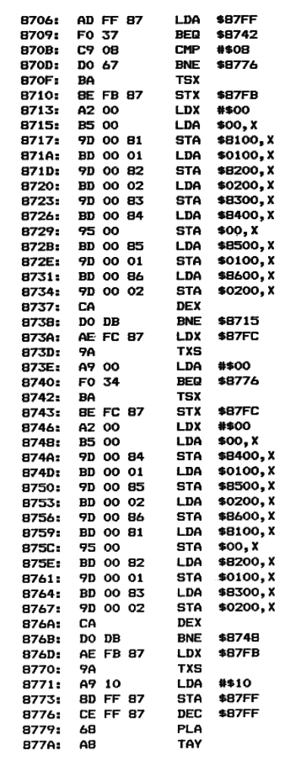

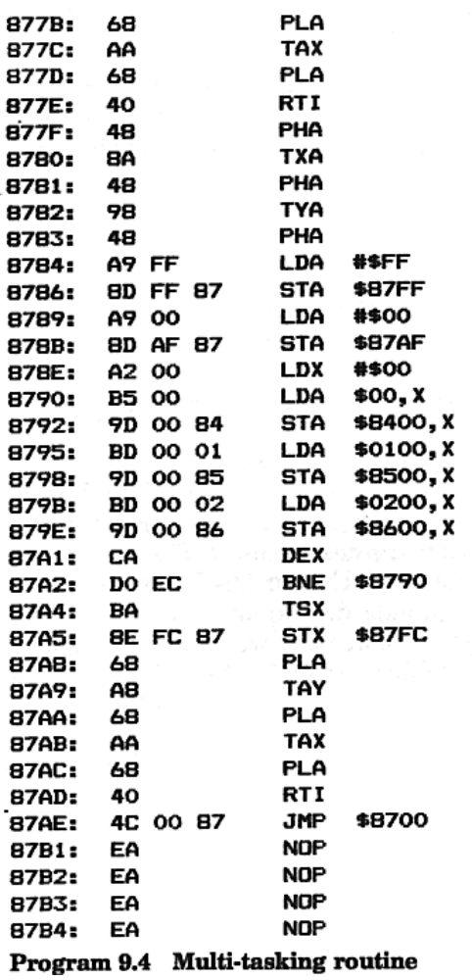

9.5 Single-key facility

Since the first appearance of cheap computers, there have evolved two methods of entering programs.
The first Sinclair computers up to the ZX Spectrum use a single-key system, in which every key, when combined with different shifts, generates a complete BASIC word. For example, pressing ‘R’ could result in ‘RANDOMIZE’ appearing.
On the Oric, and almost all of the more expensive computers, each command must be entered letter by letter. The reason for this is that BASIC is not necessarily the only language available, and the BASIC commands would be meaningless to FORTH, Assembler, etc.
The program in this section gives the capability of single-key command entry. Although intended for use with BASIC, you could quite easily change the table of commands to work with other languages.

USING THE PROGRAM
The program occupies the first two pages of the alternate character set, and so will only be dislodged by a HIRES command, or the Reset button.
To run the program, type CALL #B894.
Owners of version 1.1 ROMs should also change #B89A to #49, instead of #2F.
While the single-key program is running, you can carry on typing commands in full by switching to lower case (use control- T). Lower case will be turned into upper case when commands are entered, and lower case only is applied when quotes are used. This in itself is a useful tool when entering a lot of PRINT or DATA statements.
When a capital letter is entered outside of quotes, a command is inserted. For example, ‘N’ might produce the word ‘NEXT’. These commands are generated from a table at #B900. This table contains the ASCII codes required for each character between #40 and #5A. Each ASCII string must be terminated by #00. This will be clarified if you examine the table of single-key commands, Table 9.1.
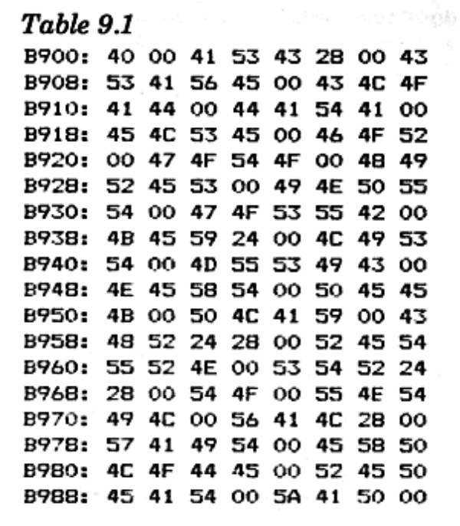

The single-key facility can be stopped by changing either #230 (version 1.0) or #24A (version 1.1) to 64, using the POKE statement.

HOW IT WORKS
The program patches into the ever-popular slow interrupt vector so that it can alter any keypress found in #2DF.
If a lower-case letter is entered and no quote has been found, it is converted to upper case with a simple AND #DF instruction. If it is upper case, then the appropriate word is located in the table, and that word is fed out to #2DF, character by character, as part of the interrupt routine. A similar technique was used by the AUTO DATA program of Chapter 8.

PROGRAM LISTING
The program occupies #B800 to #B8AA but could be easily relocated (Program 9.5).

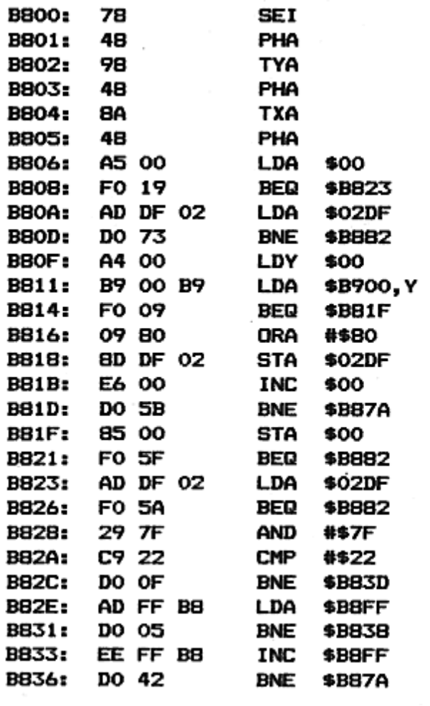

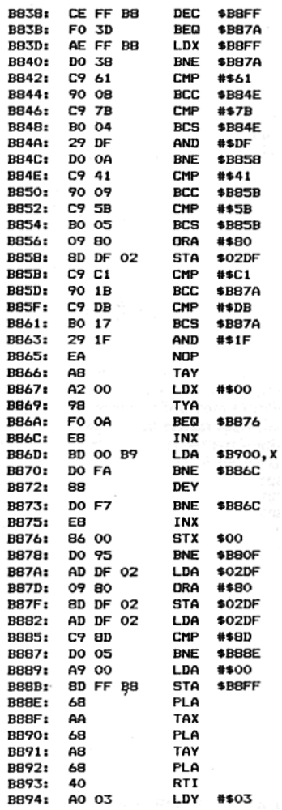

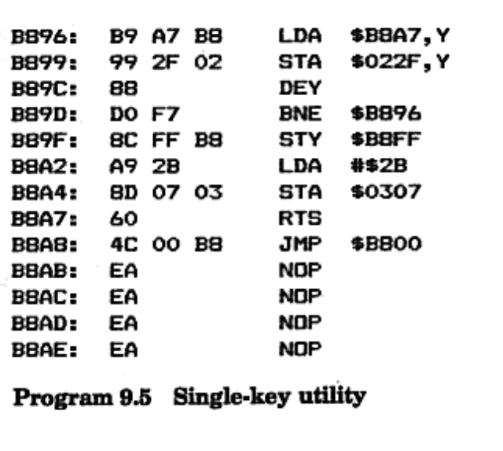

9.6 Silence routine
The last program in this book can be used to shut up even the noisiest program!
It works by altering the slow interrupt vector so that every hundredth of a second all sound channels are disabled.
The routine will work for most programs, failing in cases where the interrupts are tampered with. Most sound commands (including the keyclick) will generate a very soft click, although some sound effects (such as PING and EXPLODE) will present part of their noise before being silenced.

USING THE PROGRAM
Version 1.1 ROM owners should change the address at #42E to #F590, instead of #F535.
Load up the silence routine first, and type
DOKE#231,#420:POKE#230,76 for version 1.0 ROMs or DOKE#24B,#420:POKE#24A,76 for version 1.1 ROMs
The silence routine should now be in service – try typing ZAP – and you can now load in the program to be silenced.
The silence routine can be finished by typing POKE #230,64 for version 1.0 ROMs or POKE #24A,64 for version 1.1 ROMs.

PROGRAM LISTING
This is given in Program 9.6.

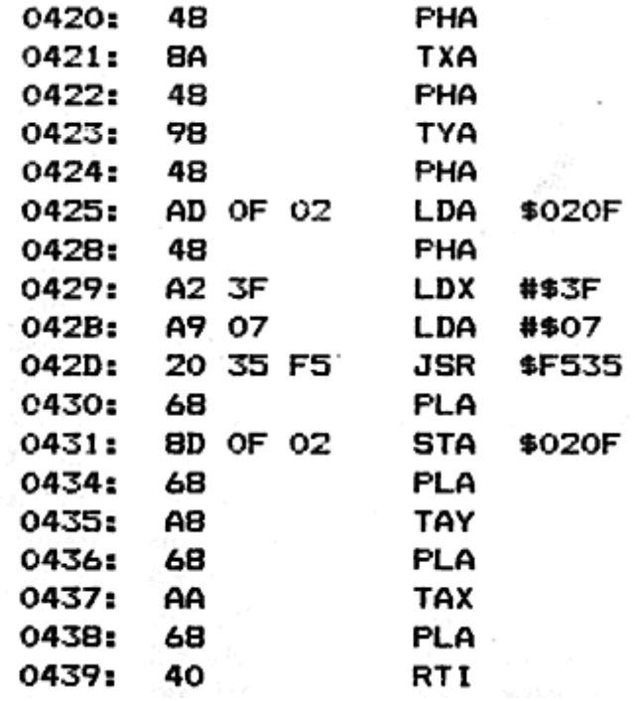

Afterthoughts (August 1998)

Hehe, this chapter shows its age doesn’t it. I’m afraid my ignorance of some of the basic concepts of digital audio in 1983 show up here, the proper way of playing back sound effects is of course to use analogue to digital, store the data, and then the fun begins when we try to playback. There is a way on this rather limited sound chip (when compared with today’s luxurious sound blasters) to playback PCM data (i.e. wave files), which is to use the volume controls on the three channels to simulate the wave’s amplitude - you’d probably need a ‘scope to do this properly.

I think my explanation of the extra op-codes is probably inaccurate, it is not so much that two instructions are executed, rather that the logic inside the ALU of the 6502 decodes the instruction, and the logic simply has the effect of following a combination of instructions.

I wonder if any of the emulators for 6502 based machines work in the same way…

I like my bias against ZX Spectrums in this chapter, heh, I did go on to program the Spectrums of this world, but I have to confess to having used an Amstrad CPC to do all the programming, I just couldn’t stand that wretched keyboard.

