Fitting & Assessing Models

Arnab Maity - Modified by Justin Post

# Introduction

In this chapter, we will go into details about training statistical learning models. In the process, we will learn about different methods for splitting the data and resampling techniques, process of tuning hyperparameters, tradeoff between bias and variance, and various criteria for evaluating model performance.

The process of building a statistical model (or multiple models) roughly has the following steps.

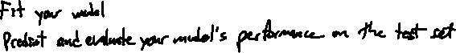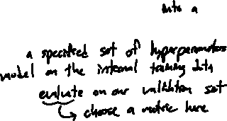

Notes:

* Most model evaluation criteria focus on prediction. The steps described are geared towards building of predictive models. The fitted model may not be easily interpreted or lend itself to inference.
* There are two points in the algorithm above that we may want to perform repeatedly: these are the inner and outer loops.
* Depending on the situation (sample size, computational cost), we can use any of the resampling and data splitting methods in each of the loops.

# Non-parametric Model: -Nearest Neighbors Regression

One of the simplest nonparametric regression methods is the -Nearest Neighbors (KNN) regression. We will develop our ideas further based on this regression technique. However, these ideas will be applicable in other cases as well.

Assume that we have a regression task and are using our usual, generic, model:



   
   
 



For any given value , KNN regression estimates as follows:



   
   
 



Formally, suppose denotes the set of indices of the points whose values are nearest to . Then we have

 



Note that the predictor can be a scalar as well as a vector, as long as there is a measure of “nearness” available.



## Distance metric

We determine points nearest to by computing a distance metric between and the values of the training data, and taking the points with smallest distance measures.

The most common distance metric is the Euclidean distance: for two vectors and , the Euclidean distance is

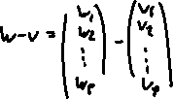

This is also known as the -norm of , that is, .



Another popular distance metric is the -norm, , that is,



The distance is also known as “taxicab” and “Manhattan” distance. The geometry of these distance metrics are shown (simplified) in Figure below.

|  |
| --- |
| L2-norm vs. L1-norm. Given two points (black dots), the L2-norm measures the distance of the straight line between these points (dashed line). In contrast, L1-norm measures the distance of the path that can only go parallel to the x- and y-axes (dotted line). |

Why might we use the -norm instead of the -norm?



   
   
 



There are other types of distance metrics in literature such as Minkowski, Mahalanobis, Hamming, Cosine distances, etc.



## The hyperparameter

The value of (the number of neighbors) must be chosen using the data. Most often, we do a resampling technique to do so. We’ll discuss this more shortly. For now, let’s look at fitting this model in R.

### Boston Dataset

Let us consider the Boston dataset in the ISLR2 package. The data set contains housing values of suburbs of Boston.

* Goal: Predict the median value of owner occupied homes (in $1000’s, the medv variable) using the lower status of the population (percent, lstat variable).



* A plot of the data is shown in Figure .

|  |
| --- |
| Plot of median housing value vs. percent of population with lower status from Boston data. |

* A snapshot of the R tibble is shown below with only the two variables of interest.

# A tibble: 506 × 2  
 medv lstat  
 <dbl> <dbl>  
 1 24 4.98  
 2 21.6 9.14  
 3 34.7 4.03  
 4 33.4 2.94  
 5 36.2 5.33  
 6 28.7 5.21  
 7 22.9 12.4   
 8 27.1 19.2   
 9 16.5 29.9   
10 18.9 17.1   
# ℹ 496 more rows



Let us see a KNN fit to the data, with . Here we are not training/testing the model yet – we are simply attempting to understand the role of the hyperparameter and its impact on the fitted model. We can use the function kknn() in the kknn library.



* We use formula notation to specify our response and predictor variable relationship
  + y ~ x



library(kknn)  
knn_fit <- kknn(medv ~ lstat,   
 train = Boston,   
 test = Boston, k = 30) #fit the model



* Now that we’ve *fit*, *trained*, or *estimated* our model (three ways of saying the same thing!), we can find the predictions from the model for our training observations and add that as a column to a tibble.

#create the predicted values as a new column and append them to our data set  
knn_estimates <- mutate(Boston, knn_est = fitted(knn_fit)) |>  
 arrange(knn_est)  
knn_estimates |>   
 select(medv, lstat, knn_est)



# A tibble: 506 × 3  
 medv lstat knn_est  
 <dbl> <dbl> <dbl>  
 1 6.3 30.0 11.5  
 2 16.5 29.9 11.5  
 3 7.4 32.0 11.5  
 4 8.1 29.7 11.6  
 5 5 30.6 11.6  
 6 8.4 34.0 11.6  
 7 17.9 34.4 11.6  
 8 7 37.0 11.6  
 9 23.7 29.6 11.6  
10 13.8 38.0 11.6  
# ℹ 496 more rows



* Let’s plot the fit!

#plot the data along with the predictions found via knn  
knn_estimates |>  
 ggplot(aes(x = lstat, y = medv)) +  
 geom_point(size = 0.5) +  
 geom_line(aes(y = knn_est), color = "blue", linewidth = 2)

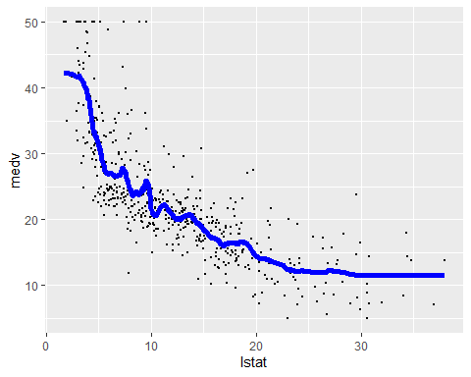

**Important** How should we choose ? Consider the fits using varying (1, 30, or 300) in Figure .

|  |
| --- |
| Estimated functions form Boston data example for different values of K. |

* We note that for small value of , KNN produces extremely rough estimate of . We are almost interpolating the data – this is an example of **overfitting** the data. While the model is most flexible, and the estimated function does capture the shape of the data (perhaps too much so), such a fit is undesirable as the estimate is much too volatile.
* In contrast, for large value – this is of our sample size – the estimate is smooth, but does not capture the shape of the data. Such a model is not flexible, and undesirable as it may produce a **biased** estimate of , and inaccurate predictions.
* For , it seems the model is flexible enough to capture the overall shape of the data, but stable enough to not overfit the data. Thus we need to discuss a criterion that evaluates the quality of model fit, and enables us to choose (hyperparameters in a regression model in general) properly.

## Regression model evaluation criterion

Recall - we evaluate regression models based on how well they predict **new** observations. We use a model **metric** to do so.



* Suppose we have new predictor value , and want to predict the response corresponding to .
* The (squared) prediction error is .

   
   
   
   
 

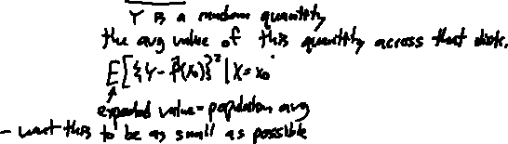

* This strategy works if we are only interested in the specific value .
* In general, we want a procedure which can predict for all possible values of , not just one specific value.



* The average performance of the procedure can be measured by taking the “average” (or **expected value**) of the previous expected prediction error over all possible values of .



   
   
 

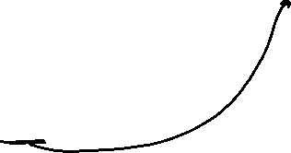

* Unfortunately, the quantity above can not be directly computed without knowing the probability distribution underlying the data generating process…
* We must estimate it using a sample.
* Suppose we have training set , and a test set . Then, based on the test set, we can estimate the quantity above as

   
   
 



where we have replaced the expected value by a sample average, and the average is taken over the **test** set. This quantity is called the **test Mean Squared Error (MSE)**.



* A similar quantity can be computed using the training set as well but this is an overly optimistic measure of predictive performance.

   
   
 



* Consider using KNN regression with .
  + The training MSE is zero (or close to zero depending on how KNN handles ties in the values) since for each in the dataset, the nearest point of is itself. However, 1-NN regression might perform very poorly in a test dataset!
  + Typically, minimizing the training MSE would result in choosing the most flexible model, but *having a low training MSE does not ensure that the test MSE will be low* as well.
* Let’s manually compute the training MSE for our KNN model fit previously

mean((knn_estimates$medv - knn_estimates$knn_est)^2)



[1] 25.19358



* If we used instead we get the training MSE value to be estimated at

knn_fit_k1 <- kknn(medv ~ lstat,   
 train = Boston,   
 test = Boston, k = 1) #fit the model  
knn_estimates_k1 <- mutate(Boston, knn_est = fitted(knn_fit_k1)) |>  
 arrange(knn_est)  
mean((knn_estimates_k1$medv - knn_estimates_k1$knn_est)^2)



[1] 7.064901



* Consider the plot below showing training and testing error for simulated data sets and varying values of .
  + Here we know the true form of the function , and thus can simulate data using it.
  + We can generate many data sets for training purposes and many for testing purposes.
  + We can then fit KNN regression model with different values of
  + Figure shows the results for one such experiment.
    - We see that the test MSE is generally higher that the training MSE.
    - Training MSE keeps increasing as increases (the procedure becomes less flexible).
    - However, the test MSE first decreases and then levels off before increasing slightly.
    - In this experiment, the minimum test MSE is produced for , while lowest training MSE is for .

|  |
| --- |
| Training and test MSE for simulated data for different values of K. Larger values of K correspond to less flexibility. |

### Bias-Variance decomposition

To understand the shape of the test MSE curve, we further investigate the form of MSE.



* Recall that we started from the expected prediction error for the test data . Let’s try to ‘decompose’ this into terms corresponding to bias and variance.



   
   
   
   
   
   
   
 

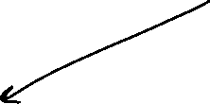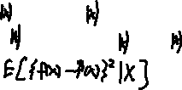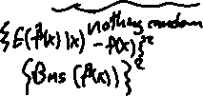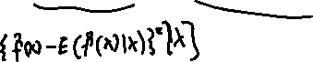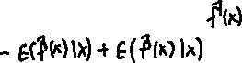

* We can now see that the expected prediction error includes terms from a combination of the variance and squared bias of the estimator .
  + We again resort to a simulation experiment to see the relative contribution of the variance and squared bias of to the prediction error.
  + Figure shows one simulated training set of size along with the true function used to generate the data ().

|  |
| --- |
| Simulated data of size n=500. |

* We generate multiple such training sets, and for each set we fit a KNN regression model with , and .
* The test set if a grid of 101 equally spaced points in and we compare the fits to the true curve.
* The estimated functions are shown in Figure .

|  |
| --- |
| Simulated data showing bias and variance of KNN fits. |

In general, this phenomenon holds for various regression models. More flexible models produce estimate with low bias but high variance. Less flexible models do the opposite – estimates have high bias but low variance. Minimizing test MSE tends to choose a model that balances between bias and variance.

### Other Model Metrics

We should be aware that test MSE is not the only metric one can use to evaluate a regression model. A few of the other evaluation metrics are shown below:

* *Root mean squared error (RMSE):* just the square root of MSE. Brings the MSE to the same using as the responses.
* *Mean absolute error (MAE):* average of absolute values of the prediction discrepancies,
* It is more robust the MSE in the sense that it does not emphasize large differences as MSE does.
* *Mean residual deviance:* generalizes the concept of MSE for generalized linear model fitted with maximum likelihood methods (e.g., Poisson and Logistic regression).
* : proportion of variance explained by the model.
* A nice property of is that it will be always between 0 and 1. values close to 0 indicate inadequate model fit, while values close to 1 indicate that the model explains a large amount of variability in the response.

# Data splitting

As we want to have a measure of prediction accuracy based on a test set, we don’t want to use the entire dataset for training and testing. We need a test data set that we can use to evaluate our model’s performance in general.

* We can the *holdout method* or resampling techniques such as *bootstrap* or *v-fold cross validation* to create test set(s) from our data, and validate our models’ performance.
* Let’s go through these ideas!

## Holdout method

The holdout method randomly splits a given dataset into two sets: one for training and one for evaluation (the holdout/validation/test set).

* In practice, , or splits are commonly used for training/test sets. Figure shows the basic layout of the holdout method.

|  |
| --- |
| The holdout method. The whole dataset is split into two parts: training and holdout sets. |



A simple way to create such a split is via *simple random sampling without replacement (SRSWOR)*, that is, by randomly choosing a subset of observations from the data set and putting them aside as the training set. The remaining observations form the holdout set.

* Consider the Boston data again. In base R, we can use the sample() function to perform SRSWOR, as follows.



# set a seed for reproducible results   
set.seed(1234567)  
  
# sample from the row indices to include in the test set  
n <- nrow(Boston)  
index <- sample(x = 1:n,   
 size = round(0.8*n),  
 replace = FALSE)  
  
# Test and training sets  
train <- Boston[index, ]  
test <- Boston[-index, ]  
  
# Data dimensions  
dim(train)



[1] 405 13

dim(test)

[1] 101 13

* We have split the data – in the example above!
* We’ll look at other R packages that make this process even easier to do and will allow us to easily do stratified sampling and other more advanced splitting techniques.

Ideally, the distribution of in the test set will be similar to that in training set. Figure shows the corresponding distributions (estimated probability densities) of medv for the training/test sets.



|  |
| --- |
| Estimate density functions for medv variable in training (orange) and test (black) sets as obtained using base R, caret, and rsample packages. |

* A disadvantage of SRSWOR is that it does not always preserve the distribution of the response variable.

*Stratified random sampling* is used to explicitly control aspects of the distribution of .

* Useful with data with small sample size or a skewed response distribution.



* Stratified random sampling strategy is to draw sample for each group (strata) of so that the test set represents the distribution of of the whole data.^

For a classification task, if extreme class imbalance is present in the response (say “No” and only “Yes”), we might choose to over-sample the rare class, or under-sample the abundant class, or a combination of both the strategies can be employed. A popular technique in this regard is *Synthetic Minority Over-sampling Technique (SMOTE)*,[1] which generates synthetic samples from the rare class.

* In particular, SMOTE takes a random observation from the rare class and then finds its nearest neighbors in the rare class.
* Then SMOTE generate new samples using the convex combinations of the original randomly selected observation and one of the the nearest neighbors.
* Many packages allow for SMOTE implementation as a possible sampling strategy.
* The authors of SMOTE also suggest that a combination of SMOTE and under-sampling the majority class works better than just using SMOTE.

Let us now investigate the holdout method using the Boston data.

* First, let’s fit the model with using just the training data

knn_train_fit <- kknn(medv ~ lstat,   
 train = train,   
 test = train, k = 30) #fit the model



* Now compute the training set MSE



#training MSE  
train_MSE <- mean((train$medv - knn_train_fit$fitted.values)^2)  
train_MSE



[1] 23.88902

* Fit again but test on the testing set to obtain the test set MSE

knn_train_fit <- kknn(medv ~ lstat,   
 train = train,   
 test = test, k = 30) #fit the model  
test_MSE <- mean((test$medv - knn_train_fit$fitted.values)^2)  
test_MSE



[1] 33.26467

* Notice the test set MSE is much larger! It is as we expected – training MSE most likely underestimates the prediction error, while test MSE can be viewed as a reasonable estimate.
  + *It is important to remember that we are operating with the setting - the test MSE might not reflect the best performance the model can have.*



### Selecting an Optimal Tuning Parameter Using Only a Holdout Set

Now let us address the question about choosing the optimal , that is, the value of that gives the best general performance. One option is to use only a holdout set to do so. Once we chose an optimal value of , the model with that would then be fit to the whole data.

Our steps would be:

* Split the data into training and test sets
* For each candidate value of , fit the model in the training set, and compute MSE using the test set.
* Choose the which gives minimum test MSE.
* Fit KNN with optimal K to the full data set.

Then the fully trained model can be used for future predictions. Let’s do this manually for now!

* We’ve already split our data into a train and test set (both are objects in our R environment).
* Now we’ll create a grid of values to fit the model on.

kgrid <- c(1:100)

* Next, we’ll use the lapply() function to apply the kknn() function to each value of our kgrid object.
  + lapply() is a function that allows us to apply a function to a list (or vector)
  + This is like a nicer way of doing a for loop
  + Here we’ll write a quick anonymous (or lambda) function to take the list elements and return the KNN fit

test_preds <- lapply(X = kgrid,   
 FUN = function(x){  
 kknn(medv ~ lstat,   
 train = train,  
 test = test,  
 k = x)  
 })



* A list of fitted objects is returned.
* We can apply an MSE calculation to each of these list elements!
  + Here we’ll write a quick anonymous (or lambda) function to take the list elements and return the test set MSE

test_MSEs <- lapply(test_preds, FUN = function(x) {   
 mean((test$medv - x$fitted.values)^2)  
 })  
test_MSEs[1:5]



[[1]]  
[1] 58.25614  
  
[[2]]  
[1] 46.16605  
  
[[3]]  
[1] 39.78201  
  
[[4]]  
[1] 38.76825  
  
[[5]]  
[1] 37.40706



* Let’s plot our test set MSE as a function of .

plot(x = kgrid, y = test_MSEs,  
 xlab = "K",  
 ylab = "Test Set MSE")

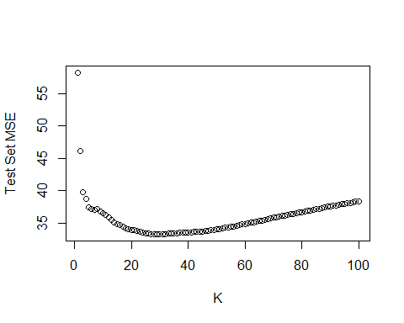



* We can find the optimal programmatically:

## Optimal K  
k_opt <- kgrid[which.min(test_MSEs)]  
k_opt



[1] 30



test_MSEs[[k_opt]]

[1] 33.26467

* Now we refit on the entire data set using this optimal .

knn_best_fit <- kknn(medv ~ lstat,   
 train = Boston,   
 test = Boston,   
 k = k_opt) #fit the model



* To predict for future observations, we could refit using a different test argument. However, we’ll see better packages for doing this type of action across many models soon!

The test MSE of 33.26, equivalently, RMSE 5.77 gives us an unbiased estimate of prediction error of our procedure in unseen test data. This also reflects the added variability due to tuning of the hyperparameter. Note again that for prediction purposes, we will still use the model fitted to the whole data.



The advantage of the holdout method is that it is conceptually and computationally simple. However, this method can produce highly variable test error!

* To see this, we can repeat the hyperparameter tuning procedure a few times. The plot of the test MSE profiles during the tuning process over multiple splits of the data is shown in Figure for 10 training runs. As we see, there is a substantial amount of variability in the test MSE.

|  |
| --- |
| Test MSE during tuning hyperparameters for 10 runs of the model training. |

* We can apply the train/test idea multiple times to get a more stable estimate. However, if we do this too much, we may end up overfitting.
* Often we split our data into a training and test set and do our tuning over multiple splits on the **training set alone**.
* We save our test set to only be used sparingly on a **final model evaluation**.

## -fold Cross-validation (V-fold CV)

The V-fold CV procedure splits the data into multiple parts, and then cycles through those parts to compute test MSE. In particular, V-fold CV is performed to estimate the test error of a model/procedure as follows:

1. Split the data randomly into (roughly) equal sized disjoint parts, called *folds*. Thus we have fold 1, , fold .
2. For each fold , do:
   1. Set Fold as the test set, and the remaining folds together as the training set.
   2. Train the model using the training set and compute MSE[2] using the test set (Fold ), say .
3. The final estimate of test error is formed by taking the average of the MSE values: .

Keep in mind that the model training step can also include tuning hyperparameter(s) as well. Figure shows the layout of -fold CV procedure.

|  |
| --- |
| Layout of the V-fold crossvalidation procedure. Data are first randomly split into V equal sized parts, called folds. Each fold is then used as a test set while the remaining folds are used to fit the model. The test error is estimated by taking the average of the MSEs from the V folds. |

Let us apply CV to our Boston data using KNN to select our hyperparameter .

1. Split the data randomly into folds.
2. For each fold , do:
   1. Set Fold as the test set, and the remaining folds together as the training set.
   2. Fit the model using the training set, and evaluate MSE/RMSE using the test set (Fold ), *for each value of the hyperparameter*.
3. From step 2., for each value of hyperparameter, we should have a MSE/RMSE value for each fold ( of them). The final MSE/RMSE for each of the hyperparameter value is calculated by taking the mean of MSE/RMSE values from the folds. Chose the optimal value of the hyperparameter by minimizing the final MSE/RMSE.
4. Use the best hyperparameter value to refit the model on the whole dataset.



For now, we won’t split our data into a training and test set first. We’ll simply use CV to tune our hyperparameter. We’ll further discuss using both a training/test split and cross-validation shortly.

To ease our programming burder, we’ll look at using the caret package in R (similar packages exist in python). caret allows us to easily specify our tuning method, keeps track of all results, and allows us to easily do predictions on new observations.



* Let us tune using 5-fold CV. Figure shows the MSE profile for the tuning process.
* We start by setting a seed for reproducibility and specifying our kgrid for clarity.

set.seed(1001)  
## Set K grid  
kgrid <- expand.grid(k = c(1:100))



* Next, we set up our trainControl() parameters. This is caret’s method for specifying how to train our model. We choose method = cv and number = 5 to do 5 fold cross-validation.

## Training control params  
cv <- trainControl(method = "cv",  
 number = 5)



* Next, we fit the model using caret’s train() function.
  + This takes a formula
  + The data to train on
  + The method or model type ot fit
  + A grid of tuning parameters (if applicable)
  + The method for training

## Fit the model  
knn_fit <- train(medv ~ lstat,  
 data = Boston,  
 method = "knn",  
 tuneGrid = kgrid,   
 trControl = cv)



* We can run the generic plot() function on the result to see the CV test error profile.

plot(knn_fit)

|  |
| --- |
| Results from hyperparameter tuning using 5-fold CV. |

* The bestTune list element tells us the optimal tuning parameter using the default criteria of RMSE

knn_fit$bestTune



k  
36 36



* Lastly, we’ll refit to the entire data set with the optimal

## Optimum K and model refit on full data   
k_opt <- knn_fit$bestTune$k  
knn_tuned <- train(medv ~ lstat,  
 data = Boston,  
 method = "knn",  
 tuneGrid = expand.grid(k = k_opt),   
 trControl = trainControl(method = "none"))



We can use the final fitted model for further predictions!

## Leave-One-Out Cross-Validation (LOOCV)

As a special case of -fold cross-validation, consider the case with , where is the sample size of your data. In this case, every observation will be its own fold. Suppose we observe data for . The CV then proceeds as follows:



1. For observation (fold) , do
   * Set the -th observation as the test set, and the remaining as the training set.
   * Fit the model on the training set, and predict (test set)
   * Compute
2. Compute the test MSE as the average of the MSE values from step 1., that is, .

This procedure is known as *leave-one-out cross-validation* (LOOCV).

Let’s do an example using LOOCV in caret.

* In caret we can specify method = "LOOCV" in the trainControl() specification.
* Figure shows the MSE profile for tuning in the Boston data.

## Values of K, and LOOCV specification  
kgrid <- expand.grid(k = 1:50)  
loo <- trainControl(method = "LOOCV")  
## Model fit  
fit <- train(medv ~ lstat,  
 data = Boston,  
 method = "knn",  
 trControl = loo,  
 tuneGrid = kgrid)  
plot(fit)



|  |
| --- |
| Results from tuning K using LOOCV on the whole Boston data. |

A disadvantage of LOOCV is its potential heavy computation cost, especially for large sample size.

* For example, in Boston data (), we have to fit models for *each* value of ! This can be extremely difficult for larger .
* In contrast, holdout and -fold CV procedures are more computationally efficient.

When we estimate the test error, we might have different goals to do so in different situations. When we are interested in evaluating model performance in a test set, the actual value of the test error is of interest. However, when we are tuning a hyperparameter (e.g., K in KNN regression), our primary goal is to find the *minimizer of test error*, rather than test error itself. In the former case, the accuracy of the cross-validation estimates might be an issue. But in the later case, the minimizer might still be valid even if the estimate of the test error itself is not accurate. Examples from several simulation studies have been presented in the textbook (Introduction to Statistical Learning) to examine the point made above.



As a final note on cross-validation, the choice of in -fold cross-validation depends the bias-variance trade-off[3] of the procedure. Given a sample size of , the -fold CV uses approximately observation to fit the model. Thus LOOCV effectively uses the whole data to train the model, and therefore produces almost unbiased estimates of the test error. However, a 5-fold CV might produce a biased estimate. On the other hand, in LOOCV the model fits essentially uses the same dataset (any two fits share common training observations), the resulting test MSE values are highly correlated. Averaging the in MSE values LOOCV does not reduce the variance due to them being highly correlated. Thus LOOCV estimates tend to have high variance. In contrast, a 5-fold CV does not have as high level of overlap between the training folds, and produces less variable estimates of test MSE. In practice, we most often use 5-fold or 10-fold cross validation.



## Bootstrapping

Recall that in the holdout method, we used simple random sampling without replacement to create a holdout set smaller than the original data. In contrast, a *bootstrap sample* is a random sample *with replacement* that is of the *same size* as the original data.



   
   
   
   
   
 

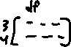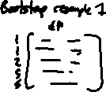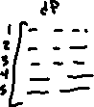

* We can perform bootstrap manually using the bootstraps() function in rsample package. The code below draws 10 bootstrap samples from the Boston data.



set.seed(10)  
# Bootstrap samples  
boot_sample <- bootstraps(Boston, times = 5)  
boot_sample



# Bootstrap sampling   
# A tibble: 5 × 2  
 splits id   
 <list> <chr>   
1 <split [506/195]> Bootstrap1  
2 <split [506/180]> Bootstrap2  
3 <split [506/173]> Bootstrap3  
4 <split [506/185]> Bootstrap4  
5 <split [506/192]> Bootstrap5

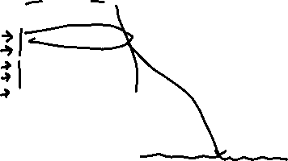

* We can look at the different splits and obtain training and testing sets using the training() and testing() functions!

# Accessing the first bootstrap sample  
boot_1 <- training(boot_sample$splits[[1]])  
dim(boot_1)



[1] 506 13



# Corresponding out of bag samples to test on  
oob_1 <- testing(boot_sample$splits[[1]])  
dim(oob_1)

[1] 195 13



* Recall, we want the distribution of our response variable in our training set(s) to mimic the distribution across all the data
* The distribution of our response (medv) in the five bootstrap resamples is compared to the overall distribution in Figure below. We see good agreement overall!

|  |
| --- |
| Distribution of medv in the Boston data (red solid line), and in 10 bootstrap samples (black dashed lines). |

* As we mentioned, the bootstrap samples will leave a proportion of observations out. On average, the proportion left out here can be estimated empirically! Here we find the sample proportion left out and plot this distribution.

boot_sample <- bootstraps(Boston, times = 500)  
oob_percent <- sapply(boot_sample$splits,  
 function(s){nrow(testing(s))/nrow(training(s))})  
ggplot() +   
 geom_histogram(aes(x=oob_percent), bins = 20) +   
 theme_bw(base_size = 18)



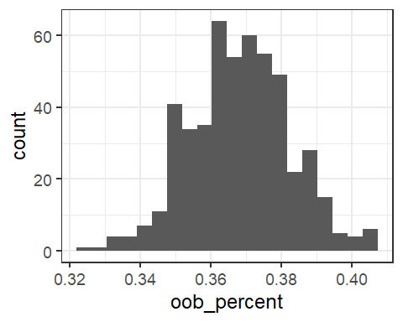



* On average, we have about 36.83 percent of observations are OOB.[4]

### General Uses of Bootstrapping

The Bootstrap is a general method, and can be used to assess accuracy of statistical procedures. Given a dataset



   
   
   
   
   
   
   
   
   
   
   
   
   
   
 

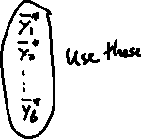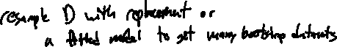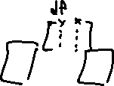

Figure shows a layout of using bootstrap as described above.

|  |
| --- |
| Layout of bootstrap procedure. |

For example, we can examine the the variance of our quantity using the sample variance of the replicates:



$$ \widehat{var}\{S(D)\} = \frac{1}{B-1}\sum_{b=1}^B[S({\cal D}_b^*) - \bar S^*]^2, $$



where



$$ S^* = \sum_{b=1}^BS({\cal D}_b^*) / B $$

is the sample mean of the bootstrap replicates.

* Consider the example of fitting KNN regression to Boston data with fixed .

knn_k30 <- knnreg(medv ~ lstat,  
 data = Boston,  
 k = 30)

Suppose we want to estimate when , that is, we want to estimate the expected value of medv when lstat = 5. We may want to estimate the standard error of this quantity or perhaps the distribution of it!

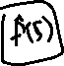

* We can obtain one estimate of this quantity from a fit on the entire data set.

pred_k30 <- predict(knn_k30,  
 newdata = data.frame(lstat = 5))  
pred_k30



[1] 31.81

* Note: The predicted value of when is the same
* However, the variability of these two quantities is not the same
  + Recall, the variability of the predicted value is represented by bias + + irreducible error.
  + In this case, we are only interested in .
* Let’s use the bootstrap to look at the distribution and standard error of
  + We will draw 200 bootstrap samples from Boston data.
  + For each bootstrap sample, we will fit the KNN procedure with , and compute the estimate.

## Wrap the prediction process in a function for easy use  
knn_k30_predict <- function(split){  
 # Input: split from bootstrap using rsample  
 # Output: prediction at lstat = 5  
   
 # Get training set  
 train_set <- training(split)  
 # fit the KNN model with K = 30  
 knn_k30 <- knnreg(medv ~ lstat,  
 data = train_set,  
 k = 30)  
 # Predict at lstat = 5  
 pred <- predict(knn_k30,  
 newdata = data.frame(lstat = 5))  
 return(pred)  
}  
## Draw bootstrap samples  
B <- 200  
boot_sample <- bootstraps(Boston, times = B)  
## Apply the prediction function to the bootstrap samples   
## sapply is similar to lapply but simplifies what is returned  
boot_pred <- sapply(boot_sample$splits, FUN = knn_k30_predict)



Figure shows the bootstrap distribution of .

|  |
| --- |
| Distribution of estimator of E(medv when lstst = 5). Also shown the mean of the bootstrap estimates (red solid lile), and original estimate from the full data (black dashed line), |

* Some summaries of the bootstrap estimates are shown below.

## Summary of bootstrap estimates  
summary(boot_pred)

Min. 1st Qu. Median Mean 3rd Qu. Max.   
 27.59 30.41 31.37 31.40 32.33 35.02

## Variance/SD of the estimate  
c(variance = var(boot_pred),  
 sdev = sd(boot_pred))

variance sdev   
1.931623 1.389828



## MSE  
mean( (boot_pred - pred_k30)^2 )

[1] 2.090899

### Tuning with the Bootstrap

In a learning method, we can tune hyperparameters using the bootstrap in a similar method to what we did with cross-validation.

* We fit the model using bootstrap samples, and compute test MSE using OOB samples.



* The best hyperparameter value can be chosen by minimizing test MSE.

In caret this can be done by specifying method = bootstrap the trainControl() function.

set.seed(1001)  
## Values of K, and bootstrap specification  
kgrid <- expand.grid(k = 1:100)  
boot <- trainControl(method = "boot",  
 number = 25)  
## Model fit  
boot_tuned_knn <- train(medv ~ lstat,  
 data = Boston,  
 method = "knn",  
 trControl = boot,  
 tuneGrid = kgrid)



Now we can plot() the fitted object to investigate the test MSE values for each .

plot(boot_tuned_knn)

|  |
| --- |
| Results from bootstrap (25 reps) tuning of K. |

Compared to -fold cross-validation, bootstrap tends to produce less variable estimates. However, on average only observations get represented in bootstrap samples. Thus bootstrap estimates may have some bias similar to using a 2-fold or 3-fold CV.



# Comparing Competing Models

We discussed specifying our function in multiple ways. For instance, we could choose a simple linear or multiple linear regression model instead of a KNN model. In this section, we look at how to use a train/test split along with cross-validation to choose an optimal model from competing models.



* Remember: We want to touch the test data as little as possible. Otherwise, we may end up training to the test set! Again, if we do this type of overfitting, we may no longer generalize well to a future test set.



* In some cases, especially when we don’t have much data, we may choose to simply use CV or the bootstrap to do our tuning and overall model evaluation! We may also do this when we only have one model form that we are considering

## Competing Models

Let’s stick with the Boston data set. We’ll compare the basic simple linear regression model to the KNN model!



For completeness, we’ll go through the entire process here.

## Train/Test split

First, let’s split our data using the basic simple random sample method. We’ll use caret’s functionality to do so.

set.seed(51)  
index <- createDataPartition(Boston$medv,  
 p = 0.8,  
 list = FALSE,  
 times = 1)  
  
train <- Boston[index, ]  
test <- Boston[-index, ]



## Tuning of KNN model Using 10-fold CV

Now that we have a training set, we can use it to select the tuning parameter for the KNN model via 10 fold CV.

cv <- trainControl(method = "cv",  
 number = 10)  
knn_fit <- train(medv ~ lstat,  
 data = train,  
 method = "knn",  
 tuneGrid = kgrid,   
 trControl = cv)



Let’s look at our best tuning parameter value and the corresponding CV error.

k_opt <- knn_fit$bestTune$k  
k_opt

[1] 29



knn_fit$results[k_opt, ]

k RMSE Rsquared MAE RMSESD RsquaredSD MAESD  
29 29 5.12014 0.6951166 3.706729 0.825852 0.06529737 0.4008271



Now we fit this to the full training set.

knn_tuned <- train(medv ~ lstat,  
 data = train,  
 method = "knn",  
 tuneGrid = knn_fit$bestTune,   
 trControl = trainControl(method = "none"))



## Fitting the SLR Model

We can also fit our SLR model on the training data. There is no need to use CV to fit the model. You might use CV to get a basic understanding of how the model does at predicting though. We won’t do that at this time.

For consistency, let’s use caret to fit this model as well.

slr_fit <- train(medv ~ lstat,  
 data = train,  
 method = "lm",  
 trControl = trainControl(method = "none"))



We can get an idea about the model fit using summary() on the fitted object.

summary(slr_fit)

Call:  
lm(formula = .outcome ~ ., data = dat)  
  
Residuals:  
 Min 1Q Median 3Q Max   
-15.143 -3.951 -1.468 1.926 23.915   
  
Coefficients:  
 Estimate Std. Error t value Pr(>|t|)   
(Intercept) 34.58380 0.62695 55.16 <2e-16 ***  
lstat -0.95702 0.04341 -22.05 <2e-16 ***  
---  
Signif. codes: 0 '***' 0.001 '**' 0.01 '*' 0.05 '.' 0.1 ' ' 1  
  
Residual standard error: 6.265 on 405 degrees of freedom  
Multiple R-squared: 0.5455, Adjusted R-squared: 0.5443   
F-statistic: 486 on 1 and 405 DF, p-value: < 2.2e-16

## Comparison on Test Set

Now that we have a KNN model and an SLR model, we can compare those two models on the test set to determine an overall ‘best’ model!

* First we get our test set predictions.

knn_preds <- predict(knn_tuned, newdata = test)  
slr_preds <- predict(slr_fit, newdata = test)



* Now we calculate the MSE!

mean((test$medv-knn_preds)^2)

[1] 30.88224



mean((test$medv-slr_preds)^2)

[1] 36.16892



Looks like the KNN model performs better at predicting for this data and choice of predictors!

# Summary

In this chapter we discussed the following main concepts.

* -nearest neighbors for regression.
* Evaluation metrics for regression: MSE/RMSE, MAE, etc.
* Bias-variance trade-off in relation to model flexibility.
* Irreducible error in a regression model.
* Training and test MSE/error
* Data splitting methods: Holdout, -fold CV, Leave-One-Out CV, Bootstrap.
* Hyperparameter tuning methods.
* Test error estimation methods.

1. N. Chawla et al. SMOTE: Synthetic minority over-sampling technique J. Artif. Intell. Res. (2002). See also, Dina Elreedy, Amir F. Atiya, A Comprehensive Analysis of Synthetic Minority Oversampling Technique (SMOTE) for handling class imbalance, Information Sciences, Volume 505, 2019.
2. We can use any other performance metric, e.g., MAE, classification accuracy etc. here.
3. See Chapter 5.1.4 of *Introduction to Statistical Learning, second edition* for a detailed discussion.
4. Interested readers: can you verify this number theoretically? Think about the probability that the -th observation being included in a typical bootstrap sample. Then see how this probability changes for different values of sample size .