- It has been hypothesised that the blisters produced in HHD form because of an imbalance in proliferation and differentiation in keratinocytes. This has not been directly tested.
- While many pathways and proteins associated with keratinocyte proliferation, differentiation and HHD have been identified, a network approach has not been used to analyse this.
- We designed a network based on the existing literature and implemented it in BMA.
- This network captured known phenomena, where an increase in extracellular calcium causes a shift from proliferation to differentiation.
- To recreate the mutations caused by Hailey-Hailey disease, we set the target function of ATP2C1 to 0.
- This led to an increase in cytoplasmic calcium which in the typical model would activate PKC. We made the decision to remove this interaction as we deemed it unlikely that sufficient calcium would be released to activate PKC.
- In the disease state, both differentiation and proliferation became unstable. This was due to instability in the activation of Notch signalling and p63. The balance between these two molecules are known to be important in the decision for a keratinocyte to differentiate.
- The instability in notch and p63 appear to be caused by an increase in the presence of reactive oxygen species and the increase in miR125. These two factors have been suggested as causal by Manca et al..
- These results support our hypothesis that the pathogenesis of HHD is caused by an imbalance between differentiation and proliferation in keratinocytes.

 | Extracellular Ca²⁺ Concentration
ATP2C1 | Low (0) | High (1)
Wild Type (1) | Stable Proliferation (0) | Stable Differentiation (1)
Mutated (0) | Unstable Proliferation (0-1) and Differentiation (0-1) | Stable Differentiation (1)
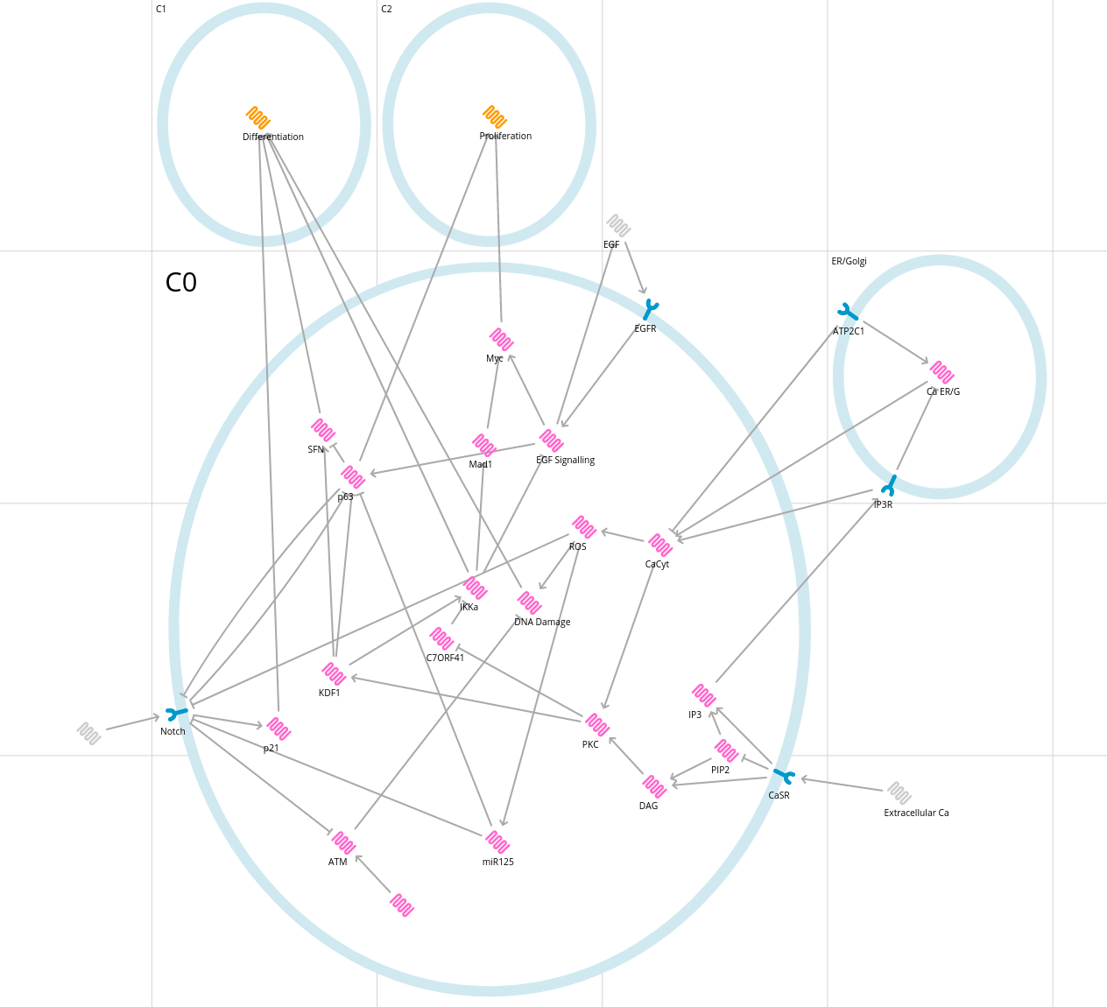
The Model
Movement of keratinocytes up the epidermis into regions of higher extracellular calcium concentration is known to trigger differentiation. The extracellular calcium binds to a receptor on the cell and triggers a PLC signalling cascade that activates PKC (Efimova et al. 1998). This in turn can activate IKKa and SFN, factors that are known to trigger differentiation, through the activation of KDF1 and the inhibition of C7ORF41 (Li 2020, Yan 2021). This pathway will also interact with pathways that trigger proliferation. The binding of growth factors to the cell triggers EGF signalling cascades which activate proto-oncogenes like p63 and Myc. IKKa inhibits EGF signalling and triggers production of Mad1 to inhibit Myc while KDF1 inhibits p63 (Liu 2009, Descargues 2008). P63 can in turn inhibit SFN. Notch can also effect differentiation and proliferation by producing p21, which triggers differentiation, and inhibiting p63 (Nguyen 2006). We have also included pathways based on current knowledge of Hailey-Hailey disease, particularly that there is an increase in the presence of reactive oxygen species and an miRNA called miR125. Reactive oxygen species can cause DNA damage, which is known to trigger differentiation. It has been suggested that an increase in Notch activity in HHD inhibits the ability of ATM to repair this damage (Cialfi et al. 2016). On the other hand, miR125 is produced in response to the presence of ROS and can inhibit Notch and p63 (Manca 2011).

Limitations:
- Time constraints mean literature review was not exhaustive – while most important pathways are included, some may have been missed particularly when considering proliferation.
- Boolean modelling misses graded responses – for example, it would be interesting to be able to model how a small increase in calcium could impact the activation of PKC rather than removing this interaction.
- Similarly, extracellular calcium concentration is along a gradient which is not captured in this model

