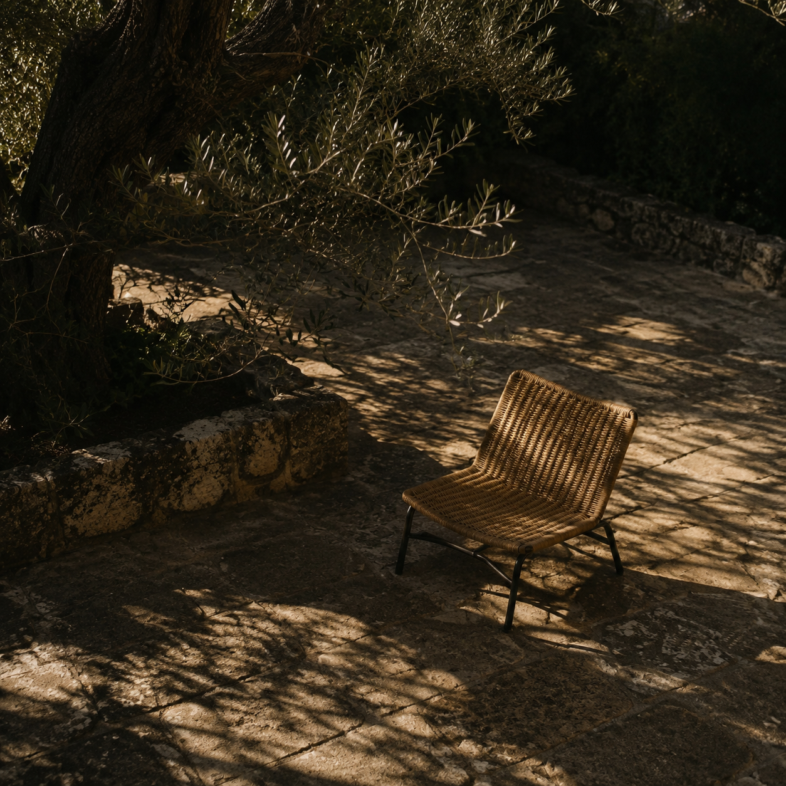

RIVET RIDGE RALLY
Design review, release direction, and evidence status |  | Prepared for Project Owner  July 2026

Contents

Executive summary 2
At a glance 2
Introduction 2
Key findings 3
Context and conditions 3
Patterns in the evidence 3
Implications 3
Recommendations 4
Conclusion 4
Appendix 5
Notes 5
Evidence sources 5

Executive summary
RIVET RIDGE RALLY 1.0.0-rc.2 has materially addressed two issues that reopened the candidate: fresh profiles now use the arrow cluster for lane and pitch control, and Rider School now teaches the full riding, heat, terrain, landing, and collision loop.
Concept-art fidelity remains unresolved. The visual response is substantial and repeatable, but owner acceptance, physical device and input review, immutable source identity, and commercial actions remain open. The correct decision is NOT READY.

At a glance
- Arrow-key defaults, targeted A/D migration, and remapping behavior are recorded as PASS.
- Rider School completes in about 1.2 automated minutes; novice comprehension is UNVERIFIED.
- Visual regression against untouched RC1 baselines still fails pending owner acceptance.

Introduction
This report consolidates the project's design, specification, QA, readiness, asset, and fidelity records as of 14 July 2026. It separates executed evidence from manual, physical, legal, and owner-controlled work.
Its purpose is to close the user's three design concerns without overstating commercial readiness, then define the shortest credible path to one frozen, fully qualified candidate.

Key findings
Controls and tutorial scope are implemented and functionally evidenced. The remaining design risk is visual acceptance: deterministic captures show material change, not proof that the experience matches the concepts.

Context and conditions
Recorded checks cover typecheck, lint, 78 unit tests, campaign qualification, local performance, soak, build, audit, manifest, and installed-Chrome smoke in stated scopes.

Patterns in the evidence
Emulation is not physical hardware, automation is not novice understanding, and repeatable screenshots are not proof of concept fidelity.

Key takeaway. Accept or bound the visual direction before freezing source and rerunning the final browser, device, performance, and artifact matrix.

Implications
Further visual changes can invalidate build and performance evidence. Records must also be reconciled after the folder move and final artifact generation.
Theme | Observation | Implication
Controls | Arrow cluster default; A/D remappable. | Complaint closed; physical review open.
Tutorial | 12 lessons and collision drills pass. | Novice comprehension remains unverified.
Visuals | Track identity and depth improved. | Owner fidelity decision remains open.

Recommendations
Close the remaining risk in this order: decide the visual target, validate learning and controls on real hardware, then freeze and qualify one exact candidate.
- Approve the visual direction. Review desktop, portrait, high-contrast, and all five track captures against the concepts; accept them or issue bounded revisions.
- Validate real play. Observe first-time players and exercise physical keyboard, touch, and gamepad controls, including accessibility modes.
- Freeze and requalify. Tie one clean commit and annotated tag to the full browser and device matrix, performance evidence, manifest, and smoke results.

Conclusion
The engineering response is credible, and the renamed workspace removes a prohibited public-release path risk. Those wins do not erase the open product and commercial gates.
Keep status at NOT READY until visual acceptance, human and physical evidence, immutable source identity, and owner-controlled legal, hosting, provenance, and support actions close.

Appendix

Notes
Evidence is scoped exactly as recorded: Playwright WebKit is not installed Safari, emulated mobile is not a physical device, and automation is not human comprehension.
The repository now resides at /Users/john/Sandbox/Rivet Ridge Rally. The workspace naming action is complete; release records must preserve that neutral naming.

Evidence sources
- README.md, GAME_BIBLE.md, GAME_SPEC.md, and ARCHITECTURE.md.
- QA_REPORT.md and LAUNCH_READINESS.md, including scoped PASS, FAIL, and UNVERIFIED evidence.
- ASSET_LICENSES.md and docs/design/FIDELITY_LEDGER.md.
- Owner feedback: arrow controls, tutorial completeness, and concept-art fidelity.

Status note. The candidate remains NOT READY; do not replace visual baselines or claim launch readiness until the named gates close.

